OMB Control Number 1205-0422
Expiration Date: xx/xx/xxxx

ATTACHMENT B

Workforce Investment Act, Section 166
Indian and Native American Programs
General Reporting Instructions for the Supplemental Youth Services Program Report (ETA Form 9085)

Revised 2006

Prepared By
Office of Performance and Technology
Employment and Training Administration

This reporting requirement is approved under the Paperwork Reduction Act of 1995, OMB Control No. 1205-0422, expiring xx/xx/xxxx. Persons are not required to respond to this collection of information unless it displays a currently valid OMB number. Public reporting burden for this collection of information is estimated to average 8 hours per quarterly report per grantee, including time for reviewing instructions, searching existing data sources, gathering and reviewing the collection of information. Respondent’s obligation to reply is mandatory. The reason for the collection of information is general program oversight, evaluation and performance assessment. Send comments regarding this burden estimate or any other aspect of this collection, including suggestions for reducing this burden, to the U. S. Department of Labor, Employment and Training Administration, Office of Performance and Technology, 200 Constitution Avenue, NW, Room S-5206, Washington, D.C. 20210 (Paperwork Reduction Project 1205-0422).

GENERAL INSTRUCTIONS

Workforce Investment Act (WIA) section 166 grantees are required to submit performance reports to the United States Department of Labor, Employment and Training Administration (USDOL/ETA) to comply with the record keeping and reporting requirements of the Supplemental Youth Services (SYS) Program grant. The SYS report provides information on current program participants, including important socio-economic characteristics, participants who have exited the program, and performance outcomes for the most recent quarter and cumulated for the most recent four-quarter reporting period. The information contained on this report will be used to determine the levels of participation, services received, and accomplishments for each SYS program grant.

REPORT FORM

The format and instructions for completing the ETA 9085 SYS Quarterly Performance Report can be found under Appendix A.

DUE DATES

All quarterly reports under section II are due no later than 45 days after the end of each reporting quarter. The table below shows the expected due dates for each reporting quarter.

Report Quarter | Due Dates
April – June | August 14th
July – September | November 14th
October – December | February 14th
January – March | May 15th

Should the due date of the report fall on a Saturday, Sunday, or holiday, the report is due the business day before.

SUBMISSION PROCEDURES

Information contained on the SYS Quarterly Performance Report must be submitted directly to ETA’s Enterprise Business Support System (EBSS) (formerly called the Enterprise Information Management System (EIMS)) via technical instructions issued through the USDOL/ETA, Division of Indian and Native American Programs (DINAP), or the ETA performance website (www.doleta.gov/performance). Grantees will only be permitted to update reported results for the 1st quarter prior to the current report quarter’s submission.
APPENDIX A
SYS Quarterly Performance Report (ETA Form 9085)

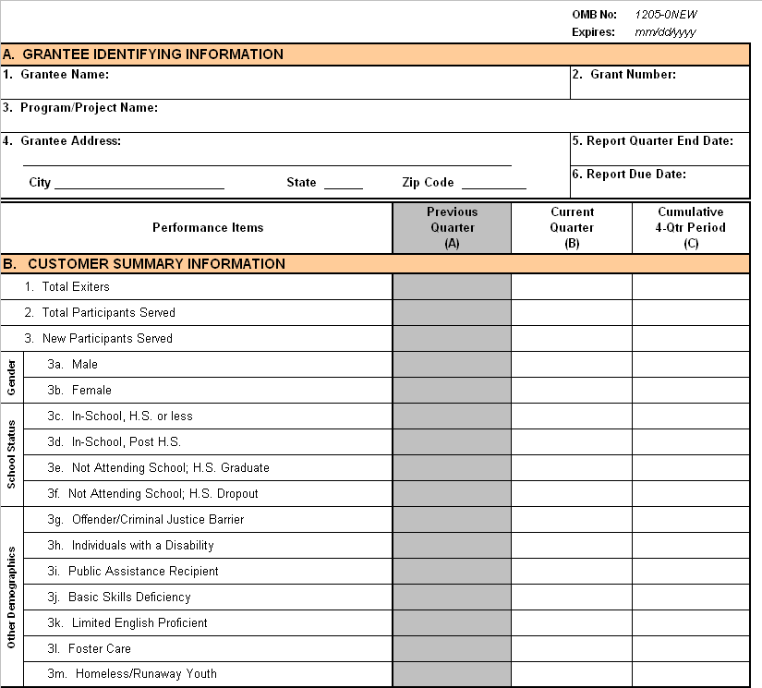
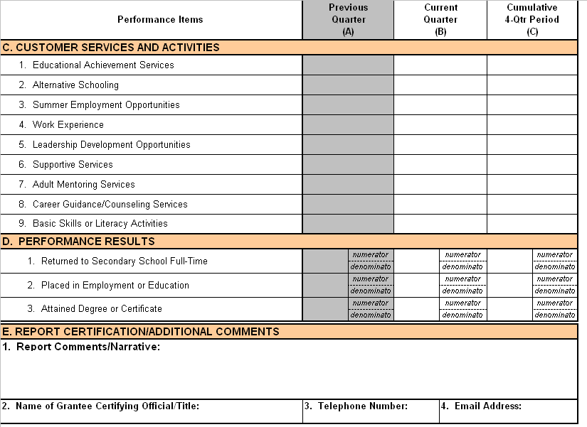

Instructions for Completing the
SYS Quarterly Performance Report

Section A. Grantee Identifying Information

A.1 Grantee Name – Enter the grantee name as it appears on the appropriate Notice of Obligation (NOO) or equivalent official document from the U.S. Department of Labor.
A.2 Grant Number – Enter the grant number as it appears on the appropriate NOO or equivalent official document from the U.S. Department of Labor.
A.3 Program/Project Name – Enter the name of the SYS program or project.
A.4 Grantee Address – Enter the mailing address as it appears on the appropriate NOO or equivalent official document from the U.S. Department of Labor.
A.5 Report Quarter End Date – Enter the last month, day, and year (mm/dd/yyyy) of the quarter on which the report is being prepared. For example, if the report is being prepared for the quarter ending September 30th, 2006, the Report Quarter End Date format should be represented as 09/30/2006.
A.6 Report Due Date – Enter the month, day, and year (mm/dd/yyyy) on which the report is due to the Department. For example, if the report is being prepared for the quarter ending 09/30/2006, the Report Due Date format should be represented as 11/14/2006.

Section B. Customer Summary Information

This section collects information on the number of current participants (including new and carried-over participants) and information on those participants who exit the SYS program during the reporting period. Socio-economic characteristics of new participants contained in this section should be based on information collected from the individual at the time of participation in the SYS program. Grantees are required to certify and submit results for both the current quarter (Column B) and cumulative totals for the most recent four-quarter reporting period (Column C). For all data collection items contained within this section, the data format is Integer with a maximum field length of 6-digits.

B.1 Total Exiters – Enter the total number of participants who exit from the program during the reporting period. Exit from the program occurs when a participant has not received any services funded by the program or a partner program for 90 consecutive calendar days and has no gap in service and is not scheduled for future services. The date of exit is applied retroactively to the last day on which the individual received a service funded by the program or a partner program.

B.2 Total Participants Served – Enter the total number of individuals (including new and carried-over) who received a service or, if it is an ongoing activity, are continuing to receive services under the program during the reporting period. A participant is any individual who is determined eligible to participate in the program and receives a service funded by the program. Participant counts do not include individuals who only receive a determination of eligibility to participate in the program.

B.3 New Participants Served – Enter the total number of individuals who, following a determination of eligibility, began receiving a first service funded by the program during the reporting period.

B.3a Male – Enter the total number of new participants whose gender is male.

B.3b Female – Enter the total number of new participants whose gender is female.

B.3c In-School, H.S. or less – Enter the total number of new participants who have not received a secondary school diploma or its recognized equivalent and are attending any secondary school (including elementary, intermediate, junior high school, whether full or part-time, and alternative school), or are between school terms and intend to return to school.

B.3d In-School, Post H.S. – Enter the total number of new participants who have received a secondary school diploma or its recognized equivalent and are attending a post-secondary school or program (whether full or part-time), or are between school terms and intend to return to school.

B.3e Not Attending School; H.S. Graduate – Enter the total number of new participants who are not attending any school and have either graduated from high school or hold a GED.

B.3f Not Attending School; H.S. Dropout – Enter the total number of new participants who are no longer attending any school and have not received a secondary school diploma or its recognized equivalent.

B.3g Offender/Criminal Justice Barrier - Enter the total number of new participants who either (a) are or have been subject to any stage of the criminal justice process for committing a status offense or delinquent act, or (b) require assistance in overcoming barriers to employment resulting from a record of arrest or conviction for committing delinquent acts, such as crimes against persons, crimes against property, status offenses, or other crimes.

B.3h Individuals with a Disability – Enter the total number of new participants who indicate they have any “disability,” as defined in Section 3(2)(a) of the Americans with Disabilities Act of 1990 (42 U.S.C. 12102). Under that definition, a “disability” is a physical or mental impairment that substantially limits one or more of the person’s major life activities. (For definitions and examples of “physical or mental impairment” and “major life activities,” see paragraphs (1) and (2) of the definition of the term “disability” in 29 CFR 37.4, the definition section of the WIA non-discrimination regulations.)

B.3i Public Assistance Recipient - Enter the total number of new participants who were receiving cash assistance or other support services from one of the following sources: Temporary Assistance for Needy Families, Food Stamp Assistance, General Assistance (GA) (State/local government), Refugee Cash Assistance (RCA), and Supplemental Security Income (SSI-SSA Title XVI), Supplemental Security Disability Insurance, Veterans Benefits, Foster Child Payments, USDA's Commodity Supplemental Food Program (CSFP), Department of Interior's, Bureau of Indian Affairs, General Assistance or Tribal Work Experience Program (TWEP).

B.3j Basic Skills Deficiency - Enter the total number of new participants who either (a) compute or solve problems, reads, writes or speaks English (Spanish in Puerto Rico) at or below grade level 8.9; or (b) are unable to compute or solve problems, read, write, or speak English at a level necessary to function on the job, in the individual’s family or in society. A determination of basic skills deficiency must be based on a generally accepted standardized testing instrument or a comparable score on a criterion-referenced test.

B.3k Limited English Proficient - Enter the total number of new participants who have limited ability in speaking, reading, writing or understanding the English language and (a) whose native language is a language other than English, or (b) who live in a family or community environment where a language other than English is the dominant language.

B.3l Foster Care - Enter the total number of new participants who are under foster care as determined by the Tribe or State.

B.3m Homeless/Runaway Youth – Enter the total number of new participants who lack a fixed, regular, adequate night time residence. This definition includes any individual who has a primary night time residence that is a publicly or privately operated shelter for temporary accommodation; an institution providing temporary residence for individuals intended to be institutionalized; or a public or private place not designated for or ordinarily used as a regular sleeping accommodation for human beings; or a person under 18 years of age who absents himself or herself from home or place of legal residence without the permission of his or her family (i.e., runaway youth). This definition does not include an individual imprisoned or detained under an Act of Congress or State law. An individual who may be sleeping in a temporary accommodation while away from home should not, as a result of that alone, be recorded as homeless.

Section C. Customer Services and Activities

This section collects information on the number of current participants (including new and carried-over participants) who received or, if it is an ongoing activity, are continuing to receive one or more of the allowable services/activities under the SYS program. Grantees are only required to report the total number of participants who received one or more of the reference program activities below. Grantees are required to certify and submit results for both the current quarter (Column B) and cumulative totals for the most recent four-quarter reporting period (Column C). For all data collection items contained within this section, the data format is Integer with a maximum field length of 6-digits.

C.1 Educational Achievement Services – Enter the total number of participants who received one or more educational achievement services during the reporting period. Educational achievement services include tutoring, study skills training, and instruction leading to secondary school completion, including dropout prevention strategies, and other activities designed to improve educational and skill competencies. This definition includes occupational skills training.

C.2 Alternative Schooling – Enter the total number of participants who participated in alternative schooling during the reporting period.

C.3 Summer Employment Opportunities – Enter the total number of participants who received summer employment opportunities directly linked to academic and occupational learning during the reporting period.

C.4 Work Experience – Enter the total number of participants who received work experience during the reporting period. This definition includes paid and unpaid work experiences, including internships, and job shadowing.

C.5 Leadership Development Opportunities – Enter the total number of participants who received one or more leadership development opportunities during the reporting period. Leadership development opportunities include, but are not limited to, program activities that encourage responsibility, employability, and other positive social behaviors such as (a) exposure to post-secondary educational opportunities; (b) community and service learning projects; (c) peer-centered activities, including peer mentoring and tutoring; (d) organizational and team work training, including team leadership training; (e) training in decision making, including determining priorities; (f) citizenship training, including life skills training such as parenting, work behavior training, and budgeting of resources; and (g) any organized group counseling program or “youth camp.”

C.6 Supportive Services – Enter the total number of participants who received one or more supportive services during the reporting period. Youth supportive services include, but are not limited to, linkages to community services, assistance with transportation, assistance with child care and dependent care, assistance with housing, referrals to medical services, and assistance with uniforms or other appropriate work attire and work-related tools, including such items as eye glasses and protective eye gear.

C.7 Adult Mentoring Services – Enter the total number of participants who received adult mentoring services during the reporting period.

C.8 Career Guidance/Counseling Services – Enter the total number of participants who received career guidance/counseling services during the reporting period.

C.9 Basic Skills Training or Other Literacy Activities – Enter the total number of participants who received remedial education, including Adult Basic Education (ABE), basic literacy training, or English-as-a-second-language (ESL) training programs during the reporting period.

Section D. Performance Results

This section collects information on important outcomes achieved by participants of the SYS Program. Grantees are required to certify and submit results for both the current quarter (Column B) and cumulative totals for the most recent four-quarter reporting period (Column C). Grantees are required to report both the numerator and denominator values for each performance measure contained in this section. This detail is needed so that the information can be aggregated across grantees to provide national estimates. For all numerator and denominator values, the data format is Integer with a maximum field length of 6-digits. The EBSS on-line reporting system will automatically calculate the percent or rate for each measure. The data format for the percentages or rates is Decimal 3.1 rounded to the first digit to the right of the decimal (e.g., 99.9%) using the 5/4 rounding method.

D.1 Returned to Secondary School Full-Time

Of those youth who, at the time of participation in the program, were not attending any school (exclusive of summer) and had not received a secondary school diploma or its recognized equivalent.

Numerator:
Enter the total number of participants who, upon exit from the program, returned to secondary school (including alternative school) full-time as a result of participating in the program.

Denominator:
Enter the total number of participants who exit during the quarter (qtr)

D.2 Placed in Employment or Education

Of those who are not in post-secondary education or employment (including the military) at the time of participation in the program:

Numerator:
Enter the total number of participants who, upon exit from the program, were placed in unsubsidized employment or enrolled in post-secondary or advanced training/occupational skills training

Denominator:
Enter the total number of participants who exit during the qtr

Additional Note: Unsubsidized employment includes non-WIA funded employment, entry into tribal, local, state, federal, or military employment, employment in a registered apprenticeship program, or self-employment.

D.3 Attained Degree or Certificate

Of those enrolled in education (at the date of participation or at any point during the program):

Numerator:
Enter the total number of participants who, at any point while participating in the program or upon exit from the program, attain a diploma, GED, or certificate

Denominator:
Enter the total number of participants who exit during the qtr

Section E. Report Certification/Additional Comments

E.1 Report Comments/Narrative – Grantees may include additional information not captured as part of the report format or attach an electronic document that describes innovative service delivery strategies, progress on measures of program accomplishments (as outlined above in Section D. Performance Results), or how youth have been impacted in a positive way by the SYS program.

E.2 Name of Grantee Certifying Official/Title – Enter the name and title of the grantee official that is certifying submission of the report to the Department.

E.3 Telephone Number – Enter the area code (999) and telephone number (999-9999) of the authorized official.

E.4 Email Address – Enter the email address of the authorized official.

