Project 134 QID 000560 |  |  | OMB No. 0535-0039: Approval Expires 3/31/2007
 | CHERRY INQUIRY  2007 CROP |  |  |  |  | NATIONAL  AGRICULTURAL STATISTICS  SERVICE
Idaho Field Office
P.O. Box 1699
2224 Old Penitentiary Road
Boise, Idaho 83701-1699
Phone 1-800-691-9987,Fax 208-334-1114
nass-id@nass.usda.gov
Please return by June 1, 2007 |  |  |  | TO IDAHO FRUIT GROWERS:  Your assistance in appraising the production of the State's fruit crop is again requested. Response to this survey is voluntary and not required by law; however, your cooperation is very important in order to estimate fruit production accurately in Idaho. Information is needed for orchards of all sizes. All reports are kept confidential. Thank you for your cooperation.  Sincerely,  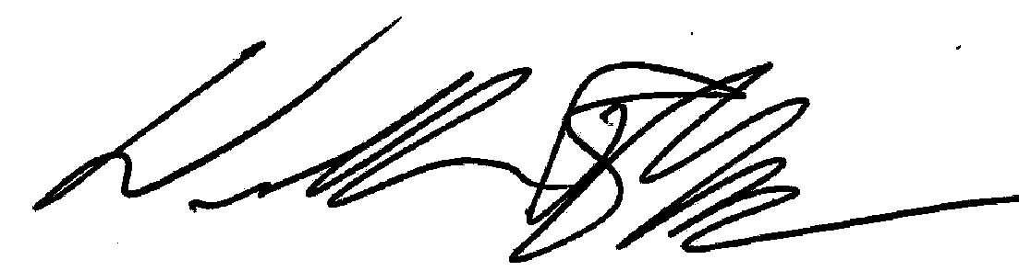  William R Meyer  Director
Is your operation known by another name?

NO YES _____________________________________
(Please list operation name)

CONDITION: Please report the condition of fruit crops now, as a percent of a full crop. Let 100 percent represent the full crop you
would expect if there was no damage from unfavorable weather, insects, diseases, etc.

REPORT FOR YOUR ORCHARD(S)

KIND OF FRUIT CONDITION
(% of a full crop)

CHERRIES, Sweet . . . . . . . . . . . . . . . . . . . . . . . . . . . . . . . . . . . . . . . . . . . . . . . . . . . . . . . .___________________________ %

COMMENTS on development, set, bloom quality, losses from weather or insect pest, harvest, etc. of the various fruits will be
helpful. Please use the reverse side, if necessary.
______________________________________________________________________________________________________

______________________________________________________________________________________________________

______________________________________________________________________________________________________

REPORTED BY: ____________________________________ COUNTY IN WHICH ORCHARD IS LOCATED: __________________

According to the Paperwork Reduction Act of 1995, no persons are required to respond to a collection of information unless it displays a valid OMB control number. The time required to complete this information collection is estimated to average 10 minutes per response.

