Public reporting burden for this collection of information is estimated to average 6 minutes per response, including the time for reviewing instructions, searching existing data sources, gathering and maintaining the data needed, and completing and reviewing the collection of information. An agency may not conduct or sponsor, and a person is not required to respond to, a collection of information unless it displays a currently valid OMB control number. Send comments regarding this burden estimate or any other aspect of this collection of information, including suggestions for reducing this burden, to: NIH, Project Clearance Branch, 6705 Rockledge Drive, MSC 7974, Bethesda, MD 20892-7974, ATTN: PRA (0925-0543).

First Month Saliva Collection

This packet contains everything that you will need to provide us with a saliva sample.

Please collect your second saliva sample as soon as you wake up on the day after the first time that you press the “m” button on your monitor. You may find it helpful to place the collection container next to your bed so that you will be reminded to obtain the sample as soon as you awaken. The sample should be collected before eating, drinking (besides water), smoking, or brushing your teeth. These substances could contaminate the sample.

To collect the sample:

- Remove the cotton roll from the enclosed collection tube.
- Place the cotton roll in your mouth and lightly chew on it until the cotton is wet (about 2 or 3 minutes).
- Place the wet roll back in the collection tube and replace the cap.
- Insert the sealed collection tube into the crush-proof mailing container.
- Complete the attached form.
- Place the saliva sample in your home freezer until it is frozen solid.
- Once the sample is frozen, place the collection container and the form in the postage paid envelope and mail.

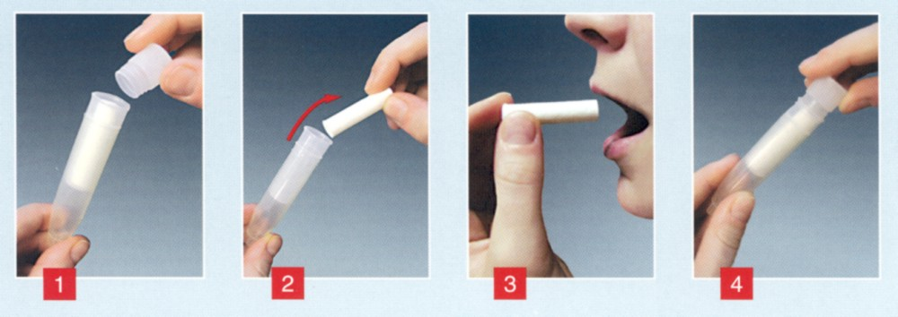
Thank you for your time and cooperation!

----------------------------------------Please Return with Sample-------------------------------------

SPID number: Date:

Time of awakening: AM/PM (circle one)

Time of sample collection: AM/PM (circle one)

Comments:

