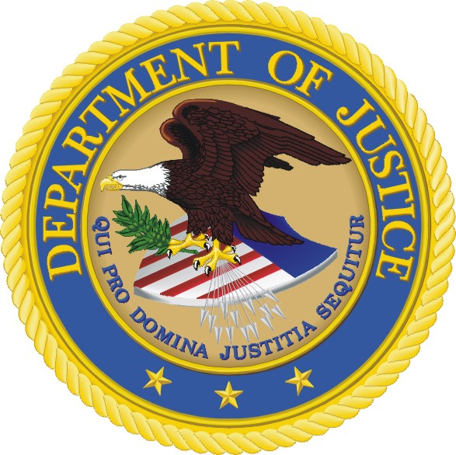
National Drug Threat Survey 2007
______________________________________________________________________________________________________________________________________
U.S. Department of Justice
National Drug Intelligence Center
319 Washington Street, 5th Floor
Johnstown, PA 15901-1622
Phone: (800) 624-4958

Fax: (814) 532-4690

Please note any changes from label:

Law Enforcement Agency
Title (of person completing the survey) First Name MI Last Name
Address
City State Zip
Telephone Fax
E-mail Address

General Instructions
Your response to this survey will help us understand the drug situation in your area. Your input, when combined with similar data collected across the country, will be invaluable in preparing our annual National Drug Threat Assessment as well as periodic regional drug threat assessments.

Please fill out the survey as thoroughly as possible, fully darkening the circles, using black or blue ink.

Please mail your completed survey in the enclosed self-addressed stamped envelope or fax it to NDIC using the fax number listed above by May 31, 2007.

Thank you for participating in the NDIC National Drug Threat Survey 2007

Paperwork Reduction Act Notice - A person is not required to respond to a collection of information unless it displays a valid OMB control number. We try to create instructions and forms that are accurate, easily understood,
and impose the least possible burden. The estimated average time to complete the form is 20 minutes. If you have any comments regarding the accuracy of this estimate or suggestions for making this form simpler, please contact the National Drug Intelligence Center, Collections Unit, at (800) 624-4958.

- What drug poses the greatest threat to your area? (Choose only ONE.)

Powder cocaine O Heroin O Marijuana O Other dangerous drugs……...O
Crack cocaine O Methamphetamine… O MDMA (ecstasy) O Diverted pharmaceuticals……O

- Indicate the level of availability of the following drugs in your area.

Not Not
Low Moderate High Available Low Moderate High Available
Powder cocaine O O O O | MDMA (ecstasy) O O O O
Crack cocaine O O O O | GHB O O O O
Heroin O O O O | LSD O O O O
Powder Methamphetamine O O O O | PCP O O O O
ICE Methamphetamine O O O O | GBL O O O O
Marijuana O O O O | Diverted pharmaceuticals O O O O

- Indicate the level of involvement of street gangs and outlaw motorcycle gangs in your area in the distribution of drugs in general as well as for the specific drugs listed below. If street gangs or outlaw motorcycle gangs are not involved in drug distribution in your area, please indicate by filling in NONE.

Street Gangs Outlaw Motorcycle Gangs
Low Moderate High None Low Moderate High None
Drugs in general O O O O | O O O O
Powder cocaine O O O O | O O O O
Crack cocaine O O O O | O O O O
Heroin O O O O | O O O O
Methamphetamine O O O O | O O O O
Marijuana O O O O | O O O O
MDMA (ecstasy) O O O O | O O O O
Other dangerous drugs O O O O | O O O O
Diverted pharmaceuticals O O O O | O O O O

- Please provide the following information for STREET GANGS in your jurisdiction.

Total Number of Total Number of Percent of STREET Gangs Past Year Change in Level of
STREET Gangs STREET Gang Members Involved in Drug Activities STREET Gang Drug Activity

None O None O None O Increased O
1–25 O 1–250 O 1 – 25% O Decreased O
26–50 O 251–500 O 26 – 50% O Remained the Same O
51–75 O 501–750 O 51 – 75% O Not Applicable O
76–100 O 751–1,000 O 76 – 100% O
101–500 O 1,001–2,500 O
501–1,000 O 2,501 or more O
1,001 or more O

- Please provide the following information for OUTLAW MOTORCYCLE GANGS (OMGs) in your jurisdiction.

Total Number of Total Number of Percent of OMGs Past Year Change in Level
OMGs OMG Members Involved in Drug Activities of OMG Drug Activity

None O None O None O Increased O
1–5 O 1–10 O 1 – 25% O Decreased O
6–10 O 11–25 O 26 – 50% O Remained the Same O
11–15 O 26–50 O 51 – 75% O Not Applicable O
16–20 O 51–75 O 76 – 100% O
21–25 O 76–100 O
26 or more O 101 or more O

- Is powder cocaine converted to crack in your area? Yes O No O

- Please indicate how cannabis is cultivated in your area. (Fill in ALL that apply.)

Indoors O Outdoors O Hydroponically O Not cultivated O

- Please indicate the level of methamphetamine production in your area.

Low production O Moderate production O High production O Not produced O

- Have you encountered powder methamphetamine being converted to ICE methamphetamine in your area?

Yes O No O

- Please indicate the most common money laundering technique used by wholesale-level traffickers in your area.
(Choose only ONE.)

Bulk cash movement O

Money services businesses (e.g., wire transmitters, check cashers, currency exchangers, etc.) O

Banks (structuring) O

Cash intensive business (e.g. restaurants, nail salons, strip clubs, etc.) O

Informal value transfer systems (e.g., black market peso exchange, hawala, etc.) O

Unknown O

- Indicate the level of diversion/illicit use for the following types of pharmaceuticals in your area.

Low Moderate High None
Narcotics (e.g Vicodin, OxyContin, Dilaudid) O O O O
Depressants (e.g. Valium, Xanax, Klonopin) O O O O
Stimulants (e.g. Adderall, Ritalin, Dexedrene) O O O O
Steroids (e.g. Anadrol, Oxandrin, Durabolin) O O O O

- Indicate the drug that most contributes to violent crime and the drug that most contributes to property crime in your area. (Choose only ONE drug for each type of crime.)

Violent Crime Property Crime
(Choose only ONE.) (Choose only ONE.)

Powder cocaine O |  | Powder cocaine O
Crack cocaine O |  | Crack cocaine O
Heroin O |  | Heroin O
Methamphetamine O |  | Methamphetamine O
Marijuana O |  | Marijuana O
MDMA (ecstasy) O |  | MDMA (ecstasy) O
Other dangerous drugs O |  | Other dangerous drugs O
Diverted pharmaceuticals O |  | Diverted pharmaceuticals O

- Please indicate the primary city or region from which drugs are transported into your jurisdiction (e.g. from Philadelphia, from South Texas).

____________________________________________________

- What is the predominant ethnicity of the major criminal groups or organizations that are involved in drug trafficking activities in your jurisdiction (e.g. Mexican, Dominican, Hispanic, Caucasian). List up to three ethnicities.

____________________________________________________

____________________________________________________

____________________________________________________

319 Washington Street 5th Floor, Johnstown, PA 15901-1622 • (814) 532-4601
NDIC publications are available on the following web sites:
ADNET http://ndicosa LEO home.leo.gov/lesig/ndic
RISS ndic.riss.net INTERNET www.usdoj.gov/ndic
082605

