DATE

Teacher
School
Address
City, State, Zip

Dear Teacher:

I am writing to you because a small number of children who are participating in the Follow Up to the Classroom Literacy Interventions and Outcomes (CLIO) study are enrolled in your first grade class. (These children are identified on the Child Report Forms included in this package.) The CLIO study is sponsored by the U.S. Department of Education and is being conducted by Westat, a research firm in the Washington, DC area. CLIO is an ongoing study of promising early childhood education curricula in a sample of preschool classrooms across the U.S. As part of the study we are now collecting information about the CLIO preschool children who are now in first grade to find out if their experience in preschool has lasting effects. CLIO is not a study of your school, district, or classroom.

We have obtained approval from your school district or central administration and we also obtained written permission from parents to collect data on their children. In addition, we notified your school principal that we would be contacting you.

We are asking you to complete a short self-administered paper survey about the classroom environment, and a short rating form for each study child in your class that focuses on the child’s development and behavior. We estimate it will take approximately 10 minutes to complete.

The questionnaire and rating form(s) are enclosed with this letter. We have tried to keep the time required to a minimum and hope that you will take the time to complete these forms. We realize that this is a busy time of year, but the information that you provide is extremely important for the success of this study. You will receive a check in the amount of $20 for the completed questionnaire and rating form(s). We have also enclosed a pen as an additional thank you. All the information we collect will be kept private, except as required by law.

Should you have any questions about the CLIO study, please call the CLIO toll-free hotline at 1-888-445-1016. On behalf of the study and the U.S. Department of Education I want to thank you in advance for your cooperation in conducting this very important study.

Sincerely,
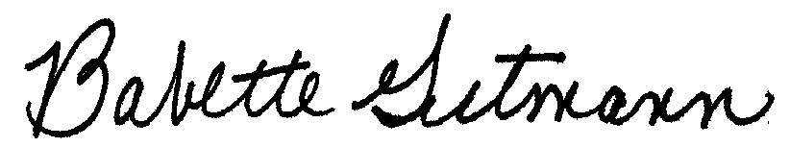

Babette Gutmann
CLIO Project Director

