DATE

PRINCIPAL
SCHOOL
Address
Address

Dear Principal:

I am writing to you because a small number of children who are participating in the Follow Up to the Classroom Literacy Interventions and Outcomes (CLIO) study are enrolled in first grade in your school. The CLIO study is sponsored by the U.S. Department of Education and is being conducted by Westat, a research firm in the Washington, DC area. CLIO is not a study of your school or district. CLIO is an ongoing study of promising early childhood education curricula in a sample of preschool classrooms across the U.S. We are now following up on the CLIO preschool children as they move into kindergarten and then into first grade to assess any sustained effects of the curricula over time. Some of these children are enrolled in first grade in your school.

For study children in first grade we obtained approval from your school district or central administration. We also obtained written permission from parents to collect data on their children.

For the CLIO children enrolled in your first grade we will ask their teachers to complete a short self-administered paper survey about the classroom environment, and a short rating form for each study child in the teacher’s class that focuses on the child’s development and behavior. We estimate it will take approximately 10 minutes per teacher.

We have tried to keep the time required to a minimum and hope the teachers will volunteer to complete the surveys. Teachers will receive a check in the amount of $20 for their completed survey and rating form(s). All the information we collect will be kept private, except as required by law.

We will be mailing the surveys and rating forms directly to the teachers within the next week. Should you have any questions about the CLIO study, please call the CLIO toll-free hotline at 1-888-445-1016. On behalf of the CLIO study I want to thank you in advance for your cooperation in conducting this very important study.

Sincerely,
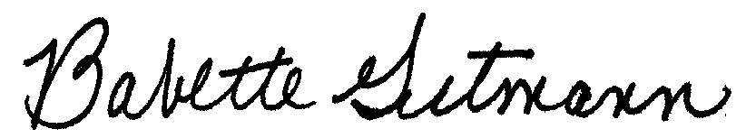

Babette Gutmann
CLIO Project Director

