Appendix B: Strategic Tracking and Reporting Tool and Item Justification

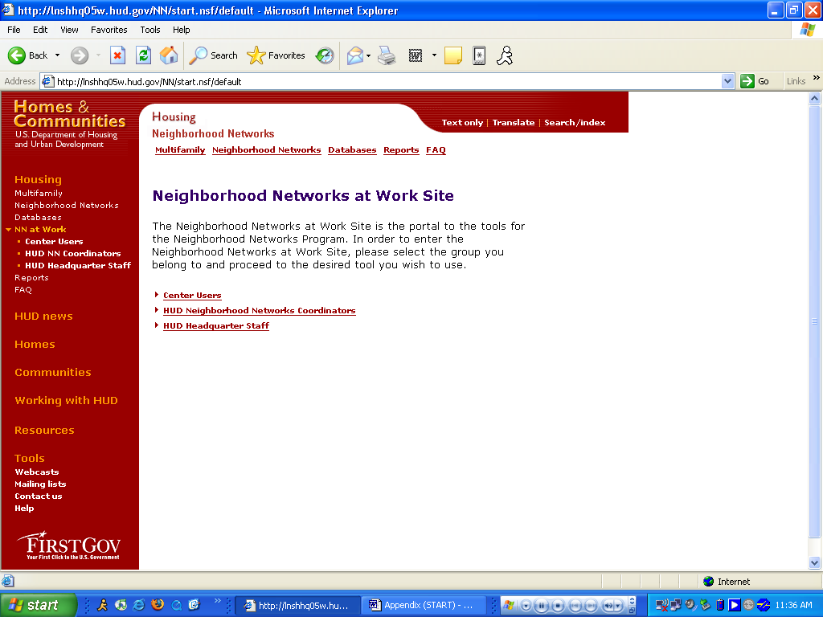

Purpose/Usage:
The purpose of this screen is to take the user to the appropriate login screen.

Description/Function:
Separate links to login screens will exist both in the center of the screen and in the left navigation bar for center users, HUD coordinators, and HUD staff.

Appendix B: Center Users Login Screen

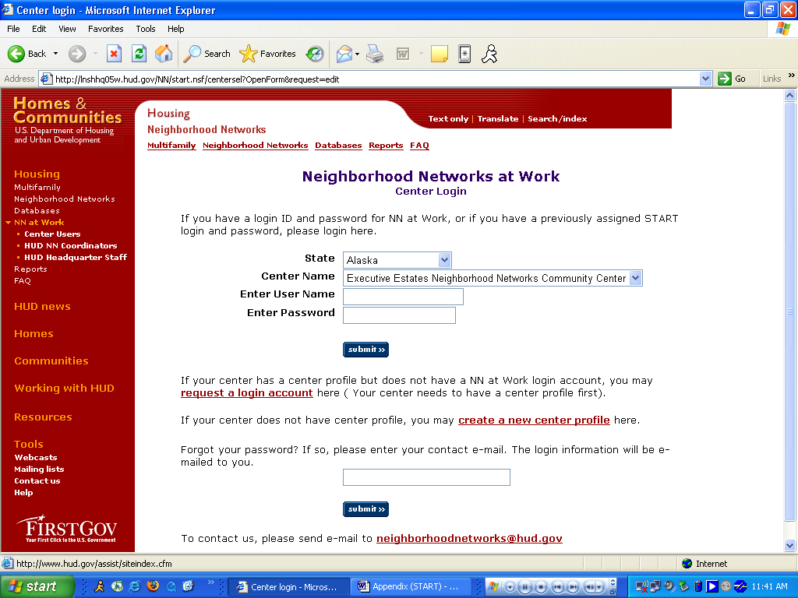

Purpose/Usage:
The purpose of this screen is to take the user to the principal login screen.

Description/Function:
The user can select to “create a new center profile”, “request a login account”, or login directly into the online web tool. The user must create a new center profile before being able to request a login account for the website.

Appendix B: Create A New Center Profile

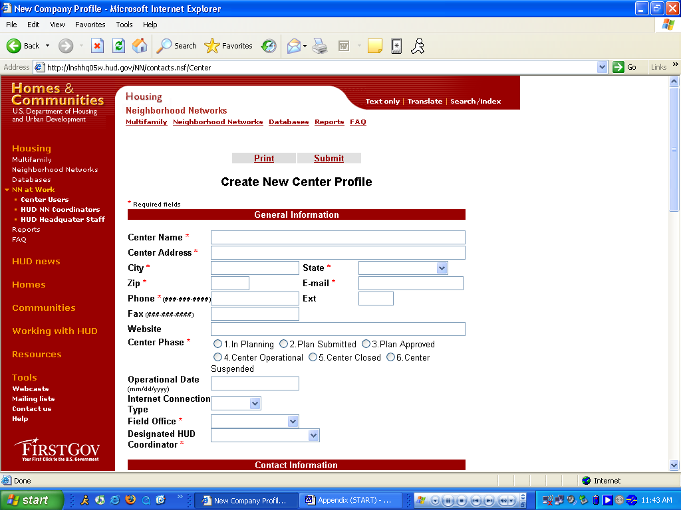

Purpose/Usage:
The Purpose of this screen is to allow centers that are not listed in the center name drop-down list to request a profile be created for their center.

Description/Function:
After filling in all of the relevant contact information. The user shall click the “submit” button at the bottom of the menu. This shall send the request for a new profile to be established to the NN Database Specialist. This form will request information concerning contact and property information.
Appendix B: Create A New Center Profile (Continued)

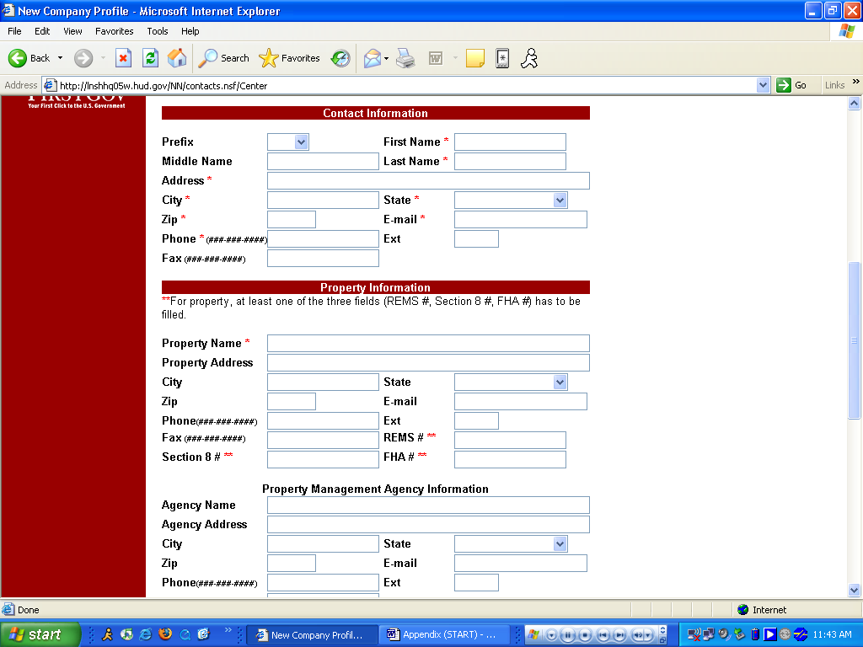

See Description Above.
Appendix B: Create A New Center Profile (Continued)

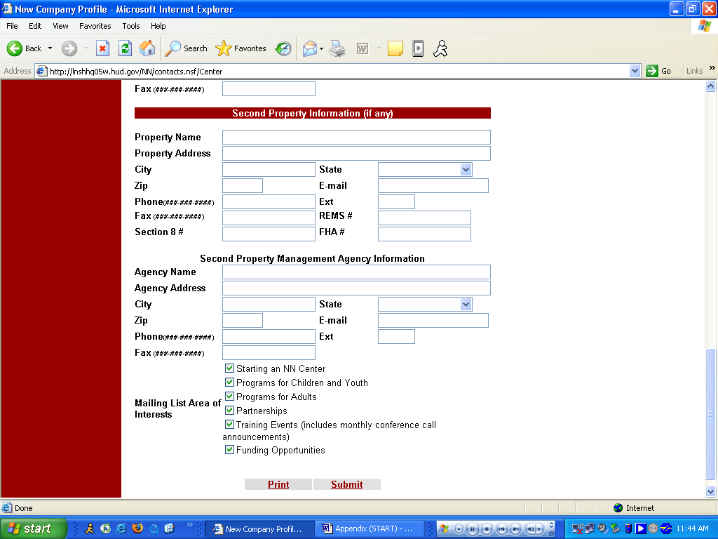

See Description Above.
Appendix B: Center Login Creation

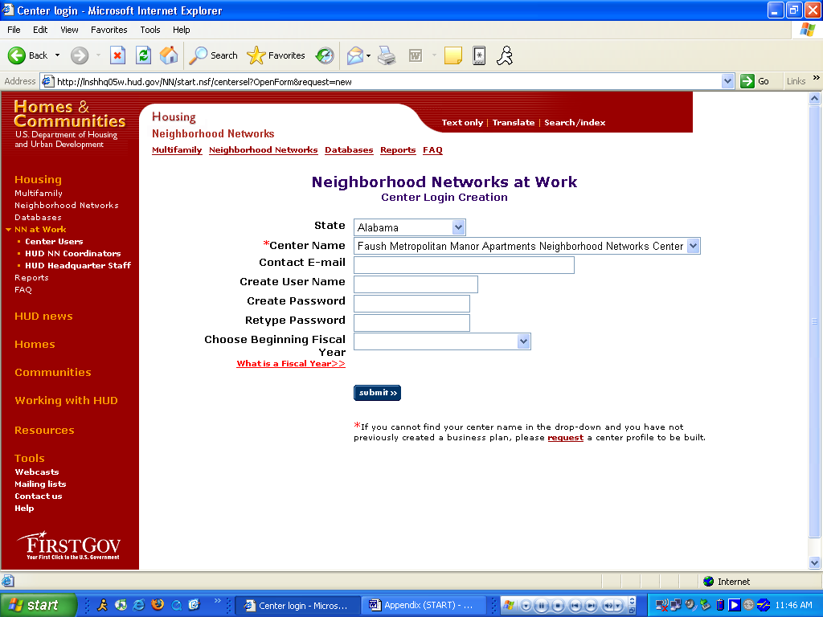

Purpose/Usage:
The Purpose of this screen is to allow centers to login to the portal.

Description/Function:
This is the initial login screen for the center user. From here they can enter their center’s credentials and log into the portal.
Appendix B: Portal Welcome Site

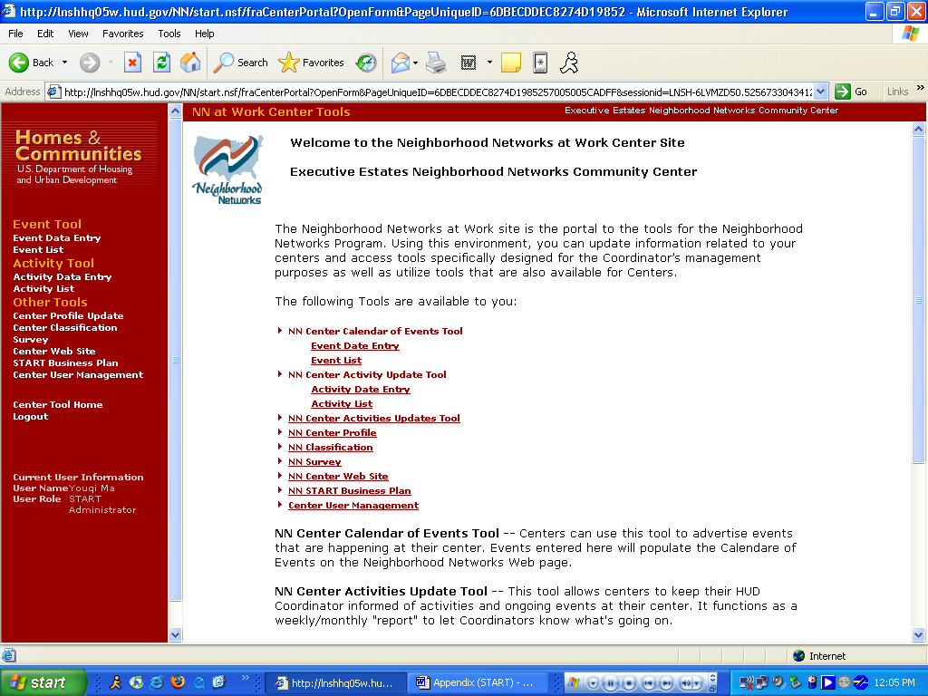

Purpose/Usage:
Welcomes the centers to their customized portal and all of the tools available to them.

Description/Function:
Serves as a main page listing all of the portals tools and resources available to the center.
Appendix B: Calendar Of Events

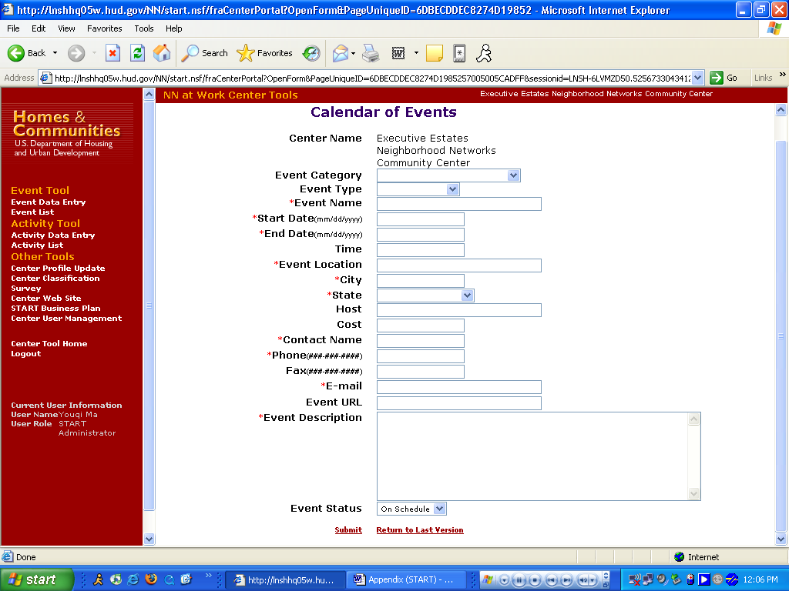

Purpose/Usage:
Centers can use this tool to advertise events that are happening at their center. Events entered here will populate the Calendar of Events on the Neighborhood Networks Web page.

Description/Function:
Website for centers to submit their events to help organize their planned events.
Appendix B: Center Activity

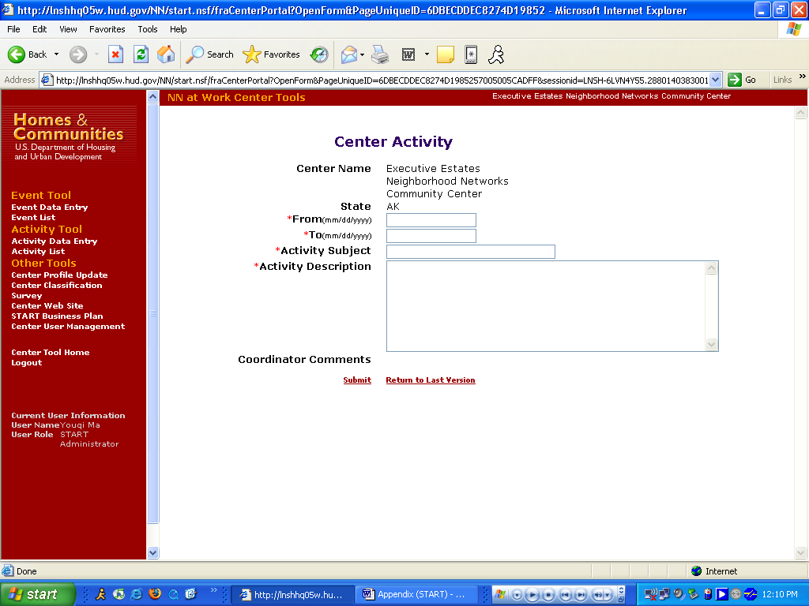

Purpose/Usage:
This tool allows centers to keep their HUD Coordinator informed of activities and ongoing events at their center. It functions as a weekly/monthly "report" to let Coordinators know what's going on.

Description/Function:
This page allows the centers to submit their activities to inform their HUD coordinators.
Appendix B: Modify Existing Center Profile

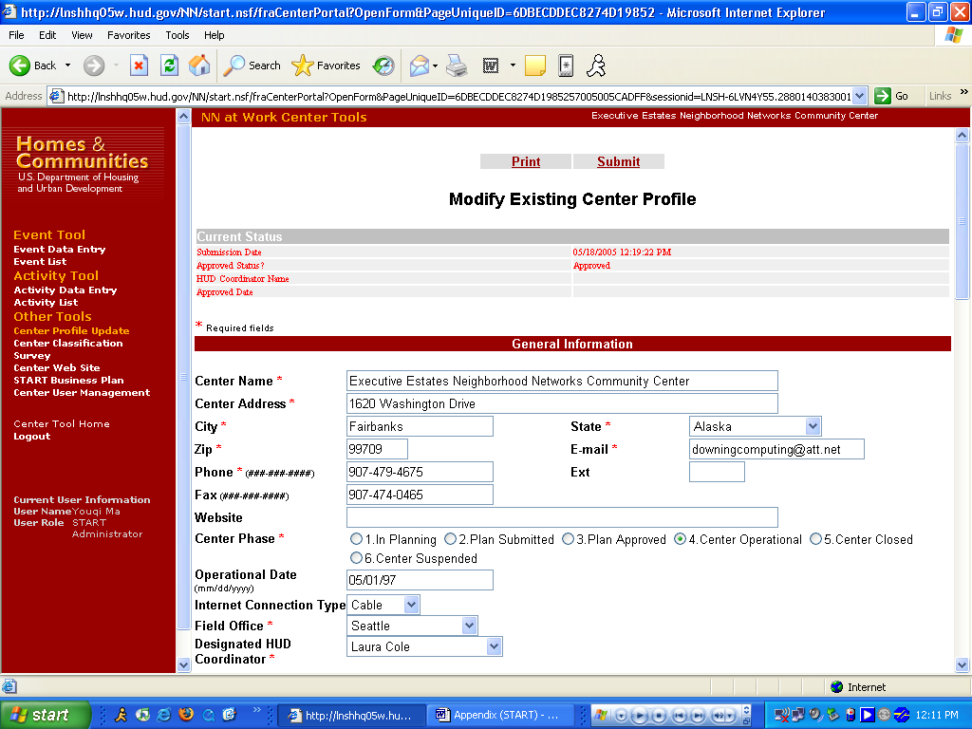

Purpose/Usage:
Centers may access their profile here and update contact information.

Description/Function:
This page allows the center to submit updates to their existing center’s profile.

Appendix B: Modify Existing Center Profile (Continued)

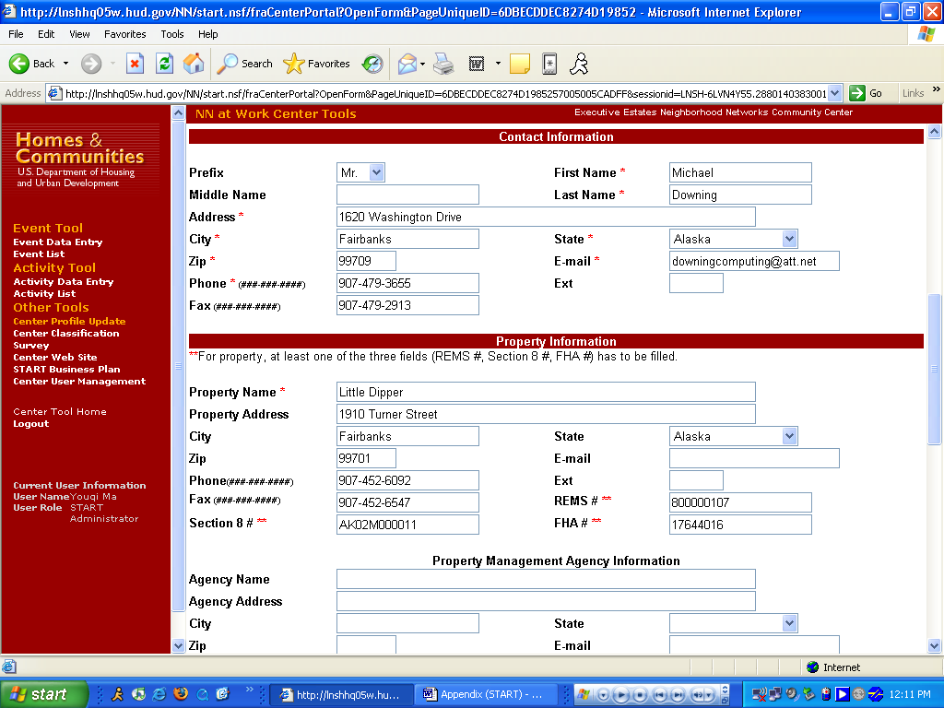

Online form continued.

Appendix B: Modify Existing Center Profile (Continued)

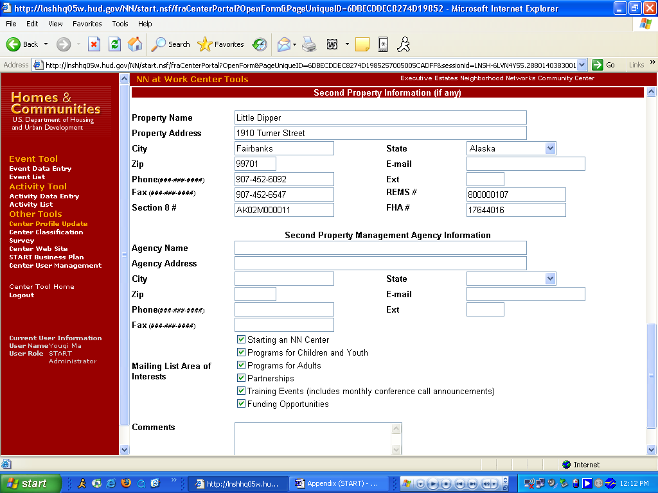

Online form continued.
Appendix B: Center Website Creation

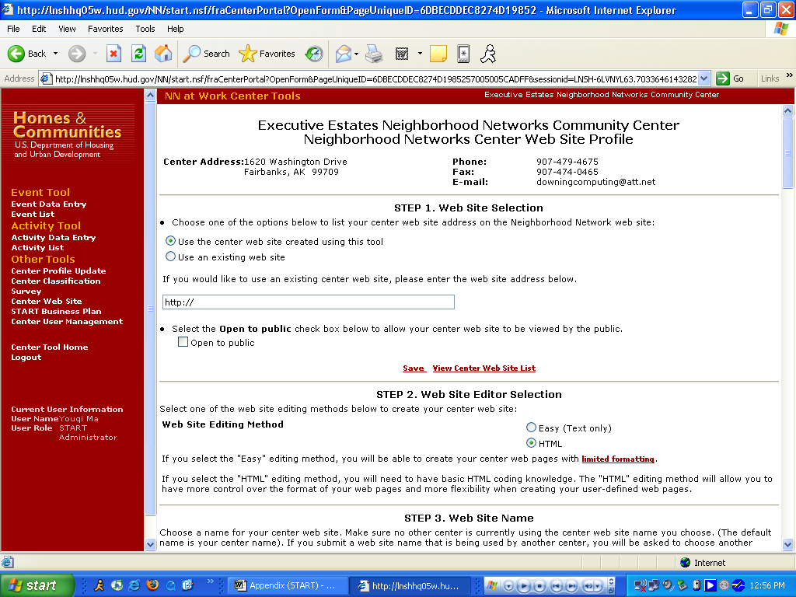

Purpose/Usage:
Centers can use this tool to create a Web site specifically for their center.

Description/Function:
This page allows the center to create or update a website for their location either by using the provided templates or their own HTML.

Appendix B: Center Website Creation (Continued)

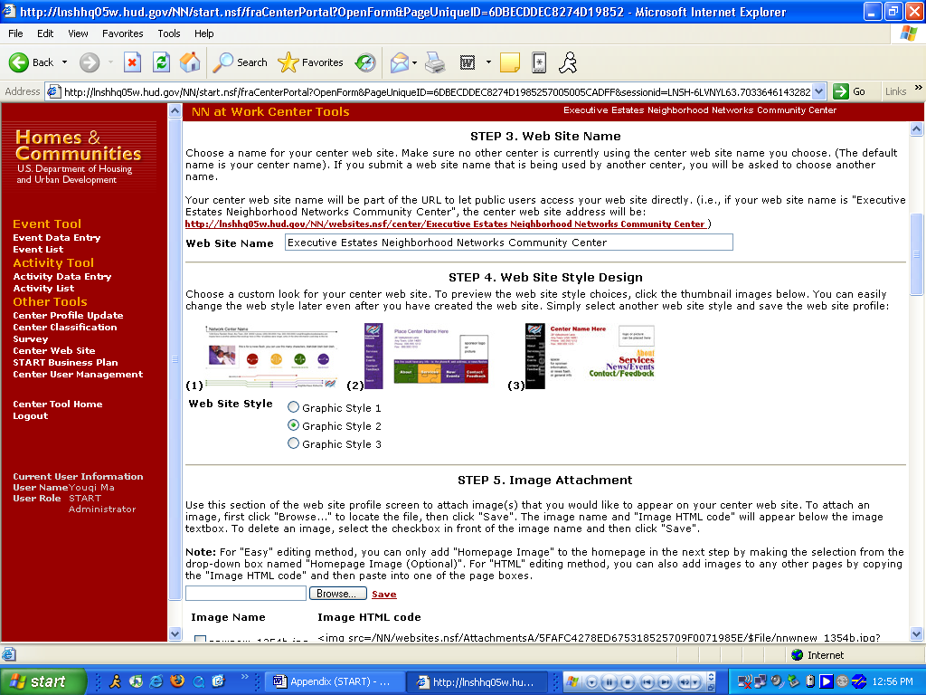

Online form continued.

Appendix B: Center Website Creation (Continued)

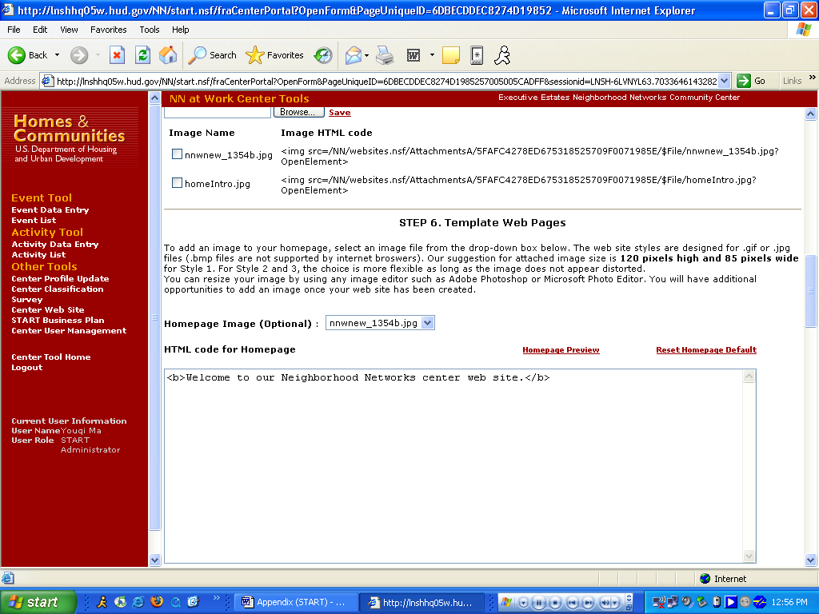

Online form continued.

Appendix B: Center Website Creation (Continued)

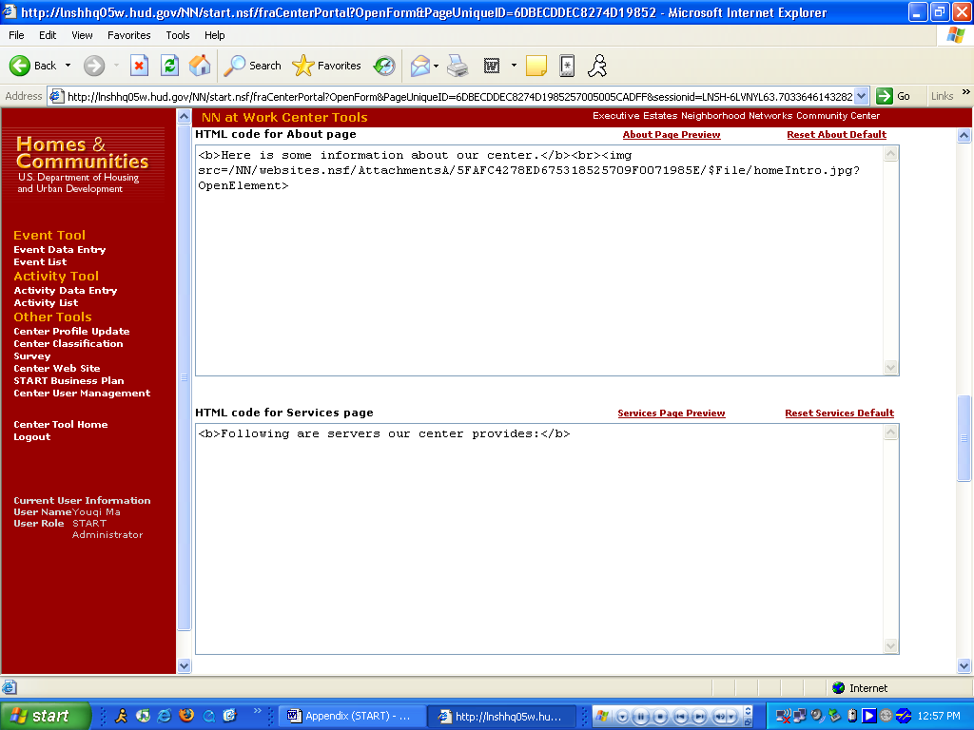

Online form continued.

Appendix B: Center Website Creation (Continued)

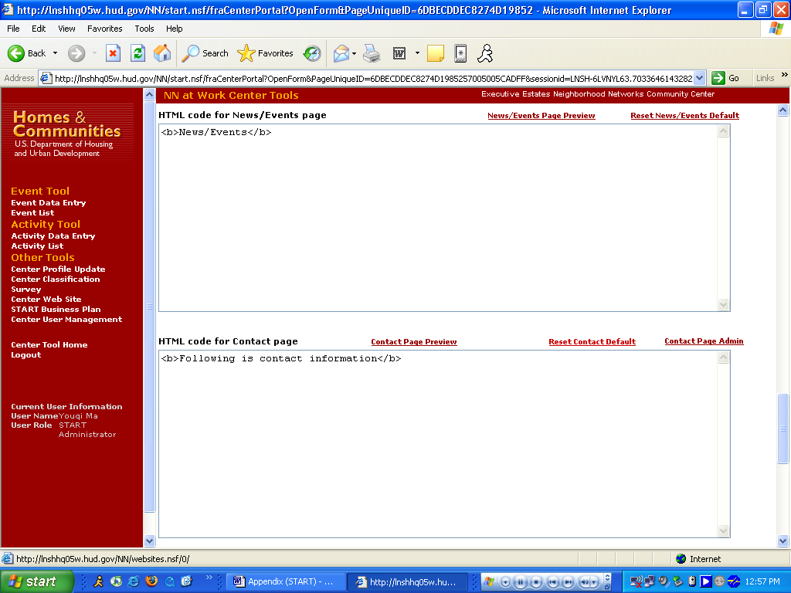

Online form continued.

Appendix B: Center Website Creation (Continued)

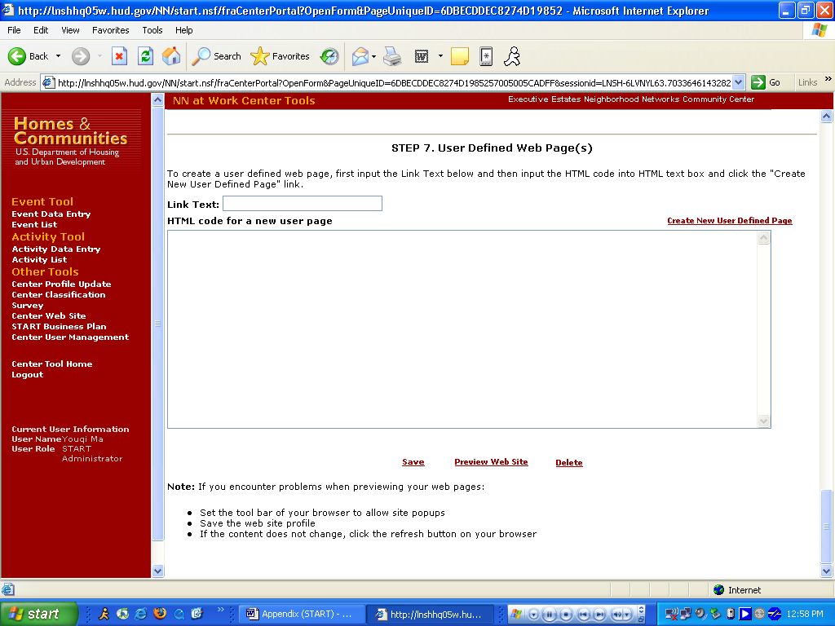

Online form continued.

Appendix B: Strategic Tracking and Reporting Tool and Item Justification

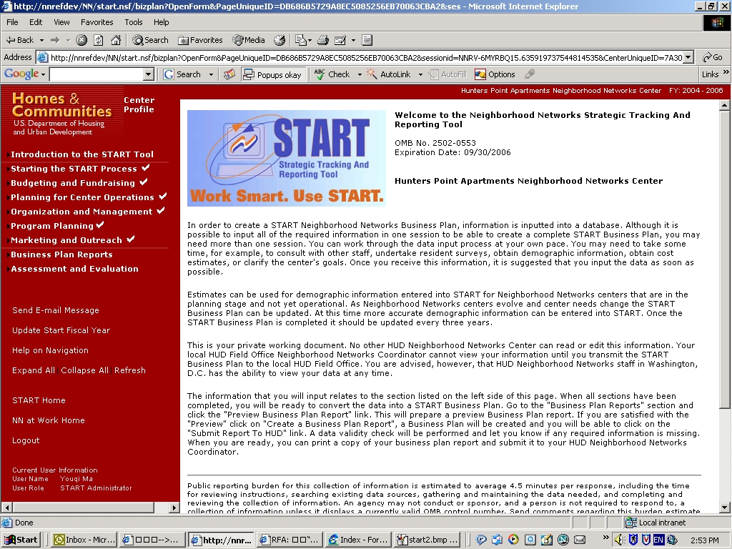

Purpose/Usage:
The purpose of this page is to welcome users to the START database.

Description/Function:
This page shall provide a brief description of how to use the START database.

