Attachment 5

Abstractor Manual

Appendix X – Instructions for Abstractors

Instructions for Completing the Morbidity Monitoring Project (MMP)
Medical Record Abstraction Form
Medical History Form

GENERAL COMMENTS

A medical record abstraction form should be completed for each patient aged 18 years and older who is selected from the provider list as outlined in the MMP protocol.

All the information entered on the forms should ONLY be completed for the time period AFTER the patient's record shows that patient is HIV positive. If the patient was receiving care in the same facility before any documentation of diagnosis of HIV, disregard that part of the information.

The medical record abstraction form is completed only if the patient has received medical care at the facility during the population definition period (PDP). Medical care is defined as a visit to the facility, or prescription of medications, including refill authorizations.

"No" should only be given as a response to a question if the medical record documents that the patient did not have a particular condition or did not receive a particular therapy. If there is no documentation in the medical record, the response should be recorded as "Unknown/Not documented."

"Medically contraindicated" should only be given as a response to a question if the medical record documents that the patient did not receive a particular treatment or procedure because they have a medical condition (such as an allergy) that makes receipt of that treatment or procedure not advisable.

If you are uncertain how to answer a question or have found contradictory medical record information, skip that question and note your concerns in the "Remarks" section for later review with your project coordinator or CDC project officer.

Patient identifier information is not transmitted to the Centers for Disease Control and Prevention (CDC).

Medical record abstraction will cover two separate periods. Therefore, we will use two different forms: the Medical History Form and the Surveillance Period (visit) Form. This manual was developed specifically for use with the Medical History Form. Please refer to the figure below which describes the time period covered by the medical record abstraction. Please refer to the Instructions for Completing the Morbidity Monitoring Project Medical Record Abstraction – Surveillance Period (visit) Form manual for abstracting the 12 month period prior to the interview date.

In some instances you may not use the medical history form. For instance, if the patient was in care for less than a year before the date of interview, all you need to fill is the Surveillance period (visit) form. In such situations fill in the patient identification number, date of contact at this facility, surveillance period, initials of person abstracting information, date of birth, sex, and race/ethnicity and proceed to use the surveillance period form.

Time period covered by medical record abstraction
- NOTE: The drawing of the medical record time frame is too large and was left out.. Please check paper copy of attachment 5.

INSTRUCTIONS

I. Abstraction and Identification Information

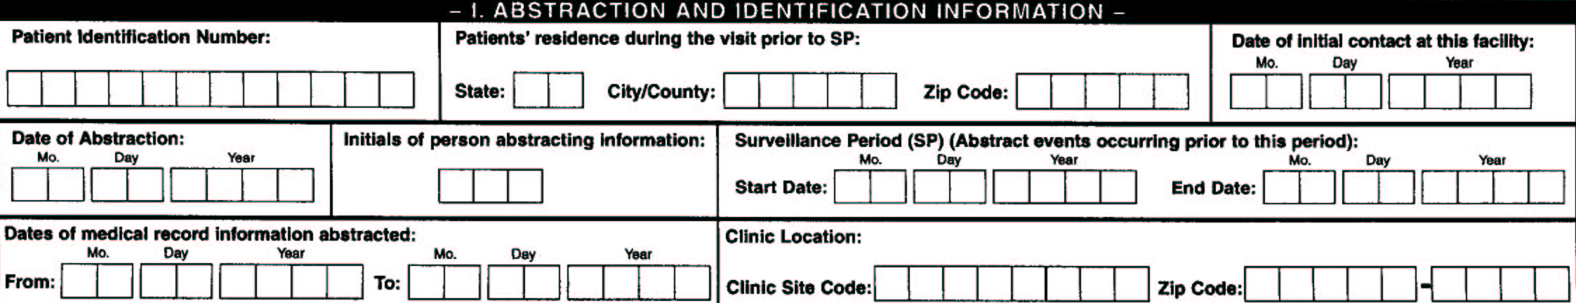
Patient Identification Number

Individual patients will be identified only by a 12 digit numeric patient ID number that will be assigned by the project area. This should be a unique identifier that will be associated with that patient throughout the project and which should appear on all data collection forms and in all databases. Patients’ 4 digit patient ID numbers will be formed starting as any consecutive 4 digit numbers that are assigned to patients on each facility’s edited patient list. The other 8 digits will include a 4-digit site code which is included as Appendix C in the MMP protocol and a 4-digit code that will be assigned to the selected facility. Abstractors should have the 12 digit numeric patient ID number (the last 4 digits of which will be the patient ID that is recognizable by the provider) before they go to the facility to abstract medical records. This 12 digit numeric patient ID number is also the number that will be used to match the interview data with the medical record abstraction data. This number will be the same for the interview data and abstraction data.

Patients’ residence during the visit prior to the SP

Record the patients’ residence during the visit prior to the surveillance period. Enter the two letters for the state, enter the city/county code, and the 5-digit ZIP code from the medical record. The state code used for the MMP is available in Appendix C in the MMP protocol.

Date of initial contact at this facility

This is the date of the first contact to the facility from which the patient was selected to participate in the project. Enter the first date at diagnosis of HIV or HIV related consultation. It is possible for patients to have some follow up for other reasons prior to diagnosis of HIV in the same facility and continue receiving care in the facility after diagnosis of HIV infection or AIDS. This information will be used to determine the length of follow up of the patient at the respective facility.

Date of Abstraction

Record the date this abstraction was completed.

Initials of person abstracting information

Record your initials in the provided space.

Surveillance Period (SP)

This period includes the one year retrospective period starting on the date of interview, from which medical record will be abstracted using the Surveillance Period (visit) Form. The start date will be dependent on the end date which is anchored at the date of interview of the patient. The Medical History Form will not be used to abstract any information from this time period.

Dates of medical record information abstracted

These dates include the period covered from the initial contact of the patient with HIV related medical care to the visit prior to the surveillance period. The “From” date will be the first documented visit at this facility at or following HIV diagnosis. The “To” date will be the date of the last visit prior to the surveillance period. For analytic reasons if there is a need to identify events that occurred during the visit prior to the surveillance period, this is the date that will be used.

Facility/Clinic Location

Record the Clinic Site Code where the patient’s medical record is abstracted. This will be an 8-digit number including 4-digit number that is assigned to the respective state or city and 4-digit number assigned to the clinic or facility where the patient’s medical record is abstracted. Record the ZIP Code of the clinic or facility where the patient’s medical record is abstracted. Clinic ZIP Code is not transmitted to CDC.

