Attachment 5 B 1

Appendix X-1 Instructions for Abstractors

Instructions for Completing the Morbidity Monitoring Project (MMP)
Medical Record Abstraction Form
Surveillance Period (Visit) Form

GENERAL COMMENTS

A medical record abstraction form should be completed for each interviewed patient aged 18 years and older who was selected from the facility patient list as outlined in the MMP protocol.

Information entered in the forms should be ONLY for the time period AFTER the patient's record indicates that the patient is HIV positive. If the patient was receiving care in the same facility before documentation of the diagnosis of HIV, disregard that part of the information.

The medical record abstraction form is completed only if the patient has received medical care at the facility during the population definition period (PDP). Medical care is defined as a visit to the facility, or prescription of medications, including refill authorizations.

"No" should only be given as a response to a question if the medical record documents that the patient did not have a particular condition or did not receive a particular therapy. If there is no documentation in the medical record, the response should be recorded as "Unknown/Not documented."

"Medically contraindicated" should only be given as a response to a question if the medical record documents that the patient did not receive a particular treatment or procedure because they have a medical condition (such as an allergy) that makes receipt of that treatment or procedure not advisable.

If you are uncertain how to answer a question or have found contradictory medical record information, skip that question and note your concerns in the "Remarks" section for later review with your project coordinator or CDC project officer.

Patient identifier information is not transmitted to the Centers for Disease Control and Prevention (CDC).

This manual specifically provides guidance on the use of the Surveillance Period (Visit) Form. Please refer to the figure below which explains the time period covered by the medical record abstraction. For abstraction using the Medical History form refer to the separate manual for that form.

As implied by the name, this form is used to abstract each visit that occurred during the surveillance period. Each visit will be abstracted using a single Surveillance Period (Visit) Form and each form will be identified by the “date of medical care visit to which this form pertains”. The number of Surveillance Period (Visit) Forms that a patient will have depends on the number of visits that the patient has made to the facility from which the patient was recruited plus the number of visits the patient had to other facilities during the surveillance period for which abstraction will be performed.

For the abstraction of visits at facilities other than the facility from which the patient was selected and recruited, the 12 digit patient identification number will remain the same but the 8 digit facility code that is entered on the form will be the facility code for the facility at which the abstraction is being performed, not the facility code for the facility from which the patient was selected and recruited.

In most instances abstractors are not required to enter the date for most events that occurred during the surveillance period. The “date of medical care visit to which this form pertains” is considered to be the date on which most of these events took place. However, later in this manual you will be made aware of situations where you may need to enter specific dates.

This form was designed with the intention to minimize the redundancy of entering dates when most events that occur following a visit will usually occur during the day of the visit or within relatively few days following the visit. When ever there are exceptions to this we request that the specific date is entered. An example of such an exception is a lab result from a specimen collected at a later date (between visits) or a test which takes more than 10 days. Another exception is when a patient did not come to the facility but there is documentation that the provider discussed patients’ issues and documented the management plans (withholding/changing ART, etc.). In this condition the information will be abstracted and entered using the Surveillance Period (Visit) Form during the visit immediately after this event.

In some instances you may not complete all sections of the Medical History Form. For instance, if the patient was in care for less than a year prior to the date of interview, the only documents you need to complete are the Surveillance Period (Visit) forms. However, there are certain identifying and demographic data that are captured only on the Medical History Form; therefore, that particular section of the Medical History Form must be completed for every patient.

The abstraction process is a one time process most of the time. When you go to a facility to abstract medical records be sure that you have made all arrangements and preparations so that you will be able to complete the abstraction of patients’ records. It is also worthwhile to communicate with your colleagues and inform them that you are going to facility X and determine whether there are additional medical records that can be abstracted while you are there.

When you go out to abstract medical records for a patient you need to carry with you the appropriate identifying information for the patient, at least one Medical History Form with patient identification number entered and at least 12 Surveillance Period (Visit) Forms in order to be able to capture all visits on individual forms. Remember, abstraction takes place after the patient is interviewed and the surveillance period for the patient has concluded. If it is decided that the patient’s medical records should be abstracted from other facilities, observe the same procedures.

On top of each page of the Surveillance Period (Visit) Form there is a space to enter the start date (12 months prior to the date of interview) and end date (date of the interview) for that patient. This will help you to restrict the abstraction to the visits that occurred within the surveillance period. Since the end date of the surveillance period is determined by the date of the interview it is possible that the surveillance period for your patients can be different.

Time period covered by medical record abstraction:
- NOTE: The drawing of the medical record time frame is too large and was left out. Please check paper copy of attachment 5.

INSTRUCTIONS

I. Abstraction and Identification Information

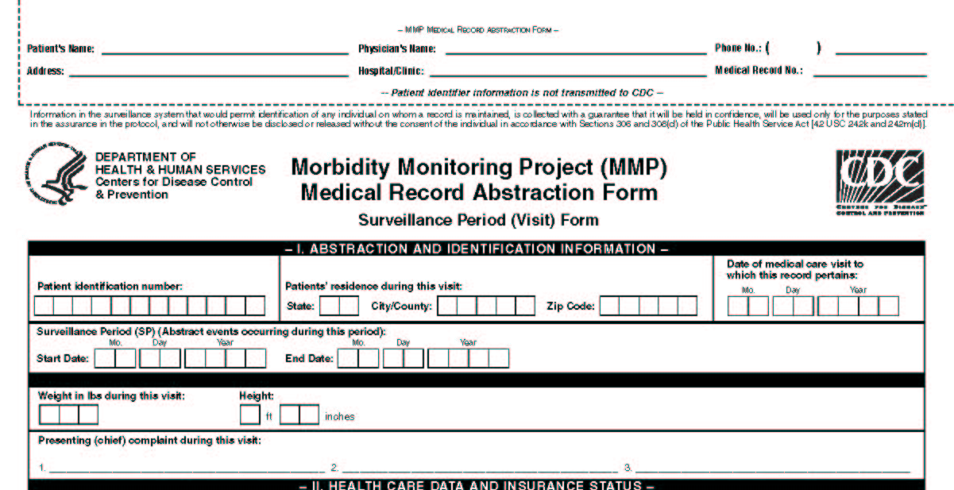
Surveillance Period (SP) (Abstract events occurring during this period):

This period includes the one year retrospective period starting on the date of interview, from which medical records will be abstracted using the Surveillance Period (Visit) Forms. The start date of the surveillance period will depend on the end date which is anchored at the date of interview of the patient. When using the Surveillance Period (Visit) Form you will abstract information ONLY from this time period (the surveillance period (SP). On top of each page you will enter this date as a reminder of the period from which you will perform abstractions. Remember that this one year period will be different from patient to patient since it is based on the date when patient interview was completed.

Although many patient interviews will occur after the end of the PDP, there are two scenarios in which patients could be interviewed during the PDP. Patients who were recruited through a process called real-time sampling (RTS) will most likely be interviewed during the PDP. In addition, patients sampled from the first patient list from a facility for which 2-list pick-up is used could also be interviewed during the PDP. For patients who were interviewed during the PDP, it will be necessary to record some brief information, such as date of visit, for any visits to the facility that occurred between the date of the interview and the end of the PDP. Medical record abstraction is NOT performed for these visits, but it is necessary to document the number of visits and if available the addresses of other facilities the patients visited after the interview and before the end of the PDP. This information will be entered into a Surveillance Period (Visit) Form; section II where it states “is there documentation that the patient visited other facilities between visits”. However if there is more than one visits during this period you need to use as many forms as the number of visit. This is because each form represents a visit and we are interested in the count of visits during that period. This means that record abstraction for patients who were interviewed during the PDP should occur well after the end of the PDP to allow time for visits that occurred between the interview date and the end of the PDP to be documented in the patient’s medical record.

The other exception to collecting information for the time period after the surveillance period is when death is documented in a medical record during the time between the interview completion date (end date of surveillance period) and the time you abstracted the medical records. In this situation you will need to use one more visit form (of course, date is out of the surveillance period) to enter the mortality data in Section XIII of this form.

Patient Identification Number

Individual patients will be identified only by a 12 digit numeric patient ID number that will be assigned by the project area. This should be a unique identifier that will be associated with that patient throughout the project and which should appear on all data collection forms and in all databases. Patients’ 4 digit patient ID numbers will be formed starting as any consecutive 4 digit numbers that are assigned to patients on each facility’s edited patient list. The other 8 digits will include a 4-digit site code which is included as Appendix C in the MMP protocol and a 4-digit code that will be assigned to the selected facility. Abstractors should have the 12 digit numeric patient ID number (the last 4 digits of which will be the patient ID that is recognizable by the provider) before they go to the facility to abstract medical records. This 12 digit numeric patient ID number is also the number that will be used to match the interview data with the medical record abstraction data. This number will be the same for the interview data and abstraction data.

Patients’ residence during this visit

Record the patients’ residence during this visit. Enter the two letters for the state, enter the city/county code, and the 5-digit ZIP code from the medical record. The state code used for the MMP is available in Appendix C in the MMP protocol.

Date of medical care visit to which this record pertains

Enter the date of the medical care visits to which the information being abstracted pertains. For example, let’s assume that a surveillance period covers September 1, 2004 to August 31, 2005. If a patient had 2 visits during this period at the facility from which abstraction is performed and the corresponding dates were 02/01/05 and 07/01/05. Then on the date of medical care visit to which this record pertains will be 02/01/05 for the first SPF and 07/01/05 for the second SPF.

Surveillance Period (SP) (abstract events occurring during this period)

This period is the one year retrospective period starting on the date of interview, from which medical record will be abstracted using the Surveillance Period (Visit) Form. The start date will be dependent on the end date which is anchored at the date of interview of the patient. The Medical History Form will not be used to abstract any information from this time period.

Weight in lbs during this visit

Enter the weight in lbs recorded during this visit. If weight is given in kilograms (Kg) change this to lbs by multiplying by 2.2. Leave space blank if no weight was recorded during this visit.

Height

Enter the height in ft/inches recorded during this visit. This information may not be available as frequently as weight will be because of the less dynamic nature of height among adults. However since young adults can come into this sample it is worthwhile to determine whether there was any documentation of change in height during the surveillance period. For most analytic use investigators have used body mass index (BMI) which is derived by dividing weight by height squared. Therefore it is imperative that we have at least one height recorded.

Presenting (chief complaint) during this visit

Patients are generally asked if they are experiencing any problems or conditions when they present to care. These presenting complaints lead to the differential diagnosis that the physician would investigate to determine a specific diagnosis. These symptoms can be related to the HIV, other conditions, or adverse events of medications they are taking. In the presence of other information such as lab results, medications prescribed, and vaccinations received one can determine the reasons for the visit particularly when it is related to adverse events of medications. The space for presenting (chief) complaint is limited to three entries. Additional documented chief complaints may be entered in the remarks (notes) section at the end of the abstraction form.

