OMB Forms
Data Input Screens for ETA 652
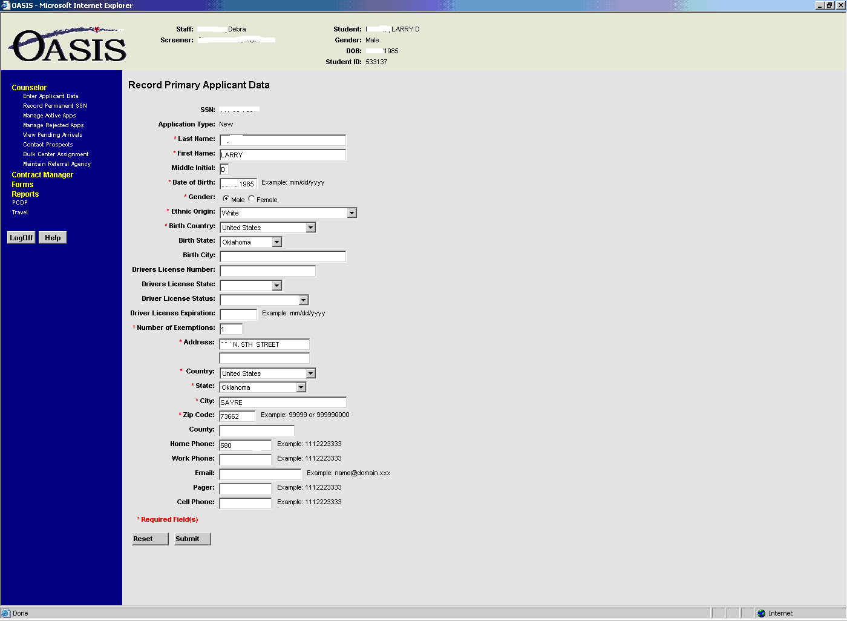

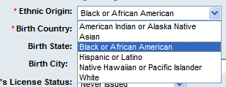

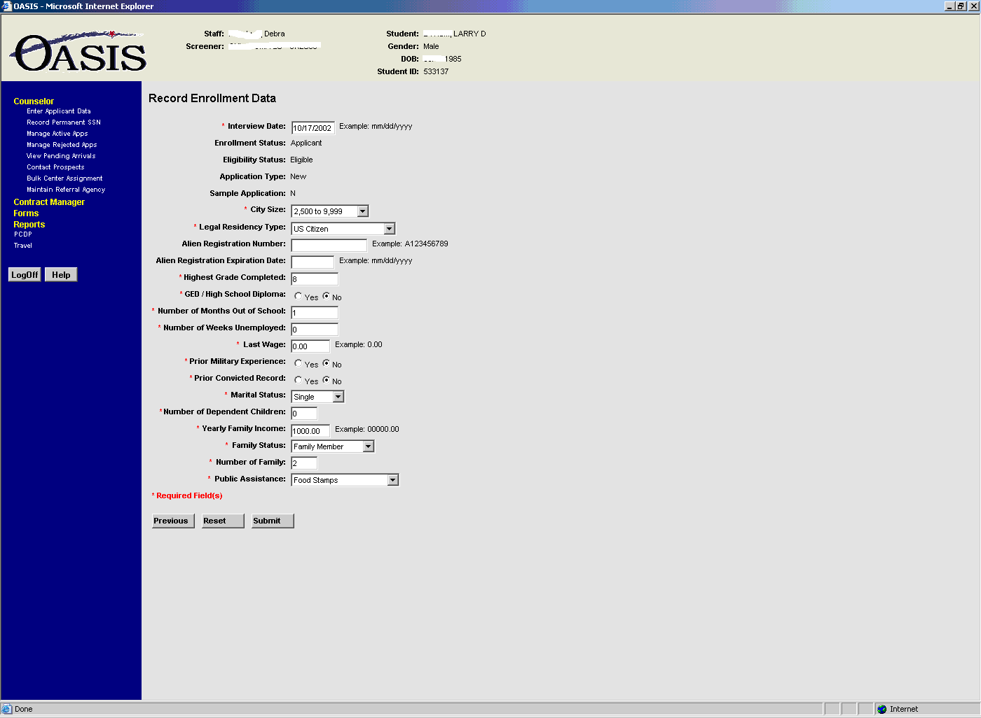

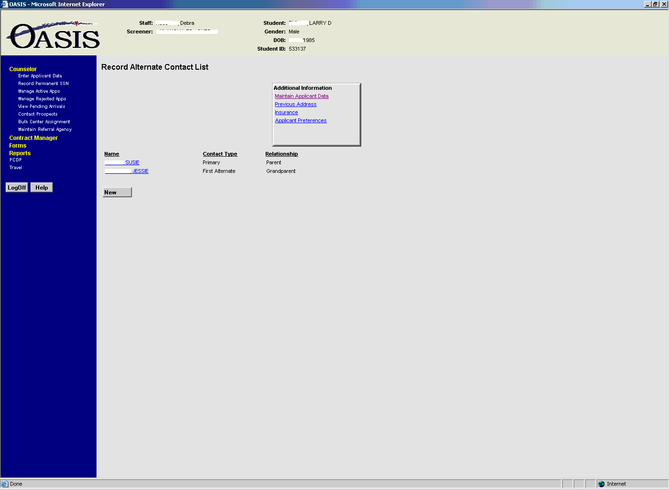
Data input screens for Child Care ETA 682
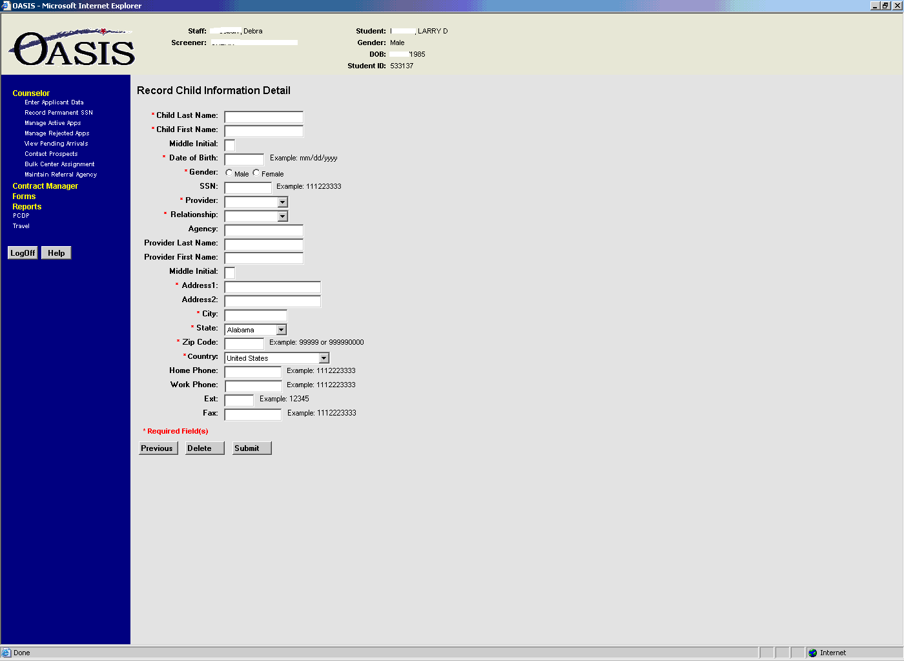

Data input screens for ETA 655 Court Statement
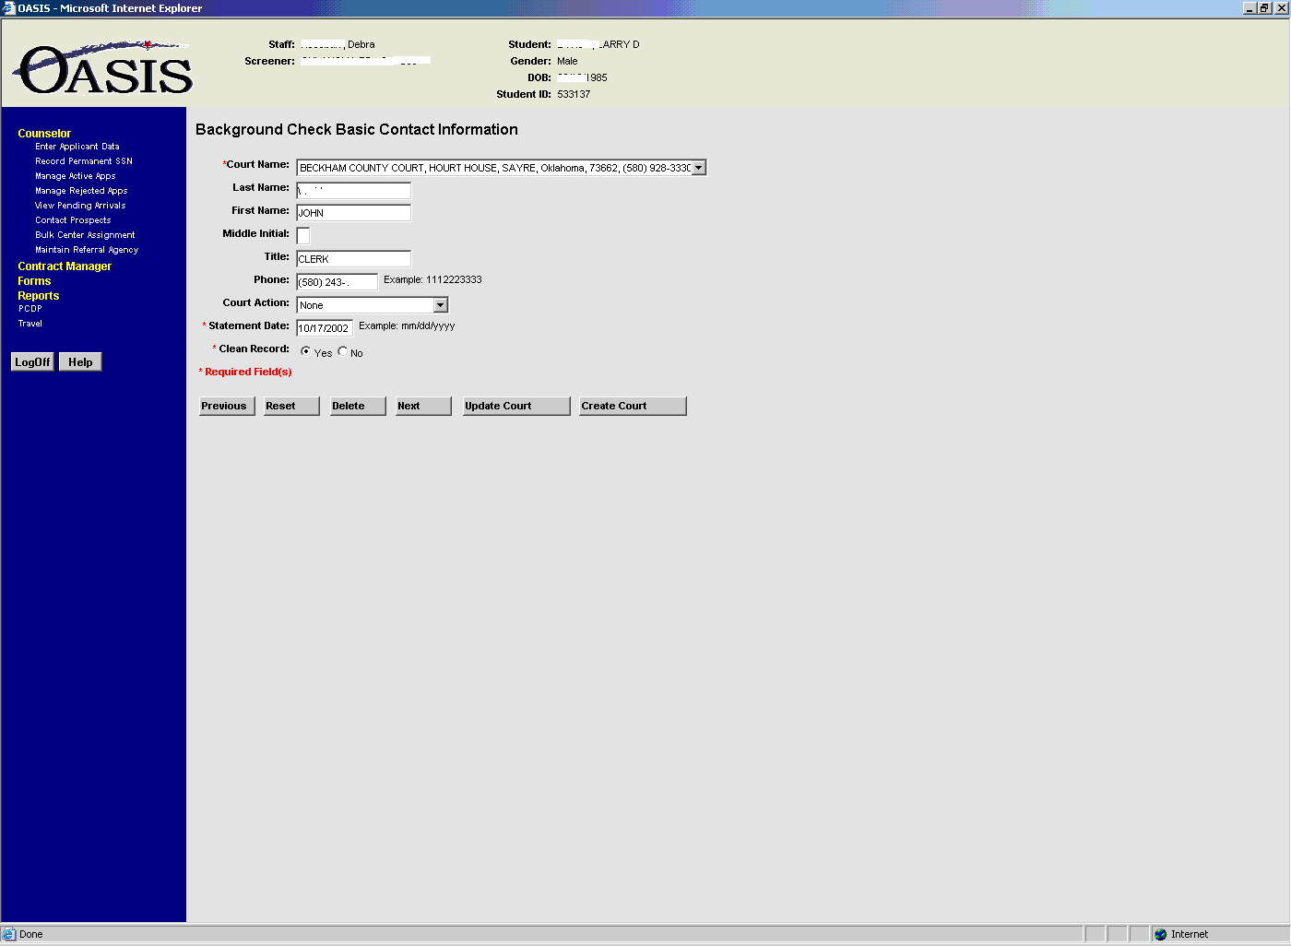

Additional data input screen if it’s not clean record
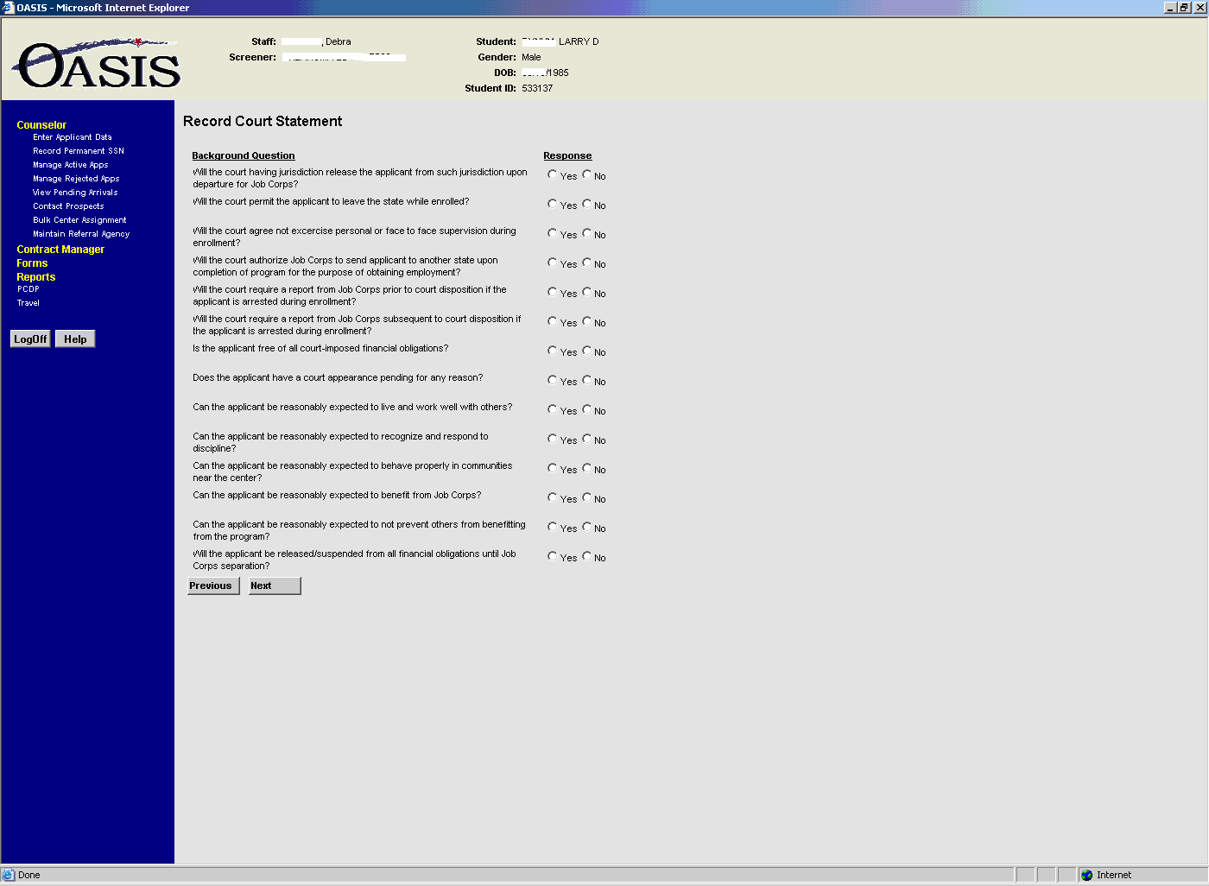

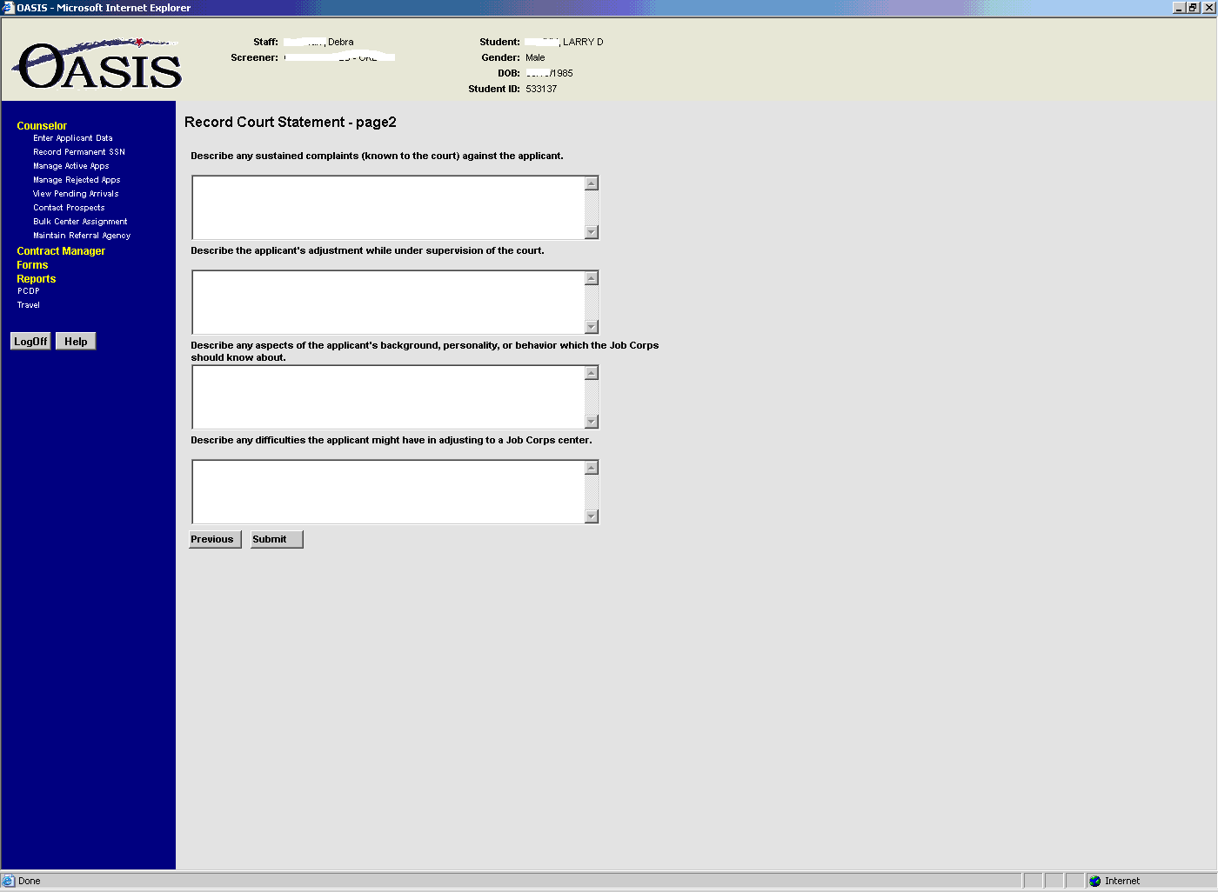
Data input screen for ETA 655A
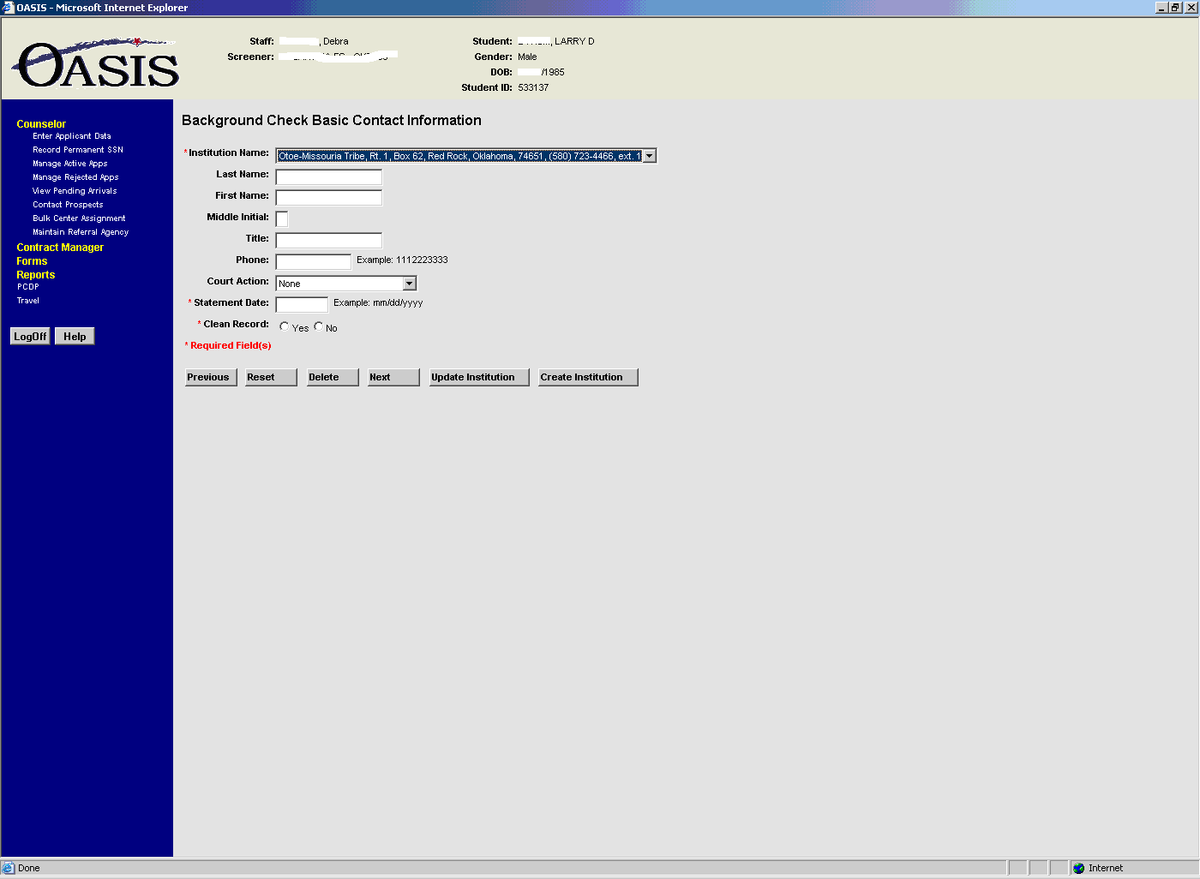

Additional data input screen if it’s not a clean record
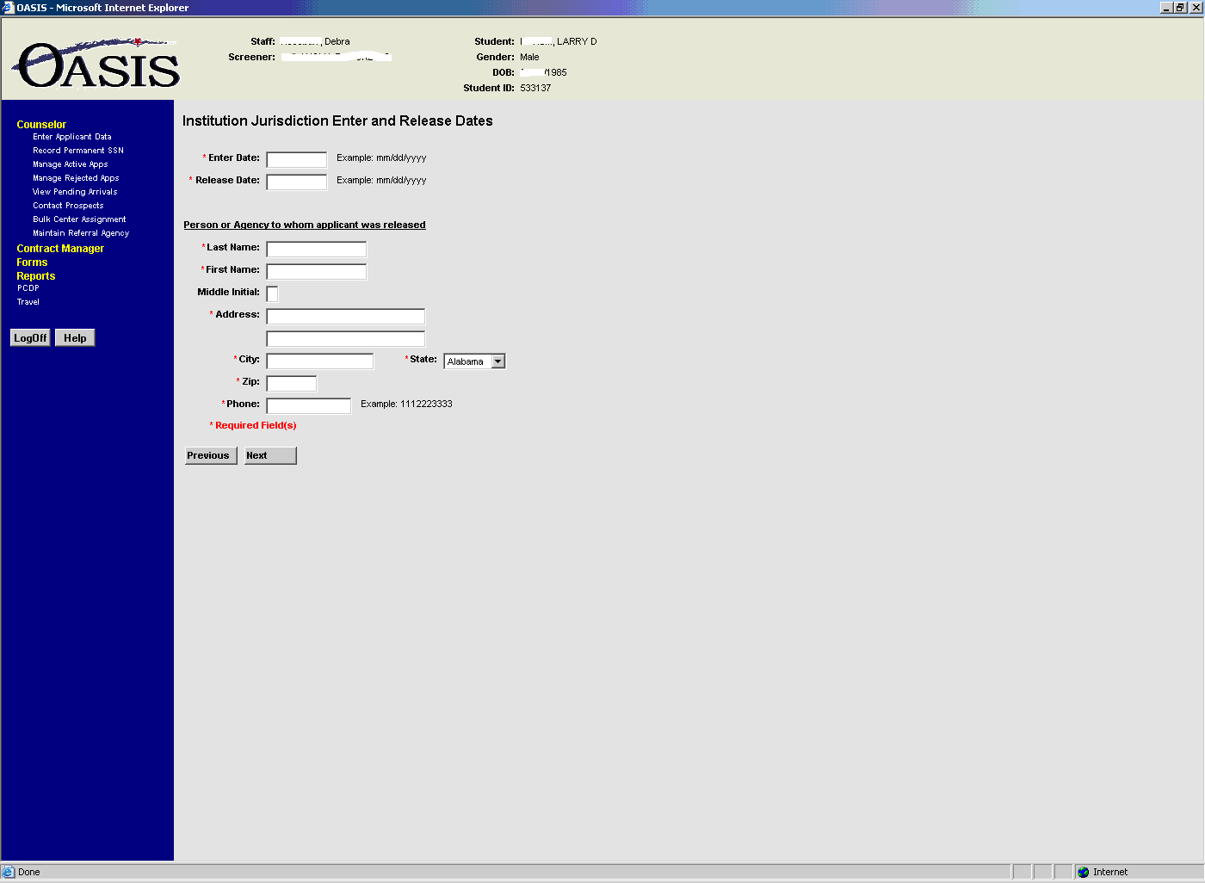

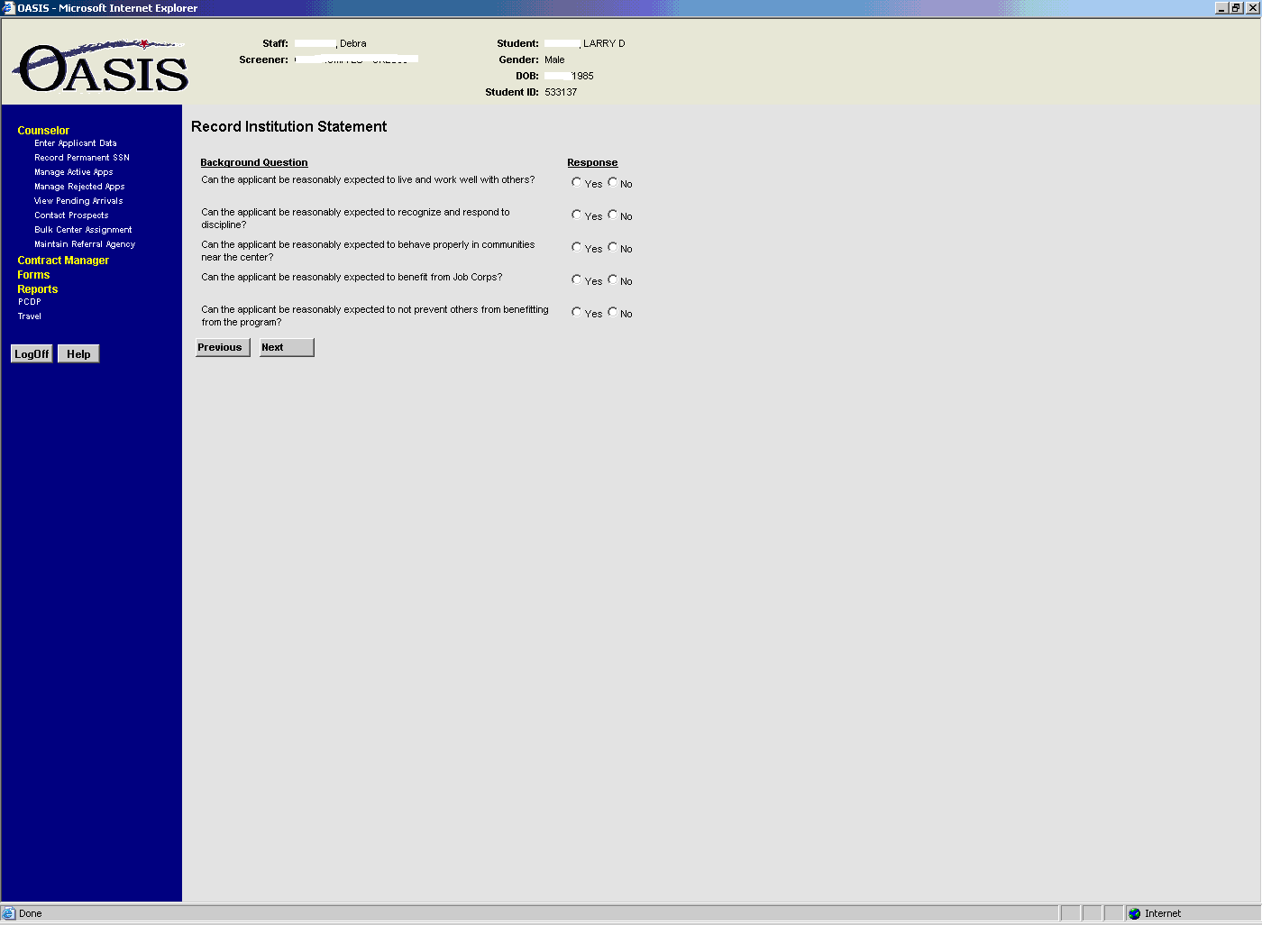

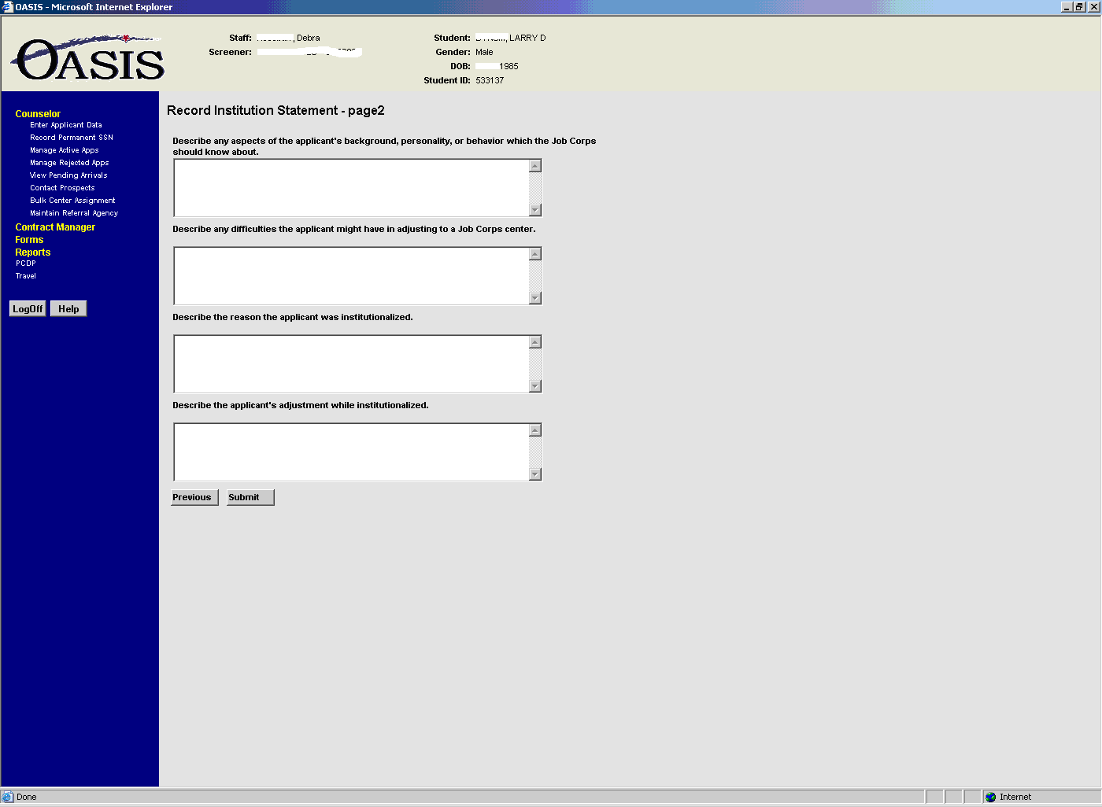

Data Elements

Student table
Column name Type Nulls
stud_id serial no
address_id integer no
ssn char(9) no
stud_lname char(20) no
stud_fname char(20) no
stud_mi char(1) yes
dob date no
sex char(1) no
race_cd integer no
birth_country_cd integer no
birth_city char(20) yes
birth_st_cd integer yes
drivers_lic char(15) yes
drivers_lic_st_cd integer yes
no_exemptions smallint no
parental_consent char(1) yes
pass_consent char(1) yes
web_theme_cd integer no
driver_lic_stat_cd integer yes
driver_lic_exp_dt datetime year to second yes

Enrollment table
Column name Type Nulls
enr_id serial no
stud_id integer no
staff_id integer no
address_id integer no
enr_dt date yes
interview_dt date no
enr_stat_cd integer no
marital_stat_cd integer no
no_dependents smallint no
city_size_cd integer no
legal_restype_cd integer no
alien_regis_no char(10) yes
alien_regis_exp_dt date yes
highest_grade integer no
hs_diploma char(1) no
prior_military char(1) no
out_of_school integer no
weeks_unemployed integer no
last_wage money(6,2) no
prior_convicted char(1) no
es char(1) no
es_eval_dt date yes
app_type_cd integer no
sample_app char(1) no
family_income money(8,2) yes
family_stat_cd integer yes
no_of_family smallint yes
elig_stat_cd integer no
enr_pub_asst_cd integer yes
sc_id integer no
curr_cdss_phase_cd integer yes

BC_statement table (court statement)
Column name Type Nulls
bc_stmnt_id serial no
enr_id integer no
institution_id integer no
bc_stmnt_dt date yes
court_action_cd integer yes
contact_lname char(20) yes
contact_fname char(20) yes
contact_mi char(1) yes
contact_title char(20) yes
contact_phone char(10) yes
juris_enter_dt date yes
juris_release_dt date yes
clean_record char(1) no

BC_question table
Column name Type Nulls
bc_question_id serial no
bc_question varchar(255) no
question_type_cd integer no
question_active char(1) no

BC_response table
Column name Type Nulls
bc_response_id serial no
bc_stmnt_id integer no
bc_question_id integer no
bc_response char(1) yes
bc_response_comm varchar(255) yes

Child table
Column name Type Nulls
child_id serial no
stud_id integer no
child_lname char(20) no
child_fname char(20) no
child_mi char(1) yes
child_dob date yes
child_sex char(1) yes
prov_id integer no
child_ssn char(9) yes

Cdc_provider table (Childcare provider)
Column name Type Nulls
prov_id serial no
address_id integer no
prov_type_cd integer no
prov_rel_cd integer no
prov_ag char(30) yes
prov_lname char(20) yes
prov_fname char(20) yes
prov_mi char(1) yes

