AD-421

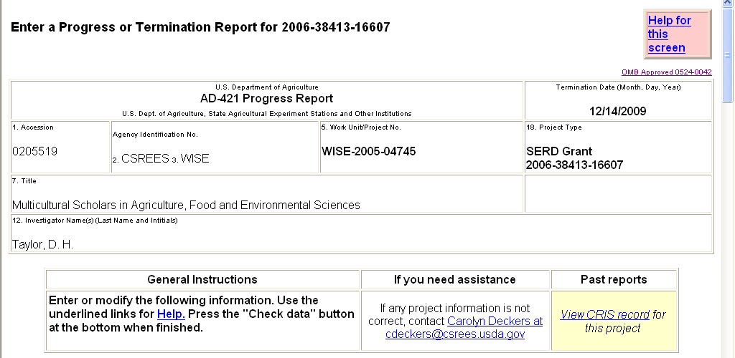

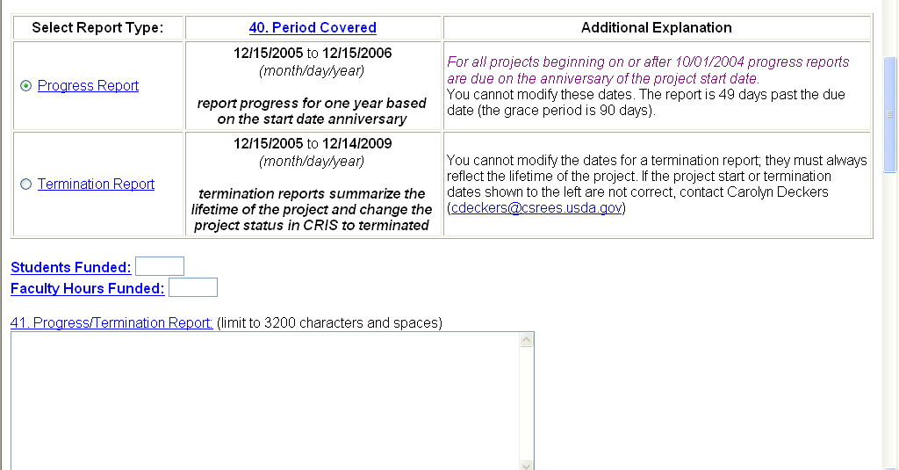

OMB Control No. _OMB-0524-0042 \

According to the Paperwork Reduction Act of 1995, an agency may not conduct or sponsor, and a person is not required to respond to, a collection of information unless it displays a valid OMB control number. The valid OMB control number for this information collection is OMB-0524-0042 . The time required to complete this information collection is estimated to average 162 minutes per response, including the time for reviewing instructions, searching existing data sources, gathering and maintaining the data needed, and completing and reviewing the collection of information.
AD-421 (CONT’D)

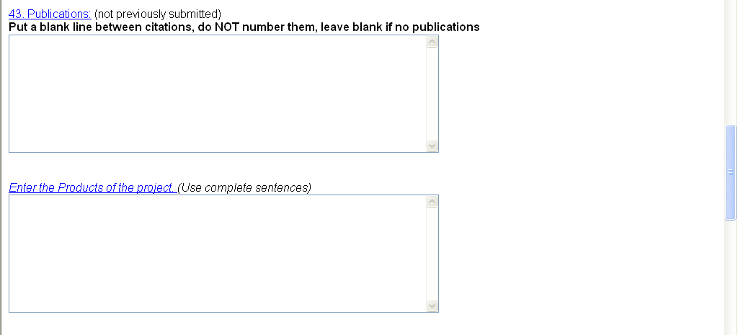

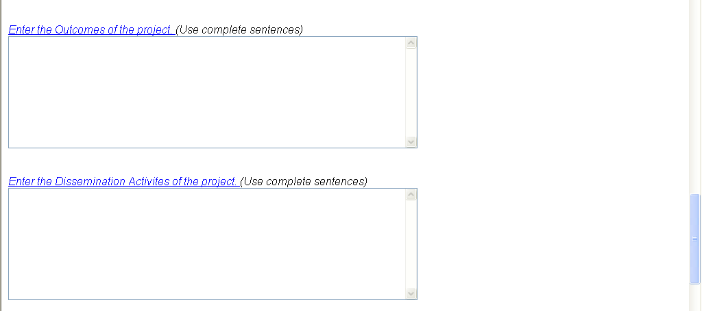

AD-421 (CONT’D)

