This form 6500-214 appears on the FSWEB for the ASC under Financial Information Security Request Form (FISRF) at this URL: http://fsweb.r3.fs.fed.us/asc/bfm/programs/technical-support/.

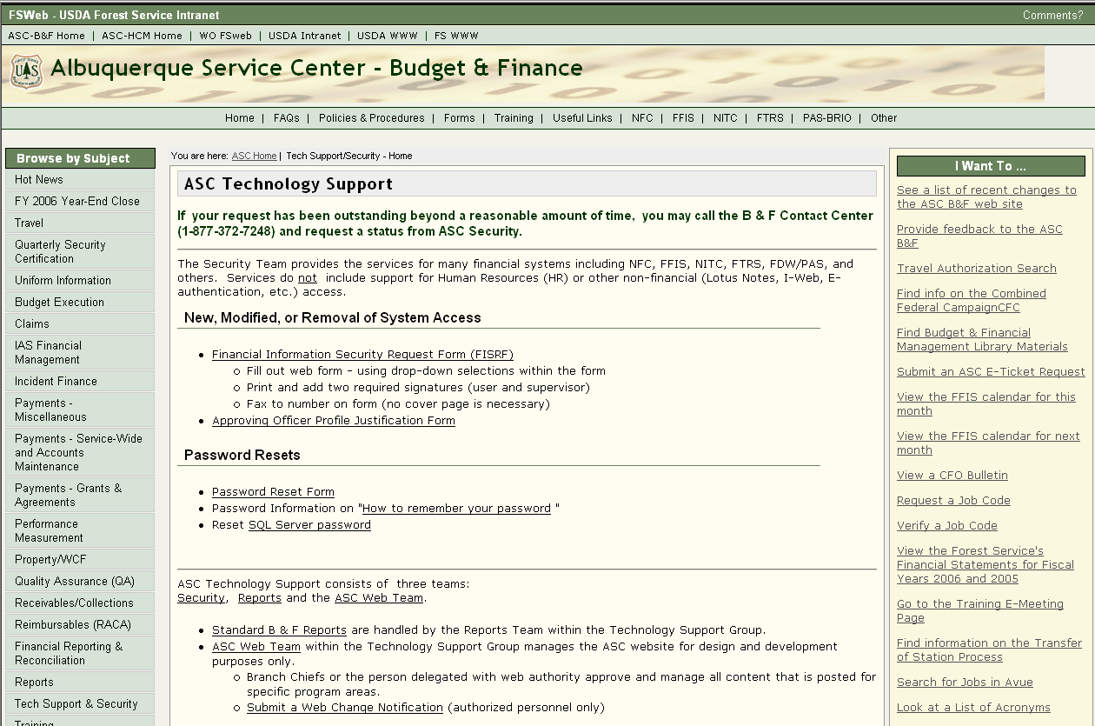

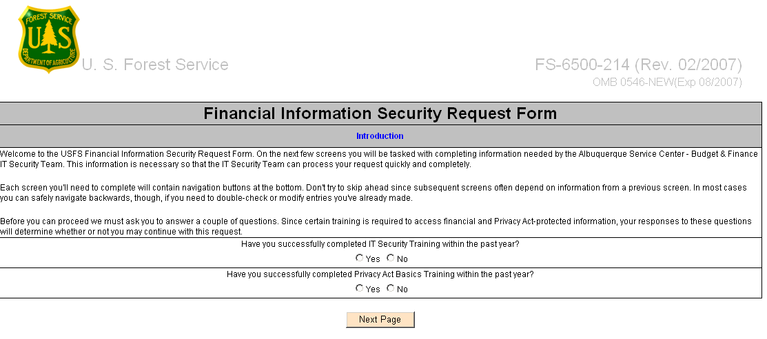

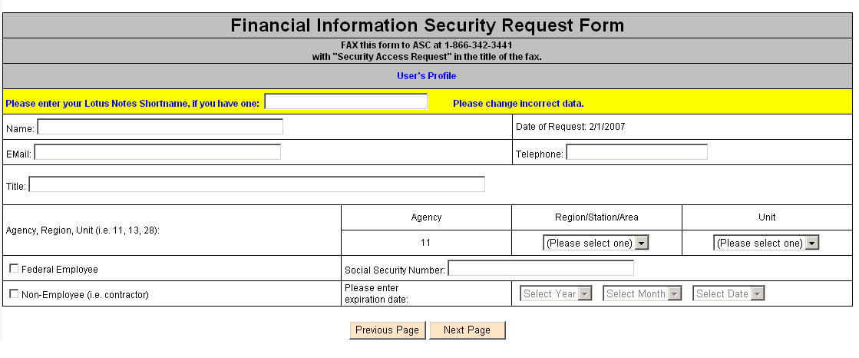
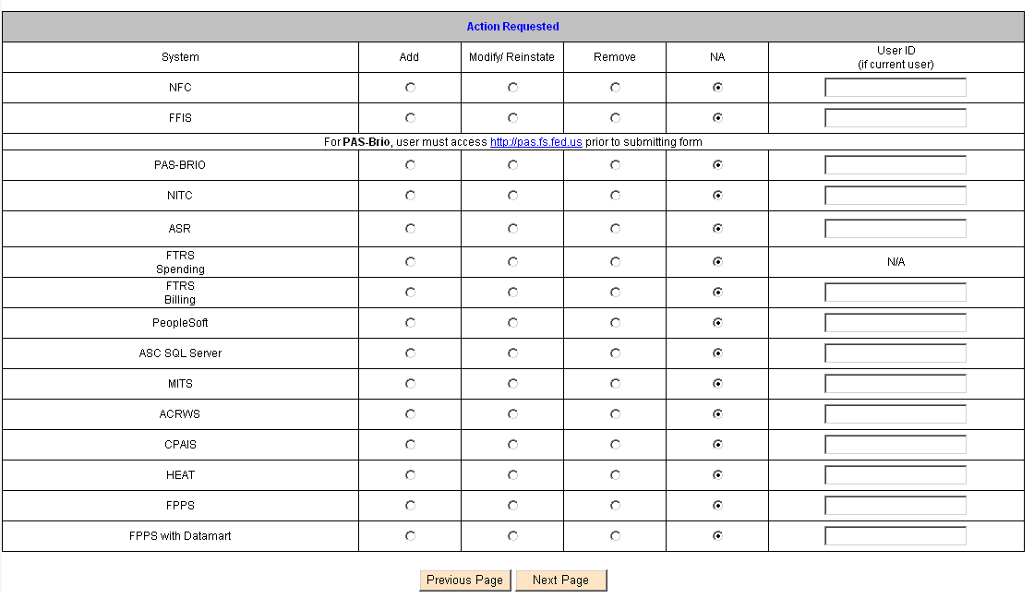

If NFC chosen:
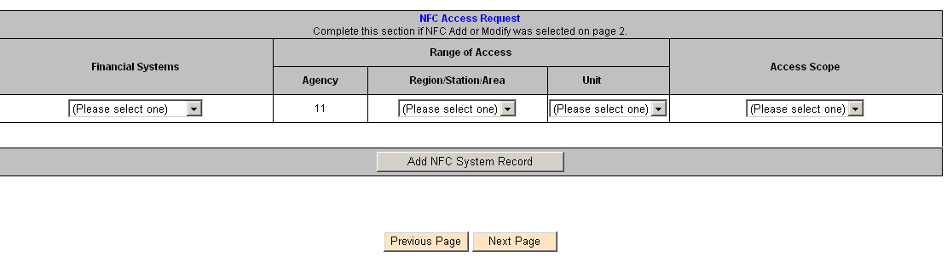
If FFIS chosen:
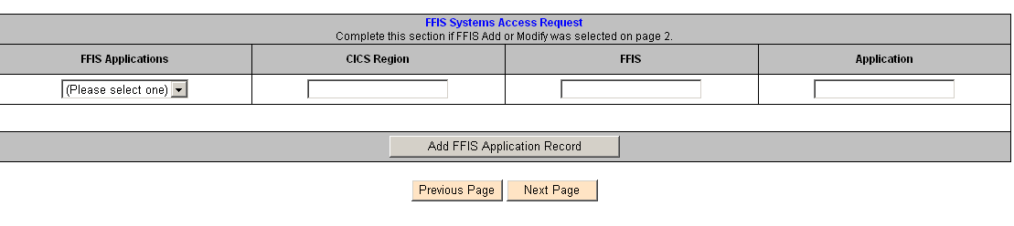

If PAS/BRIO chosen:

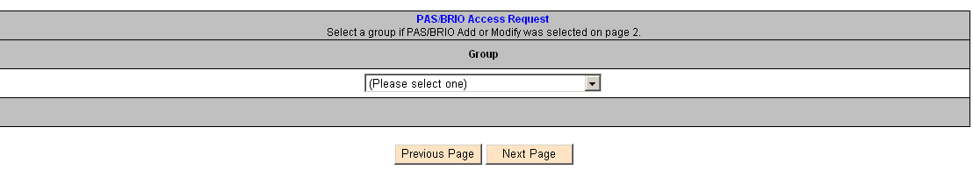

If NITC chosen:

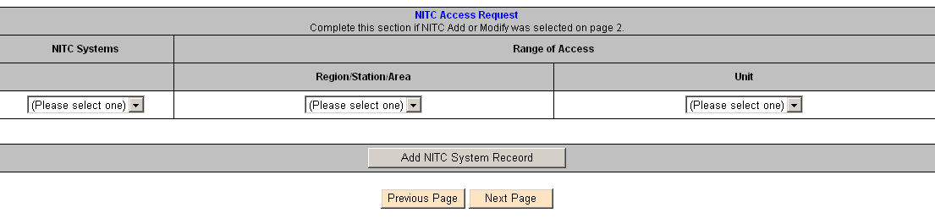

If ASR or other options are chosen:

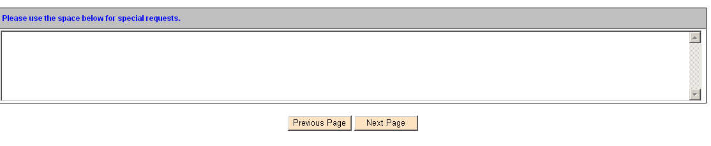
If MITS chosen:

After choices are made from drop-down options:

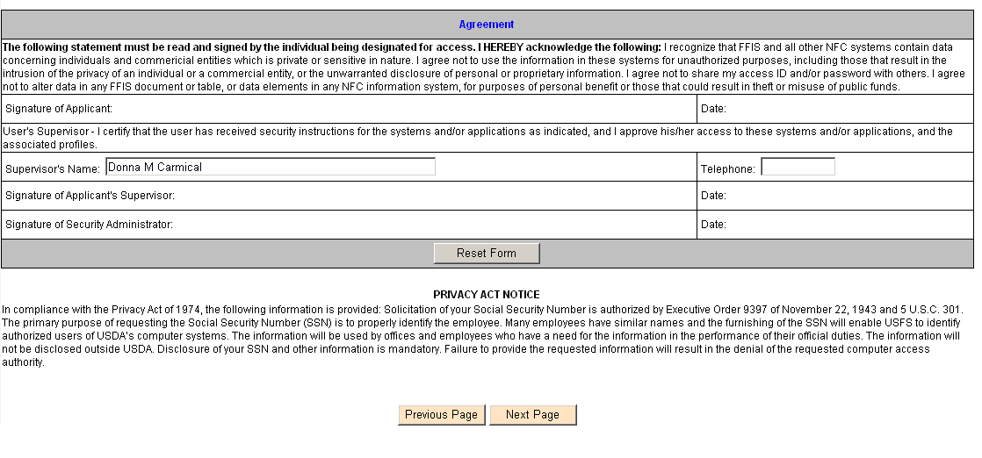
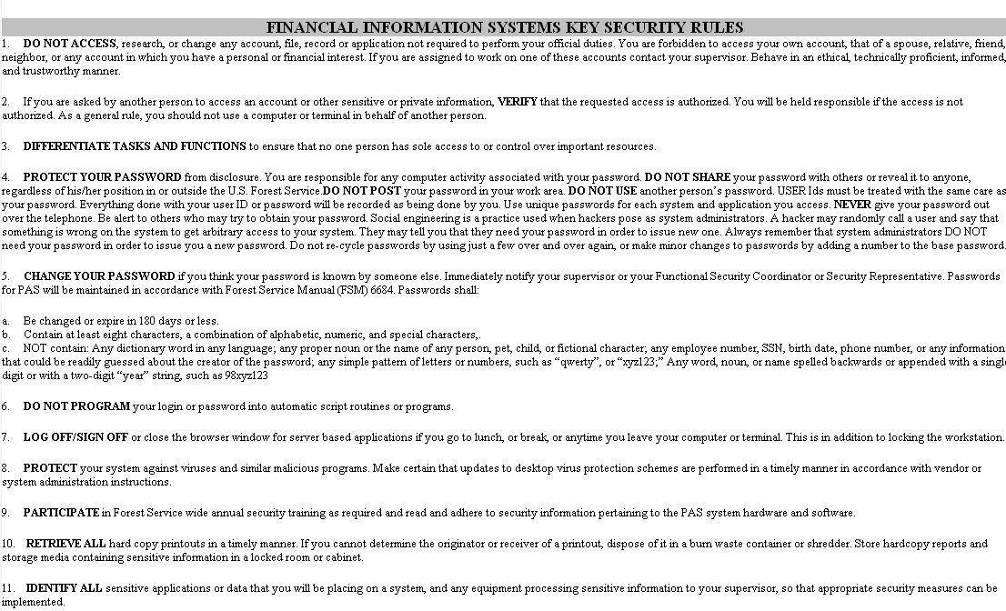
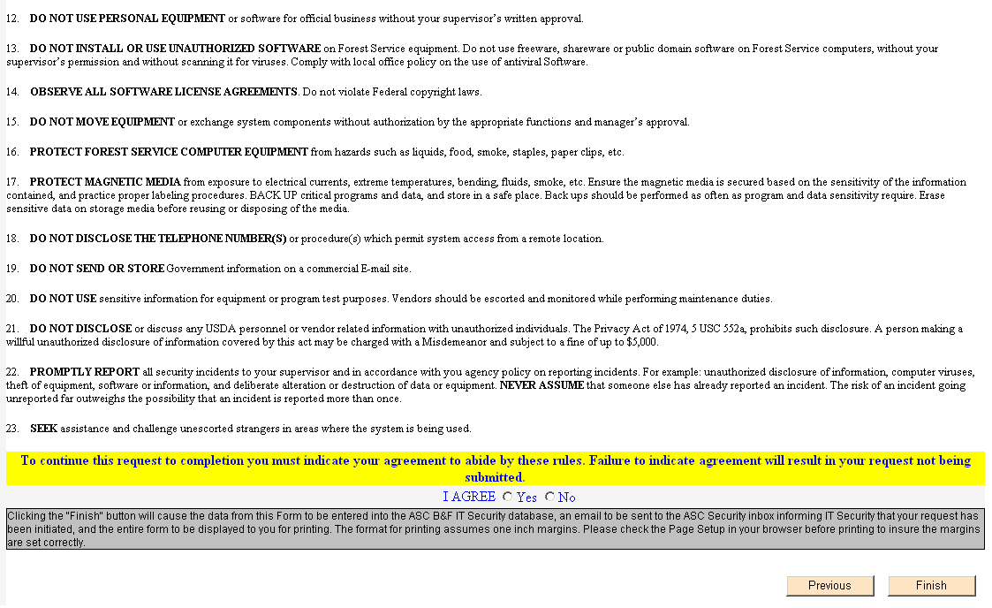

After the selections are made, the form is printed and the request signed, a one page printout is faxed to 1-866-342-3441. This one page printout reflects the request and the signatures of the employee/contractor and the supervisor granting approval for this access. The one page printout is only required due to lack of e-signature approval and for audit purposes. Otherwise, this is an electronic request.

