
U.S. Department of Justice

Office of Community Oriented Policing Services (COPS)

Grants Administration Division
______________________________________________________________________________

1100 Vermont Avenue, NW

Washington, D.C. 20530

Date

Grantee Title and Name
Department Name
Address
City, State Zip

Dear NAME:

The COPS Office is pleased to announce the COPS Interoperable Communications Technology Program (ICTP) Assessment Survey. The ICTP Assessment Survey is the result of a cooperative agreement awarded to the Institute of Law and Justice (ILJ), a non-profit research organization, to assess the ICTP grants awarded between fiscal years 2003-2006. The assessment will identify best practices and lessons learned that can be shared with the public safety community at large.

The survey will be administered via telephone, and has been approved under the Paperwork Reduction Act. Your agency will be contacted to arrange an appointment time that will be convenient for you to respond to the survey.

Thank you for your participation in this survey. If you have any questions, please do not hesitate to contact Delka Bright at (202) 514-6398 or via e-mail at delka.bright@usdoj.gov.

Sincerely,
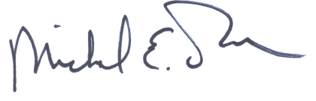Michael E. Dame
Assistant Director for Grants Administration

