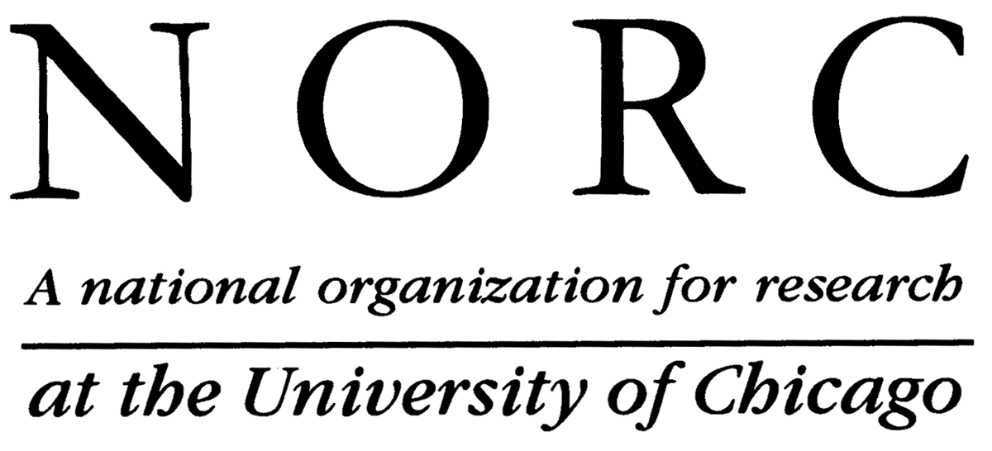
February 16, 2007
Dear [Principal]:

I am writing to notify you that your school has been selected as part of a nationally-representative sample to participate in the National Survey of Algebra Teachers (NSAT). This study is being conducted by the National Opinion Research Center (NORC) at the University of Chicago for the National Mathematics Advisory Panel of the U.S. Department of Education. We would like to include in the survey all teachers currently teaching one or more classes of algebra I in your school. The survey will collect information only from the algebra I teachers and will not include you or other members of your school. The survey will take about 25 minutes to complete and we will provide a check for $20 to each survey respondent as a token of our appreciation for their participation.

The National Mathematics Advisory Panel is a Presidentially-appointed group charged with developing recommendations for reform of K-12 mathematics education, and is focusing on beginning-level algebra courses as a top priority for improvements. The purpose of this study is to obtain algebra I teachers’ observations on student preparation, motivation, work habits, and skills as well as their views on how math is now taught, how earlier math education could be improved to better prepare children to succeed at algebra, and what would help all mathematics teachers do a better job. The results of the study will be used by the National Mathematics Advisory Panel and the U.S. Department of Education in developing reports to the President and general public in the months ahead.
Your district superintendent has already been notified and given approval for the NSAT study. Your school’s participation is important to enable this study to provide policymakers with accurate and complete information. Algebra teachers from a relatively small sample of schools throughout the nation are being included in the survey. This greatly increases the importance of your participation since your teachers will represent those in many other schools. Participation of schools and their teachers is voluntary and no negative consequences will attend a decision not to participate. Responses to this data collection will be used only for statistical purposes. The reports prepared for this study will summarize findings across the sample and will not associate responses with a specific district or individual. We will not provide information that identifies you or your district to anyone outside the study team, except as required by law.
We will be calling you in the next few weeks to discuss any concerns and, with your permission, to obtain a list of your Algebra I teachers and how to best contact them in order to request their participation. If you have any questions or concerns, you may contact me directly at (773) 256-6097 or hoffer-tom@norc.uchicago.edu. You may also contact the NSAT research team at algebra@norc.org or by calling our study toll-free number at 800-XXX-XXXX. . While completion of this survey takes approximately 25 minutes, this is entirely voluntary and no teacher is obligated to respond.

We thank you for considering this request and we hope we will be able to include the algebra I teachers in your school in this important new study.
Sincerely,

Tom Hoffer, Ph.D.
Project Director

