Project 727 QID 030371 |  |  | OMB No. 0535-0002: Approval Expires 3/31/2010
 |  |  |  |  |  | NATIONAL  AGRICULTURAL STATISTICS  SERVICE
 | IDAHO ALFALFA AND CLOVER SEED  DEALER SURVEY  2006 CROP |  |  |  | Idaho Field Office  P.O. Box 1699  2224 Old Penitentiary Road  Boise, Idaho 83701-1699  Phone 1-800-691-9987,Fax 208-334-1114  nass-id@nass.usda.gov
Dear Reporter:

The Alfalfa & Clover Seed Commission has contracted with us to determine the quantity of alfalfa and clover seed produced in Idaho. Your voluntary response is appreciated. All individual reports are kept confidential and used only to prepare the State total. Please fill in the table below and return it in the enclosed envelope which needs no stamp. If you prefer to fax the report, our fax number is 334-1114.

Sincerely,
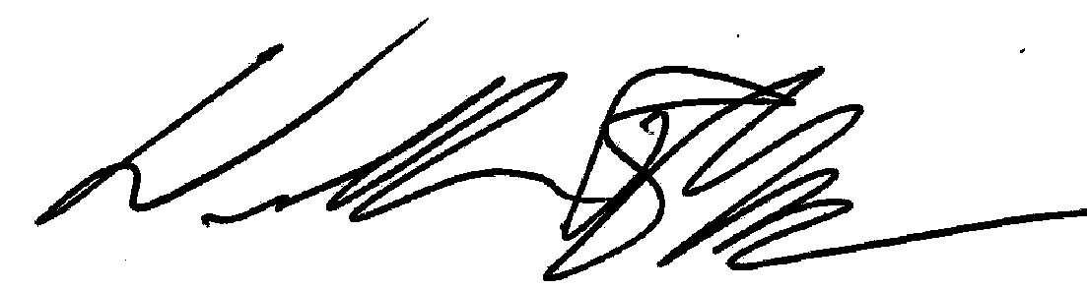
William R Meyer
Director

Please make corrections to name, address, and zip code, if necessary.

SEED HANDLERS: Report only for seed handled by your firm. Do not make an estimate for the total crop in each state. Report acreage and quantity of 2006 crop seed cleaned, regardless of ownership, by your plant(s). Include seed that has been partly cleaned on farms where cleaning operations are confined to the farmer’s own production. However, exclude from you report any cleaned or partly cleaned seed that you received from some other cleaner. Please report the average price growers received for clean seed BEFORE paying cleaning charges.

Report seed handled by your firm that was harvested during 2006.
 | Seed Harvested in: | Acres Harvested | Quantity of Seed  Cleaned  (Pounds) | Average Price Paid  Per Pound  (Dollars)
Alfalfa Seed | Idaho
Alfalfa Seed | Other States: _________
Red Clover Seed | Idaho
Red Clover Seed | Other States: _________
White Clover Seed | Idaho
White Clover Seed | Other States: _________

Comments: ________________________________________________________________________________________________________

_________________________________________________________________________________________________________________

Would you like to receive a copy of the results of this survey? | Yes |  | No

Reported By: ____________________________________ Phone: _____________________________ Date: _______________________

According to the Paperwork Reduction Act of 1995, no persons are required to respond to a collection of information unless it displays a valid OMB control number. The time required to complete this information collection is estimated to average 10 minutes per response.

