Project 191 QID 030310 |  | OMB No. 0535-0002: Approval Expires 3/31/2007
 | DRY EDIBLE BEANS  2006 CROP |  |  | 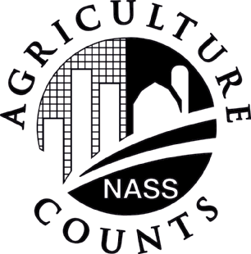 | NATIONAL  AGRICULTURAL STATISTICS  SERVICE
Minnesota Field Office
P.O. Box 7068
8 E. 4th St. Suite 500
St. Paul, MN 55107
Phone 1-800-453-7502, Fax 1-800-839-2186
nass-mn@nass.usda.gov
PLEASE RETURN BY NOVEMBER 3rd  (Please make corrections in name, address, and zip code, if necessary) |  |  | Dear Minnesota Dry Bean Dealer:  We are in the process of making our December Dry Bean estimate and would appreciate your help again this month. The results of this survey will be published on December 11, 2006.  Please answer the following questions and return the completed form by November 3rd in the self-addressed enclosed envelope which requires no stamp, or fax it to us at 1-800-839-2186. Response to this survey is voluntary and not required by law. However, your cooperation is needed to ensure accurate estimates. Individual reports will be kept confidential and used only in preparation of state totals. Thanks for you cooperation.

PLEASE REPORT FOR YOUR SEED PLACEMENTS
CLASS | Acres Planted |  | Acres Harvested 1/ |  | Yield Per Harvested Acres 2/
CLASS | Minnesota | North Dakota | Minnesota | North Dakota | Minnesota | North Dakota
NAVY
PINTO
DARK RED KIDNEY
LIGHT RED KIDNEY
GREAT NORTHERN
BLACK TURTLE
PINKS
LARGE GARBANZO 3/
SMALL GARBANZO 4/
SMALL RED
SMALL WHITES
OTHER TYPES (specify)
1/ Include only acreage harvested for food or seed.
2/ An estimate of the growers’ average yield on a clean basis in your marketing area.
3/ Chickpeas larger than the 20/64 inch screen.
4/ Chickpeas that pass through a 20/64 inch round hole screen.

COMMENTS:
Reported By: |  | Phone: |  | Date:

According to the Paperwork Reduction Act of 1995, no persons are required to respond to a collection of information unless it displays a valid OMB control number. The time required to complete this information collection is estimated to average 5 minutes per response.

