QID 060030 |  |  | OMB No. 0535-0002: Approval Expires 12/31/2007
 | DRY EDIBLE BEANS  2006 CROP |  |  |  |  | NATIONAL  AGRICULTURAL STATISTICS  SERVICE
Minnesota Field Office
P.O. Box 7068
8 E. 4th St. Suite 500
St. Paul, MN 55107
Phone 1-800-453-7502, Fax 1-800-839-2186
nass-mn@nass.usda.gov
June 1, 2006

Dear Minnesota Dry Bean Dealers:

Now that planting is nearly complete, planted acreage estimates are being made for dry edible beans grown in Minnesota and surrounding states in 2006. Around this time of year, our office contacts you by phone or letter to obtain data which will be used in preparing crop estimates.

Please answer the following questions and return this form by June 16th in the self-addressed envelope enclosed, which requires no stamp. Response to this survey is voluntary and not required by law. Your report will be kept confidential and used only in preparation of state totals. Thank you for your cooperation.

If you wish to fax your response, our toll free fax number is 1-800-839-2186.

Sincerely,
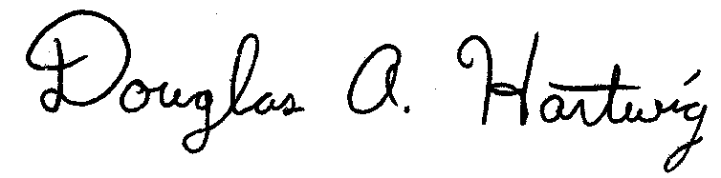
Douglas A. Hartwig
Director
PLEASE FAX (1-800-839-2186) OR RETURN BY JUNE 16TH

PLEASE REPORT FOR THE FIRM YOU OPERATE:

CLASS | ESTIMATED ACRES PLANTED FROM SEED SOLD IN 2006
CLASS | Minnesota  ---Acres--- | North Dakota  ---Acres--- | Other States  ---Acres---
Pinto
Navy
Dark Red Kidney
Light Red Kidney
Great Northern
Black Turtle
Pink
Small Red
Other (Specify)

Reported By: |  |  | Date:
Comments:

According to the Paperwork Reduction Act of 1995, no persons are required to respond to a collection of information unless it displays a valid OMB control number. The time required to complete this information collection is estimated to average 15 minutes per response.

