Project 195 QID 060049 |  |  | OMB No. 0535-0002: Approval Expires 3/31/2010
 | POTATO ACREAGE SURVEY  JUNE 2007 |  |  |  |  | NATIONAL  AGRICULTURAL STATISTICS  SERVICE
Idaho Field Office
P.O. Box 1699
2224 Old Penitentiary Road
Boise, Idaho 83701-1699
Phone 1-800-691-9987,Fax 208-334-1114
nass-id@nass.usda.gov
Please make corrections in name and address. |  |  |  | TO IDAHO POTATO GROWERS:  In order to provide data useful to the potato industry, we are asking acreage by intended marketing channel. This data will be published along with total acreage on July 12. Your individual report will be kept confidential. The enclosed envelope, for your reply, does not require a stamp. A telephone follow-up on this survey will be conducted to ensure adequate response.  Sincerely,  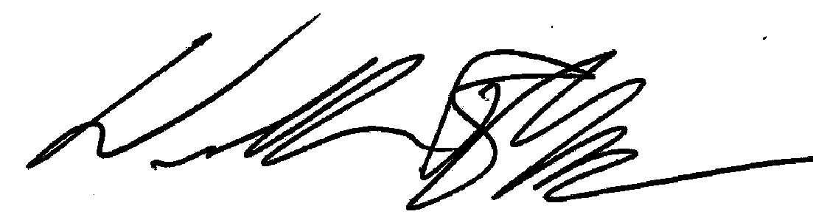  William R Meyer  Director

Fax #: 208-334-1114

REPORT 2007 POTATO ACRES PLANTED FOR THE FARM YOU OPERATE

Please report all acreage intended to be sold to a packer or shipper as marketed through fresh channels even though some of these potatoes will be diverted to processing.

How many acres of potatoes are intended to be . . .
. . . . marketed through fresh channels + | 1
. . . . marketed directly to a processor + | 2
. . . . . . . . . marketed or used for seed + | 3
Total acres planted in 2007 = | 4

Check box if you would like the results of this survey:

COMMENTS: _____________________________________________________________________________________

__________________________________________________________________________________________________

__________________________________________________________________________________________________

REPORTED BY: ________________________________ DATE: ________________ PHONE: ____________________

According to the Paperwork Reduction Act of 1995, no persons are required to respond to a collection of information unless it displays a valid OMB control number. The time required to complete this information collection is estimated to average 10 minutes per response

