Project 195 QID 060208 |  |  | OMB No. 0535-0002: Approval Expires 3/31/2007
 | 2006 POTATO DISPOSITION  JULY 2007 |  |  |  |  | NATIONAL  AGRICULTURAL STATISTICS  SERVICE
Idaho Field Office
P.O. Box 1699
2224 Old Penitentiary Road
Boise, Idaho 83701-1699
Phone 1-800-691-9987,Fax 208-334-1114
nass-id@nass.usda.gov
Please make corrections in name, address and zip code. |  |  |  | Dear Reporter:  The information asked for in this survey is used in preparing potato disposition estimates. This data will be published on September 20. Your report will be kept confidential. If available, previously reported data is provided where applicable. A telephone follow-up on this survey will be conducted to ensure adequate response.  Sincerely,  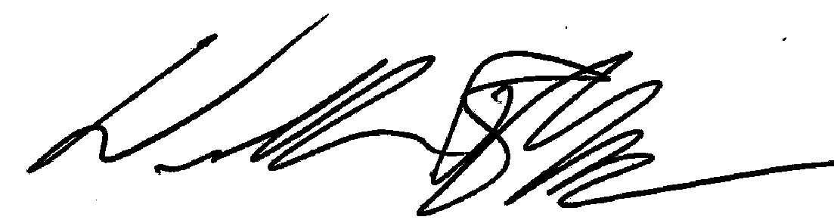  William R Meyer  Director
1. a) Are you currently growing potatoes (under the name or combination of names as listed on the label)? Do not include share/cash renting to others where you were a landlord!
 | YES - Continue |  | NO-Skip to 6.

b) Is your operation known by another name other than the one printed above?
 | NO
 | YES – Enter Name _______________________________________________
 | Do you want this name to appear on the label? |  |  |  |  |  | YES |  | NO

2. Were you engaged in a joint farming operation last year so that potato acreage you reported might also have been reported by another person? (Check One)
 | YES – continue by recording partners below |  | NO – skip to Question 4 on back

Share/Cash Renters Should Not Be Reported Here!!

Name _____________________________________________ Telephone No. _________________________
(Last) (First) (Middle) (Area Code)

Address___________________________________________________________________________________
(Route or Street) (City) (State) (Zip Code)
Was he a: |  | Partner |  | Landlord |  | Corporate Member |  | Manager |  | Other

How many acres of potatoes were in the joint arrangement? ACRES ______________________

Partnership or Corporation Name _____________________________________________________________

If partner, did this partner operate individually as well as in the partnership listed above? _________________

3. Did you operate individually as well as in the partnership listed above? |  | YES | NO

PLEASE REPORT POTATO ACREAGE ON ALL LAND YOU OPERATE (include acres rented from others;
Exclude acres share rented or cash rented to others.)
12
4. How many total acres of potatoes have you planted in 2007?
(exclude acres rented out) . . . . . . . . . . . . . . . . . . . . . . . . . . . . . ACRES

5. How many hundredweight of seed potatoes were used to plant this 2007 acreage? | 1 | cwt
a) How much of the total seed for 2007 was purchased? . . . . . . . . . . . . . . . . . . . . . | 2 | cwt

PLEASE REPORT BELOW FOR THE FARM OR FARMS YOU OPERATED IN 2006

6. Did you grow potatoes last year (2006 crop)?
 |  | YES - Continue |  | NO – Skip to 8.
a) Total acres of potatoes harvested in 2006 on the farm or farms you operate |  |  |  |  |  | 3 |  |  | ACRES
b) Quantity of potatoes harvested from all the acres reported in Item 6a.  (report total quantity hauled from field) . . . . . . . . . . . . . . . . . . . . . . . . . . . |  |  |  |  |  | 4 |  |  | cwt
DISPOSITION – 2006 CROP |  |  |  |  |  |  |  | PERCENT
7. Of the potatoes reported harvested in Item 6b, what quantity,  Including any remaining 2006 crop potatoes, was or will be:  a) Lost through shrinkage, decay and dumping? . . . . . . . . . . . . |  |  |  |  |  |  |  | OF
 |  |  |  |  | cwt |  | (or) | TOTAL
 |  |  |  |  | 5
b) Sold or Contracted for:
(1) Table stock . . . . . . . . . . . . . . . . . . . . . . . . . . . . . . . . . . . . |  |  |  |  | 6
(2) Processing ( chipping, frozen, dehydrating, starch, etc) . |  |  |  |  | 7
(3) Seed . . . . . . . . . . . . . . . . . . . . . . . . . . . . . . . . . . . . . . . . . . |  |  |  |  | 8
(4) Livestock Feed . . . . . . . . . . . . . . . . . . .. . . . . . . . . . . . . . . |  |  |  |  | 9
c) Used on this farm: (include only potatoes reported in Item 6b
used for human food; used for planting your 2007 crop; used for livestock and poultry feed. (DO NOT INCLUDE POTATOES YOU PURCHASED FOR FOOD, SEED OR FEED) . . .. . . . . . . . . . . . . . .
 |  |  |  |  | 10
d) TOTAL (sum of Items 7a, b and c should equal Item 6b) . . . |  |  |  |  | 11 |  |  | 100

8. If you would like to receive a report based on the results of this survey, enter a “1” in the box.

COMMENTS:______________________________________________________________________________

THANK YOU FOR YOUR HELP

REPORTED BY: ____________________________________ PHONE: _________________________ DATE: _______________

According to the Paperwork Reduction Act of 1995, no persons are required to respond to a collection of information unless it displays a valid OMB control number. The time required to complete this information collection is estimated to average 15 minutes per response.

