Project Code 195 QID 06049 060214 |  | O.M.B Number 0535-0002: Approval Expires 3/31/2007
 | IRISH POTATO FINAL INQUIRY  2006 CROP |  |  | 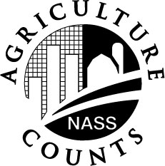 | NATIONAL  AGRICULTURAL  STATISTICS SERVICE
North Carolina Field Office  P.O. Box 27767  Raleigh, NC 27611  919-856-4394 Fax: 919-856-4139  E-mail: nass-nc@nass.usda.gov  Please make corrections to name, address and Zip Code, if necessary. |  |  | Dear Reporter:  The purpose of this survey is to determine the quantity of Irish potatoes harvested in 2006. Response to this survey is voluntary and not required by law. However, your cooperation is needed in providing reliable Irish potato information. Individual reports are kept confidential and used only in compiling State totals for prices and County totals for acres and yield. Please return this inquiry in the enclosed postage paid envelope. Thank you for your help.  Sincerely,  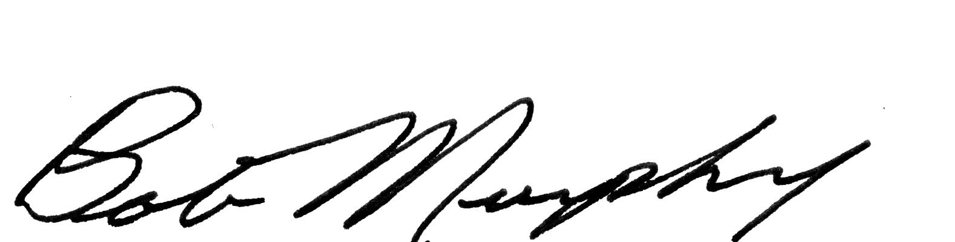  Bob Murphy  Director

PLEASE REPORT FOR THE FARM(S) YOU OPERATE

UNIT OF MEASURE: If the unit you use for reporting yield differs from cwt., please indicate the pounds per unit and unit for your report.
1. How many acres were planted on this farm this year (2006)?. .. . . . . . . . . . . . . . . . . . . . Acres |  |  | 101  ._____
2. How many acres harvested on this farm this year (2006)?. . . . . . . . . . . . . . . . . .. . . . . . ..Acres |  |  | 102  ._____
3. How many acres harvested on this farm last year (2005)? . . . . . . . . . . . . . . . . . . . . . . . . Acres |  |  | 103  ._____
4. What is the total quantity harvested on this farm this year (2006)?. . . . . . . . . . . . . . . . . . . .Cwt. |  |  | 104  OR
What is the average yield per acre on this farm this year (2006)?. . . . . . . . . . . . . . . . . . . . .Cwt. |  |  | 105
Average price received for your 2006 potatoes:
Only report sales of potatoes grown by you. Exclude any potatoes purchased from other growers.
IRISH POTATOES SOLD
(Include contract and open market sales)
 | Average price  Received | Quantity  Sold |  | % Sold in  June
A. Sold for Table Stock or Fresh Market..................... | 106  $ . ___ ___ | 107  Cwt. |  | 108
B. Sold for Chipping or Processing……………………. | 109  $ . ___ ___ | 110  Cwt. |  | 111
C. Sold for Seed. .………………………………………. | 112  $ . ___ ___ | 113  Cwt. |  | 114
D. Sold for Livestock Feed…………………………….. | 115  $ . ___ ___ | 116  Cwt. |  | 117

6. Quantity harvested but not sold or used. . . . . . . . . . . . . . . . . . . . . . . . .. . . . . . . . . . . . . . . . . Cwt. | 120
COMMENTS:

Reported by: |  |  |  |  |  |  |  |  |  | Telephone:
   |  |  | - |  |  |  | -
E-Mail Address:
Survey results will be available in the USDA Crop Production Report on the internet at http://www.nass.usda.gov/Publications/,
October 12, 2005 at 8:30 am, or on the October Farm Report Released October 25, 2006. If you would like to receive results of this survey, please indicate below.
To receive a copy of the October Farm Report via e-mail, please check this box  0099= 2
To receive a paper copy, please check this box.  0099 = 1
 |  |  |  |  |  |  |  |  |  |  |  |  |  |  |  |  | 0099
Response |  |  |  |  |  | Respondent |  | Mode |  |  |  | Enum. |  | Eval. | Date
1-Comp  2-R  3=Inac  4-Office Hold | 5-R-Est  6-Innac-Est  7-OffHOld-Est  8-Known Zero |  |  | 9901 |  | 1-Op/Mgr  2-Sp  3-Acct/Bkpr  4-Partner  9-Other | 9902 | 1-Mail  2-Tel  3-Face to Face  4-CATI  5-Web | 6-E-Mail  7-Fax  8-CAPI  9-Other |  | 9903 | 0098 |  | 0100 | 9910
 |  |  |  |  |  |  |  |  |  |  |  |  |  |  | __ __ __ __ __ __
 |  |  |  |  |  |  |  |  |  |  |  |  |  |  | M M D D Y Y
S/E Name
According to the Paperwork Reduction Act of 1995, no persons are required to respond to a collection of information unless it displays a valid OMB control number. The time required to complete this information collection is estimated to average10 minutes per response.

