Project 198 |  |  |  | OMB No. 0535-0002 Approval Expires 03/31/2007
 | USDA, NASS, North Carolina Field Office  PO Box 27767  Raleigh, NC 27611  1-800-437-8451, Fax: 919-856-4139  ncagstat@ncmail.net | Tobacco Inquiry  Fall 2006 |  |  |  |  | NATIONAL  AGRICULTURAL  STATISTICS  SERVICE
Dear Producer:

Your cooperation is needed to determine the 2006 tobacco acreage and production, and the 2007 intentions. Response to this survey is voluntary and not required by law. However, your answers to the questions below will be appreciated and will be kept confidential as required by law (US Code, Title 7). Please return this inquiry promptly in the enclosed envelope, which requires no stamp.

Sincerely,
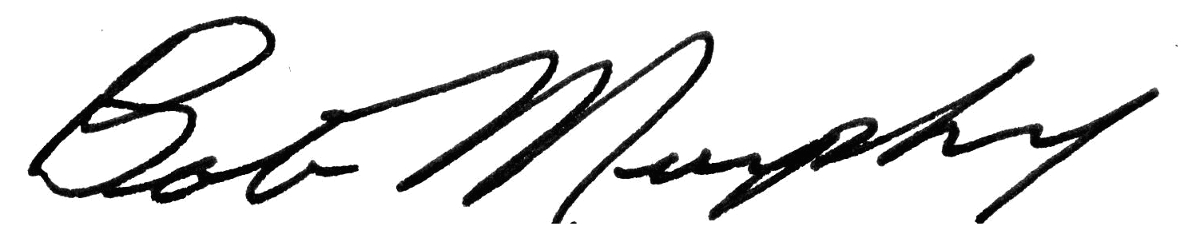

Bob Murphy
Director
Please make corrections to name, address and Zip Code, if necessary.

Final 2006 |  | Flue-Cured  Type 11-14 | Burley  Type 31 | Other Types  (specify)  _________________
Acres harvested in 2006 . . . . . . . . . . .. . . . | (tenth of acre) | 110  . _______ | 210  . _______ | 310  . _______
Yield per acre . . . . . . . . . . . . . . . . . . . . . .  OR  Total production . . . . . . . . . . . . . . . . . . . . . | (pounds/acre) | 111 | 211 | 311
 | (total pounds) | 112 | 212 | 312
Total lbs marketed from the 2006 crop  (exclude 2005 carryover) . . . . . . . . . . . . . | (pounds) | 113 | 213 | 313
Price per pound . . . . . . . . . . . . . . . . . . . . . .  OR  Total sales from the 2006 crop . . . . . . . . | ($/Lb) | 114  . ___ ___ | 214  . ___ ___ | 314  . ___ ___
 | (dollars) | 115 | 215 | 315
Flue Cured Cropping Practices
Acres irrigated in 2006. . . . . . . .. . . . . . . . . | (tenth of acre) | 120  . ________
Yield per irrigated acre . . . . . . . . . . . . . . . .  OR  Total production on irrigated acres . . . . . . .. | (pounds/acre) | 121
 | (total pounds) | 122
Intentions for 2007
Acres expected for harvest in 2007. . . . . . . | (tenth of acre) | 101  . _______ | 201  . _______ | 301  . _______

Reported by: |  |  |  |  |  |  |  |  |  | Telephone:
   |  |  | - |  |  |  | -
E-Mail Address:
Survey results will be available in the USDA Crop Production Report on the internet at http://www.nass.usda.gov/Publications/,
January 2007, or in the February Farm Report released February 26, 2007. If you would like to receive a copy of this report please indicate below.
To receive a copy of the February Farm Report via e-mail, please check this box  0099= 2 (e-mail)
To receive a paper copy, please check this box.  0099 = 1 (mail)
 |  |  |  |  |  |  |  |  |  |  |  |  |  |  |  |  | 0099
Response |  |  |  |  |  | Respondent |  | Mode |  |  |  | Enum. |  | Eval. |  | Date
1-Comp  2-R  3=Inac  4-Office Hold  5-R-Est | 6-Innac-Est  7-OffHOld-Est  8-Known Zero |  |  | 9901 |  | 1-Op/Mgr  2-Sp  3-Acct/Bkpr  4-Partner  9-Other | 9902 | 1-Mail  2-Tel  3-Face to Face  4-CATI  5-Web | 6-E-Mail  7-Fax  8-CAPI  9-Other |  | 9903 | 0098 |  | 0100 |  | 9910
 |  |  |  |  |  |  |  |  |  |  |  |  |  |  |  | __ __ __ __ __ __
 |  |  |  |  |  |  |  |  |  |  |  |  |  |  |  | M M D D Y Y
S/E Name
According to the Paperwork Reduction Act of 1995, no persons are required to respond to a collection of information unless it displays a valid OMB control number. The time required to complete this information collection is estimated to average10 minutes per response.

