Project 701/725 QID 191000 |  |  | OMB No. 0535-0002: Approval Expires 3/31/2010
 | 2007 WHEAT & BARLEY VARIETY SURVEY |  |  |  |  | NATIONAL  AGRICULTURAL STATISTICS  SERVICE
Idaho Field Office
P.O. Box 1699
2224 Old Penitentiary Road
Boise, Idaho 83701-1699
Phone 1-800-691-9987,Fax 208-334-1114
nass-id@nass.usda.gov
Dear Reporter:

This survey is funded by the Idaho Wheat and Barley Commissions and the American Malting Association. Survey results will enhance their marketing efforts. Information four your operation will be kept confidential and combined with other reports to make an official estimate of wheat and barley varieties planted in Idaho. Response is voluntary and not required by law.

Your response is greatly appreciated. Please return this report in the enclosed envelope which requires no stamp.

Sincerely,
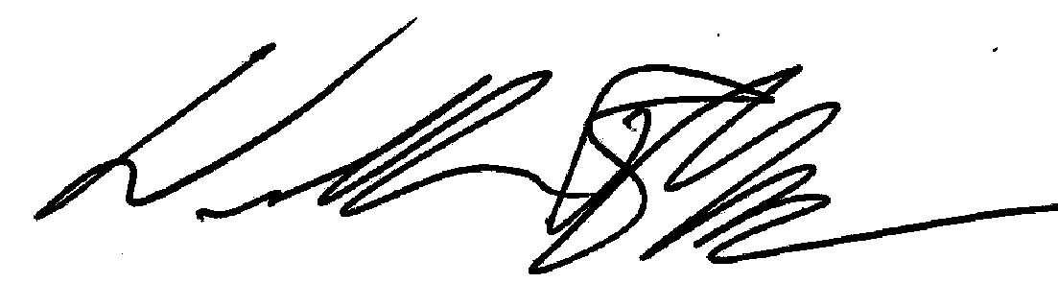
William R. Meyer
Director
Please return by May 11 2007
INSTRUCTIONS: Record 2007 barley and wheat acres planted by variety. Please specify all unlisted varieties planted.

ALL BARLEY – TOTAL ACRES
MALTING VARIETIES | ACRES
2-Row Malting Varieties
AC Metcalfe
B1202
Conrad (B5057)
Harrington
Merit (B4947)
Moravian 37
Moravian 69 (C69)
CDC Stratus
Other 2-Row Malt (Specify)
______________________
Unknown 2-Row Malt
6-Row Malting Varieties
Drummond
Excel
Foster
Lacey
Legacy (B2978)
Morex
Stander
Tradition (B2482)
Other 6-Row Malt (Specify)
______________________
Unknown 6-Row Malt

FEED VARIETIES | ACRES
2-Row Feed Varieties
Ab2323
Adage
Bancroft (Ab10274)
Baronesse
CDC Bold
Burton
Camas
Cooper
Crest (WA8771)
Criton
Bear Lake
Crystal*

2-Row Feed Varieties-Con’t
Farmington (WA9504)
Gallatin
Garnet (Ab2317)*
Haybet
Hector
Hoody
Idagold
Idagold II (C32)
Lud
Menuet
Piroline*
Radiant
Spaulding
Sunbar 560
Xena
757
Other 2-Row Feed (Specify)
_____________________
Unknown 2-Row Feed
6-Row Feed Varieties
Belford
Boyer (w)
Colter
Creel
Eight Twelve
Logan
Medallion
Millennium
Milton (w)
Mucho
Nebula
Sprinter (w)
Steptoe
Sunstar Double
Sunstar Pride (w)
Tango
Walker
WestBred 501
Westford
Other 6-Row Feed (Specify)
_____________________
Unknown 6-Row Feed

*Recommended for malting by the American Malting Barley Association in previous years.
(w) Winter Variety.

According to the Paperwork Reduction Act of 1995, no persons are required to respond to a collection of information unless it displays a valid OMB control number. The time required to complete this information collection is estimated to average 10 minutes per response.

WINTER WHEAT – TOTAL ACRES
HARD RED WINTER
Bonneville
Boundary
D W
Declo
Deloris
Falcon
Garland
Moreland
Promontory
Symphony
Utah 100
Weston
Other (Specify) ____________________
Unknown Hard Red Winter
SOFT WHITE WINTER
Beamer
Brundage
Brundage 96
Cashup
Clearfirst
Daws
Eltan
Finch
Hill 81
IDO 587
Lambert
Madsen
Malcolm
Mohler
ORCF 101
Rod
Simon
Sprague
Stephens
Tubbs
Weatherford
WestBred 470
WestBred 528
Mixed Soft White Varieties
(Specify)
Other (Specify)
Unknown Soft White Winter
HARD WHITE WINTER
Gary
Nufrontier
Nuhorizon 610
Other (Specify) ____________________
Unknown Hard White Winter
WINTER CLUB
Chukar
Coda
Hiller
Mel
Other (Specify) ____________________
Unknown Winter Club

SPRING WHEAT – TOTAL ACRES
(Excluding Durum)
HARD RED SPRING
Bannock
Fremont
Hank
Jefferson
Jerome
McNeil
Pinnacle
Pondera
Proband 751
Rick
Sunstar King
Tara 2002
WestBred 906R
WestBred 926
WestBred 936
WestBred Express
Other (Specify) ____________________
Unknown Hard Red Spring
SOFT WHITE SPRING
Alpowa
Alturus
Centennial
Challis
Jubilee
Louise
Nick
Penawawa
Treasure
Wakanz
Wawawai
Zak
Other (Specify) ____________________
Unknown Soft White Spring
HARD WHITE SPRING
Blanca Grande
IDO 377S
Klasic
Lochsa
Lolo
Pristine
Snowcrest
Other (Specify) ____________________
Unknown Hard White Spring
SPRING CLUB
Eden
Other (Specify) ____________________
Unknown Spring Club
DURUM WHEAT – TOTAL ACRES
Kronos
Utopia
Other (Specify) ____________________
Unknown Durum

REPORTED BY: ____________________________ PHONE: _______________________ DATE: __________________

Comments: _________________________________________________________________________________________________

_________________________________________________________________________________________________

