Section B – 10a – Ambulance – Base 1 Screen
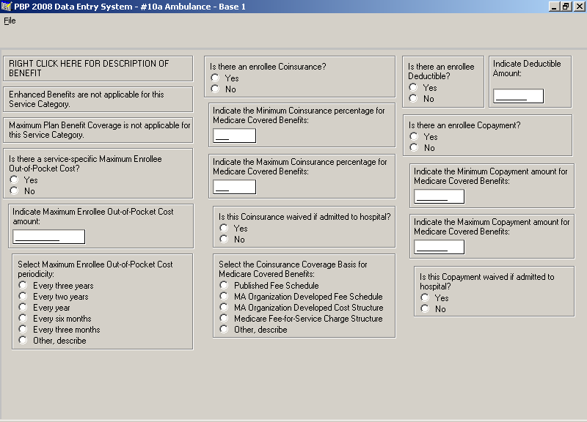

Section B – 10a – Ambulance – Base 2 Screen
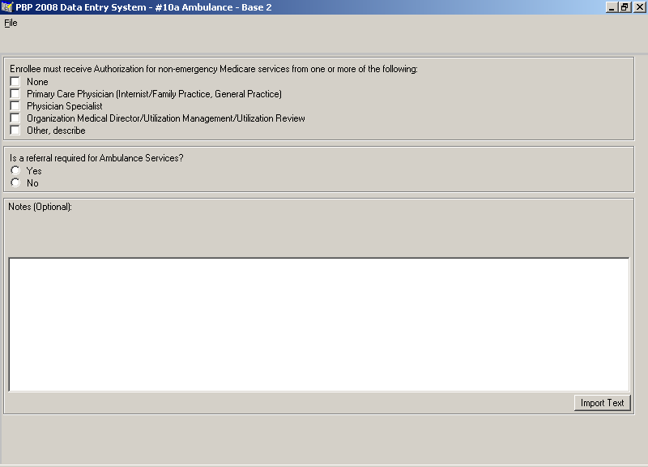

Section B – 10b – Transportation – Base 1 Screen
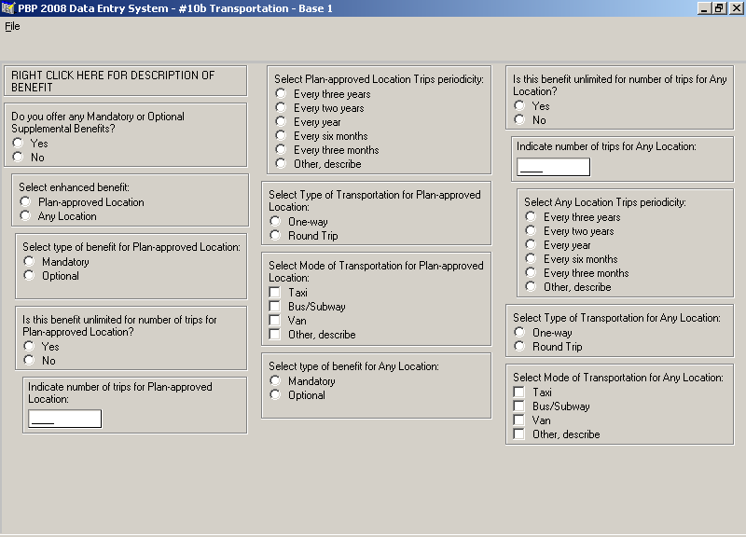

Section B – 10b – Transportation – Base 2 Screen
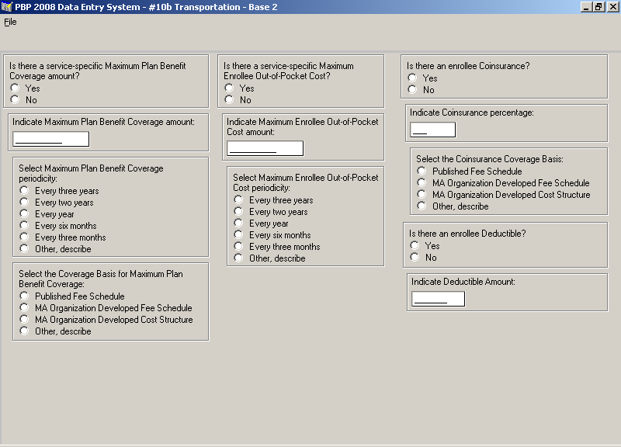

Section B – 10b – Transportation – Base 3 Screen
