Section B – 15 – Medicare Part B Prescription Drugs – Base 1 Screen
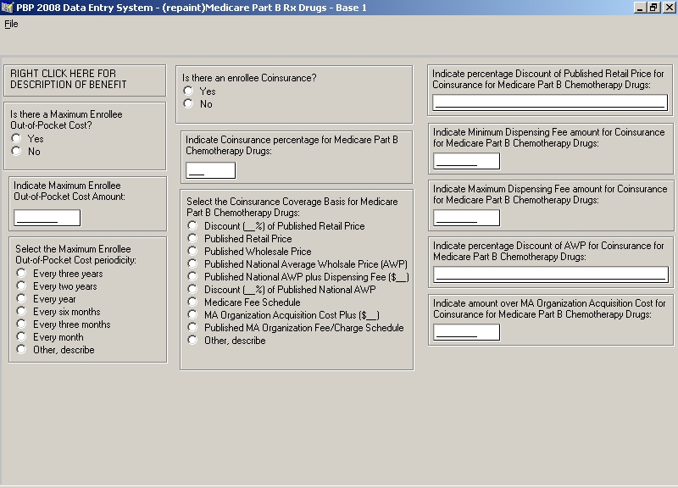

Section B – 15 – Medicare Part B Prescription Drugs – Base 2 Screen
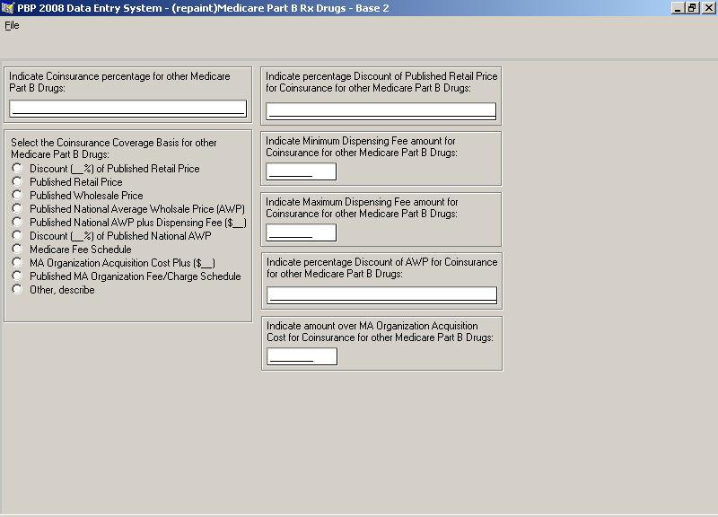

Section B – 15 – Medicare Part B Prescription Drugs – Base 3 Screen
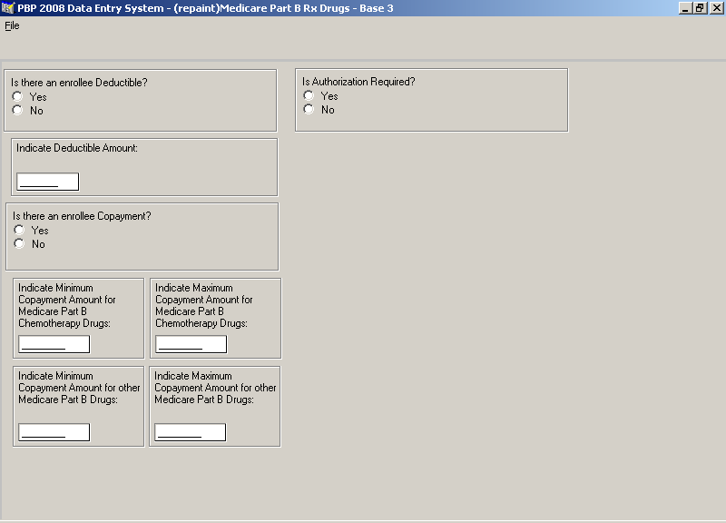

Section B – 15 – Medicare Part B Prescription Drugs – Notes (Optional)
