Section B – 20 – Outpnt Drugs – Base 1 Screen
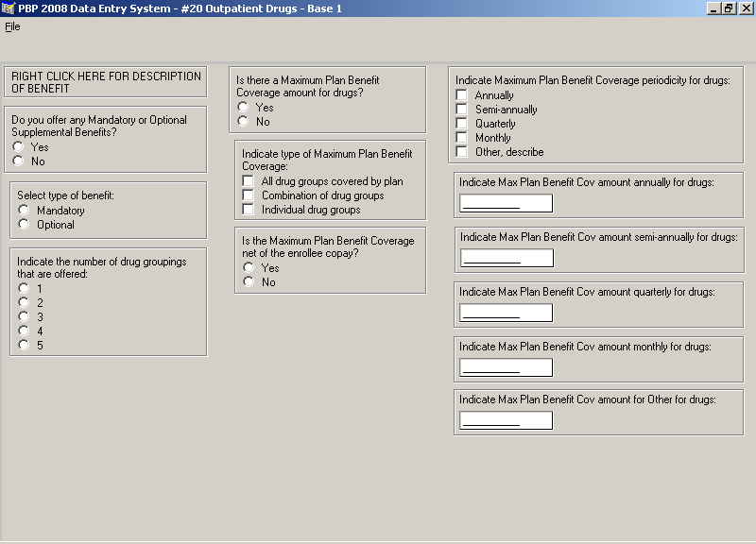

Section B – 20 – Outpnt Drugs – Base 2 Screen
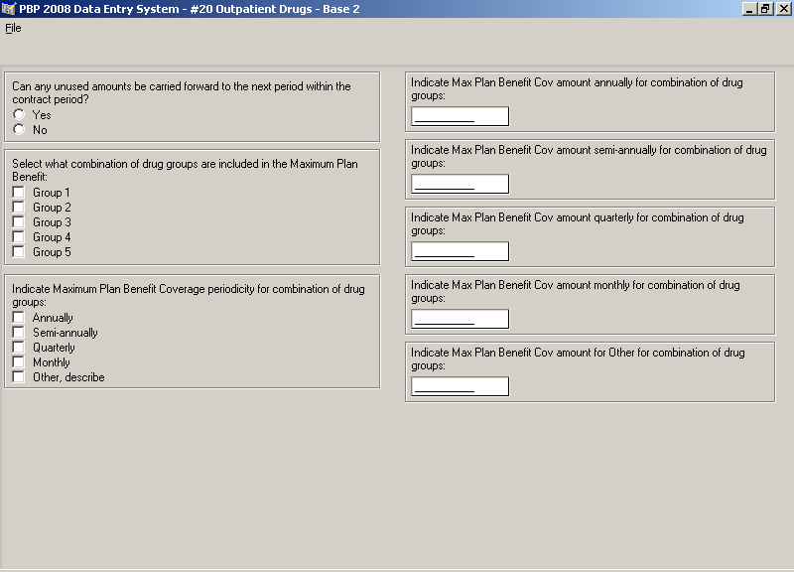

Section B – 20 – Outpnt Drugs – Base 3 Screen
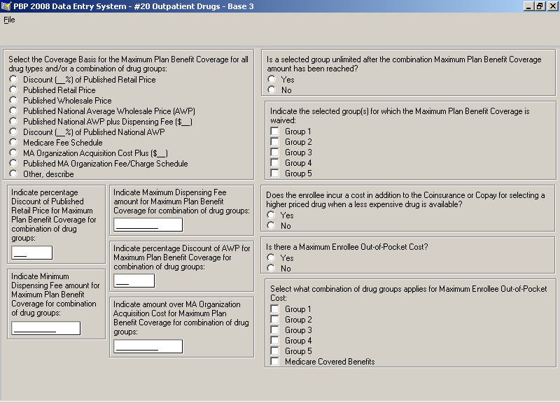

Section B – 20 – Outpnt Drugs – Base 5 Screen
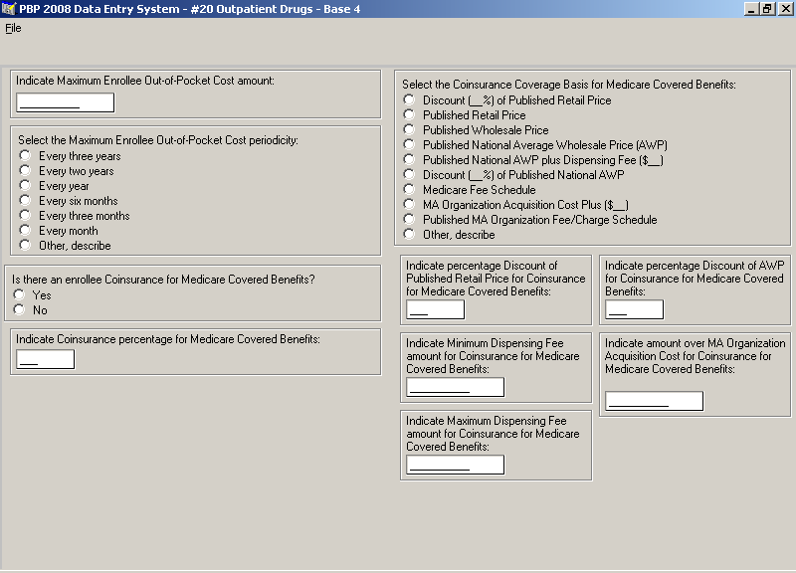

Section B – 20 – Outpnt Drugs – Base 5 Screen
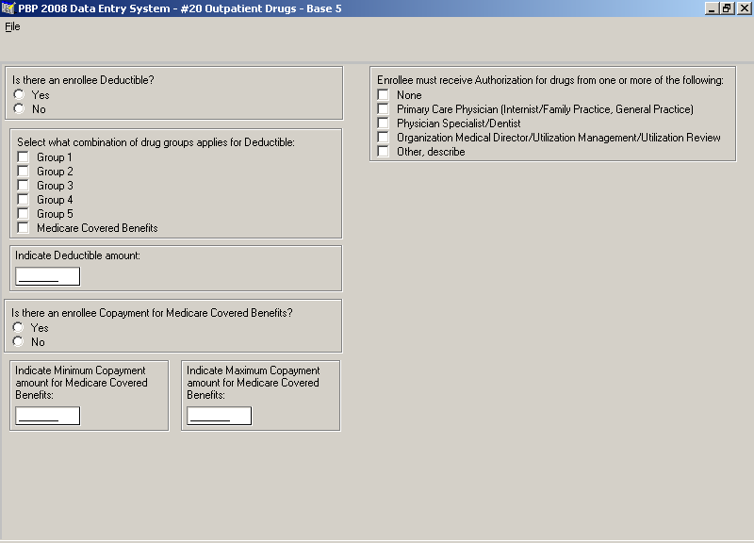

Section B – 20 – Outpnt Drugs – Notes (Optional)
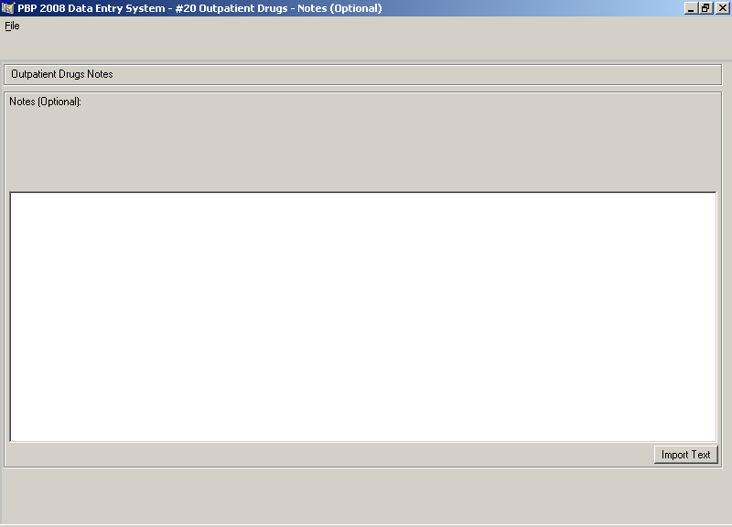

Section B – 20 – Outpnt Drugs – Group 1- Base 1 Screen
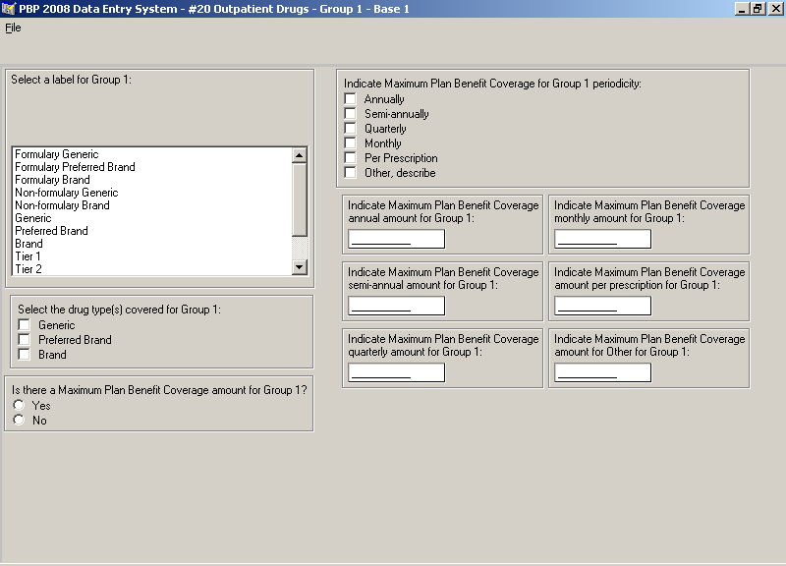

Section B – 20 – Outpnt Drugs – Group 1- Base 2 Screen
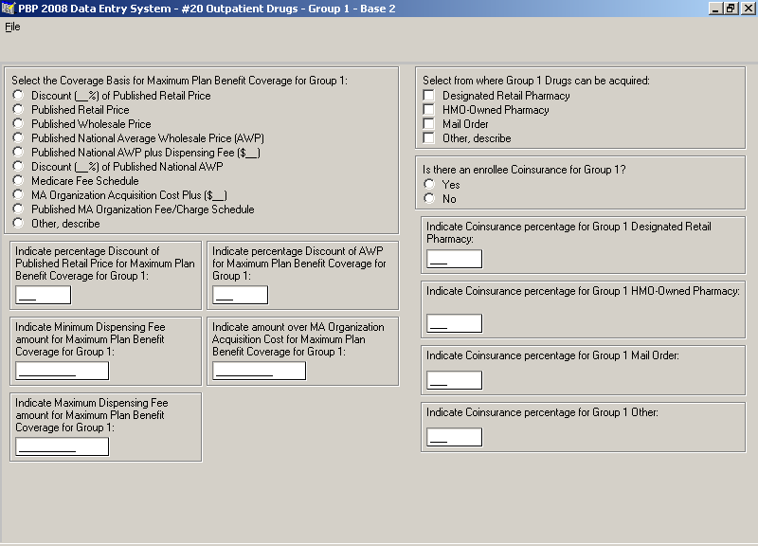

Section B – 20 – Outpnt Drugs – Group 1- Base 3 Screen
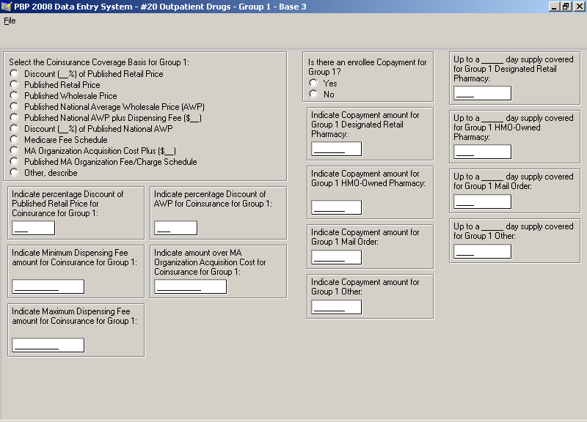

Section B – 20 – Outpnt Drugs – Group 2- Base 1 Screen
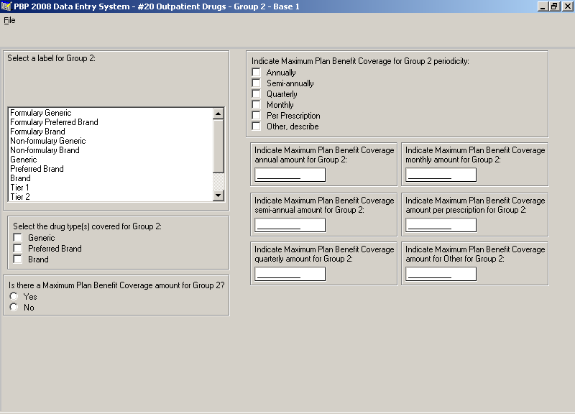

Section B – 20 – Outpnt Drugs – Group 2- Base 2 Screen
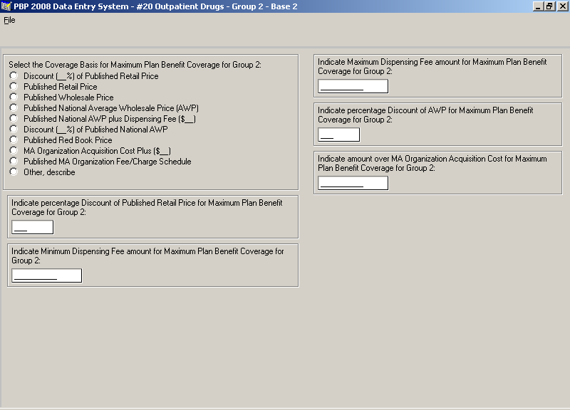

Section B – 20 – Outpnt Drugs – Group 2- Base 3 Screen
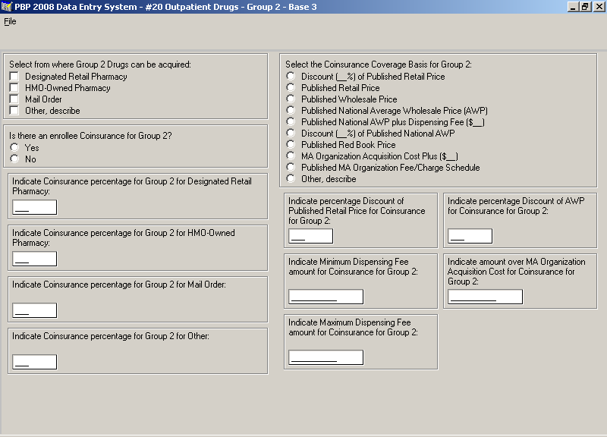

Section B – 20 – Outpnt Drugs – Group 2- Base 4 Screen
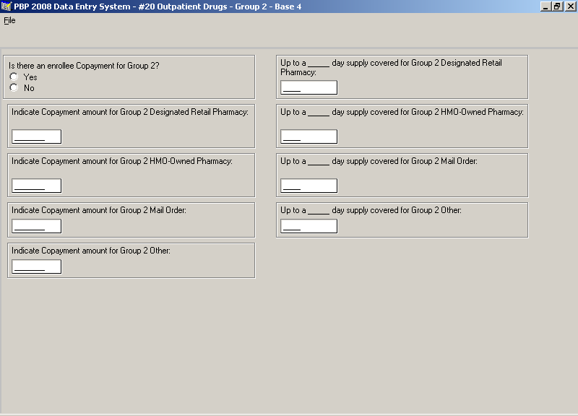

Section B – 20 – Outpnt Drugs – Group 3- Base 1 Screen
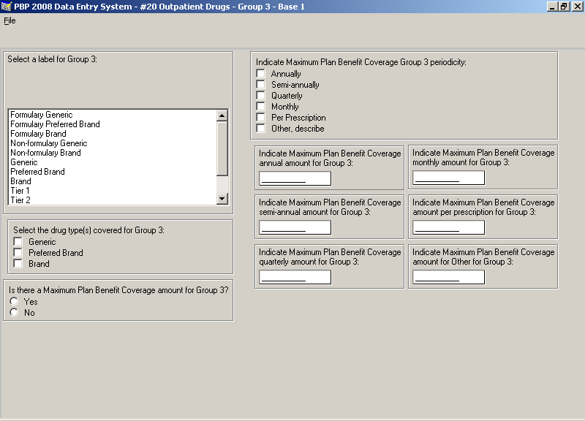

Section B – 20 – Outpnt Drugs – Group 3- Base 2 Screen
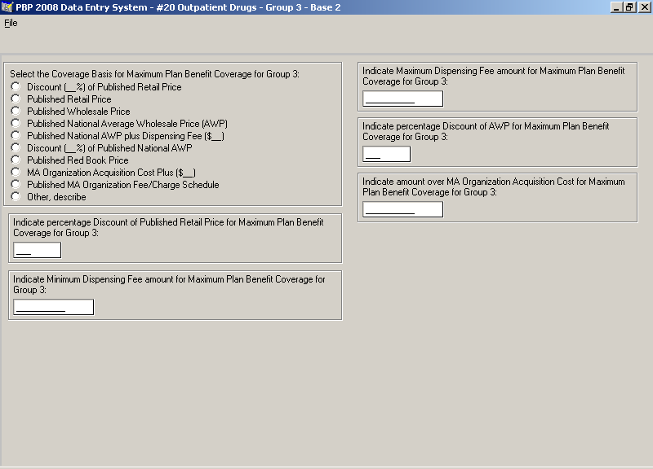

Section B – 20 – Outpnt Drugs – Group 3- Base 3 Screen
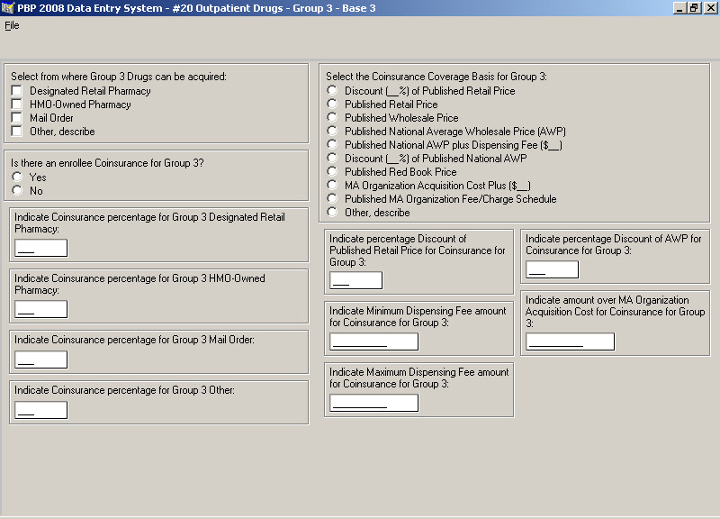

Section B – 20 – Outpnt Drugs – Group 3- Base 4 Screen
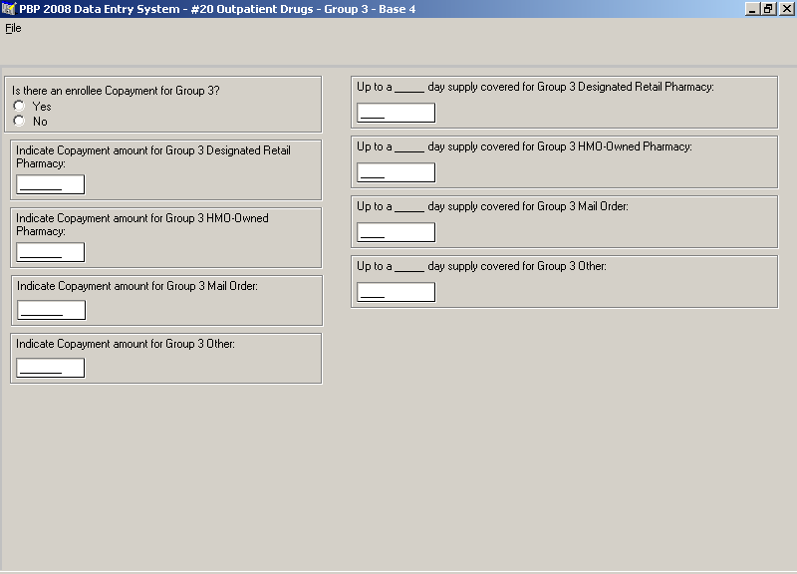

Section B – 20 – Outpnt Drugs – Group 4- Base 1 Screen
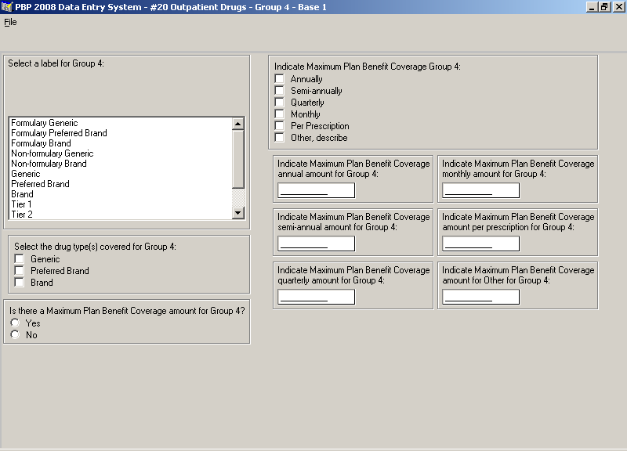

Section B – 20 – Outpnt Drugs – Group 4- Base 2 Screen
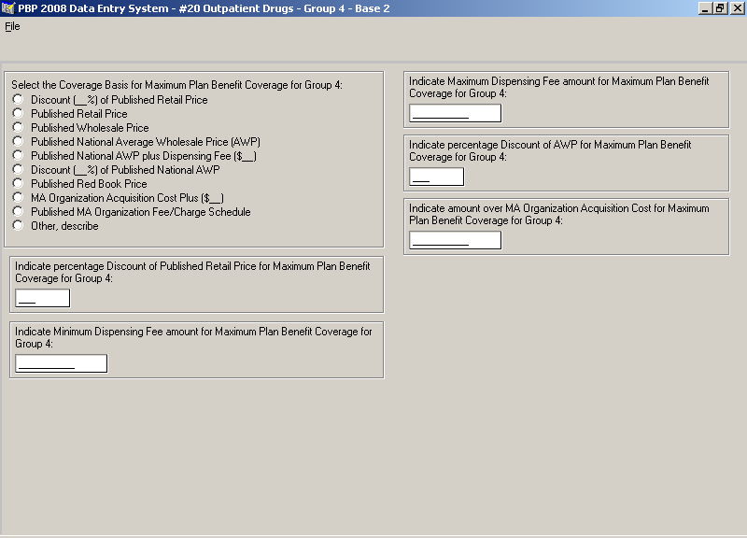

Section B – 20 – Outpnt Drugs – Group 4- Base 3 Screen
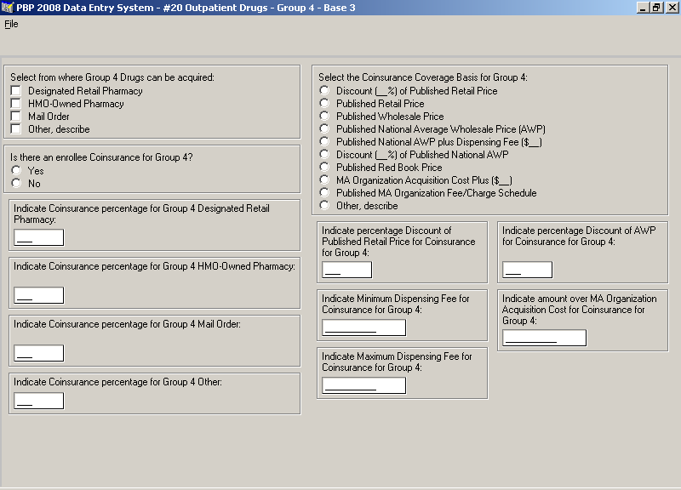

Section B – 20 – Outpnt Drugs – Group 4- Base 4 Screen
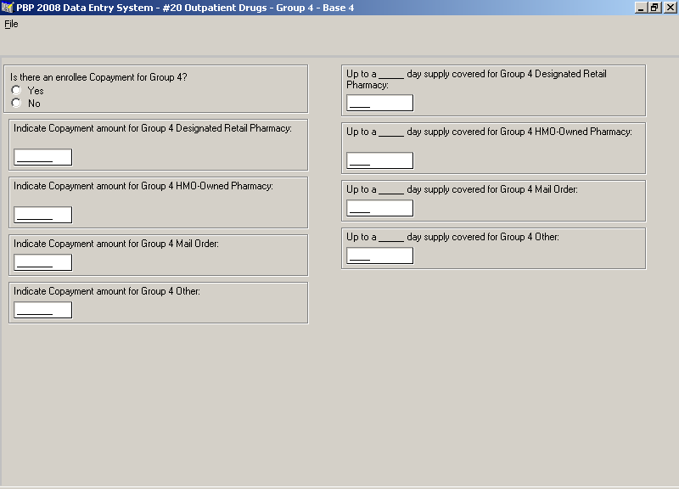

Section B – 20 – Outpnt Drugs – Group 5- Base 1 Screen
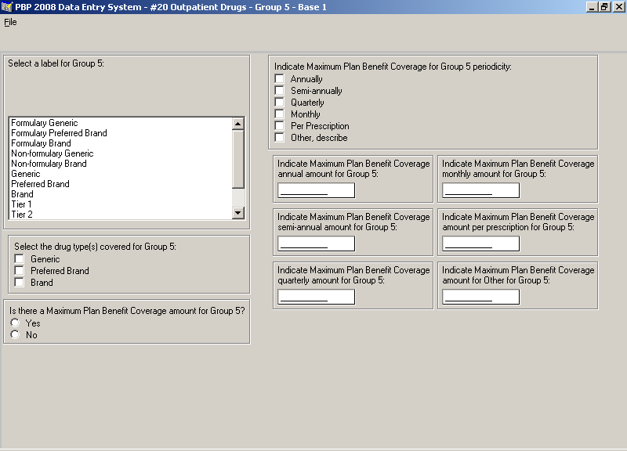

Section B – 20 – Outpnt Drugs – Group 5- Base 2 Screen
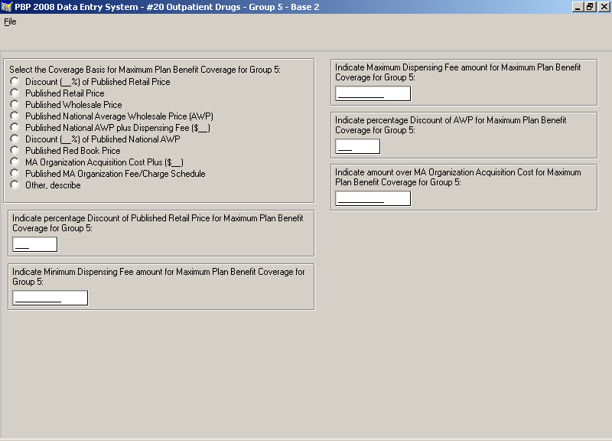

Section B – 20 – Outpnt Drugs – Group 5- Base 3 Screen
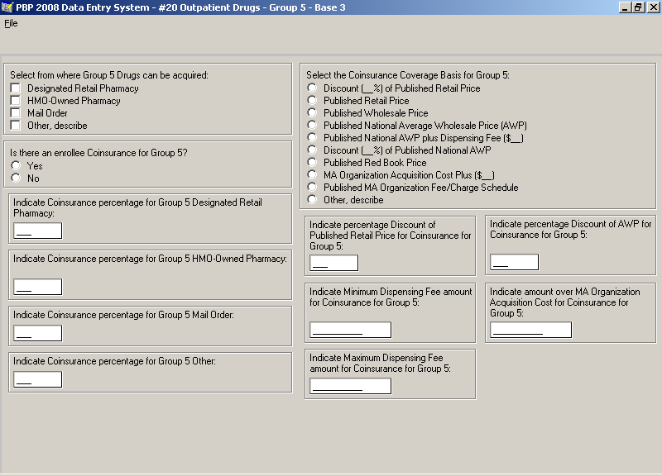

Section B – 20 – Outpnt Drugs – Group 5- Base 4 Screen
