Section C – OON – General – Base 1 Screen
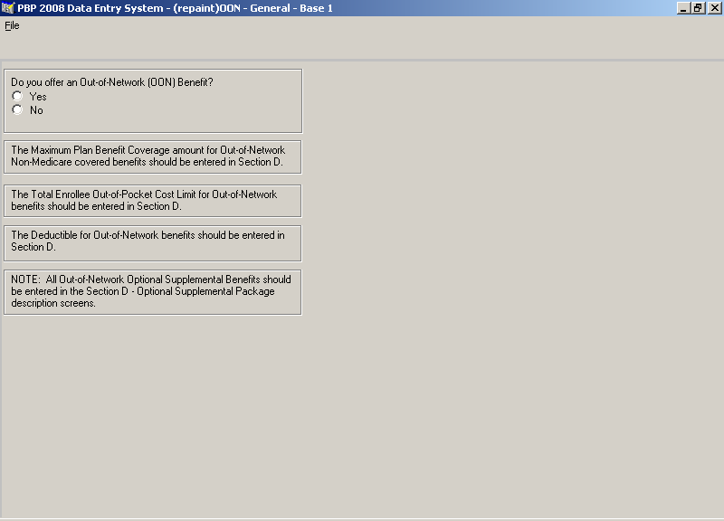

Section C – OON – General – Base 2 Screen
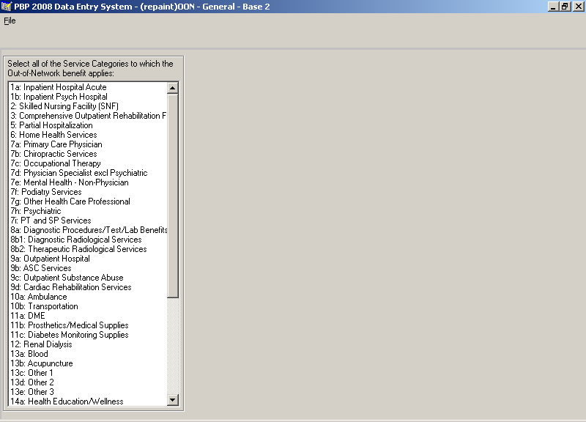

Section C – OON – General – Notes Screen
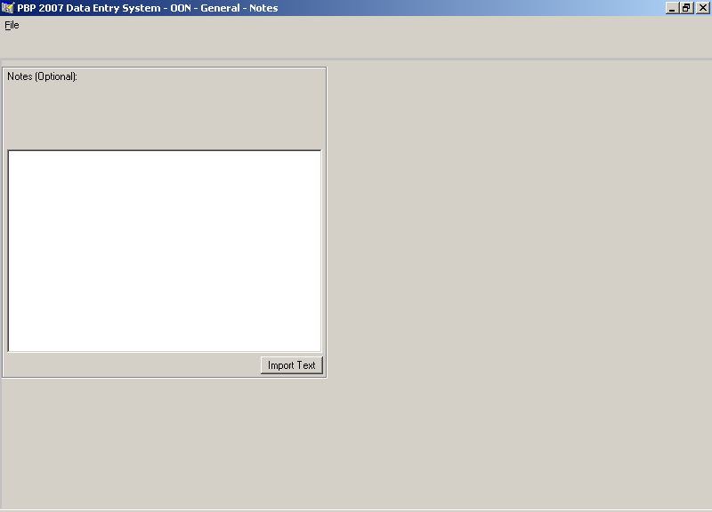

Section C – OON – Inpatient – Base 1 Screen
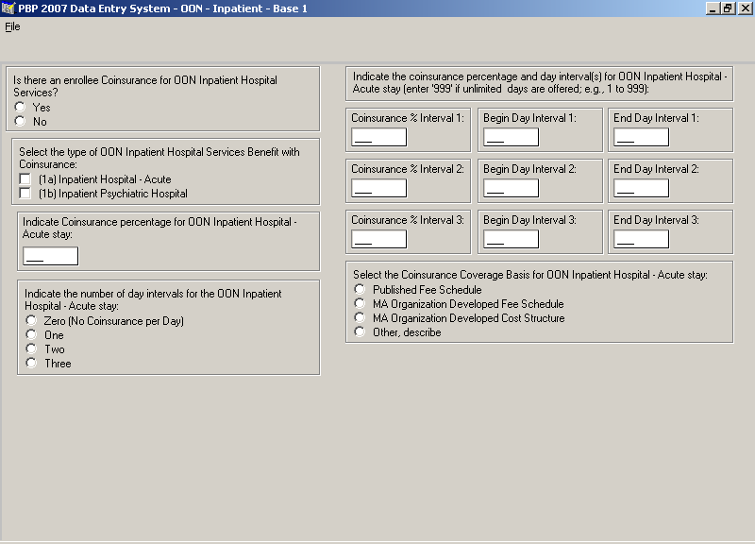

Section C – OON – Inpatient – Base 2 Screen
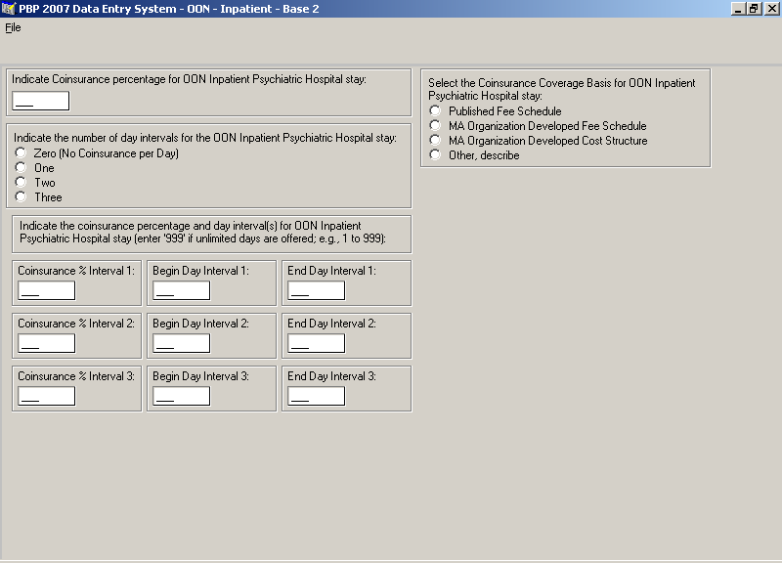

Section C – OON – Inpatient – Base 3 Screen
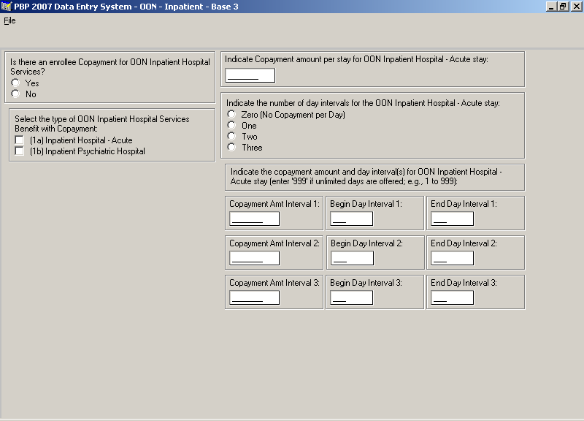

Section C – OON – Inpatient – Base 4 Screen
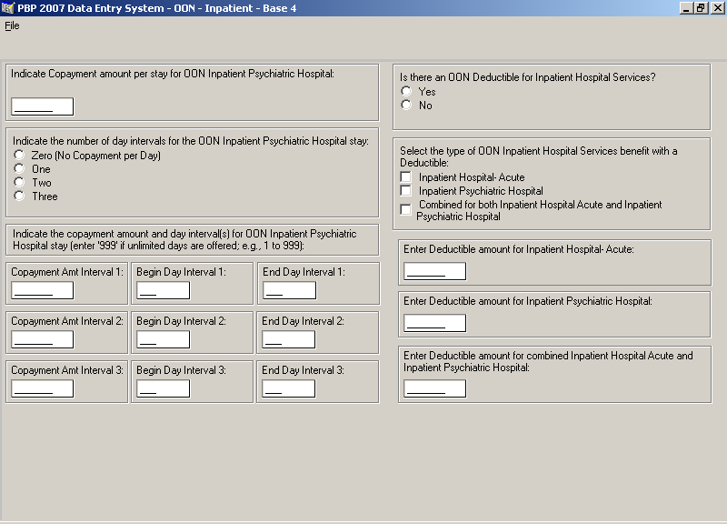

Section C – OON – Groups – Group Screen
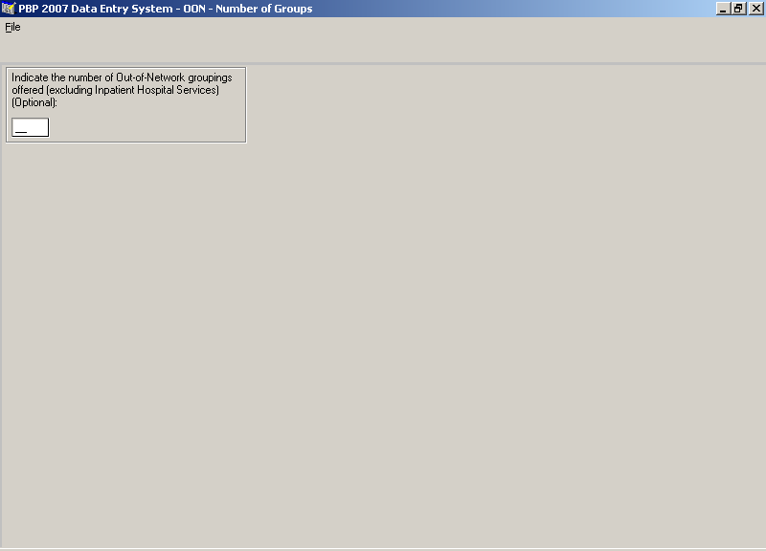

Section C – OON – Groups – Base 1 Screen
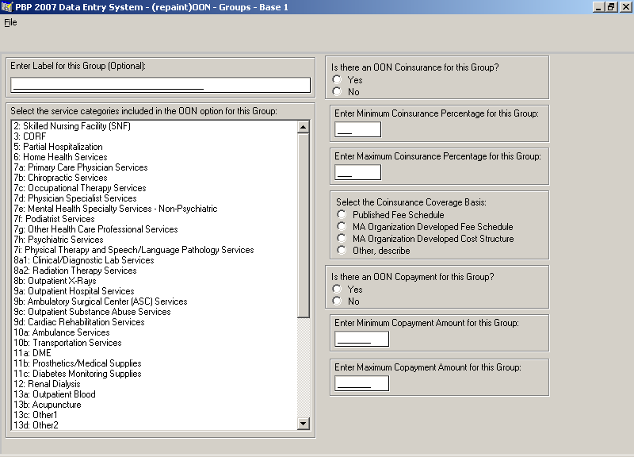

Section C – OON – Groups – Base 2 Screen
