Medicare Prescription Drugs Section – Actuarially Equivalent – Deductible and Pre-ICL Screen
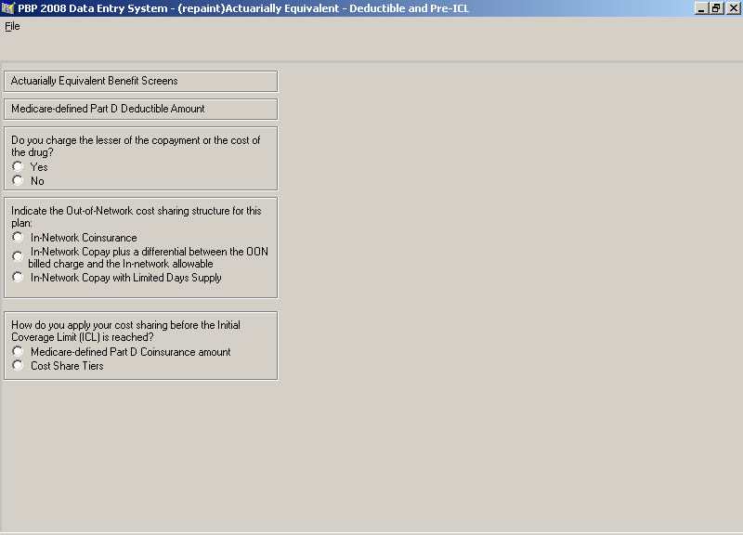

Medicare Prescription Drugs Section – Actuarially Equivalent – Pre-ICL Tier Label Screen
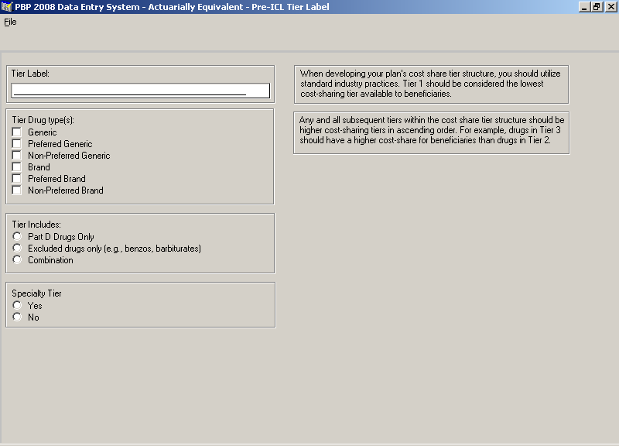

Medicare Prescription Drugs Section – Actuarially Equivalent – Pre-ICL Tier Location Screen
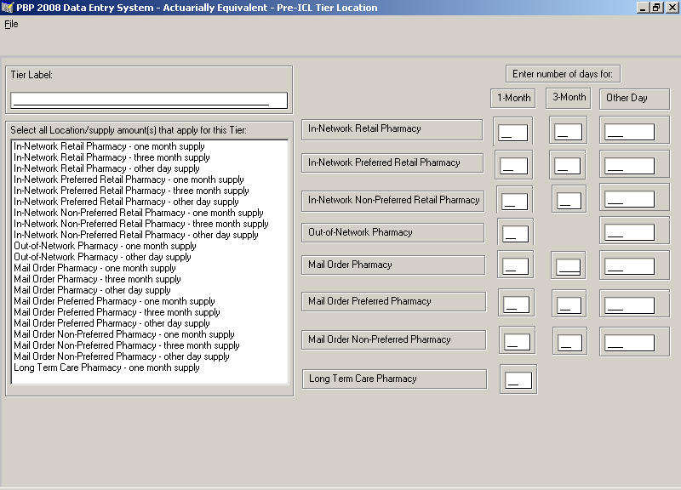

Medicare Prescription Drugs Section – Actuarially Equivalent – Pre-ICL Tier Cost Share Screen
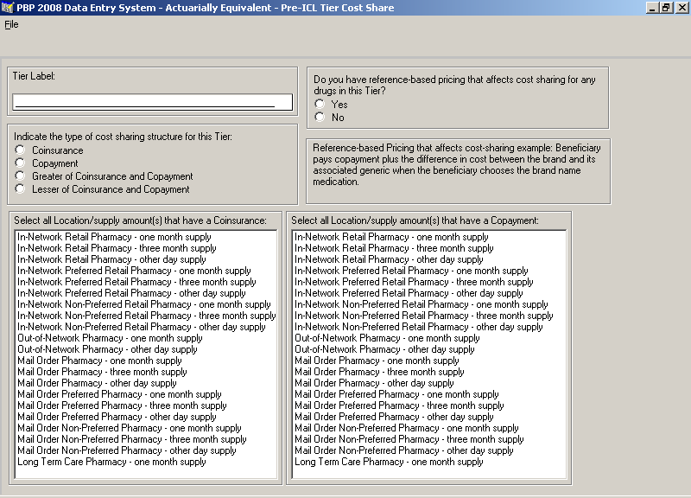

Medicare Prescription Drugs Section – Actuarially Equivalent – Pre-ICL Tier Coinsurance Screen
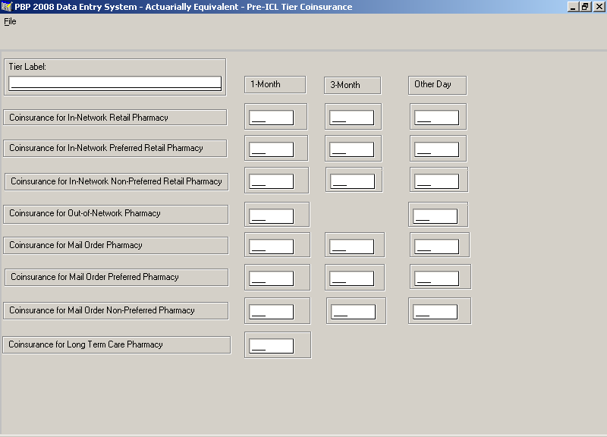

Medicare Prescription Drugs Section – Actuarially Equivalent – Pre-ICL Tier Copayment Screen
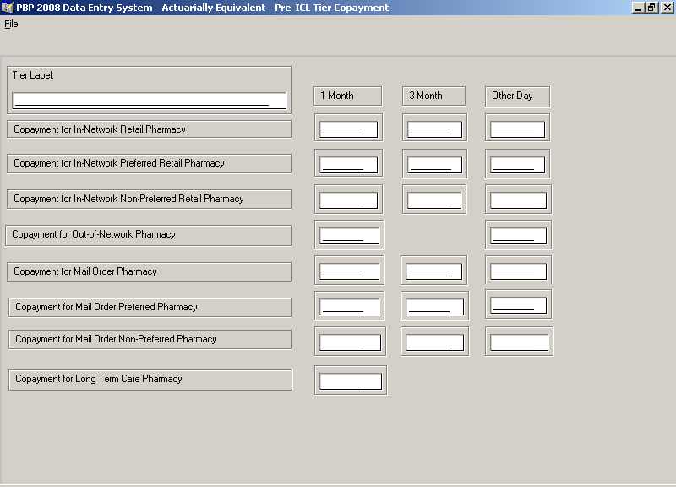

Medicare Prescription Drugs Section – Actuarially Equivalent – OOP Threshold Screen
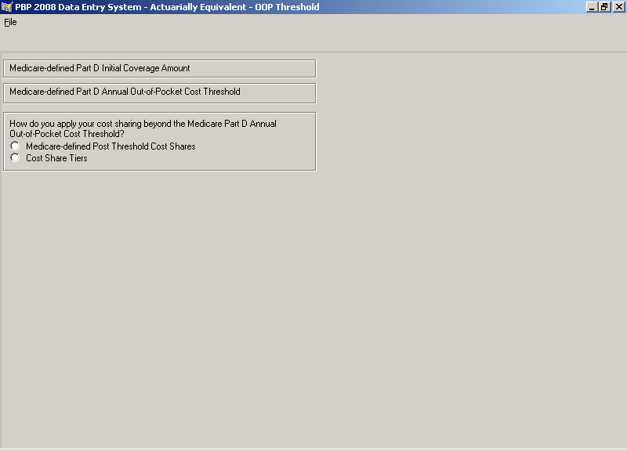

Medicare Prescription Drugs Section – Actuarially Equivalent – Post-OOP Threshold Tier Screen
