Section B – 9a – Outpatient Hospital – Base 1 Screen
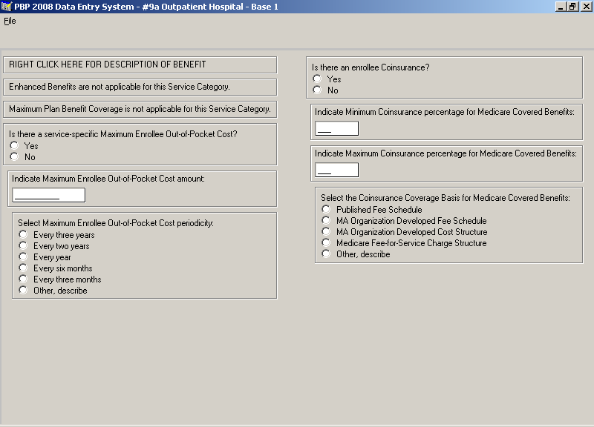

Section B – 9a – Outpatient Hospital – Base 2 Screen
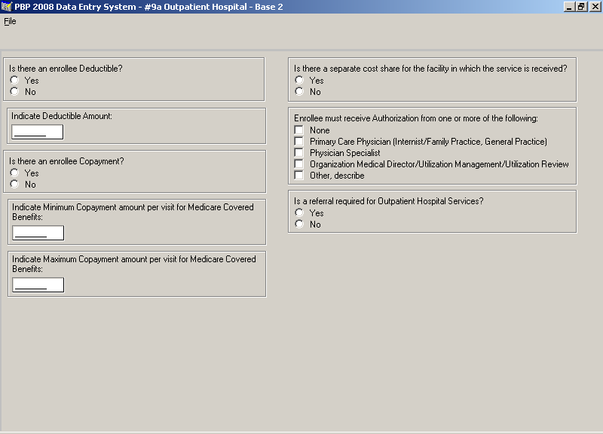

Section B – 9a – Outpatient Hospital – Base 3 Screen
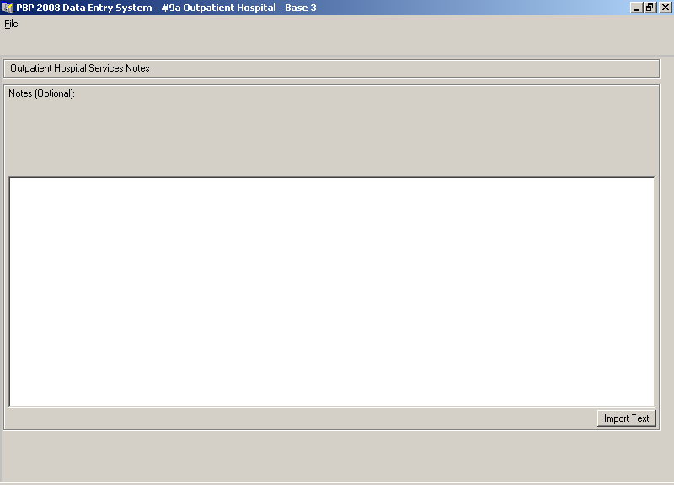

Section B – 9b – Ambulatory Surgical Center Services – Base 1 Screen
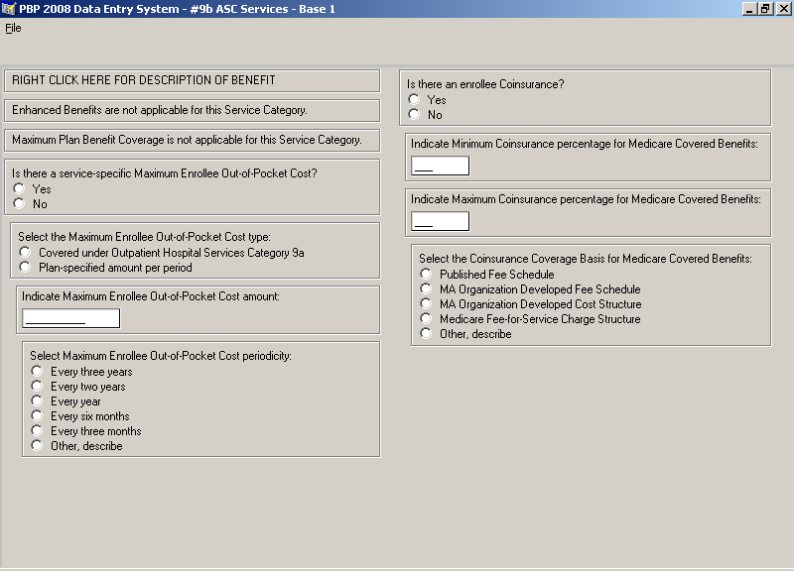

Section B – 9b – Ambulatory Surgical Center Services – Base 2 Screen
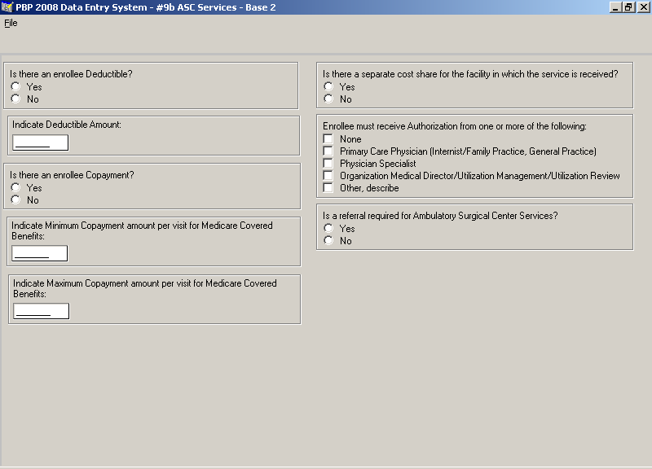

Section B – 9b – Ambulatory Surgical Center Services – Base 3 Screen
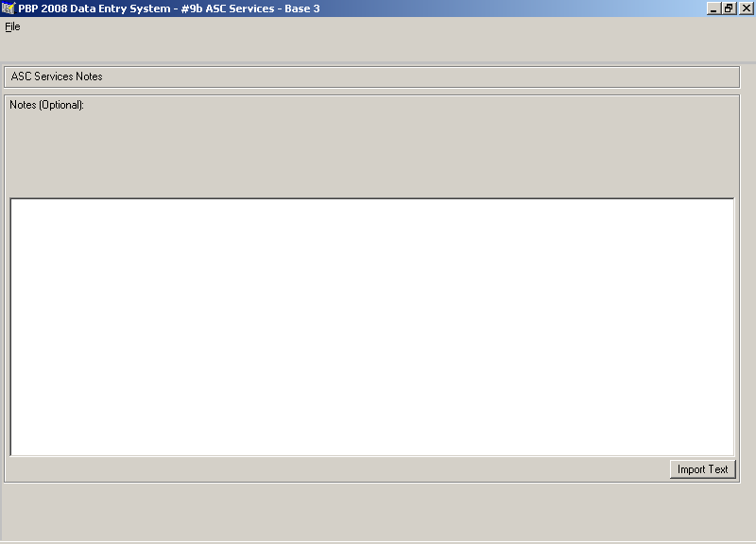

Section B – 9c – Outpatient Substance Abuse Services – Base 1 Screen
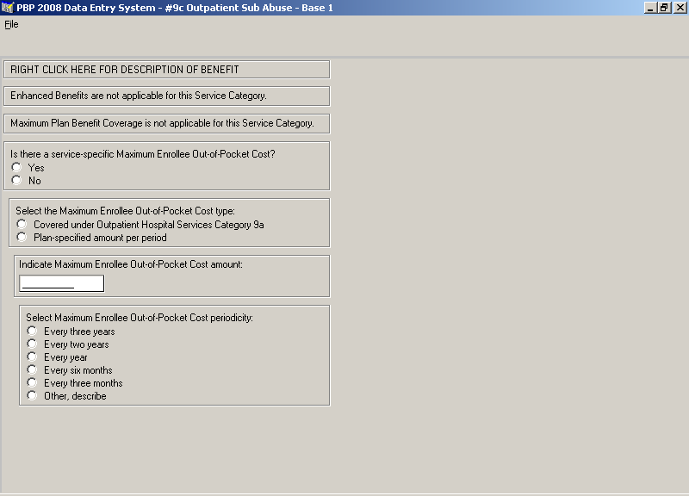

Section B – 9c – Outpatient Substance Abuse Services – Base 2 Screen
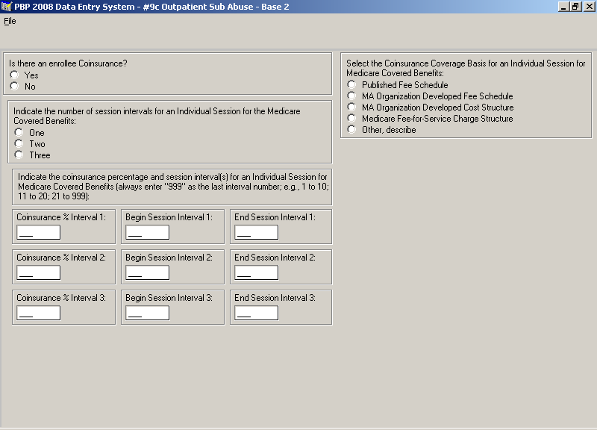

Section B – 9c – Outpatient Substance Abuse Services – Base 3 Screen
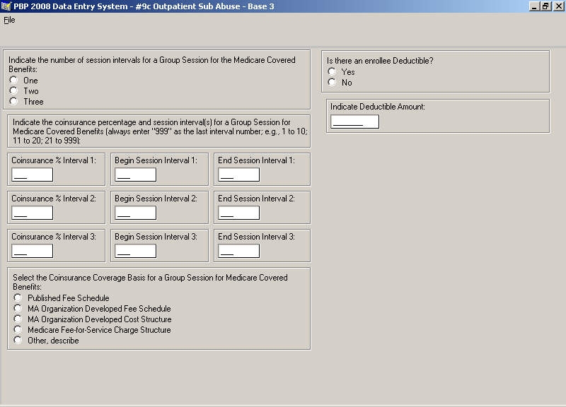

Section B – 9c – Outpatient Substance Abuse Services – Base 4 Screen
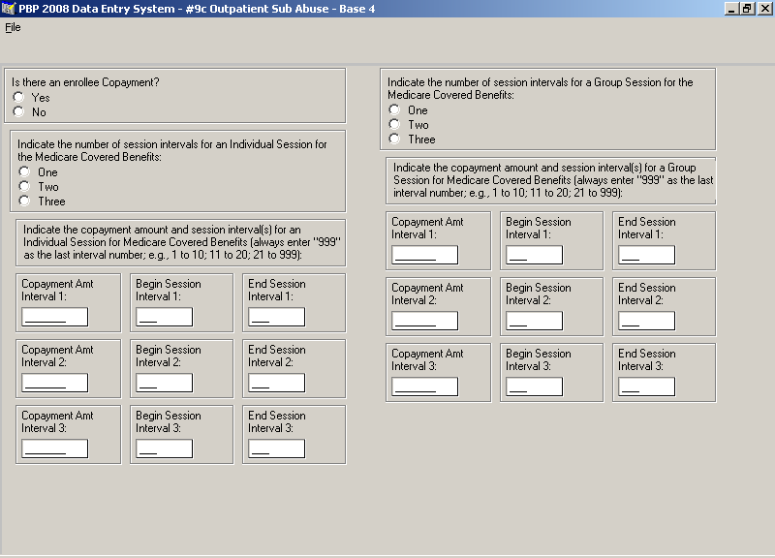

Section B – 9c – Outpatient Substance Abuse Services – Base 5 Screen
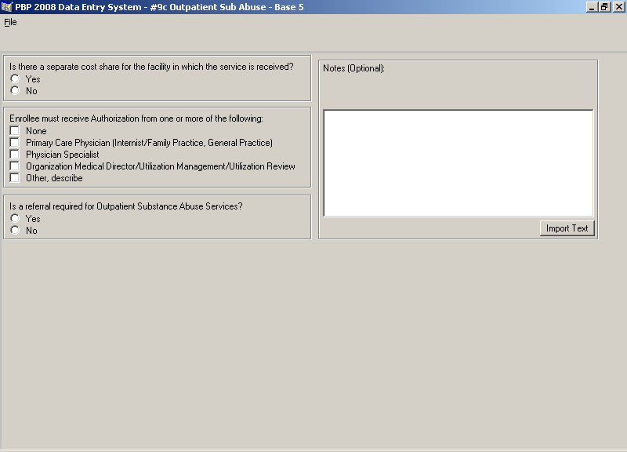

Section B – 9d – Cardiac Rehab Services – Base 1 Screen
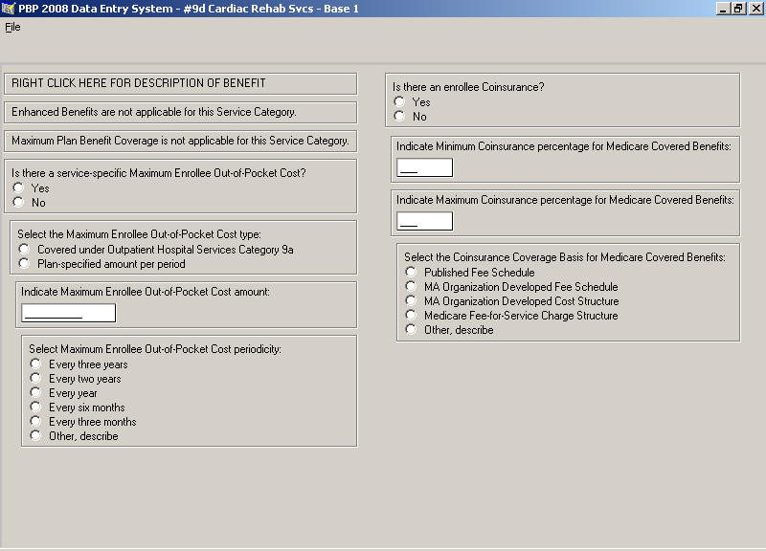

Section B – 9d – Cardiac Rehab Services – Base 2 Screen
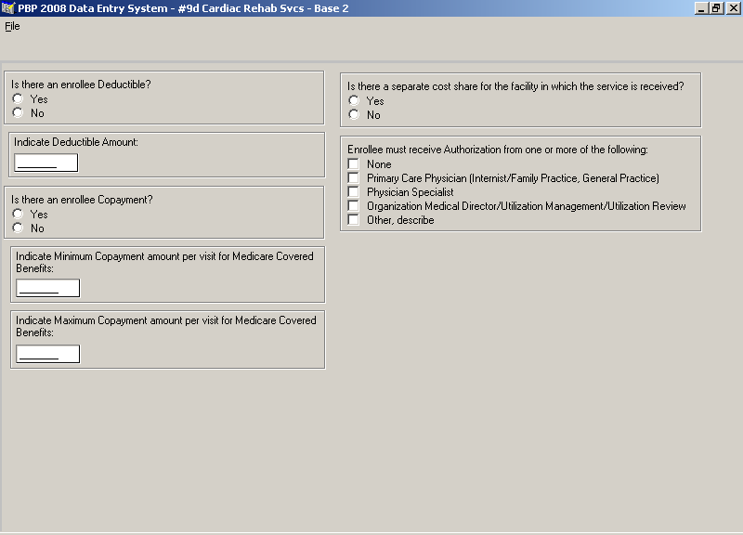

Section B – 9d – Cardiac Rehab Services – Base 3 Screen
