Attachment 4 — Respondent Introduction Letter and Frequently Asked Questions about the NLSY79

«DATE»

«FNAME» «LNAME»
«ADDR1» «APT»
«ADDR2»«CITY», «STATE» «ZIP»

Dear «FNAME»,

We need your help!

The National Opinion Research Center (NORC) at the University of Chicago will be calling on you in the next few weeks to recruit participants for the National Longitudinal Survey of Youth. The NLSY79, sponsored by the Bureau of Labor Statistics in the U.S. Department of Labor, is one of the preeminent studies in the country. For nearly three decades, the NLSY79 has served as an important tool for economists, sociologists, and other researchers.

The NLSY79 surveys Americans born between 1957 and 1964 about topics such as employment, education, health, and social policy issues. A professional interviewer from NORC will be contacting you soon to administer a 10-15 minute screener interview to see if you qualify to be part of the study. The study itself, which takes about an hour, will begin in October and is re-administered every two years.

If you qualify for the study, you will have the opportunity to represent hundreds of people in your age group by providing just one hour of your time every two years. Those selected for the study are also provided an honorarium as appreciation for the time given.

We hope you will consider becoming a participant in this important study. If you should have any questions in the meantime, please feel free to contact the study hotline toll-free at XXX-XXX-XXXX.

We look forward to talking with you soon! And again, thank you!

Sincerely,
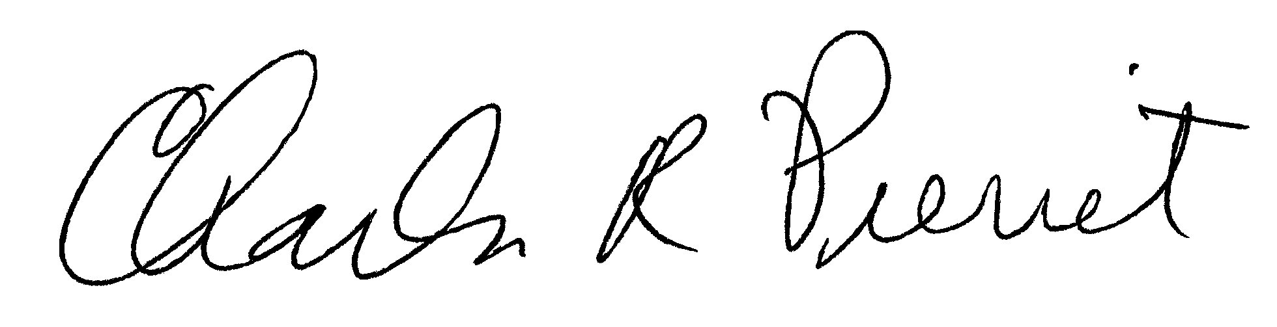
Dr. Charles R. Pierret
Program Director
National Longitudinal Surveys

Frequently Asked Questions

- What is the National Longitudinal Survey of Youth (NLSY79)?
The National Longitudinal Survey of Youth 1979 is a survey of people across the nation born between 1957 and 1964. The study gathers information Americans as they make the transition from school to work and to independent households. The information collected in this survey will be used by the Bureau of Labor Statistics (BLS) and other researchers to understand the labor market experience of individuals over time.

- Who conducts the survey?

The Ohio State University’s Center for Human Resource Research (CHRR) and The National Organization for Research (NORC) at the University of Chicago conduct the survey for the U.S. Bureau of Labor Statistics, which is part of the U.S. Department of Labor.

- I’ve been hearing things about privacy and identity theft in the media lately. Will my answers be made public or will my information be given to anyone else?
The information you provide in the survey is protected by the Privacy Act of 1974 and the Confidential Information Protection and Statistical Efficiency Act (CIPSEA) of 2002. All the staff members who work on this survey at NORC and CHRR are required to sign an affidavit stating that they will not disclose the identities of survey respondents to anyone who does not work on the survey and is therefore not legally authorized to have such information. The answers that you and other survey participants provide will be made available to researchers at the Bureau of Labor Statistics and other government agencies, universities, and private research organizations, but only after all personal identifiers—such as names, addresses, Social Security Numbers, and places of work—have been removed. In addition, the administrators of the survey also remove from the publicly available data file any information on the state, county, and metropolitan area in which you live. Some researchers are granted special access to data files that include geographic information, but only after they undergo a special application process at the Bureau of Labor Statistics and sign a written agreement stating that they will protect the confidentiality of survey respondents. In no case will these researchers be provided with information on your personal identity.
Because it is so important that you participate in the survey, the three prestigious organizations that administer the survey make every effort to protect your confidentiality. These organizations continuously monitor their security procedures and improve them when necessary. Anyone who violates your confidentiality is subject to criminal and civil penalties. The organizations that administer the survey have never had an instance in which a survey participant’s identity was illegally disclosed.
Survey data also will be made available to the National Archives and Records Administration or the General Services Administration, which are responsible for storing the Nation’s historical documents. The information provided to these agencies will not include your personal identity.

- What kind of information do you get from this survey / what is the information used for?
The information from the survey enables us to determine the factors that influence a person's decision to enter or leave the labor force, or to re-enter it after a period away from work. It also helps us to determine the effectiveness of various job training programs, the ways in which education, social attitudes, and family background affect individual opportunities for employment and advancement, and many other aspects of a person's experience in the labor market. The survey is uniquely designed to examine the challenges today's adults face as they experience economic transitions, more generally, from adolescence to adulthood and on into older adulthood.

- For how many years am I going to be asked to participate in this survey?

Because the survey is longitudinal (interviewing the same respondents over an extended time period) we would like to continue to contact you every other year for the next few years. Government funding continues to be extended for this study since the information gained is so vital. Knowing how people make decisions and adapt to changes in their personal and professional lives over time is very important for researchers who use the data. As additional funding is secured, the survey will continue.

- Will I be paid for my participation?
You will not be paid for the initial interview to determine if you qualify for the study. If you qualify, you will receive a payment if you participate in the interview this October to thank you for your important contribution to the survey. You also will receive payments each time you participate in the survey when it is conducted every two years in the future. The payment will be mailed to you within 2 to 3 weeks after your interview. Because the study is funded by the government, we try to offer the highest possible amount without burdening other taxpayers who fund the study.

