Attachment 6 — Respondent Thank You Letter

«DATE»

«FNAME» «LNAME»
«ADDR1» «APT»
«ADDR2»«CITY», «STATE» «ZIP»

Dear «FNAME»,

Thank you for agreeing to participate in the National Longitudinal Survey of Youth 1979. We at the Bureau of Labor Statistics, the Ohio State University Center for Human Resource Research, and NORC at the University of Chicago are proud to work with you.

For almost 30 years, the NLSY79 has provided vital information about the lives of people from all walks of life. Few surveys can match the NLSY79 in helping us understand who we are and where our country is headed. You and the other respondents are the main reason the NLSY79 has been so successful and influential. We look forward to talking to you about the things going on in your life and welcoming you to the NLSY79 family.

In the meantime, if you have any questions about the study, please call our toll-free number at XXX-XXX-XXXX or e-mail us at EMAIL. You can learn more about BLS, CHRR, and NORC through our web sites at:

http://www.bls.gov/nls
http://www.chrr.ohio-state.edu
http://www.norc.org

Thank you again for your help.

Sincerely yours,
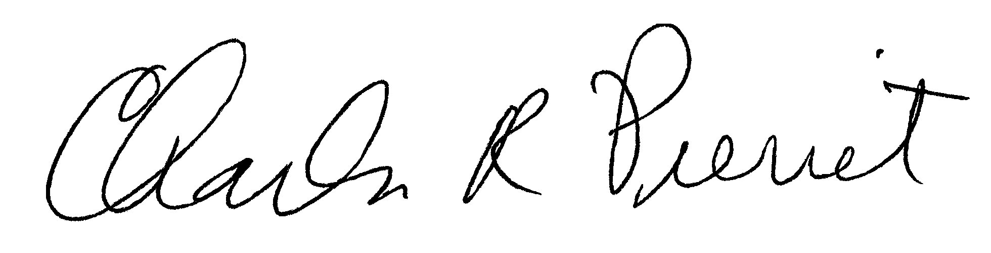
Dr. Charles R. Pierret
Program Director
National Longitudinal Surveys
U.S. Bureau of Labor Statistics

