Appendix O

Notification Letter to Coordinator
for Follow-Up Interview

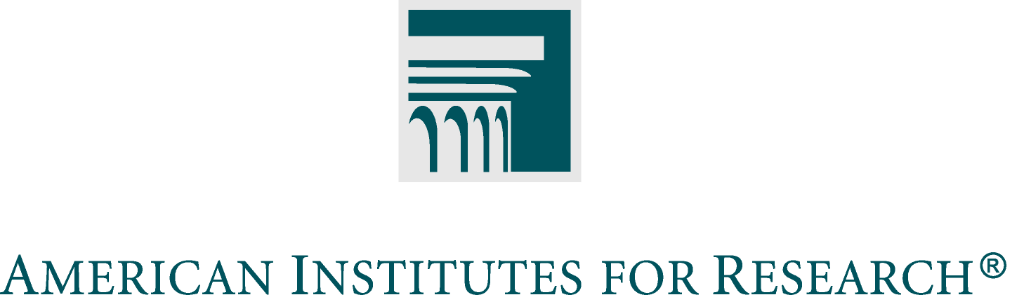

Date

[Name of local MSAP Project Director]
[Title]
[District Name]
[District Address
[District City, State, zip code]

Dear [Name]

I work for The American Institutes for Research, a not-for-profit research organization based in Washington, DC and Palo Alto, California. As you may know, your district has been assisting us and our partners at Berkeley Policy Associates with an evaluation of conversion magnet schools that receive support from the federal government’s Magnet Schools Assistance Program (MSAP). The Office of Innovation and Improvement, which manages the MSAP, has a mandate to evaluate its program, and is very interested in understanding the relationship between implementation of its funded magnet programs and improvements in student achievement. OII has asked the Institute of Education Sciences to conduct this important evaluation. We are now in the final year of this Conversion Magnet Schools Evaluation, which focuses on elementary schools that used MSAP grants to introduce new magnet programs during the 2004 or 2007 grant periods.

At the beginning of the study in 2007, we interviewed [name(s)] in your district office about your district’s choice program and elementary magnet schools. Because important changes may have occurred over the past three years, we are now conducting short follow-up interviews with the MSAP project directors or other staff who are familiar with the magnet program. The purposes of the interview are to:
- verify some information about the schools in this study,
- identify major changes that may have occurred in the district’s school choice program or in the recruitment, application, and admissions practices for your federally funded elementary school magnet programs
- learn whether there are plans to continue the programs in these schools.

The interview will take no more than 20 minutes to complete. We will send the interview questions in advance, including the information we would like you to verify for us.

The answers you give us are confidential, and responses to the study’s data collections will be used only for statistical purposes. The reports prepared for this study will summarize findings across the sample and will not associate responses with a specific district, school, or individual. We will not provide information that identifies respondents, students, or districts to anyone outside the study team, except as required by law.

While your participation is voluntary, we hope that you will be willing to assist the Department of Education with this important evaluation. I or one of my colleagues will contact you by phone within the next few days to schedule an interview. In the meantime, if you have questions, please feel free to contact me at the phone number or email address below

Sincerely,

Marian Eaton
Senior Research Scientist
American Institutes for Research
(650) 843-8171
meaton@air.org

