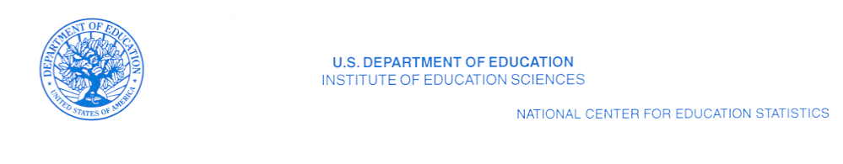
July 19, 2008

(Header Information)

Dear :

The National Center for Education Statistics (NCES) within the Department of Education requests your assistance in improving the coverage and quality of our private school listings and statistics. Every two years, the NCES conducts the Private School Survey (PSS). The PSS data allow the NCES to report on enrollment trends; counts of private schools, students, teachers, and high school graduates; program emphasis; and types of private schools. The PSS also serves as a list of private schools for additional NCES studies. In order to conduct the 2009-2010 PSS, we must compile a complete and accurate list of all private schools in the United States. Please help us to identify all private or non-public schools in your state.

What we request from you:

- A computer file (preferably a spreadsheet) of all private and non-public schools in your state that provide instruction for at least one grade between kindergarten and grade twelve.

- If a computer list is not available, a paper list is acceptable.

Definition of eligible school:

- Please include all private, non-public, or religious exempt schools with any of the grades kindergarten through grade twelve.
  - Kindergarten is defined as: An educational program for children (primarily 5-year-olds) who would normally enter first grade in the following year, even if “kindergarten” is not in the name of the program.

  - Include programs such as transitional or developmental kindergarten if children are expected to enter the first grade upon completing the program.

- Please exclude all programs that:

- Teach only adult education or postsecondary students;
- Are designed only for 3- or 4-year-old children and do not include kindergarten (e.g., Head Start programs, pre-kindergarten, or nursery schools);
- Provide only before- or after-school care for children who attend school in another facility;
- Provide only child care and do not include kindergarten.
The file or list should include the following information for each program:

- school name,
- mailing address,
- telephone number,

- grade range,
- enrollment, and
- number of teachers.

In addition to the information above that we have requested from you in the past, please also provide:
- school location address and
- school contact email address.

Please supply the date the list was last updated.
Sending the list:

- The U.S. Census Bureau collects the private school lists for us. You may send your list to the Census Bureau by email or regular mail. Please send your list by August 21, 2008.

To transmit your file via email, please send a message to the following address:
dsmd.private.school.lists@census.gov

Note that email attachments have a suggested size limit of 2MB (two megabytes). If you have difficulty sending your attachment because it is too large, please call 1.800.579.8520 to make alternative arrangements.

To send your list on diskette or paper, please mail the file to the following address:

U.S. Census Bureau
ATTN: Lowell Allen
Bldg. 66, Room 313
1201 E. 10th St.
Jeffersonville, IN 47132

For additional information on the PSS and other surveys that NCES conducts, please visit our website http://nces.ed.gov. If you have any questions about our list updating, please contact Mr. Allen toll free at 1.800.579.8520.

Thank you in advance for your assistance in improving the accuracy of our private school data collection.

Sincerely yours,
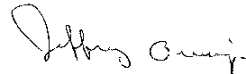

Jeffrey Owings
Associate Commissioner for
Elementary/Secondary and Library Studies

