Proposed Tasks for Think-Aloud Study

1. What is the population of the US?

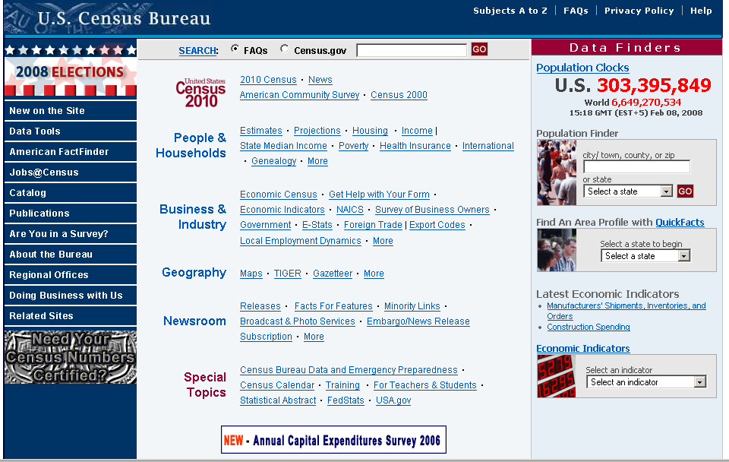
Figure 1. Screen shot of the Census Bureau home page, current population circled.

2. What is the population of Florida?

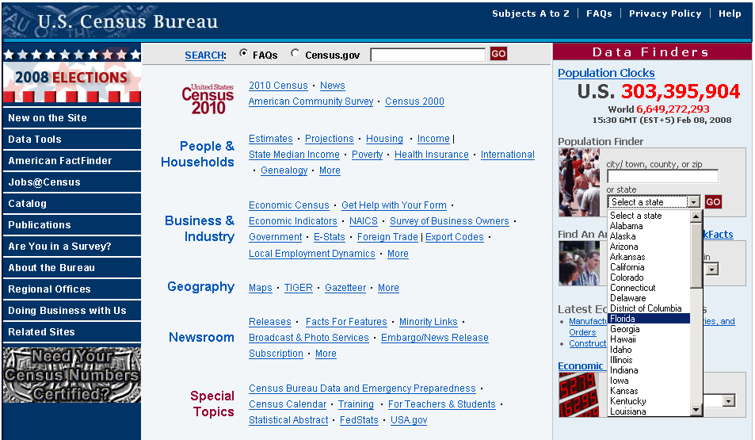
Figure 2. Screen shot of the Census Bureau home page with the Population Finder tool open, highlighting Florida.

3. What is the average household income of Americans?

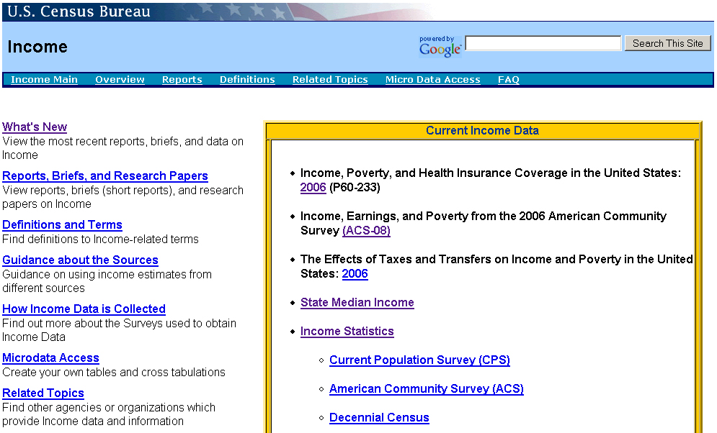
Figure 3. Screen shot of the Income main page, one link in off of the Census.gov home page.

4. What percent of the elementary and secondary public school funding comes from the federal government?

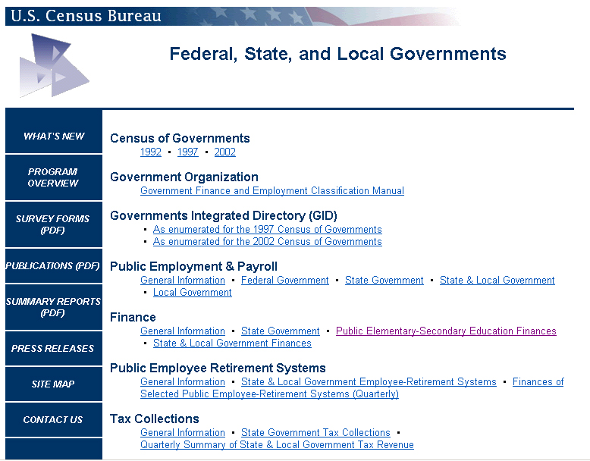
Figure 4. Screen shot of the Federal States and Local Governments page, one link in off of the Census.gov home page.

5. How many minority-owned businesses are in Virginia?

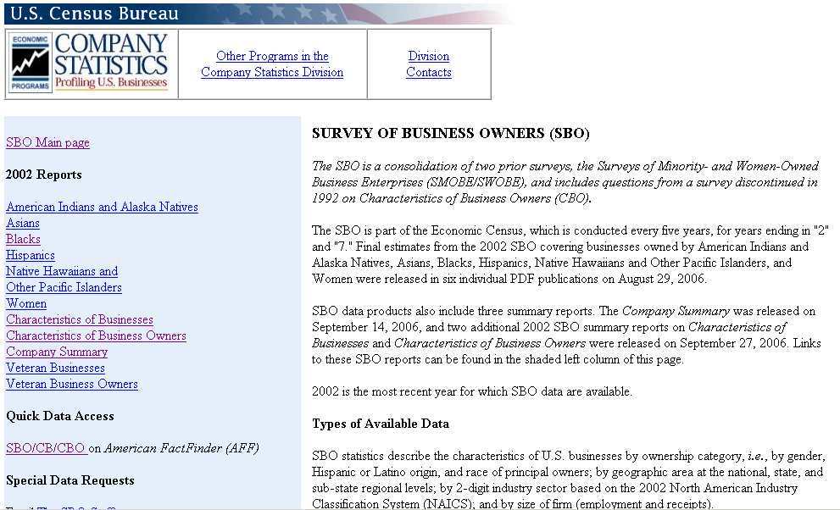
Figure 5. Screen shot of the Survey of Business Owners page, one link in off of the Census.gov home page.

6. What is the expected population for Maryland in 2025?

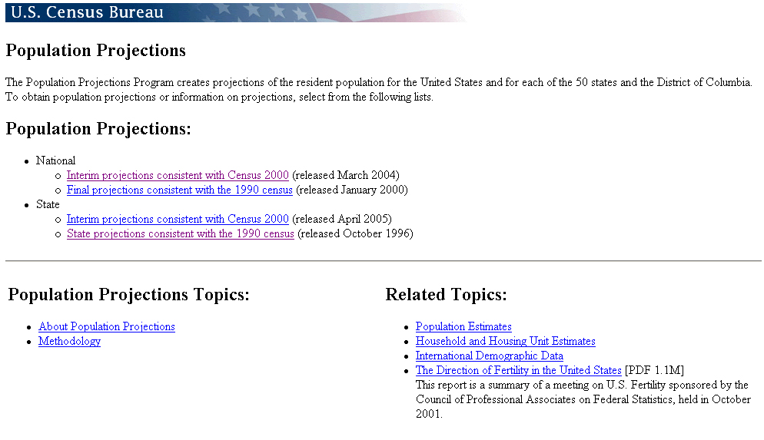
Figure 6. Screen shot of the Population Projections page, one link in off of the Census.gov home page.

7. What percent of the population has health insurance?

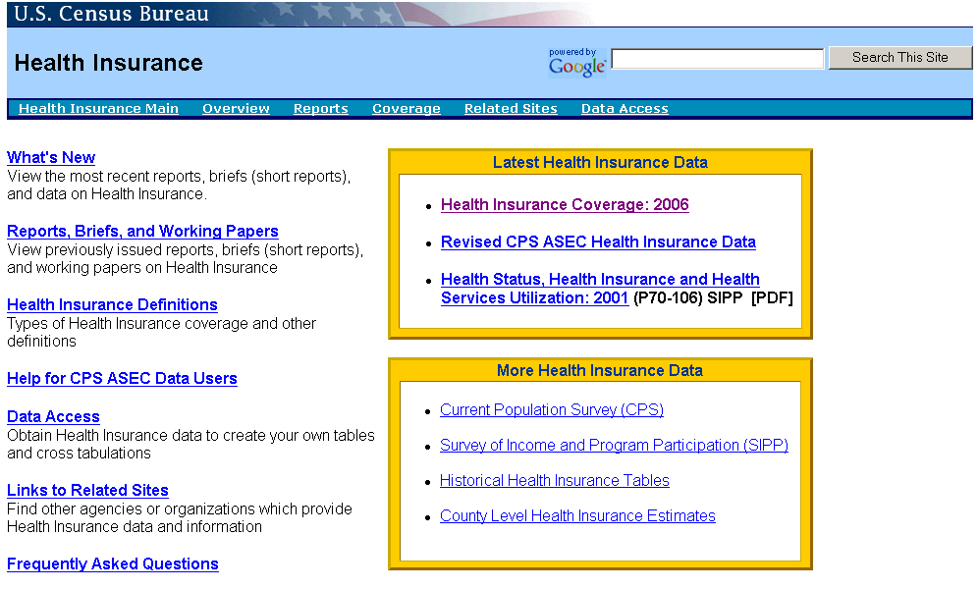
Figure 7. Screen shot of the Health Insurance page, one link in off of Census.gov home page.

8. What’s the unemployment rate for the US?

Note: these are not the finalized task sets, these tasks will likely be tweaked before official testing begins.

