Supporting Statement for Paperwork Reduction Act of 1995 – Submission to OMB

NEBRASKA

RURAL AREA ELIGIBILITY DETERMINATION PILOT

(NeRAED)

Contract #: AG-3198-C-06-0013

May 1, 2007

Submitted By:

John A. Kirlin, Ph.D.

Contracting Officer’s Representative

USDA, Food and Nutrition Service

Office of Analysis, Nutrition and Evaluation

Table of Contents

Introduction…………………………………………………………………………………..........1

A. Justification…………………………………………………………………………………….1

B. Collections of Information Employing Statistical Methods…………………………………..Error! Bookmark not defined.6

Supplementary Documentation…………………………………………………………………..21

Appendix 1: 60-Day Notice……………………………………………………………………..22

Appendix 2: NeRAED Matrix: Research Questions……………………………………………27

Appendix 3: Provider Survey…………………………………………………………………...33

Appendix 4: Dropout Survey…………………………………………………………………...43

Introduction
The U.S. Department of Agriculture’s (USDA’s) Child and Adult Care Food Program (CACFP), established under the 1968 National School Lunch Act, is a Federal program that subsidizes meals and snacks in nonresidential day care centers and family day care homes (FDCHs) in order to provide healthy meals and snacks to both children and adults who are receiving day care. For the FDCH component of the program, each State contracts with “sponsors” who recruit FDCH providers into the program, provide program training, process claims for meal and snack reimbursements, and monitor provider compliance with program regulations.
The Personal Responsibility and Work Opportunities Reconciliation Act of 1996 (PRWORA) mandated a two-tiered reimbursement structure for the CACFP that was designed to offer greater benefits to low-income children. FDCHs that are operated by providers with incomes at or below 185 percent of the Federal poverty guidelines or that are located in low-income areas are designated as tier I, while those FDCHs that do not meet this income criterion are designated as tier II providers.
The Food and Nutrition Service (FNS), on behalf of the Secretary of Agriculture, is authorized by Public Law 108-265 (through Section 119 of the Child Nutrition and WIC Reauthorization Act of 2004) to establish a demonstration pilot of the CACFP in Nebraska rural areas only for each of the fiscal years 2006 and 2007, using a lower threshold of 40 percent (instead of 50 percent) for determining eligibility for tier I reimbursement in areas in which poor economic conditions exist.
Through a competitive procurement process, USDA selected McFarland & Associates to conduct an evaluation of the Nebraska Rural Area Eligibility Determination (NeRAED) Pilot Project to assess the impact of the change in eligibility criteria for FDCHs in rural Nebraska. Exceed Corporation is a subcontractor to McFarland for this study. The USDA will utilize the results of this evaluation to report the findings to Congress by March 31, 2008, as required by the authorizing legislation.

A. Justification
A1. Explain the circumstances that make the collection of information necessary. Identify any legal or administrative requirements that necessitate the collection. Attach a copy of the appropriate section of each statute and regulation mandating or authorizing the collection of information.
Public Law 108-265, through Section 119 of the Child Nutrition and WIC Reauthorization Act of 2004, established a demonstration pilot for the NeRAED Project for fiscal years 2006 and 2007. During this pilot, eligibility criteria for the CACFP are being determined using an expanded threshold of 40 percent, rather than 50 percent, of residents being below 185 percent of the poverty level. Elementary School data are being utilized for this determination.
Congress further required the Secretary of Agriculture to conduct a study to evaluate the effects of the pilot on the number of FDCHs and children benefiting from the project.
The evaluation results and reports will form the basis for a report that USDA/FNS will submit to the House Education and Workforce Committee and the Senate Agriculture, Nutrition, and Forestry Committee by March 31, 2008.
A2. Indicate how, by whom, and for what purpose the information is to be used. Except for a new collection, indicate the actual use the agency has made of the information received from the current collection.
This supporting statement is for a new collection of data. The information to be collected will be used in order to inform Congress as stated above. The law requires USDA/FNS to evaluate the impact of the change in CACFP eligibility criteria for FDCHs in rural Nebraska. The Act specifies that the evaluation shall assess the impact of the 40-percent threshold on:
  - the number of FDCHs offering meals through the CACFP in rural areas;
  - the number of FDCHs offering meals as a tier I entity that would otherwise be defined as tier II FDCHs under program regulations;
  - the geographic location of FDCHs;
  - a description of services provided to eligible children; and
  - other factors determined by the Secretary.
The survey questions have been designed to collect information that will address these issues. The evaluation is being conducted by McFarland & Associates and Exceed Corporation on behalf of the USDA/FNS.
A3. Describe whether, and to what extent, the collection of information involves use of automated, electronic, mechanical or other technological collection techniques or other forms of information technology, e.g., permitting electronic submission of responses, and the basis for the decision for adopting this means of collection. Also describe any considerations of using information technology to reduce burden.
Data collection requiring OMB approval includes two surveys. The first survey is of a sample of all FDCH providers in rural areas of Nebraska who are participating in the CACFP in early summer of 2007. The second survey is of a sample of providers who choose to quit the CACFP after the pilot ends on September 30, 2007.
The first survey will be a mixed-media online and hardcopy survey to facilitate respondents’ access to the questionnaire and to maximize their flexibility in completing the survey. Based on preliminary discussions with CACFP sponsors and a small group of providers, the contractor estimates that approximately half of the potential respondents for this survey – FDCH providers in rural Nebraska – utilize the Internet. For those who do not or who prefer not to use the Internet for this survey, the contractor will mail them the survey questionnaire, which can be mailed back to the contractor with a postage-prepaid envelope.
The text from the first page of the online draft of the Provider Survey is shown below, with several other screenshots shown on following pages.. The full draft of the questionnaire may be viewed at the following URL:
http://www.neraedsurvey.com/
Use passcode “100” to enter the site and review the questionnaire.

Introductory Page – Draft Online Provider Survey
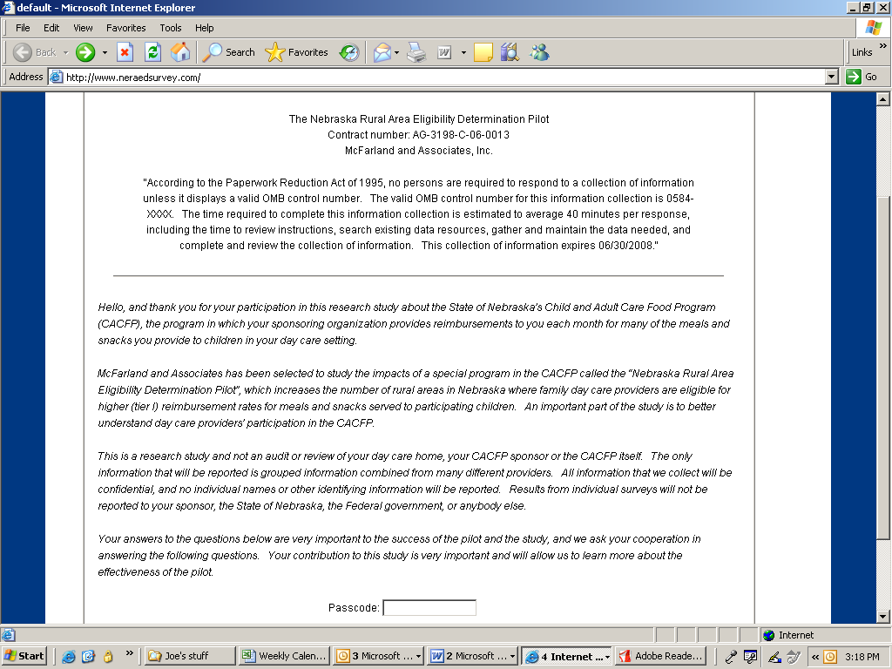

The second survey of FDCH providers who leave the program after the pilot ends will be much smaller (an anticipated sample size of 50 or fewer compared to a planned sample of 582 providers in the first survey), and it is not cost-effective to develop a Web-based survey for this second survey. Furthermore, because of extreme time constraints, the second survey will be conducted by telephone as soon as the contractor is able to identify exiting providers.
To the maximum extent possible, the contractor plans to collect information contained in both sponsor databases and the Nebraska Department of Education’s (NDE’s) CACFP administrative database through downloads and file sharing. This will reduce the amount of information that needs to be collected by the surveys.

Initial Questions – Draft Online Provider Survey
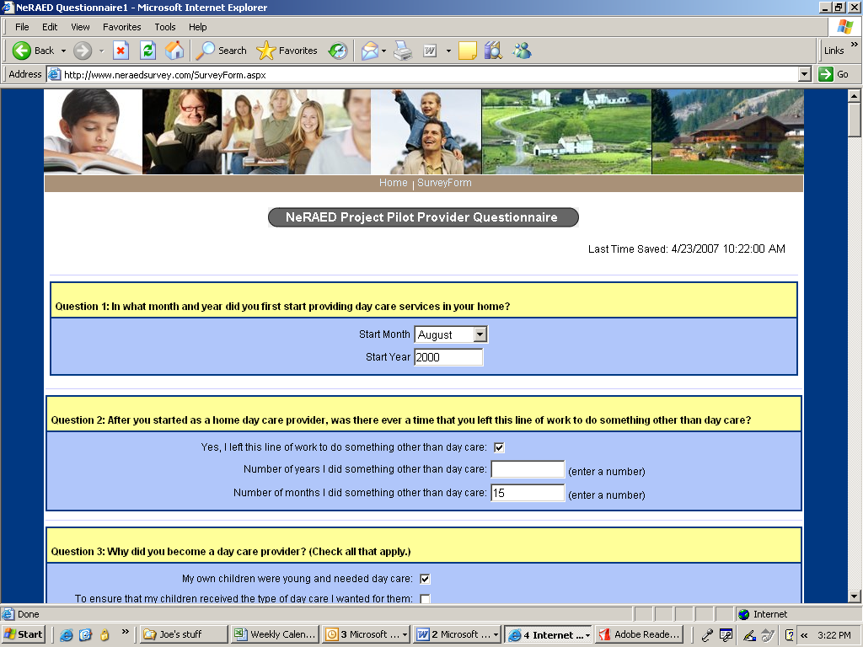

A4. Describe efforts to identify duplication. Show specifically why any similar information already available cannot be used or modified for use for the purposes described in item 2 above.
Although much of the information needed to evaluate the NeRAED Pilot is available through existing administrative data from the NDE and sponsor agencies, some data can be elicited only from participating providers.

Question 19 with Dropdown Menu – Draft Online Provider Survey
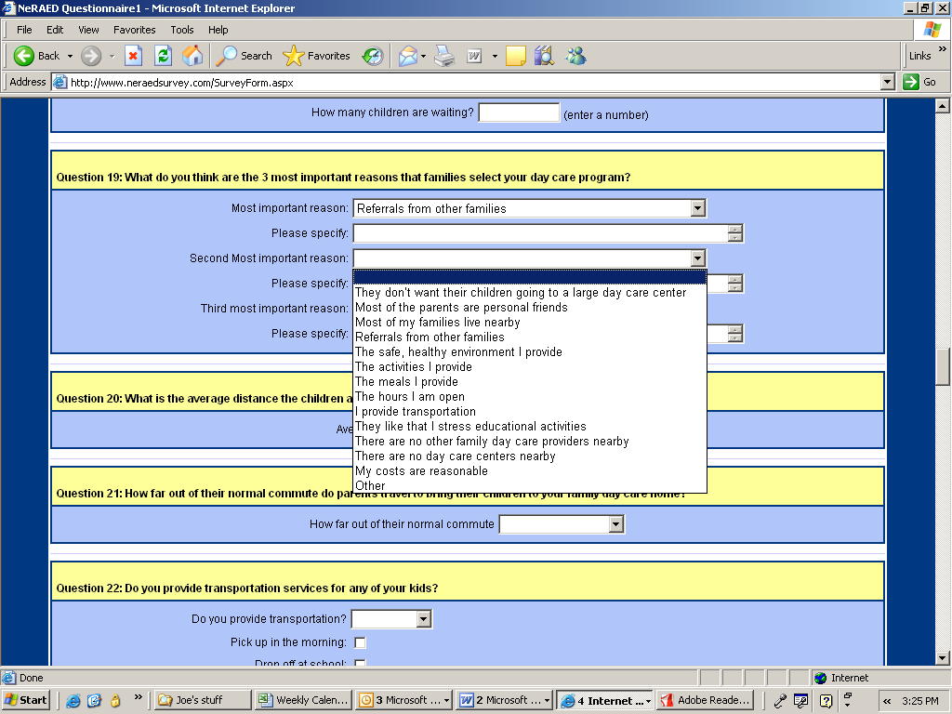

Because this pilot is new, this will be the first time that the data will be gathered from those directly participating in the management of FDCHs. It is their experiences and insights that must be captured in order to complete an assessment of the pilot. This information is not available elsewhere.
The contractor has evaluated existing administrative data and is not requesting respondent data currently available from administrative sources. In addition, administrative data will be used to minimize respondents’ burden by skipping questions. For example, if the administrative database shows that a provider was not active in 2005, then the online survey will skip over questions applicable only to 2005.
A5. If the collection of information impacts small businesses or other small entities (Item 5 of OMB Form 83-I), describe any methods used to minimize burden.
The planned collection of information does affect small businesses—family day care providers. The survey instruments, both online and hardcopy versions, have been designed and pretested to ensure clarity and ease of use. In the written pretests, the burden to respondents was found to be minimal. In the Internet version, the survey will be even less time consuming, as features such as automatic skip patterns will be utilized. The mail-out version of the survey will also be designed to allow respondents to move quickly to the appropriate sections.
A6. Describe the consequences of Federal program or policy activities if the collection is not conducted or is conducted less frequently, as well as any technical or legal obstacles in reducing burden.
If this collection is not conducted, one of the key research questions specified in the authorizing legislation for the pilot (i.e., a description of services provided to eligible children) cannot be addressed by the evaluation. Furthermore, information relevant to the reasons why providers participate in the CACFP and barriers to continued participation will not be collected. This latter information is crucial to better understanding how participation in the CACFP by rural FDCH providers can be expanded.
Because this collection is set to occur on a one-time-only basis, the question of collecting on a less-frequent basis is not relevant.
There are no technical obstacles in reducing the burden. As noted, the authorizing legislation for the pilot program specifies a research question that can be addressed only by collecting information from FDCH providers.
A7. Explain any special circumstances that would cause any information collection to be conducted in a manner:
- requiring respondents to report information to the agency more often than quarterly;
- requiring respondents to prepare a written response to a collection of information in fewer than 30 days after receipt of it;
- requiring respondents to submit more than an original and two copies of any documents;
- requiring respondents to retain records, other than health, medical, government contract, grant-in-aid, or tax records, for more than 3 years;
- in connection with a statistical survey, that is not designed to produce valid and reliable results that can be generalized to the universe of study;
- requiring the use of statistical data classification that has not been reviewed and approved by OMB;
- that includes a pledge of confidentiality that is not supported by authority established in statute or regulation, that is not supported by disclosure and data security policies that are consistent with the pledge, or which unnecessarily impedes sharing of data with other agencies for compatible confidential use; or
- requiring respondents to submit proprietary trade secrets, or other confidential information unless the agency can demonstrate that it has instituted procedures to protect the information’s confidentiality to the extent permitted by law.
Except as noted below, there are no special circumstances that would cause any information collection to be conducted in a manner that contradicts the bulleted specifications.
With regard to the second bullet, “requiring respondents to prepare a written response to a collection of information in fewer than 30 days after receipt of it,” the contractor will be requesting that respondents complete the survey in an expeditious fashion (hopefully in fewer than 30 days). Responses will typically include circling or checking the correct response and will involve only minimal writing.
The indirect request to complete the survey in fewer than 30 days is needed for several reasons. First, if the provider does not respond in a timely manner, he or she may forget about the survey request or lose track of the cover letter requesting his or her participation. Second, cover letters will be mailed to all sampled providers at the same time. If all the providers respond in a timely manner, all the collected data will reference the same time period. If some providers respond after 30 days, there is a chance that an intervening event could affect their responses and make these responses less comparable to those from the rest of the sample. Third, data collection costs increase as the length of the data collection period increases, and the contractor is operating under a fixed-price contract capped by the dollar amount authorized by Congress. As data collection costs increase, fewer resources will be available for analysis of the data and presentation of results. Finally, timely response is needed to adhere to the contract schedule and provide a final report to Congress by March 31, 2008.
A8. If applicable, provide a copy and identify the date and page number of publications in the Federal Register of the agency’s notice, required by 5 CFR 1320.8(d), soliciting comments on the information collection prior to submission to OMB. Summarize public comments received in response to that notice and describe actions taken by the agency in response to these comments. Specifically address comments received on cost and hour burden.
A copy of the agency’s notice in the Federal Register is attached as Appendix 1 to this supporting statement. The notice was published on February 27, 2007 and may be found at 72 FR 8684. No public comments were received.
Describe efforts to consult with persons outside the agency to obtain their views on the availability of data, frequency of collection, the clarity of instructions and recordkeeping, disclosure, or reporting format (if any), and on the data elements to be recorded, disclosed, or reported.
The contractor has visited, had telephone conversations with, and consulted with staff of the NDE and staff at six CACFP sponsor organizations located in the State. These discussions provided information about the content and availability of CACFP administrative data and the availability of information on FDCH providers in rural areas for purposes of identifying the sample population and obtaining contact information for cover letters and telephone followup. The contractor also pretested the primary survey instrument with five providers in Nebraska.
Consultation with representatives of those from whom information is to be obtained or those who must compile records should occur at least once every 3 years – even if the collection of information activity is the same as in prior periods. There may be circumstances that may preclude consultation in a specific situation. These circumstances should be explained.
The two surveys will be conducted in the period from July to November 2007, on a one-time-only basis.
A9. Explain any decision to provide any payment or gift to respondents, other than remuneration of contractors or grantees.
There will not be any payment or gifts to respondents of either survey.
A10. Describe any assurance of confidentiality provided to respondents and the basis for the assurance in statute, regulation, or agency policy.
Survey respondents will be informed in the introductions to the surveys that the answers they are providing are for a research study and are not in any way involved with an audit or review of their day care home, the CACFP sponsor, or the CACFP itself. The respondents will be assured that all information will be reported in aggregate form with others and that no individual names, addresses, telephone numbers or other individual identifying information will be reported. Assurance is given that results from individual respondents will not be reported to their sponsor, the State of Nebraska, the Federal government, or anybody else, except as may be required through a court order.
A11. Provide additional justification for any questions of a sensitive nature, such as sexual behavior and attitudes, religious beliefs, and other matters that are commonly considered private. This justification should include the reasons why the agency considers these questions necessary; the specific uses to be made of the information, the explanation to be given to persons from whom the information is requested, and any steps to be taken to obtain their consent.
Neither survey contains any questions of a sensitive nature.
A12. Provide estates of the hour burden of the collection of information. The statement should:
Indicate the number of respondents, frequency of response, annual hour burden, and an explanation of how the burden was estimated. Unless directed to do so, agencies should not conduct special surveys to obtain information on which to base hour burden estimates. Consultation with a sample (fewer than 10) of potential respondents is desirable. If the hour burden on respondents is expected to vary widely because of differences in activity, size, or complexity, show the range of estimated hour burden, and explain the reasons for the variance. Generally, estimates should not include burden hours for customary and usual business practices.
If this request for approval covers more than one form, provide separate hour burden estimates for each form and aggregate the hour burdens in Item 13 of OMB Form 83-I.
For the two surveys, the combined number of respondents is estimated as 632 and the estimated annual burden is 410 hours.
As shown in Table 1, the expected number of respondents is 582 for the Provider Survey and 50 for the Dropout Survey. Based on a pretest of the Provider Survey with five providers in Nebraska, the estimated average time to complete the survey is 40 minutes (0.67 hours) or 388 hours over the entire sample of 582 providers. The estimated average time to complete the Dropout Survey is 20 minutes (0.33 hours), or 17 hours over the entire sample of 50 providers.

Table 1 – Estimated Total Annual Burden on Respondents
Description | Number of respondents | Responses per respondent | Hours per response | Total
Provider Survey | 582 | 1 | 0.666 | 388
Provider Survey Non-responses | 251 | 1 | .02 | 5.02
Dropout Survey | 50 | 1 | 0.33 | 17
Total | 883 | 1 | 0.46 | 410

Provide estimates of annualized cost to respondents for the hour burdens for collections of information, identifying and using appropriate wage and rate categories. The cost of contracting out or paying outside parties for information collection activities should not be included here. Instead, this cost should be included in Item 13.
Given that FDCH providers responding to our survey are self-employed business owners, it is difficult to know their average salaries. Utilizing data from the Bureau of Labor Statistics’ May 2005 State Occupational Employment and Wage Estimates, however, the contractor estimates that the average wage for day care providers (utilizing wage estimates for Home Health Aides) is $10 per hour.
At 405 person/hours for completion of both surveys, the total labor cost would be approximately $4,050.00.
A13. Provide an estimate for the total annual cost burden to respondents or record keepers resulting from the collection of information. (Do not include the cost of any hour burden shown in Items 12 and 14.)
The estimated total annual cost burden to respondents is zero. There is no capital or startup cost component related to either survey, nor is there an operation, maintenance, or purchase of services component.

A14. Provide estimates of annualized costs to the Federal Government. Also, provide a description of the method used to estimate cost, which should include quantification of hours, operational expenses (such as equipment, overhead, printing, and support staff), and any other expense that would not have been incurred without this collection of information. Agencies may also aggregate cost estimates from Items, 12, 13, and 14 in a single table.
The total annualized cost to the Federal Government is $110,905.

Table 2 depicts estimated costs for the survey portion of the contractor’s contract with the USDA to conduct this study. These costs were estimated as part of the contractor’s business proposal and are reflective of expected staff labor and direct expenses (e.g., postage) needed for completion of the activities listed.

Table 2 – Survey Administration Costs

Activity | Cost
Preparation of Data Collection Instruments | $45,871
Preparation of OMB Clearance Package | $10,645
Training of Data Collectors | $54,389
Total | $110,905

A15. Explain the reasons for any program changes or adjustments reported in Items 13 or 14 of the OMB Form 83-I.
This new information collection is requesting approval of 410 hours as a result of a program change.
A16. For collections of information whose results will be published, outline plans for tabulation and publication. Address any complex analytical techniques that will be used. Provide the time schedule for the entire project, including beginning and end dates of the collection of information, completion of report, publication dates, and other actions.

Plans for Tabulation
The contractor’s plan for collection of information is designed to produce the necessary information for the various types of analyses outlined for evaluation of the pilot. These include the following:
- Qualitative analysis/Descriptive analysis
- Comparative and Geographic analysis
- Regression analysis
Qualitative/descriptive analysis is intended to help the contractor determine how the pilot was implemented and commonality in the perceived impact amongst sponsors and providers, as well as to provide the baseline for survey questions. Qualitative data collection has or will include: meetings with CACFP staff, sponsors, and providers in Nebraska, and the two surveys for which OMB clearance of data collection instruments is requested. As an example, Research Objective 1 asks for the processes of the implementation of the NeRAED Pilot. Many of the questions pertaining to Research Objective 1 were asked in the initial interviews with six sponsors. As a result of the interviews and site visits, the contractor was able to reduce the number of questions for the planned Provider Survey. Questions 31, 32, and 35 on the Provider Survey all directly correspond with Research Objective 1, while other questions were asked of the sponsor in the initial interview (see matrix- appendix 2).
Following the qualitative analyses, the contractor expects to have the following information: a logical chain of events as the pilot was implemented; identification of dominant themes; patterns and themes occurring among providers; divergences among providers; and identification of key decision makers, as well as an assessment of their relative importance/role in the implementation effort.
The Provider Survey will fill in many of the gaps left by the in-person visits. It will also provide some of the quantitative data required to perform the regression analyses, which will help the researchers assess the impact of the change in eligibility criteria on CACFP participation as opposed to changes due to other intervening factors.
Comparative analyses will be used to assess the impact of the pilot and to address many of the research objectives and questions. For example, questions 13, 14, 15, and 16 in the Provider Survey inquire as to the numbers and characteristics of children in the FDCH during predetermined data points. These questions are specifically designed to answer Research Objective 3 (see matrix- appendix 2).
Another function of the table is to examine the differences that exist among providers before-during-after the NeRAED Pilot. The table analysis will also demonstrate differences between 50-percent-eligible and 40-percent-eligible providers and the services they provide. Three types of summary and comparative analyses will be conducted: across time, across provider category, and across geography.
Across time: There are two types of comparisons across time that will be employed. First, a simple comparison between years before and during the pilot will allow us to see how the overall status of the CACFP has changed due to the expansion of eligibility. Second, a time series analysis across months will be developed.
Across provider category: This includes comparisons among categories of providers and will show differences across provider categories.
Across geography: This will be utilized to compare services, numbers, and characteristics of FDCHs in rural versus urban areas.
Geographic analysis and mapping
Three comparisons by geography that will be made are rural versus urban, population density, and poverty. For each of these three types of geographic characterizations, two types of data analysis will be conducted. First, tables will be produced showing comparisons. Second, data from the administrative database (provider location information), the 2000 Decennial Census (poverty levels), and the State’s data (poverty and roads) will serve as the basis for a series of maps created to:
- Provide visual representations and quantitative analysis of the CACFP provider sites in conjunction with pockets of poverty;
- Delineate geographic features such as the sponsor and provider locations, major streets, and transportation networks;
- Calculate the relative distance of the provider to the nearest urban center using Geographic Information Systems (GIS);
- Compare geographic locations and accessibility of providers under the 40-percent and 50-percent thresholds; and
- Assess the impact of the change in eligibility threshold on the geographic location of the providers, using GIS.
Most of the geographic analysis and mapping will rely on administrative and publicly available data; however, the contractor may use geographic designations to report survey responses by geographic areas.

Regression analysis
Two- and three-way comparisons can show basic changes occurring over time or differences across segments of the child care provider population, but they do not measure the impact of the legislative change, and they cannot separate changes or differences in the outcomes of the numbers of providers, children, and meals due to other intervening factors. Multivariate regression analysis will be used to separate out the contribution of external factors from the contribution of the pilot itself.
The multivariate model will help us to determine whether any change in either the number of FDCHs or the number of children is a function of the change in eligibility criteria or other factors, e.g., economic changes in the Nebraska economy over time, or the release of the exempt provider list by the Nebraska Department of Health and Human Services.
A number of variants to the analysis model will be tested, depending on data availability and hypotheses arising from the interviews and survey data collection. The contractor plans to estimate the parameters of four separate general models as follows:
$$H_{\text{ct}}=α+{βX}_{\text{ct}}+{γR}_{c}+{λM}_{t}+{μC}_{c}+ε_{\text{ct}}$$
$$K_{\text{ct}}=α+{βX}_{\text{ct}}+{γR}_{c}+{λM}_{t}+{μC}_{c}+ε_{\text{ct}}$$
$$H^{I_{\text{ct}}}=α+{βX}_{\text{ct}}+{γR}_{c}+{λM}_{t}+{μC}_{c}+ε_{\text{ct}}$$
$$K^{I_{\text{ct}}}=α+{βX}_{\text{ct}}+{γR}_{c}+{λM}_{t}+{μC}_{c}+ε_{\text{ct}}$$
where
Subscript c denotes a county
Subscript t denotes the month
Superscript I denotes tier I FDCHs or children that would have otherwise been designated tier II under the original regulations
H is the number of FDCHs
K is the number of children served
X is a vector of variables reflecting social, economic, and geographic conditions surrounding the provider (e.g., the unemployment rate at the county level, family income, and population density)
R denotes whether a county is rural. 1 for rural, 0 for urban
M is a vector of dummy variables indicating the month
C is a vector of dummy variables indicating the county
$λ$ captures aggregate time effects (e.g., factors facing all providers in any month)
$μ$ portrays unobserved fixed factors that are specific to the county
$ε$ is a random error term
These models are based on the assumption that the data contain multilevel information (e.g., providers are nested within the county). If that assumption is not confirmed, the analytical model will be adjusted.

Plans for Presentation
The timeline for this project began with the Orientation Meeting with the contractor at FNS headquarters on September 13, 2006. The project began on the 25th of September on the contractor’s first visit to Nebraska, where contractor staff met with NDE staff and sponsors to discuss the State’s implementation of the pilot and availability of program administrative data. A draft of the Provider Survey was pretested with five providers during December 19-22, 2006. The Provider Survey will be conducted as soon as OMB clearance is received. The Dropout Survey will be conducted in November 2007, the earliest date that the contractor can identify providers who leave the program after the end of the pilot.
The final report will be submitted to USDA on January 28, 2008, with a journal article due on June 28, 2008. The project schedule is depicted in Table 3.

Table 3 – Project Survey Schedule

Description of Activity | Date
Meetings with NDOE and CACFP Sponsors | 9/2006
Collection of Administrative Data | Began 9/25/2006 – Ongoing
Pretest of Provider Survey Instrument | 12/19 – 12/22/2006
Survey Data Collection | July – November 2007
Final Report | 1/28/2008
Journal Article | 6/28/2008

A17. If seeking approval to not display the expiration date for OMB approval of the information collection, explain the reasons that display would be inappropriate.
FNS is planning to display the expiration date on the information collection and is therefore not seeking an exception.
A18. Explain each exception to the certification statement identified in Item 119, Certification for Paperwork Reduction Act Submissions, of OMB Form 83-I.
There are no exceptions to Item 19 of Form 83-I.

While this general model is based on county-level data, an appropriate level of aggregation (county or Census tract) will be used.

