Why is this survey being done?

The mission of the National Institute for Occupational Safety and Health (NIOSH) is working to improve the safety and health of American workers. As part of this effort, NIOSH/Pittsburgh Research Laboratory (PRL) is collecting demographic and other data on the mining industry.

Since 1986, there has been little research on the demographics of the mining labor force, such as age, gender, job title, languages used, educational attainment, race, ethnicity, and years of mining experience. These data are needed to customize safety and health interventions for specific groups of the mining industry and to understand the risk of work-related injuries, disease and fatalities. These data can also be used to learn more about the underlying causes of these events and to identify ways to reduce their occurrence.

NIOSH/PRL is sponsoring this survey of mining operations and their employees to fill this data gap. Our main objectives are to:

- collect basic information about mining operations;

- establish the demographic and occupational characteristics of mine operator employees for each mining commodity (i.e., coal, metal, nonmetal, stone, and sand and gravel); and

- estimate the number of independent contractor employees used by mining operations and their occupational characteristics.

What will the mining industry and my mine get out of this survey?

The ultimate goal of the survey is to minimize and prevent work-related injuries and diseases that harm miners and reduce productivity. NIOSH will use the information you provide to customize safety and health interventions and calculate injury rates for various occupations. Once the survey is completed, NIOSH will send you a copy of the final report.

What data will be collected?

There are two sets of data being collected:

- The mine questions include items about the mining operation and its use of independent contractors.

- The employee questions include demographic and occupational questions about individual mine employees.

It is important that you complete both parts of the survey. You have the option of completing either the survey questionnaire booklet or an Internet survey questionnaire. Both versions ask the same questions. Instructions to access the Internet questionnaire are attached to the cover letter included in this mailing.

Am I required to participate?

Your participation is voluntary and you may refuse to answer any question for any reason. However, the participation of each selected mining operation is vital to the success of the survey.
Why was my mining operation chosen?

Your mining operation was randomly selected from a list of all mining operations nationwide. The sample must represent the diversity of mining operations across the Nation. The information you provide is essential to obtain an accurate picture of the mining industry.

Who will see my responses?

Your responses will be treated in a confidential manner. Only NIOSH researchers, and researchers from Westat, NIOSH’s data collection contractor, will see your responses. Both organizations are firmly committed to protecting the survey data in a confidential manner. The answers from all participating mines will be published only as summarized data so that no single company or individual employee can be identified.

Do I need to report data for all
employees of our mining operation?

If you have less than 30 employees at this mining operation, we ask you to report for all of them.

If you have 30 or more employees at this mine, we ask you to report data for only a sample of them.

In order to get good data about the mining industry, it is very important that you sample accurately. Our aim is to make the sampling of employees as simple as possible. Step by step instructions are provided in the survey booklet on how to select employees for this survey.
Should I include independent contractors in
the employee questions?

Contractor information should only be included when responding to the mine questions. Contractors should not be counted as employees when completing the employee questions. Only data for mine operator employees should be included on the employee questions.

If the mining operation is being run by your company under contract to the owner, report for your employees but exclude workers associated with other independent contractors.

Is it appropriate for me to release information about employees
who work here?

You will not be reporting the names or other identifying information of individual employees. The data you provide cannot be linked to any of your individual employees. The employee data will be treated in a confidential manner.

How long will the survey take?

Although this varies by mining operation, on average it will take 120 minutes to complete the survey. This includes obtaining information from personnel records, and should take less time for smaller mines.

For further information on the purpose of this survey, please contact:

Linda McWilliams
Project Director
NIOSH, Pittsburgh Research Laboratory
P.O. Box 18070, Bldg. 01
626 Cochrans Mill Road
Pittsburgh, PA 15236
(412) 386-6116
E-mail: LMcWilliams@cdc.gov

http://www.cdc.gov/niosh/mining/statistics/survey.htm

For further information on how to fill out the questionnaire, please contact:

Westat
Attn: National Mining Survey
1650 Research Boulevard
Rockville, MD 20850
(888) 814-4707

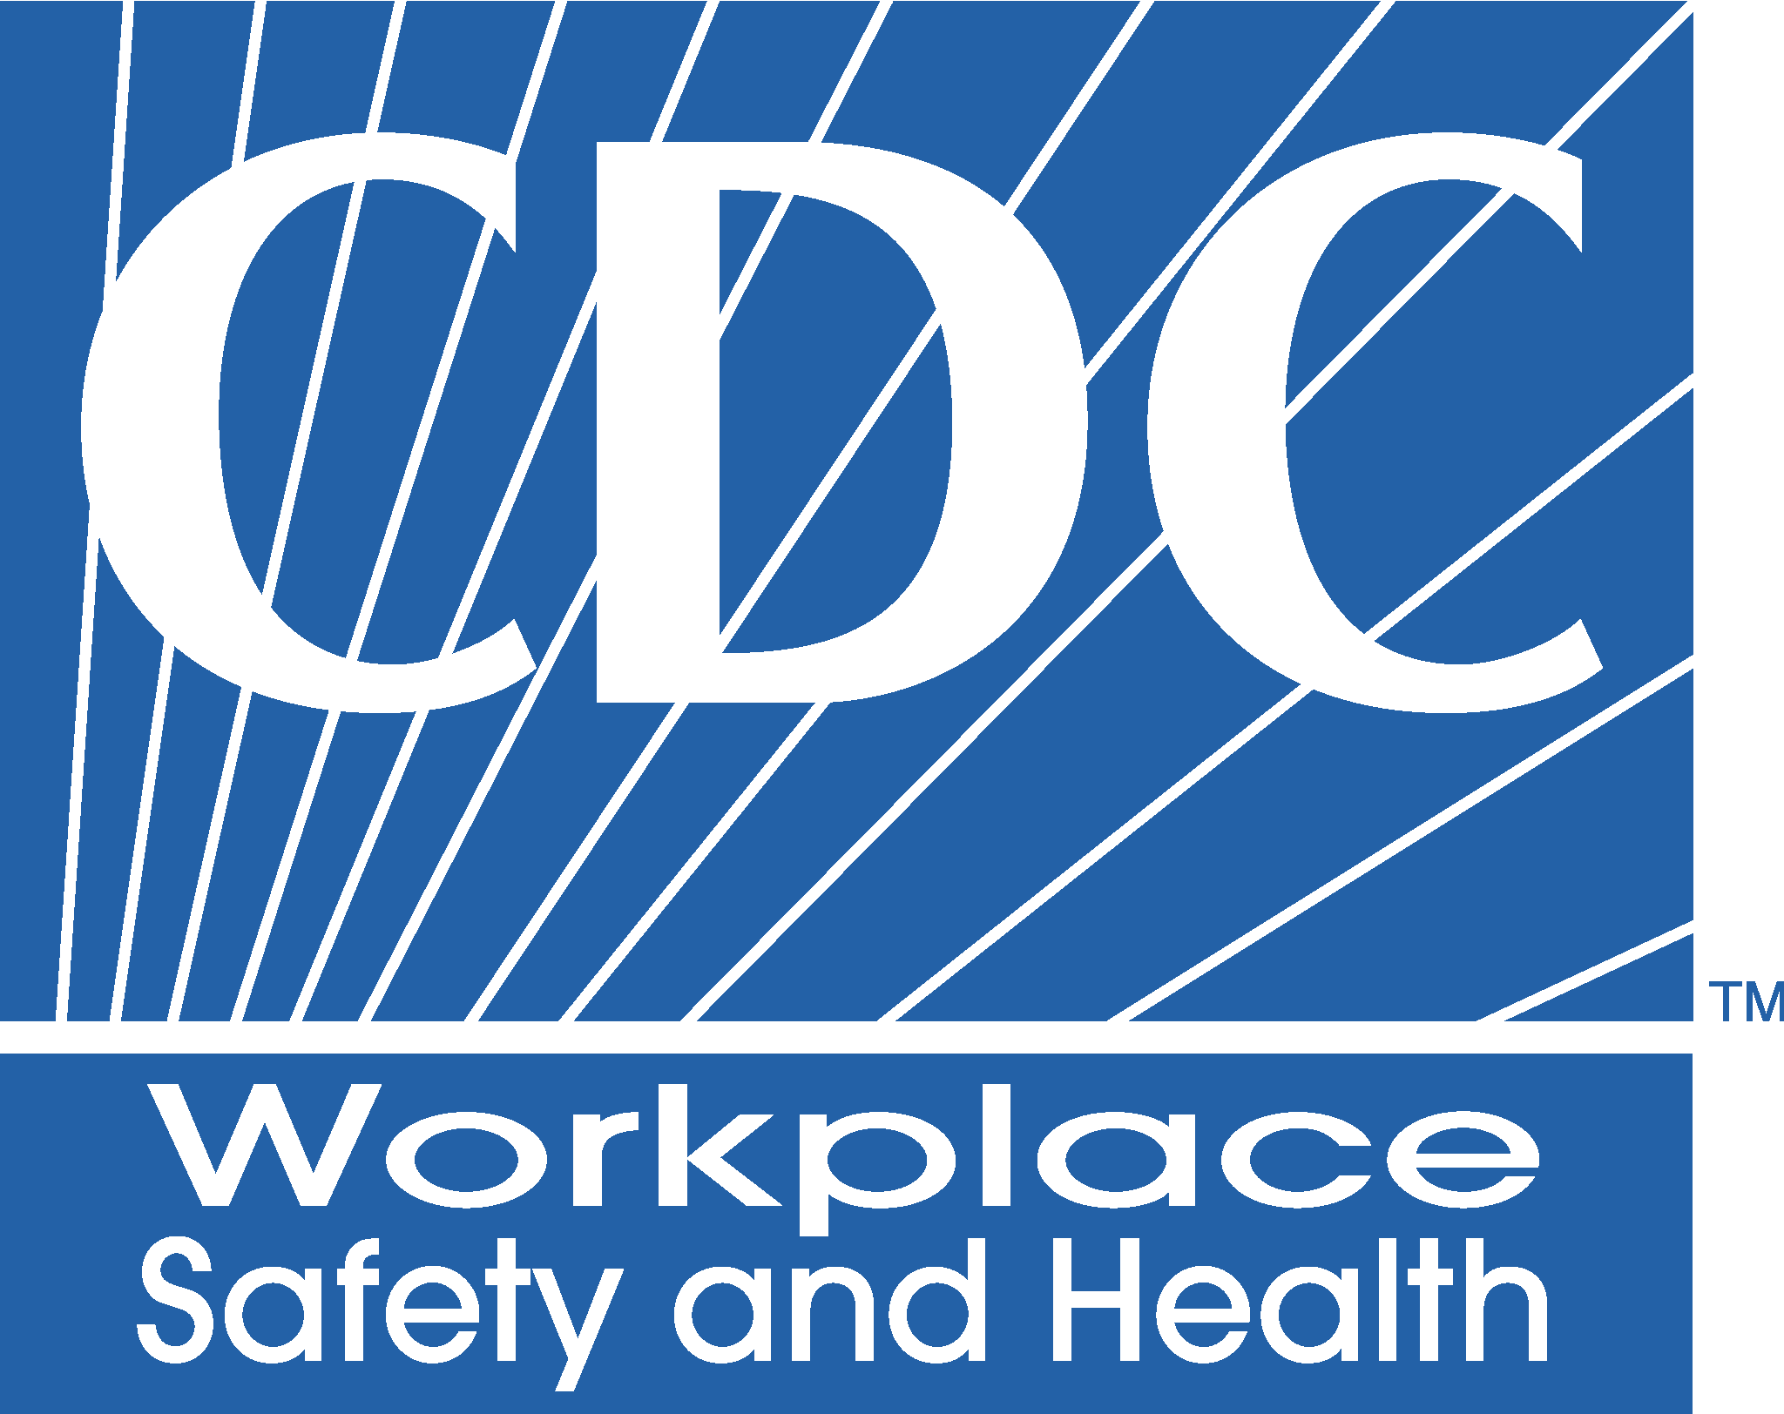

National Survey of the
Mining Population

Questions and Answers



Sponsored by the
National Institute for Occupational
Safety and Health (NIOSH)
Pittsburgh Research Laboratory
P.O. Box 18070
Pittsburgh, PA 15236

