U.S. Department of the Interior  Minerals Management Service | OMB Control Number 1010-0151
U.S. Department of the Interior  Minerals Management Service | OMB Approval Expires: July 31, 2008

ROV Survey Report

A. Instructions:
The Minerals Management Service is requesting that selected operators perform a limited ROV visual habitat survey before and after operations. This survey report form is to be used for recording basic information and observations made during two sets of excursions of an ROV from the drilling rig or platform to a minimum distance of 100 meters from the well site.

OCS Lease # |  | Area/Block # |  | MMS Control # |  | Date
ROV Operator |  |  |  | Location: Lat.___________ Long.____________
Facility Name |  |  |  | Water Depth

B. The ROV Survey Report consists of:
1). Recorded information on this ROV Survey Report Form.
2). Video tape (VHS) of bottom throughout deployment.
3). Any additional imagery that may help depict bottom conditions such as scanning sonar data.

This data set is to be sent to the address on the last page of this report form.

C. Two separate deployments are required.
1). Prior to any activities.
2). After all operations have been completed.

ROV Transect Information

The Figures below depict a suggested SURVEY PATTERN and a blank space for a sketch of the actual survey tracks that were used. Sketch in your best estimate of your actual surveys with bearings and distances.

Example Survey Pattern | Your Actual Survey Pattern
Bearing (degrees) and Distance (meters) |  | Bearing (degrees) and Distance (meters)

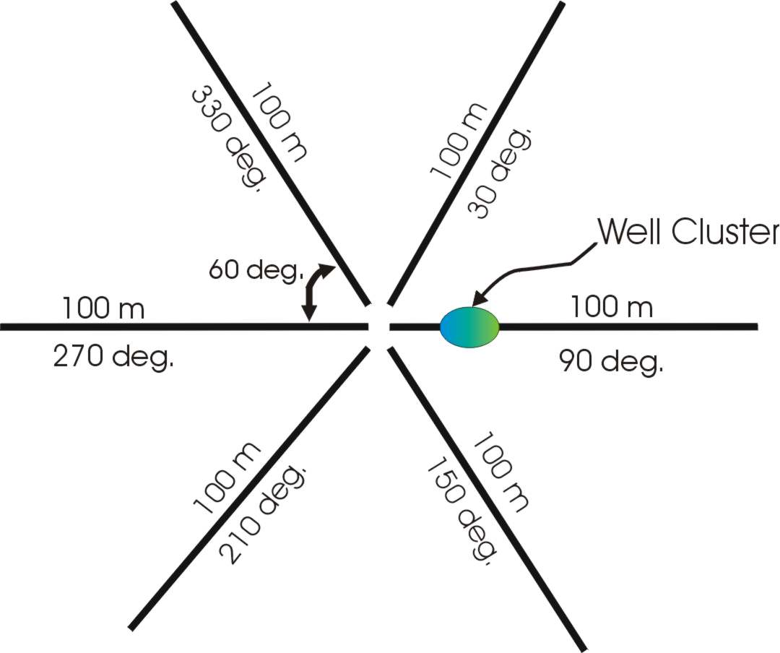

At least one transect should pass over or near the well or well cluster site (indicate location).

MMS Form MMS-141 (July 2005 - Supersedes all previous editions of form MMS-141 which may not be used) Page 1 of 5

ROV Survey Log Sheet
Tape Transcript

Instructions: Similar to standard ROV operations, log in all major events (examples: start transect, animals sighted, beginning and end of bottom features, currents, etc.). See page 3 for names of many common deep-sea animal groups. Of particular interest are any rocky or hard bottoms and attached animals.

Enter Elapsed Time from beginning of tape and description of EVENT or OBSERVATION
Time | Counter  # | Description
Example  O:55 | 135 | Z with 1 N and 3Q, tan sediment type S. OR this style;  Large 2 ft. rock with an eel-like fish and 3 small corals on rock, tan bottom mud, a few burrows
IMPORTANT: If any rock outcrops or hardbottom is seen and there are any living animals growing on it, record on this page. In-house ROV log sheets can be used, or copy this form as necessary.
MMS Form MMS-141 (July 2005 - Supersedes all previous editions of form MMS-141 which may not be used) Page 2 of 5

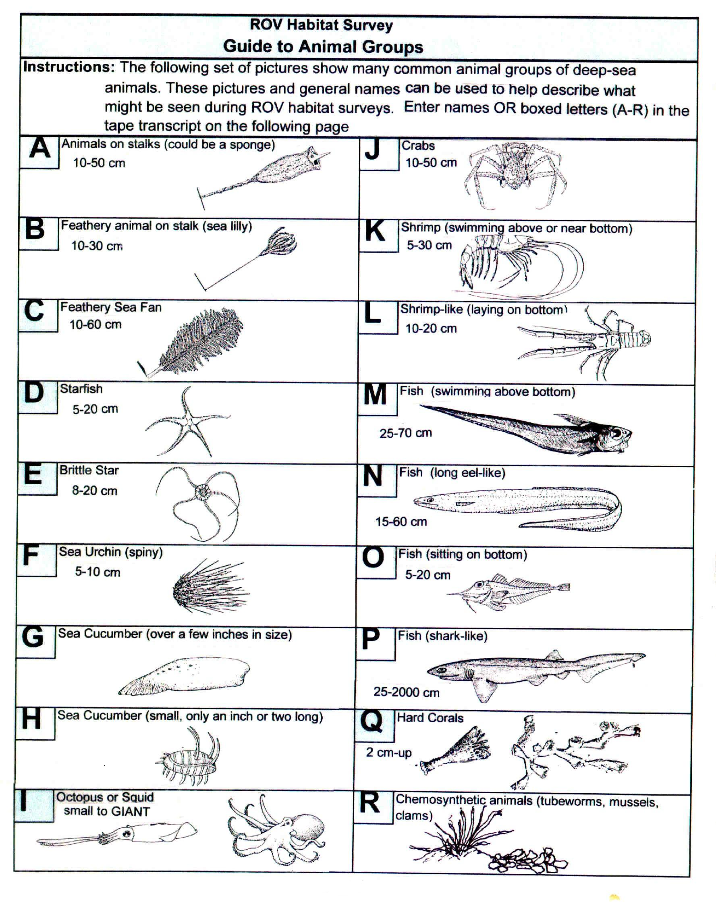
MMS Form MMS-141 (July 2005 - Supersedes all previous editions of form MMS-141 which may not be used) Page 3 of 5
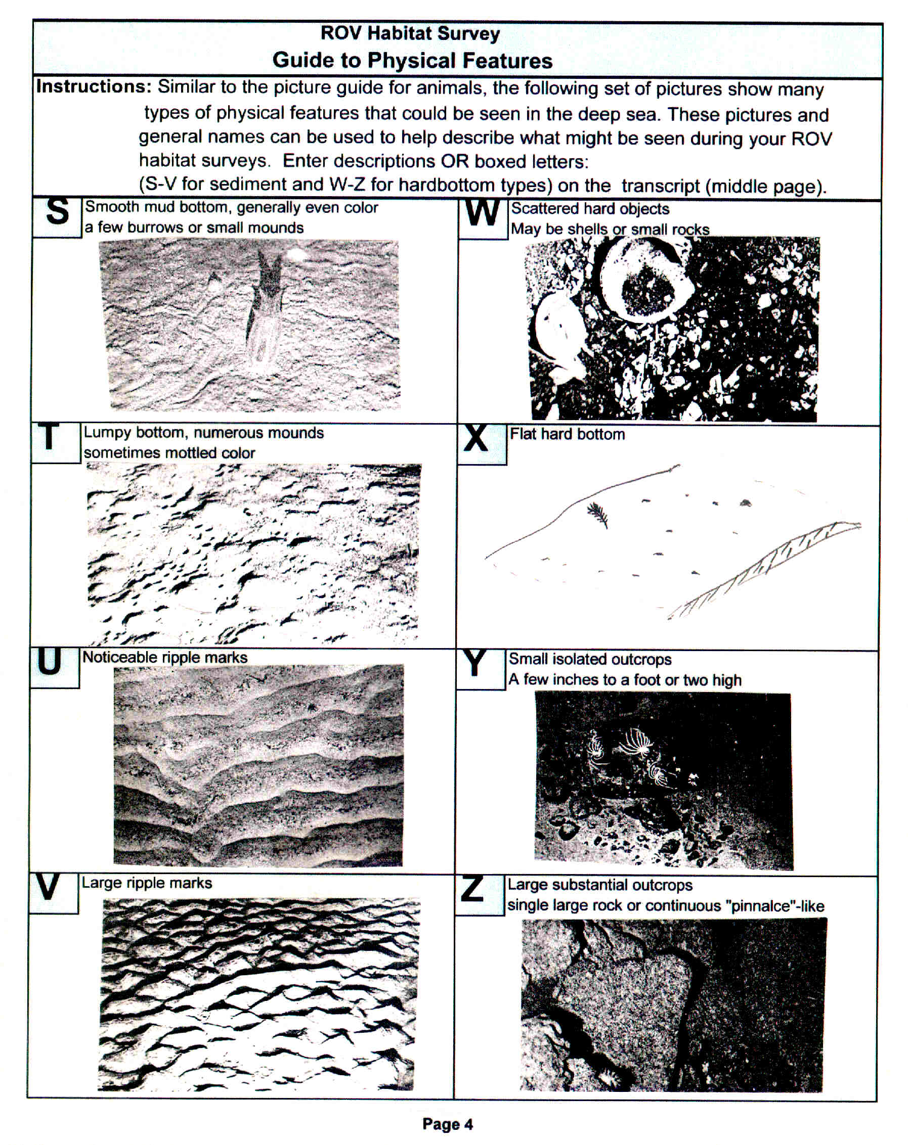
MMS Form MMS-141 (July 2005 - Supersedes all previous editions of form MMS-141 which may not be used) Page 4 of 5

Summary Sheet for ROV Pilot and Navigator

The Minerals Management Service (MMS) regulates the development of Outer Continental Shelf (OCS) oil and natural gas resources, and strives for operations that are both safe and environmentally sound. Several activities related to development in deepwater may have localized impacts on benthic communities, if such communities exist near the facility.

An ROV survey is required of selected operators as a verification of the effectiveness of existing MMS environmental reviews and mitigations imposed to avoid impacts to certain types of seafloor biologic communities. The ROV survey consists of recording biological and physical information on this ROV survey form and submitting the forms and videotapes of the transects and any additional imagery that may help depict bottom conditions such as ROV scanning sonar data.

Conduct the two ROV surveys and complete pages 1 and 2, documenting basic visual sightings of deepwater animals and bottom conditions. What we are looking for is an account of the types of animals present and the appearance of the bottom such as color and texture. No scientific expertise is required, simply do the best job possible using the pictures or simple descriptions. We have found that the seafloor is generally a rather featureless plain with relatively few visible animals and minimal currents. We are interested in all observations of animals and indications of currents such as ripple marks and bottom types. Of particular interest is the observation of hardbottom areas or outcrops with any attached animals.

Fly the ROV close enough to the bottom so that relatively small animals and features (one inch and larger) can be observed and identified on the resulting videotape. Suggested track lines at 60-degree intervals are depicted on page 1. This is just a suggested pattern, the important requirements being that each of the six excursions extend at least 100 meters from the launch point and that a minimum of one transect pass directly over or near the well or well cluster (template) site. Show the tracks in the survey report with transect numbers, times, and bearings indicated so that video images can be later located in relation to the well or well cluster site and using the videotape timelines. Close-up shots of individual animals or new bottom types are very helpful.

For operators interested in becoming familiar with the appearance of chemosynthetic communities, there are other sites, including one maintained by MMS that contain excellent images:
http://www.gomr.mms.gov/homepg/regulate/environ/chemo/chemo.html
http://www.bio.psu.edu//cold_seeps/index.html

Paperwork Reduction Act of 1995 (PRA) Statement: The PRA (44 U.S.C. Chapter 35) requires MMS to inform you that we collect the information on this form to identify high-density biological communities that may occur on the seafloor in deep water and, if such areas are found, to help design mitigation measures to avoid them in the future. The survey will help to assess the effectiveness of existing avoidance criteria and expand the knowledge base regarding the benthic habitats of the deep-water seafloor. Authority for collecting this information is 30 CFR 250.203(o) and 250.204(s). An agency may not conduct or sponsor and a person is not required to respond to, a collection of information unless it displays a currently valid OMB Control Number. The Office of Management and Budget (OMB) approved the collection of information required under 30 CFR, subpart B. Responses are mandatory. Public reporting burden for this form is estimated to average 2 hours, including the time for reviewing instructions, gathering and maintaining data, and completing and reviewing the forms associated with subpart B. Direct comments regarding the burden estimate or any other aspect of this information collection to the Information Collection Clearance Officer, Mail Stop 4230, Minerals Management Service, 1849 C Street, NW, Washington, DC 20240.

MMS Form MMS-141 (July 2005 - Supersedes all previous editions of form MMS-141 which may not be used) Page 5 of 5

Upon completion of the two separate ROV deployments,
please mail this form and videotapes/sonar data to:

Office of Field Operations, Plans Section
MS 5230
Department of the Interior
Minerals Management Service
1201 Elmwood Park Boulevard
New Orleans, Louisiana 70123

Information Contacts:
Gregory Boland or Robert Rogers

Leasing and Environment
Environmental Sciences Section
(504) 736-2740 or (504) 736-2898

