THE NATIONAL ASSESSMENT OF
EDUCATIONAL PROGRESS

Wave 1 Submittal for 2008

VOLUME II

Part 2 of 5

BACKGROUND QUESTIONS

FOR 2008 ASSESSMENT

Grade 8 School Background Questions
- Visual Arts Questions
- Music Questions



Volume II contains:
- Part 1 of 5 - Grade 8 Student Background Questions (Visual Arts and Music)
- Part 2 of 5 - Grade 8 School Background Questions ( Visual Arts and Music)
- Part 3 of 5 - Grade 12 Student Background Questions (Reading, Mathematics, Reading Motivational Study)
- Part 4 of 5 - Grade 12 School Background Questions (Reading Motivational Study)
- Part 5 of 5 – Student with Disabilities (SD) and English Language Learner (ELL) (for LTT administrations)

June 8, 2007
School Questionnaires

OMB Information on School Questionnaire Cover Page

According to the Paperwork Reduction Act of 1995, no persons are required to respond to a collection of information unless such collection displays a valid OMB control number. The valid OMB control numbers for this information collection are 1850-0790. The time required to complete this information collection is estimated to average 20 minutes per response, including the time to review instructions, search existing data resources, gather the data needed, and complete and review the information collection. If you have any comments concerning the accuracy of the time estimate(s) or suggestions for improving this form, please write to: U.S. Department of Education, Washington, D.C. 20202-4651. If you have comments or concerns regarding the status of your individual submission of this form, write directly to: NAEP/NCES, U.S. Department of Education, 1990 K Street N.W., Washington, D.C. 20006-5651.

A project of the Institute of Education Sciences.

This report is authorized by law (P.L.107-110, 20 U.S.C. §9010). While your participation is voluntary, your cooperation is needed to make the results of the survey comprehensive, accurate, and timely. All responses that relate to or describe identifiable characteristics of teachers or schools may be used only for statistical purposes and may not be disclosed, or used, in identifiable form for any other purpose, unless otherwise compelled by law.
OMB OMB No. 1850-0790 Approval Expires 05/31/2010
Mark Reflex® forms by Pearson NCS EM-166###-001-1:654321
Printed in U.S.A.
School Questionnaire
Grade 8

This questionnaire should be completed by the principal or the head of the school.
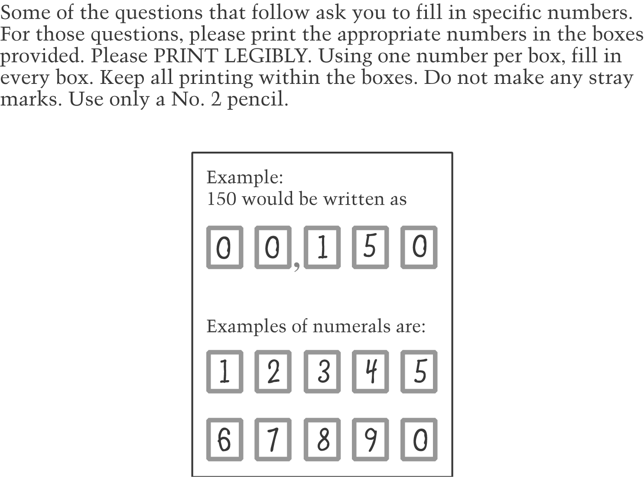

School Questionnaire
Grade 8
Part I: School Characteristics and Policies

1. What grades are taught in your school? Fill in all ovals that apply. (VB337248)
A Pre-kindergarten
B Kindergarten
C 1st grade
D 2nd grade
E 3rd grade
F 4th grade
G 5th grade
H 6th grade
I 7th grade
J 8th grade
K 9th grade
L 10th grade
M 11th grade
N 12th grade
2. Do all students in your school follow the same calendar? (VB556165)
A Yes → Go to Question 3
B No → Skip to Question 4

3. Please indicate the number of hours of instruction that eighth-grade students in your school completed as of February 1, 2008. (VB607886)
 | , |  |  |  |  |  | hours of instruction as of February 1, 2008

4. For each group of students following a separate calendar, please indicate the number of hours of instruction that eighth-grade students in your school completed as of February 1, 2008. (VB607887)
First group: |  | , |  |  |  |  |  | hours of instruction as of February 1, 2008 (VB607888)

Second group: |  | , |  |  |  |  |  | hours of instruction as of February 1, 2008 (VB607889)

Third group: |  | , |  |  |  |  |  | hours of instruction as of February 1, 2008 (VB607890)

5. What is the current enrollment in your school? (VB337250)
,

6. Approximately what percentage of eighth-graders in your school…
(Please be sure your answers sum to 100%.) (VC189012)

a. is new this year? |  |  |  |  |  | % | (VC189050)
b. has been attending your school for 1-2 years? |  |  |  |  |  | % | (VC189051)
c. has been attending your school for 3 or more years? |  |  |  |  |  | % | (VC189053)
TOTAL | 1 |  | 0 |  | 0 | %

7. Of the students currently enrolled in your school, what percentage has been identified as limited-English proficient? (VB337256)
A 0%
B 1–5%
C 6–10%
D 11–25%
E 26–50%
F 51–75%
G 76–90%
H Over 90%

8. What type of school is this? Fill in ovals for all that apply. (QK070740)
A Regular middle or secondary school
B A regular school with a magnet program
C A magnet school or a school with a special program emphasis, e.g., science/math school, performing arts school, talented/gifted school, foreign language immersion school, etc.
D Special education: a school that primarily serves students with disabilities
E Alternative: a school that offers a curriculum designed to provide alternative or nontraditional education, not clearly categorized as regular, special education, or vocational
F Private (independent)
G Private (religiously affiliated)
H Charter school
I Privately run public school
J Other ______________________

- About what percentage of your students is absent on an average day? (Include excused and unexcused absences in calculating this rate.) (HE000917)
  - 0–2%
  - 3–5%
  - 6–10%
  - More than 10%

- About what percentage of your teachers is absent on an average day? (Include all absences in calculating this rate.) (LC000488)
  - 0–2%
  - 3–5%
  - 6–10%
  - More than 10%

- About what percentage of students who are enrolled at the beginning of the school year is still enrolled at the end of the school year? (Exclude students who transfer into the school during the school year in figuring this rate.) (HE000918)
  - 98–100%
  - 95–97%
  - 90–94%
  - 80–89%
  - 70–79%
  - 60–69%
  - 50–59%
  - Less than 50%

- About what percentage of this year’s eighth graders was held back and is repeating eighth grade? (HE002230)
  - 0%
  - 1–2%
  - 3–5%
  - 6–10%
  - More than 10%

- Of the full-time teachers who started in your school last year, what percentage left before the end of the school year? (HE000920)
  - 0%
  - 1–2%
  - 3–5%
  - 6–10%
  - 11–15%
  - 16–20%
  - More than 20%

14. Does your school participate in the National School Lunch Program? (HE002094)
A Yes → Go to Question 15
B No → Skip to Question 18

15. How does the school operate the program? (VB556173)
A Student eligibility is determined individually, and eligible students receive free or reduced-price lunch → Skip to Question 17
B All students in school receive free lunch under special provisions (e.g., Provision 2 or 3) → Go to Question 16

16. If your school distributes free lunch to all students under Provision 2 or 3, what was the base year during which individual student eligibility was collected? (New)
A This school does not distribute free lunch to all students under Provision 2 or 3—eligibility is determined annually.
B 2007
C 2006
D 2005
E 2004
F 2003
G 2002 or earlier

17. During this school year, about what percentage of students in your school was eligible to receive a free or reduced-price lunch through the National School Lunch Program? (VB608487)
A 0%
B 1–5%
C 6–10%
D 11–25%
E 26–34%
F 35–50%
G 51–75%
H 76–99%
I 100%

18. Does your school receive Title I funding? (Title I is a federally funded program which provides educational services, such as remedial reading or remedial math, to children who live in areas with high concentrations of low-income families.) (VB608488)
A No
B Yes, our school receives funds, which are targeted to eligible students
C Yes, our school receives funds, which are used for schoolwide purposes

19. Approximately what percentage of students in your school receives the following services? Fill in one oval on each line. Students who receive more than one service should be counted for each service they receive. Please report the percentage of students who receive each of the following services as of the day you respond to this questionnaire. (VB485284)

 | None | 1–5% | 6–10% | 11–25% | 26–50% | 51–75% | 76–90% | Over 90%
a. Targeted Title I services | A | B | C | D | E | F | G | H | (VB610145)
b. Gifted and talented program | A | B | C | D | E | F | G | H | (VB485286)
c. Instruction provided in student’s home language (non-English) | A | B | C | D | E | F | G | H | (VB485287)
d. English-as-a-second-language (not in a bilingual education program) | A | B | C | D | E | F | G | H | (VB485288)
e. Special education | A | B | C | D | E | F | G | H | (VB485289)

School Questionnaire
Grade 8

Part II: Arts

- Are eighth-grade students typically assigned to classes by ability and/or achievement levels (so that some classes are higher in average ability and/or achievement levels than others) in any of the following subjects? Fill in one oval on each line. (HE000928)

 | Yes | No
- Dance (HE002231) | A | B
- Music (HE002233) | A | B
- Theatre (HE002235) | A | B
- Visual arts (HE002236) | A | B

- How often does a typical eighth-grade student in your school receive instruction in each of the following subjects? Fill in one oval on each line. (HE002145)

 | Every Day | Three or Four Times a Week | Once or Twice a Week | Less Than Once a Week | Subject Not Taught
- Dance (HE002147) | A | B | C | D | E
- Music (HE002152) | A | B | C | D | E
- Theatre (HE002150) | A | B | C | D | E
- Visual arts (HE002151) | A | B | C | D | E

- Are computers available to students in your classes in any of the following ways? Fill in one oval on each line. (HE000862)

 | Yes | No
- Available all the time in classrooms (HE000843) | A | B
- Grouped in a separate computer laboratory available to classes (HE000864) | A | B
- Available to bring to classrooms when needed (HE000866) | A | B

- Is this a school with a special focus on any of the following (e.g., a magnet school)? Fill in one oval on each line. (New)

 | Yes | No
- Dance (New) | A | B
- Music (New) | A | B
- Theatre (New) | A | B
- Visual arts (New) | A | B

- Does your district or state have a curriculum in any of the following subject areas that your school is expected to follow? Fill in one oval on each line. (New)

 | Yes | No
- Dance (New) | A | B
- Music (New) | A | B
- Theatre (New) | A | B
- Visual arts (New) | A | B

- In the last year, did your school sponsor eighth-grade field trips in connection with any of the following subject areas? Fill in one oval on each line. (New)

 | Yes | No
- Dance (New) | A | B
- Music (New) | A | B
- Theatre (New) | A | B
- Visual arts (New) | A | B

- Do eighth graders in your school participate in school-sponsored extracurricular activities such as clubs, competitions, fairs, or exhibits in any of the following areas? Fill in one oval on each line. (New)

 | Yes | No
- Dance (New) | A | B
- Music (New) | A | B
- Theatre (New) | A | B
- Visual arts (New) | A | B

- Do eighth graders in your school participate in school-related summer programs in any of the following areas? Fill in one oval on each line. (New)

 | Yes | No
- Dance (New) | A | B
- Music (New) | A | B
- Theatre (New) | A | B
- Visual arts (New) | A | B

- What is the position of the person(s) on your staff who teach dance or movement to eighth graders? Fill in one oval on each line. (New)

 | Yes | No
- Full-time specialist (New) | A | B
- Part-time specialist (New) | A | B
- Physical education teacher (New) | A | B
- Elementary classroom teacher (New) | A | B
- Other faculty member (New) | A | B
- Artist-in-residence (New) | A | B
- Volunteer (New) | A | B

- What is the position of the person(s) on your staff who teach music to eighth graders? Fill in one oval on each line. (New)

 | Yes | No
- Full-time specialist (New) | A | B
- Part-time specialist (New) | A | B
- Elementary classroom teacher (New) | A | B
- Other faculty member (New) | A | B
- Artist-in-residence (New) | A | B
- Volunteer (New) | A | B

- What is the position of the person(s) on your staff who teach theatre or drama to eighth graders? Fill in one oval on each line. (New)

 | Yes | No
- Full-time specialist (New) | A | B
- Part-time specialist (New) | A | B
- English or language arts teacher (New) | A | B
- Elementary classroom teacher (New) | A | B
- Other faculty member (New) | A | B
- Artist-in-residence (New) | A | B
- Volunteer (New) | A | B

- What is the position of the person(s) on your staff who teach visual arts to eighth graders? Fill in one oval on each line. (New)

 | Yes | No
- Full-time specialist (New) | A | B
- Part-time specialist (New) | A | B
- Elementary classroom teacher (New) | A | B
- Other faculty member (New) | A | B
- Artist-in-residence (New) | A | B
- Volunteer (New) | A | B

- Which best describes the space for the teaching of dance in your school? (HE002074)

A Dance is not taught.

B Dance studio with special dance equipment

C Room(s) dedicated to dance teaching, without special equipment

D Gymnasium, auditorium, or cafeteria

E Classrooms only

F Other (specify) __________

- Which best describes the space for the teaching and performing of music in your school? (HE002073)

A Music is not taught.

B Room(s) dedicated to music teaching, and stage

C Room(s) dedicated to music teaching, no stage

D Stage, no room dedicated to music teaching

E Classrooms only

F Other (specify) __________

- Which best describes the space for the teaching of theatre in your school? (HE002075)

A Theatre is not taught.

B Stage with special equipment (e.g., curtains, dressing rooms)

C Stage without special equipment

D Room(s) dedicated to theatre teaching

E Gymnasium, auditorium, or cafeteria

F Classrooms only

G Other (specify) __________

- Which best describes the space for the teaching of visual arts in your school? (HE002072)

A Visual arts are not taught.

B Art studio with special equipment

C Room(s) dedicated to art but with no special equipment

D Art-on-a-cart; no dedicated space

E Classrooms only

F Other (specify) __________

- In the last year, did your school bring in visiting artists to perform, demonstrate, or teach in the following areas? Fill in one oval on each line. (New)

 | Yes | No
- Dance (New) | A | B
- Music (New) | A | B
- Theatre (New) | A | B
- Visual arts (New) | A | B

- In the last year, did your school sponsor a visiting artist program (such as an Artist-in-the-Schools program) in any of the following areas? Fill in one oval on each line. (New)

 | Yes | No
- Dance (New) | A | B
- Film (New) | A | B
- Folk arts (New) | A | B
- Music (New) | A | B
- Theatre (New) | A | B
- Visual arts (New) | A | B

- During this year, what percentage of eighth graders received instruction in the following arts in your school? Fill in one oval on each line. (HE002213)

 | 0-10% | 11-20% | 21-40% | 41-60% | 61-80% | 81-100%
- Dance (HE002214) | A | B | C | D | E | F
- Music (HE002215) | A | B | C | D | E | F
- Theatre (HE002216) | A | B | C | D | E | F
- Visual Arts (HE002217) | A | B | C | D | E | F

School Questionnaire
Grade 8

Part III: Supplemental Charter-School Questions

If your school is a charter school, please continue. If your school is not a charter school, you have finished the survey. Thank you for your time.

1. In which year did your school start providing instruction as a charter school? (VC104697)

2. How many times has your charter been renewed? (If “0 Times” skip to Question 5) (VC104699)

Times

3. In which year was your charter most recently renewed? (VC104700)

4. For how many years was your charter renewed? (VC104701)
A 1 to 3 years
B 4 to 5 years
C 6 to 10 years
D 11 or more years

5. Who granted your school’s original charter? (VC104703)
A School district
B State board of education (includes State Board of Regents and District of Columbia Board of Education)
C Postsecondary institution
D State charter-granting agency
E City or state public charter school board
F Other

6. Is your charter school a newly created school or was it converted from a pre-existing school? (VC104705)
A Newly created school → Skip to Question 8
B Converted from a pre-existing school → Go to Question 7

7. Was the pre-existing school a public school or a private school? (VC104756)
A Public school
B Private school

8. Which one of the following best describes your charter school’s primary focus in terms of program content? (VC104758)
A We have a comprehensive curriculum with no specialized area of focus.
B We have a special curricular focus, for example, the arts, math/science, foreign language immersion.
C Our curriculum is based on a particular educational theory, for example, Montessori, open school, Core Knowledge.
D Our curriculum is based on a particular moral philosophy or set of values, for example, African-centered education, character-based education, Eastern philosophy.

9. Among eighth-grade students who are new to your school this year, approximately what percentage performs at or above average on your state assessment? (VC104970)

Percent

10. Does your school participate in the National School Lunch Program? (HE002094)
A Yes → Skip to Question 12
B No → Go to Question 11

11. Why does your school not participate in the National School Lunch Program? (VC104793)
A My school has eligible students but chooses not to participate in the program.
B My school does not have students who qualify for free or reduced-price lunches.
C My school does not have a cafeteria or does not serve lunch.
D Other

12. What is the legal status of your school? (VC104799)
A Officially part of the school district or local education agency (LEA)
B Independent from the school district or local education agency (LEA)
C A separate local education agency (LEA) as stipulated by state law

13. Who has primary control or authority over the following aspects of your school? Fill in one oval on each line. (VC104818)
 | Your school | Management company | District/  charter-granting agency | Governing board/board of trustees | Other | [Same at:]
a. Total budget | A | B | C | D | E | [8] | (VC104825)
b. Purchase of supplies and equipment | A | B | C | D | E | [8] | (VC104832)
c. School calendar | A | B | C | D | E | [8] | (VC104838)
d. Student discipline policies (e.g., suspension/expulsion) | A | B | C | D | E | [8] | (VC104842)
e. Curriculum | A | B | C | D | E | [8] | (VC104844)
f. Personnel, including hiring of teaching staff | A | B | C | D | E | [8] | (VC104846)

14. In which of the following areas is your school monitored/audited by the state or your school’s charter-granting agency? (VC104856)
 | Yes, by state | Yes, by charter-granting agency | Not monitored | [Same at:]
a. Curriculum topics taught | A | B | C | [8] | (VC104866)
b. Teaching methods used | A | B | C | [8] | (VC104871)
c. Student achievement | A | B | C | [8] | (VC104880)
d. Student behavior | A | B | C | [8] | (VC104886)
e. Student attendance | A | B | C | [8] | (VC104895)
f. School governance | A | B | C | [8] | (VC104898)
g. School finances | A | B | C | [8] | (VC104900)
h. Compliance with state or federal regulations | A | B | C | [8] | (VC104901)
i. Special education services | A | B | C | [8] | (VC104903)

15. Are you required to report directly to any of the following groups on your school’s progress? Fill in one oval on each line. (VC104905)
 | Yes | No | [Same at:]
a. Chartering agency | A | B | [8] | (VC104943)
b. Parents | A | B | [8] | (VC104944)
c. Community/general public | A | B | [8] | (VC104945)
d. School governing board | A | B | [8] | (VC104946)
e. Private funders or donors | A | B | [8] | (VC104947)
f. State Board of Education | A | B | [8] | (VC104948)
g. State department of education (if this is not the chartering agency) | A | B | [8] | (VC104949)
h. Legislature | A | B | [8] | (VC104950)

16. Have you surveyed or interviewed the parents of the students in your school to find out why they chose to send their children to your school? (VC104951)
A Yes → Go to Question 17
B No → You are finished.

17. About how many parents indicate that they chose to send their children to your school for the following reasons? Fill in one oval on each line. (VC104952)
 | Less than half | About half | About three-quarters | All or almost all | [Same at:]
a. Their child was performing poorly in another school. | A | B | C | D | [8] | (VC104954)
b. They wanted a more rigorous curriculum for their child. | A | B | C | D | [8] | (VC104957)
c. They wanted the particular curricular focus this school has. | A | B | C | D | [8] | (VC104958)
d. They wanted a safer environment for their child. | A | B | C | D | [8] | (VC104960)
e. They were seeking greater parental involvement in their child’s education. | A | B | C | D | [8] | (VC104961)
f. They wanted smaller class sizes. | A | B | C | D | [8] | (VC104962)
g. Other reason | A | B | C | D | [8] | (VC104963)

