Guidance for Industry and FDA Staff
Administrative Procedures
for CLIA Categorization
Document issued on: [release date of FR Notice]

The draft of this document was issued on August 14, 2000

For questions regarding this document, contact Carol Benson at 240-276-0491 X 117 or by e-mail at carol.benson@fda.hhs.gov.

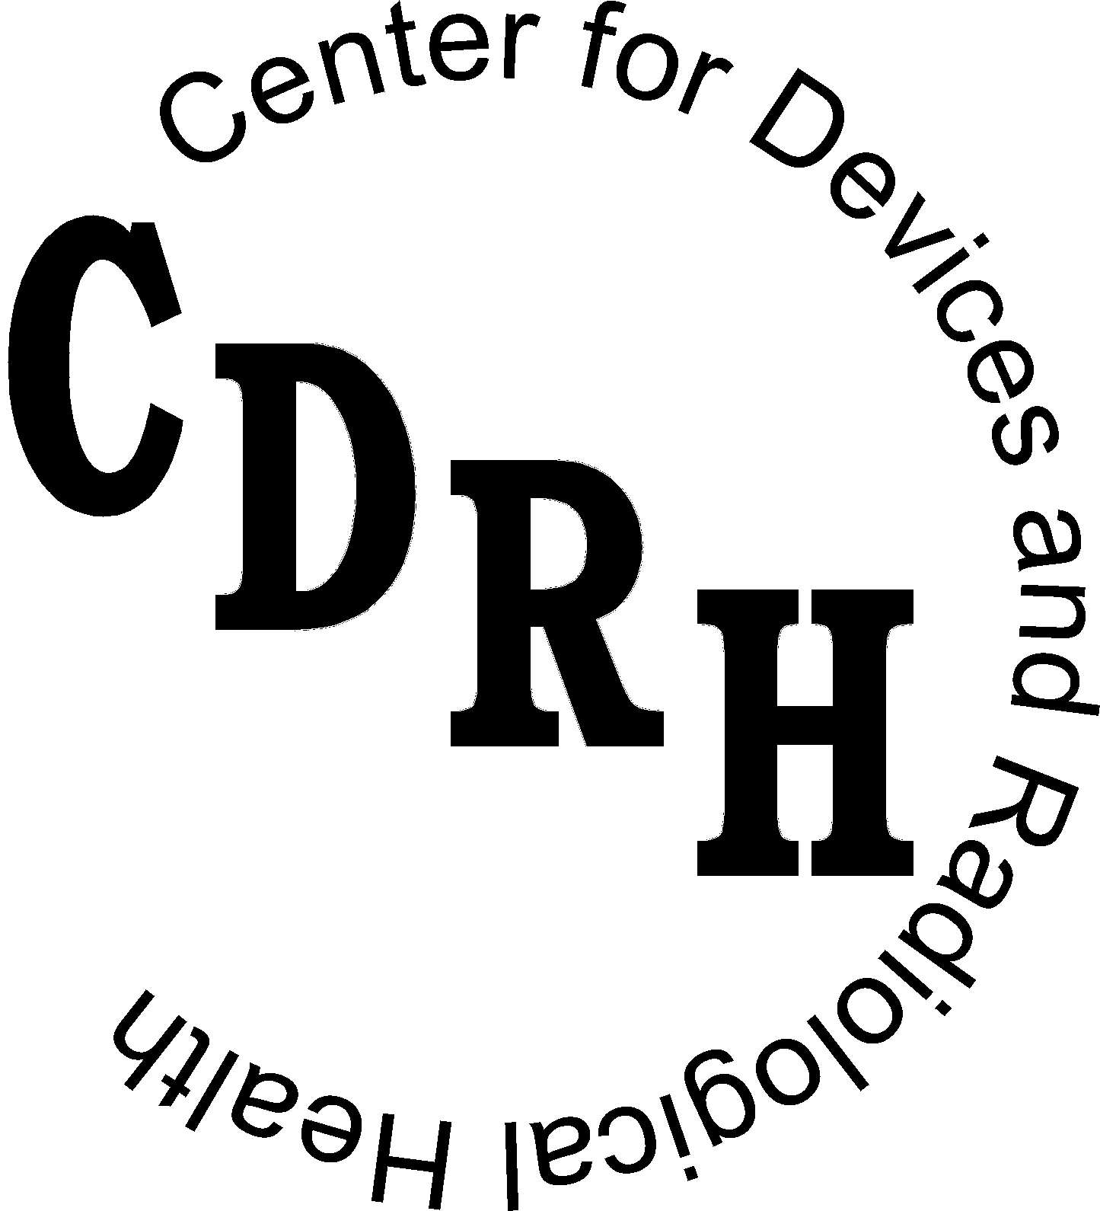
U.S. Department of Health and Human Services
Food and Drug Administration
Center for Devices and Radiological Health
Office of In Vitro Diagnostic Device Evaluation and Safety

Preface

Public Comment

Written comments and suggestions may be submitted at any time for Agency consideration to the Division of Dockets Management, Food and Drug Administration, 5630 Fishers Lane, Room 1061, (HFA-305), Rockville, MD, 20852. Alternatively, electronic comments may be submitted to http://www.fda.gov/dockets/ecomments. Please refer to Docket No. 00D-1401 when submitting comments. Comments may not be acted upon by the Agency until the document is next revised or updated.

Additional Copies

Additional copies are available from the Internet at: http://www.fda.gov/cdrh/oivd/1143. You may also send an e-mail request to dsmica@fda.hhs.gov to receive an electronic copy of the guidance or send a fax request to 240-276-3151 to receive a hard copy. Please use the document number 1143 to identify the guidance you are requesting.
Table of Contents

1. Introduction 1
The Least Burdensome Approach 2
2. Procedures for Determination of CLIA Categorization 2
3. CLIA Waiver Protocols and Applications 4

Guidance for Industry and FDA Staff

Administrative Procedures
for CLIA Categorization

This guidance represents the Food and Drug Administration's (FDA's) current thinking on this topic. It does not create or confer any rights for or on any person and does not operate to bind FDA or the public. You can use an alternative approach if the approach satisfies the requirements of the applicable statutes and regulations. If you want to discuss an alternative approach, contact the FDA staff responsible for implementing this guidance. If you cannot identify the appropriate FDA staff, call the appropriate number listed on the title page of this guidance.

Introduction
On February 28, 1992, the Department of Health and Human Services (DHHS) published the final laboratory standards regulations (57 FEDERAL REGISTER 7002) implementing CLIA (Clinical Laboratory Improvement Amendments, codified at 42 CFR part 493). CLIA expands regulation of laboratory testing and calls for minimum requirements to help ensure the accuracy of tests, assays, or examinations of materials derived from the human body for the purpose of providing information for the diagnosis, prevention, or treatment of any disease or the impairment of, or assessment of the health of human beings. CLIA regulations describe three levels of test complexity:
- waived tests
- moderate complexity tests
- high complexity tests

Laboratories performing only waived tests are subject to minimal regulation. Laboratories performing moderate or high complexity tests are subject to specific laboratory standards governing certification, personnel, proficiency testing, patient test management, quality assurance, quality control, and inspections.
On January 31, 2000, the responsibility for categorization of commercially marketed in vitro diagnostic (IVD) tests was transferred from the Centers for Disease Control and Prevention (CDC) to the Food and Drug Administration (FDA). This allows manufacturers to submit premarket notifications or applications for products and requests for complexity categorization of these products under CLIA to one agency.
This document describes general administrative procedures FDA will use to assign a device’s complexity category under CLIA regulations (42 CFR 493.17). This guidance does not specifically address CLIA waiver applications. A draft guidance entitled “Draft Guidance for Industry and FDA Staff: Recommendations for Clinical Laboratory Improvement Amendments of 1988 (CLIA) Waiver Applications” is available at http://www.fda.gov/cdrh/oivd/guidance/1171.pdf. When finalized, that guidance will provide recommendations concerning CLIA waiver applications, including studies to support CLIA waiver.
FDA's guidance documents, including this guidance, do not establish legally enforceable responsibilities. Instead, guidances describe the Agency's current thinking on a topic and should be viewed only as recommendations, unless specific regulatory or statutory requirements are cited. The use of the word should in Agency guidances means that something is suggested or recommended, but not required.

The Least Burdensome Approach
We believe we should consider the least burdensome approach in all areas of medical device regulation. This guidance reflects our careful review of the relevant scientific and legal requirements and what we believe is the least burdensome way for you to comply with those requirements. However, if you believe that an alternative approach would be less burdensome, please contact us so we can consider your point of view. You may send your written comments to the contact person listed in the preface to this guidance or to the CDRH Ombudsman. Comprehensive information on CDRH's Ombudsman, including ways to contact him, can be found on the Internet at http://www.fda.gov/cdrh/ombudsman/.

Procedures for Determination of CLIA Categorization

CLIA categorization for IVD tests is determined by FDA at the time of review of a premarket notification or premarket application. In cases where a premarket notification or application is not needed, but CLIA categorization is still appropriate (see the table below for examples) manufacturers should submit a request for CLIA categorization, including a copy of the test package insert with test instructions to FDA.
For moderate and high complexity tests, FDA determines test complexity by reviewing the package insert test instructions in the premarket submission, using the criteria listed in 42 CFR 493.17. The determination for waived tests is based on the list of tests specified as waived by regulation within 42 CFR 493.15. Manufacturers requesting CLIA waiver for tests not waived by this regulation should submit a CLIA waiver application (see section below). These applications are submitted after the test is cleared or approved.
In order to expedite CLIA categorization by FDA, manufacturers should submit the material described in the following table. The information should be addressed to CDRH's Document Mail Center (DMC), HFZ-401, 9200 Corporate Blvd., Rockville MD 20850.
In the following situations: | The 510(k) sponsor should provide:
510(k) (Traditional or abbreviated) | A copy of the package insert identified as "For CLIA categorization". The package insert that the manufacturer provides in the duplicate copy of the 510(k) can be used for this purpose.
Electronic 510(k) or PMA submissions | The electronic version of the package insert can be used for CLIA categorization. No additional information needed.
Special 510(k) | A package insert identified as "For CLIA categorization." The package insert that the manufacturer provides in the duplicate copy of the 510(k) can be used for this purpose.  (Note: Not all special 510(k) submissions need re-categorization. FDA evaluates each submission to determine if CLIA categorization is needed.)
Name change for a previously cleared or approved device, i.e., if the manufacturer changes the test or manufacturer’s name or if the test is labeled with a distributor’s name in place of the original manufacturer’s name | A package insert identified as “For CLIA categorization only – name change for previously cleared device” and a reference to the original 510(k) number.
A test that is exempt from 510(k) review | A package insert identified as: “For CLIA categorization only – 510(k) exempt device” and a reference to the regulation number, classification, and product code.
A test system that falls under the Replacement Reagent Policy. (See http://www.fda.gov/cdrh/oivd/guidance/950.pdf for guidance on OIVD’s Replacement Reagent and Instrument Family Policy.) | A package insert identified as: “For CLIA categorization only” and a reference to the original 510(k), including the regulation numbers, classification, and product codes for the test and instrument.
Original PMA or PMA Supplement | A copy of the package insert identified as "For CLIA categorization". The package insert that the manufacturer provides in the duplicate copy of the submission can be used for this purpose.

FDA will notify manufacturers of the assigned complexity through routine written correspondence. Categorization will be effective as of the date of the written notification to the manufacturer (42 CFR § 493.17 (c) (1) (iii)). A searchable database of CLIA categorizations for IVD devices, which is updated periodically, is available at http://www.accessdata.fda.gov/scripts/cdrh/cfdocs/cfCLIA/clia.cfm.

CLIA Waiver Protocols and Applications
We recommend that a manufacturer who wishes to request CLIA waiver for a device (other than those devices already waived by 42 CFR 493.15), refer to the guidance entitled “Draft Guidance for Industry and FDA Staff: Recommendations for Clinical Laboratory Improvement Amendments of 1988 (CLIA) Waiver Applications,” http://www.fda.gov/cdrh/oivd/guidance/1171.pdf. When finalized, that guidance will provide recommendations concerning CLIA Waiver Applications, including studies to support CLIA waiver.

Manufacturers have the option to submit their planned protocols or study designs to support CLIA waiver in order to obtain feedback from FDA prior to conducting the study. These planned protocols or study designs are logged in by the document mail center as “Pre-IDE”s. See the FDA website for more information on the Pre-IDE process: http://www.fda.gov/cdrh/devadvice/ide/approval.shtml. Pre-IDEs for CLIA waiver should include a reference to the original 510(k) or PMA number, 2 copies of the protocol/study design, and an electronic version if available.

