Attachment 1

Moderator’s Guide:
Suicide Prevention Messages and Materials for Veterans

Note: Materials to be assessed include the following (Attachment 8):
- “Know the Warning Signs of Suicide” Brochure
- “It Takes the Courage and Strength of a Warrior” Posters
- Veterans Suicide Prevention Hotline Logos
- Television Public Service Announcement

Welcome/Introduction

Welcome and thank you very much for agreeing to participate in this focus group. My name is _________ and I work for a consulting firm called Macro International Inc., which is located outside of Washington, DC.

We are working with the National Suicide Prevention Lifeline, under a project funded by the Substance Abuse and Mental Health Services Administration to conduct focus groups in different cities with veterans and National Guardsmen who have served in Iraq or Afghanistan. The purpose of these groups is to get your opinions about materials related to suicide prevention.

I will be your moderator for the discussion. I’ll be asking you some questions and inviting you to tell us about your experiences, thoughts, and opinions. There is no right or wrong answer. I didn’t create these materials, so whatever you say, you’re not going to hurt my feelings. We are interested in your honest responses and reactions to the questions. That will help the most in making these materials as effective as possible.

Informed Consent
Everyone who has agreed to participate in the discussion must sign an informed consent form. Did everyone have a chance to read the form? Let me review the main points of the form to see if you have any questions before you sign it.

Review consent form, emphasizing voluntary participation, audio taping, note taker, observers, confidentiality, and using first names only

I’d like to introduce you to (name of VA suicide prevention coordinator) whom some of you may have already met. (Name) is the suicide prevention coordinator at the (name of city) VA Medical Center. S/he is also a (professional affiliation; e.g., licensed social worker). (Name) will be observing the focus group and—because talking about suicide can sometimes bring up tough feelings—s/he is also here in case any of you want to talk confidentially either during or after the group. S/he can also answer any questions you might have about the VA after the group is over.

Does anyone have any questions about the Informed Consent or the group itself?

After all questions have been answered, ask participants to sign the form and collect them.

Ground Rules
Before we begin, I’d like to go over some ground rules for our discussion tonight:
- The reason that we have invited you here tonight is to hear a range of responses and opinions to the questions we’re going to be discussing. For that reason, I’d like to encourage everyone to actively participate in the discussion. Again, you can choose to skip any question you like, but we’d love to hear your thoughts about everything.
- Please speak loudly, and one at a time.
- Please do not have side conversations.
- Everything that is said in this session will be confidential; your name will never be linked to anything that you say in any future reports.
- Please be sure to turn off your cell phone if you have not already done so.

I’m going to ask a series of questions, but mainly I want to hear from you. As I mentioned, my role is simply to guide the discussion. Sometimes we may get involved with one question, and I’ll have to move our discussion along to the next question so that we cover everything. Please do not take it personally! We just need to hear from as many of you as possible and make sure we cover all of the topics.

Do you have any questions before we get started?

Warm-Up (5 minutes)
Now that you’ve gotten to know a little more about why we are here and how things will go, I’d like you to introduce yourselves.

Write bullets on flip chart.

Please share with us:
- Your first name.
- Whether you were stationed in Iraq or Afghanistan, or both.
- How many times you were deployed.
- How long you were deployed, each time.
- When you most recently returned.

General Questions (10 minutes)
Okay, let’s get started.

- If you thought that one of your close buddies was considering suicide, where would you go or where would you suggest he or she go for help?

- What do you know about suicide prevention services for veterans?
PROBE: What have you seen or heard?

- Have you seen or heard anything about the Veterans Suicide Prevention Hotline? What have you seen or heard?
PROBE: Do any of you know someone who has called this hotline? What did that person think about the hotline?

- You’ve told me that you would go to…fill in answers from the first bullet under #5. If you knew that there was a Veterans Suicide Prevention Hotline, how likely or unlikely would you be to make that one of your first suggestions? Why?

Brochure (15 minutes)
Pass out brochure.

Let’s take a couple of minutes to silently read through this brochure. Once you’re done reading, I’ll ask you some questions to see what you think about it.

- What were your first thoughts about the brochure?

- What did you like the most about it? What did you like the least about it?

- What do you think of the pictures in the brochure?

- What do you think of the colors that are used?

- What is the brochure trying to tell you?
PROBE: How easy was it for you to understand the information? Did you learn anything new? Was it easy to read? What captured your attention?

- Who do you think these materials are for?
PROBE: People like you and/or your combat buddies? If not, who are they for?

PROBE: What would they look like if they were supposed to be for people like you and your combat buddies?

PROBE: What would they say if they were supposed to be for people like you and your combat buddies?

PROBE: Do you have to be thinking about suicide to call?

- Would you share this brochure with one of your combat buddies? Why or why not?

- Would you ever consider calling this hotline for you or for a buddy?
PROBE: Why or why not?

PROBE: What would make you more likely to call?

- What information would you want to know about the hotline before you would be willing to call?

- If you were in crisis or having suicidal thoughts, would it encourage you or your buddies to call the hotline?
PROBE: Why or why not?

PROBE: What should we change to make you more likely to be willing to call?

Posters (25 minutes)
Show VA poster #1 to all participants. Read the message aloud.

- What is your overall impression of this poster?
PROBE: What did you like most? What did you like least?

- Who do you think this poster is for?

- What do you think this poster is trying to say?
PROBE: What was not clear?

- What do you think about the pictures used?

- What is it about this poster that stands out for you?

- If you were in a crisis or having suicidal thoughts, would this encourage you or your buddies to call the hotline?
PROBE: Why or why not?

PROBE: What could we change to make you more likely to call the hotline?

- How would you make this poster different?

Hide VA poster #1. Show VA poster#2 to all participants. Read the message aloud.

- Who do you think this poster is for?

- What is your overall impression of this poster?
PROBE: What did you like most? What did you like least?

- What do you think this poster is trying to say?
PROBE: What was not clear?

- What do you think about the pictures used?

- What is it about this poster that stands out for you?

- If you were in a crisis or having suicidal thoughts, would this encourage you or your buddies to call the hotline?
PROBE: Why or why not?

PROBE: What could we change to make you more likely to call the hotline?

- How would you make this poster different?

Show both posters.

- Which poster do you like better? Why?

Television Public Service Announcement (15 minutes)

I’m going to show you a 30-second television advertisement. I’ll then ask you some questions about what you saw.

- Give me one word to describe what you just saw.

- What did you think of the actor in this ad? What did you like? What did you dislike?
PROBE: How do you think your combat buddies would react to the actor in this ad?

- Would you choose another celebrity to star in this ad? If so, who would you choose? Why?

- Are you more likely to call the hotline from watching this ad or from reading the brochure? What did you like better about (the TV ad/brochure)?

Depending on their response, ask one of the following questions:

- If the brochure was more influential: What would you like to see added or removed from the ad?

OR

- If the TV ad was more influential: What is in the ad that should be included in the brochure?

Branding (15 minutes)

Before we continue our discussion, I want to give you a little bit more information about the Veterans Suicide Prevention Hotline. It’s a part of a larger national hotline, which serves everyone in the country, not just veterans. When you call the toll free number, you hear a greeting telling you to press 1 if you are a veteran. If you press 1, you’re automatically connected to a specialized call center run by the Department of Veterans Affairs and staffed by mental health professionals.

If you were to dial the number for the toll free number right now, you would hear the following message…

Use a tape recorder to play the Lifeline greeting.

- What do you think of the recording?

- What instructions should materials like the brochure have so that veterans know they should press 1?

Now we’re going to look at some logos for the Veterans Suicide Prevention Hotline.

Show logo #1.

- What do you like most about this logo? Why?

- What do you like least about this logo? Why?
Hide logo #1 and show logo #2.

- What do you like most about this logo? Why?

- What do you like least about this logo? Why?

Show both logos.

- Which logo do you like better? Why?

Distribution (5 minutes)
- For those of you who had already heard about the Veteran’s Suicide Prevention Hotline or National Suicide Prevention Lifeline, how did you hear about it?

- What do you think are some ways we can let others know about the Veteran’s Suicide Prevention Hotline and the materials we looked at today?

PROBE: Where would you be more likely to pick up these materials?

PROBE: Where would you and/or your buddies want to see these materials?

False Close (5 minutes)
Tell participants that you are going to speak with the observers (or the note-taker) to see whether they have any follow-up questions. The remainder of the session will be focused on this follow-up.

Closure and Thank You
Thank you very much for taking the time to participate in this discussion. Your input has been very helpful. If anyone would like to contribute additional ideas but would prefer to speak with one of us privately, we’d be happy to stay after the group is over. There is a VA Suicide Prevention Coordinator available to you, should you need to speak to him. We also have some information for you about the VA Suicide Prevention Hotline; please feel free to take any of these materials with you. One last thing, please be sure to speak with ____ on your way out to receive your thank you gift for participating this evening/morning/ afternoon. Thanks again and have a good day/evening.
Attachment 2

Privacy Protection Agreement for Focus Group Participant Recruiters

Because of concerns about protecting participant privacy and fostering an atmosphere of respect for the participants, it is important for all persons who are recruiting participants for focus groups to accept the following:

- Use only the pre-determined screener with potential participants and not ask additional questions.

- Refrain from interacting with focus group participants beyond the initial screening phone call, unless specifically requested to do so by the focus group moderator and/or participants.

- Do not disclose names or information about individuals who have elected to participate in the focus group, with the exception of providing this information to the focus group moderator.

- Do not discuss the identity of participants or what was said by individual participants with others who did not sign this participant protection form.

- Do not take part in the focus group or interact with any of the participants beyond the screening call.

Your signature below indicates that you understand and accept these conditions.

Recruiter Name: | _______________________________________________________
Recruiter Signature: | _______________________________________________________
Date: | _______________________________________________________

Witness Name: | _______________________________________________________
Witness Signature: | _______________________________________________________
Date: | _______________________________________________________
Attachment 3

Privacy Protection Agreement for Focus Group Moderators, Note Takers, and Observers

Because of concerns about protecting participant privacy and fostering an atmosphere of respect for the participants, it is important for all persons who are moderating, taking notes, or observing focus groups to accept the following:

- Treat all information obtained or collected for this project as confidential.

- Do not discuss the identity of any focus group participant or what was said by any individual participants with others, with the exception of those who are authorized to have access to the information.

- Do not use the collected information for any purposes other than for your work on this project.

- Maintain all collected information, notes, and materials in my possession and in a secure location at all times until they are sent to Marcela Aguilar, Campaign Manager, Macro International.

- If a computer is used to enter or store collected information, keep that information in password-protected electronic files only, and on a computer that has current virus protection software.

- Report the loss of any collected information or materials or the corruption of any computer files containing collected information immediately Marcela Aguilar, Campaign Manager, Macro International at 240-747-4828.

- Comply fully with any other data participant protection procedures required for this project.

Your signature below indicates that you understand and accept the above requirements.

Moderator/Note Takers/Observer Name: | _________________________________________
Moderator/Note Takers/Observer Signature: | _________________________________________
Date: | _________________________________________

Witness Name: | ________________________________________________
Witness Signature: | ________________________________________________
Date: | ________________________________________________

Attachment 4

Privacy Protection Agreement for Transcribers

Because of concerns about protecting participant privacy and fostering an atmosphere of respect for participants, it is important for all persons who transcribe focus group audiotapes to accept the following related to the handling and use of the tapes and transcripts:

- Do not discuss the identity of participants or what was said by individual participants with others who were not observers or moderators and as such, did not sign a privacy protection agreement for this project.

- Keep the tapes and transcripts secure while in your possession to eliminate any third party access to the tapes and transcripts.

- Do not play the audiotapes to any third party.

- Do not distribute or make copies of tapes or transcripts unless requested to do so by Marcela Aguilar, Campaign Manager, Macro International (240-747-4828).

- Protect the identity of all participants, and do not transcribe participants’ last names.

- Return all project information to Marcela Aguilar, Campaign Manager, Macro International, when completed.

- Do not use knowledge gained from audiotapes for personal or professional gain.

Your signature below indicates that you understand and accept these conditions.

Transcriber Name: | _______________________________________________________
Transcriber Signature: | _______________________________________________________
Date: | _______________________________________________________

Witness Name: | _______________________________________________________
Witness Signature: | _______________________________________________________
Date: | _______________________________________________________

Attachment 5
Informed Consent Form

Macro International (Macro) is conducting focus groups on behalf of the National Suicide Prevention Lifeline (Lifeline) under a project funded by a federal agency, the Substance Abuse and Mental Health Services Administration (SAMHSA) to test suicide prevention materials for veterans.

You have been invited to participate in a two-hour discussion with a representative of Macro and with other Iraq and Afghanistan veterans. Discussions from this group will be used to improve materials that encourage veterans to call the Veterans Suicide Prevention Hotline.

A report of the results from all of the discussions will be prepared by Macro for the Lifeline and SAMHSA. Before you agree to join in this discussion, please review and consider the conditions listed below:
- Your participation in this focus group is completely voluntary. Although we would like to hear what you think about every question we ask, you can choose to skip any question you like for any reason.
- You will receive $50 for participating in this focus group.
- Although we will not ask about your personal experiences with suicide, this can be a difficult topic for many people. Some people may feel uncomfortable during the discussion. If that happens to you, please feel free to leave the room. A VA Suicide Prevention Coordinator will be here during and after the discussion if you want to talk.
- You can leave the group for any time and for any reason and still receive your $50.
- The information you give will be confidential and your full name will not be associated with your answers.
- You name will not be used in any reports about this discussion and no quotes will be attributed to you.
- In addition to the VA Suicide Prevention Coordinator, a note taker and observer will also be present. All notes will be destroyed when the project is completed.
- The discussion will be audio taped. The audiotape will be transcribed. The audiotape will be destroyed when the project is completed.

Do you have any questions about this form or the group? Please ask the moderator before you sign the form.

After the group is over, should you have any questions regarding this project, you may contact Karina Jimenez-Donovan or Marcela Aguilar at Macro at 1-866-447-2284. If you think participation in this project has caused you any harm, please contact Macro’s Institutional Review Board (IRB) at Macro at 301-572-0340 and ask to speak to Ms. Rená Agee, the IRB secretary.

Your signature below indicates that you understand the conditions stated above and agree to participate in this focus group. You will be given a copy of this consent for your records.

Signature ___________________________________

Date ____________________________________
Attachment 6

Recruitment Flyer

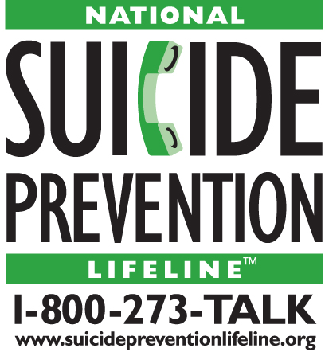

Are you an

Iraq or Afghanistan veteran

between the ages of 20 and 29?
Would you like to provide feedback on
suicide prevention materials for veterans?

We’d love to hear what you think!

Macro International Inc., a consulting firm based outside of Washington, DC, is working with the National Suicide Prevention Lifeline, through a project funded by the U.S. Substance Abuse and Mental Health Services Administration (SAMHSA), to test suicide prevention materials for veterans. We’d like to hear your suggestions on how to improve these materials.

We will be conducting focus groups in [CITY] at the [SITE] on [DATE]. Each group will last approximately 2 hours. Participants will receive $50 for their participation.

If you are interested in participating in the focus groups or would like more information, please call Karina Jimenez-Donovan toll-free at Macro at 1-866-447-2284.
We look forward to hearing from you!
Attachment 7

Participant Screener and Recruitment Script

General Information and Recruiting Specifications

Recruit participants with the following profile:
- Veterans from all branches of military services—with an emphasis on those who served, or are serving, in the National Guard.
  - With combat experience in Iraq or Afghanistan during the current conflicts.
  - Between the ages of 20 to 29.
- Gender and ethnically diverse.
- Between 30 to 50% of the participants should not currently be enrolled in VA services.

Other considerations for recruitment:
- Recruit six to eight people for each group so that a minimum of four to six participants show.
- Focus groups in LOCATION AND CITY will be held at TIME OF 1ST GROUP and TIME OF 2nd GROUP.
- If people ask where the groups are being held, you can say LOCATION AND CITY.
- Ask all participants to bring their reading glasses if necessary, because they may be asked to look at one or more documents as part of the group.

Recruiting Script

Hello, I am calling on behalf of the Substance Abuse and Mental Health Services Administration, a federal agency also known as SAMHSA. We’re sponsoring a series of focus groups in your area so that we can get opinions on some materials we’re developing. The groups will be held on DAY, DATE and DAY, DATE—you could choose the group that would best fit your schedule. Each group will take about 2 hours. Would you be interested in participating in one of these focus groups?

- No à Record reason (not interested, not available on that date, etc.); thank them politely and end call.
- Yes à Continue to screening questions.

Screening Questions

Okay, great. First, I need to ask some questions to see if you qualify for this project. This shouldn’t take more than 5 minutes.

- Are you currently serving or have you ever served in the National Guard or Reserves?
- No à Continue with Question 2.
- Yes à Continue with Question 3.

- Are you separated from the Army, Navy, Air Force, Marines, or National Guard?
- No à Thank respondent politely and end call.
- Yes à Continue.

- Have you served in either Iraq or Afghanistan during the current conflicts?
- No à Thank respondent politely and end call.
- Yes à Continue.

- Are you currently enrolled in the Department of Veterans Affairs (VA) health care system?
- No à Continue.
- Yes à Continue.

- What is your age?
- 19 or younger à Thank respondent politely and end call.
- 20 to 29 à Continue.
- 30 or older à Thank respondent politely and end call.

- Are you comfortable reading material in English and sharing your opinions about it?
- No à Thank respondent politely and end call.
- Yes à Continue.

- Are you able to participate in a local in-person group discussion lasting about 2 hours?
- No à Thank respondent politely and end call.
- Yes à Continue.

- Record gender
- Male à Continue.
- Female à Continue.

- Are you Hispanic or Latino?
- No à Continue.
- Yes à Continue.

- Which of the following best describes you? You can select more than one.
- American Indian or Alaska Native à Continue.
- Asian à Continue.
- Black or African American à Continue.
- Native Hawaiian or Other Pacific Islander à Continue.
- White à Continue.
- Prefer not to answer à Continue.

Invitation to Participate

Extend invitation to eligible respondent and record information below.

Thank you for answering our questions.

Based on your responses, we would like to invite you to participate in one of two sessions at TIME on DAY DATE or TIME on DAY DATE. Again, each session will take 2 hours. Are you available at one of these sessions? (Check to indicate for which session volunteer is available.)

Date | Time | Availability

I’m glad that you will be able to join us! At this point, I need to collect some contact information from you.

Name: ____________

Address: ______ ____________

Telephone (Day): _______ (Evening): __________________

We are only inviting a few people, so it is very important that you notify us as soon as possible if for some reason you are unable to participate. Please call CONTACT NUMBER AND PHONE if this should happen. We look forward to having you participate on DAY, DATE.

Do you have any questions?

Great! Thank you for your time and we will be in touch again before the focus group.

Terminate Text

Thank you very much for your time, and thank you for answering our questions. Unfortunately, based on the focus group requirements, we cannot extend an invitation to you at this time. Perhaps at a future time, we can include you in a focus group. Have a good [DAY/EVENING].
Attachment 8

Messages and Materials to be Pretested

“Know the Warning Signs of Suicide” Brochure (Exterior)

“Know the Warning Signs of Suicide” Brochure (Interior)

“It Takes the Courage and Strength of a Warrior” Poster 1

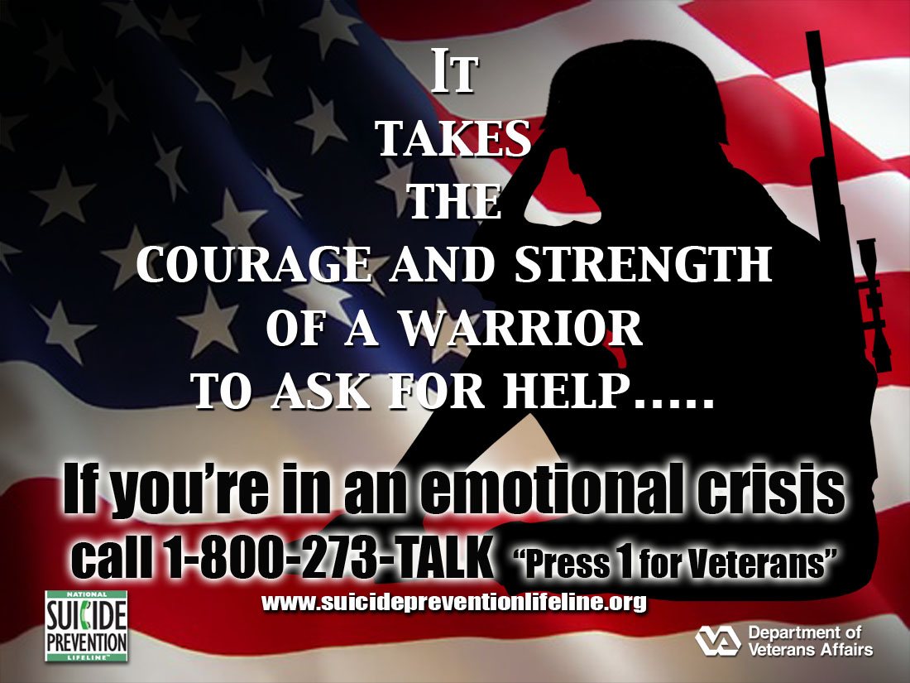
“It Takes the Courage and Strength of a Warrior” Poster 2

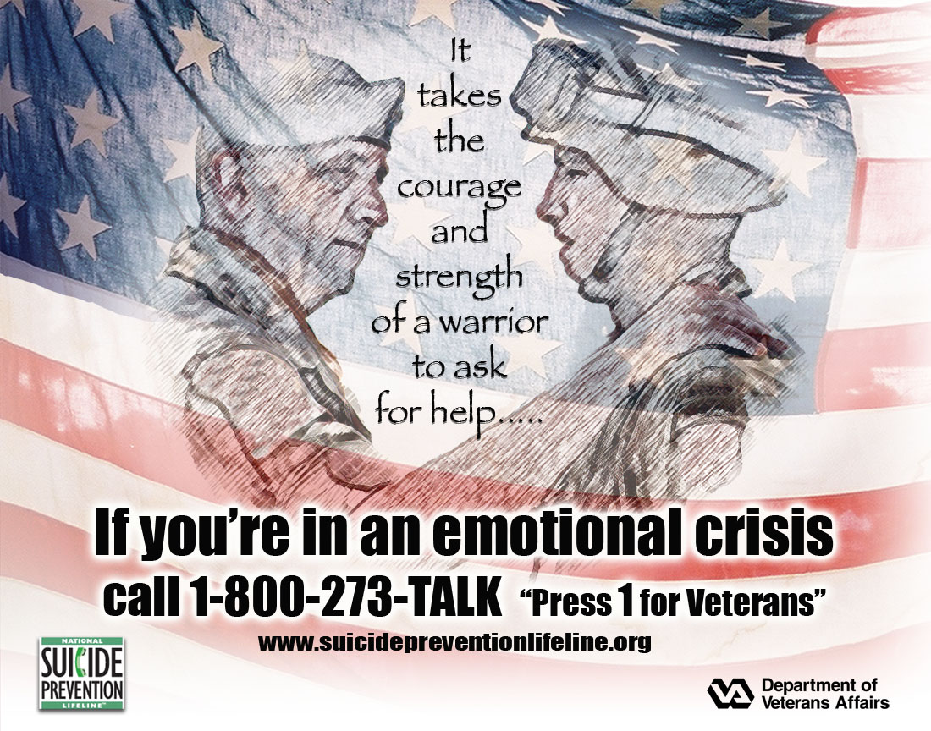

Veterans Suicide Prevention Hotline Logo 1

Veterans Suicide Prevention Hotline Logo 2

Television Public Service Announcement Transcription

I’m Gary Sinise. You may know me as Lieutenant Dan from the movie Forrest Gump or as the bass player in the Lieutenant Dan Band. I’ve had the honor to meet many of our soldiers and veterans. It’s a sad fact that some of our warriors—some of our Nation’s finest citizens—are wasting their lives through suicide. Suicide is not the answer. It’s final. It robs you of your chances for a better life and brings pain and heartbreak to your loved ones. You don’t have to go it alone. VA cares about you. VA is reaching out to veterans who are thinking about suicide. So reach back now. Don’t wait. Call 1-800-273-TALK and press one. Our counselors will not share your information with anyone. Thousands of veterans have had the courage to call. How about you? Call 1-800-273-TALK and press one.

Available online:
http://www.mentalhealth.va.gov/suicide_prevention/Sinise_092008.asx

Attachment 9

IRB Approval

