These screen shots from the Disclosure to CMS Form include references from the Disclosure to CMS guidance. The Disclosure to CMS form must be completed on-line at https://www.cms.hhs.gov/apps/ccdisclosure/ .
The disclosure to CMS web form below is not valid for submission to CMS.

BOX A

SAMPLE DISCLOSURE FORM – NOT FOR SUBMISSION TO CMS

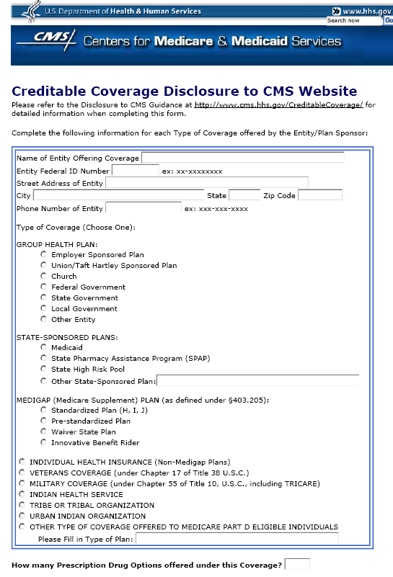

1.
2.
3.

4.

5.
6.

BOX B
SAMPLE DISCLOSURE FORM – NOT FOR SUBMISSION TO CMS

7.
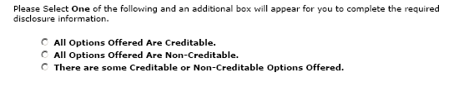

Box C - All Options Offered Are Creditable

SAMPLE DISCLOSURE FORM – NOT FOR SUBMISSION TO CMS

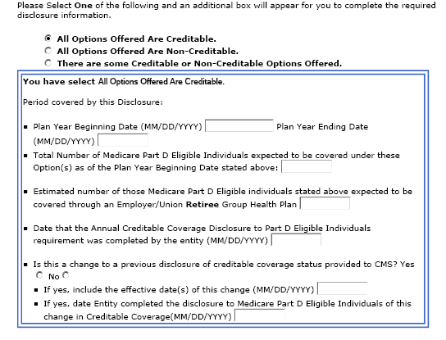
9.
10.
11.
12.
8.

Box D - All Options Offered Are Non-Creditable

SAMPLE DISCLOSURE FORM – NOT FOR SUBMISSION TO CMS

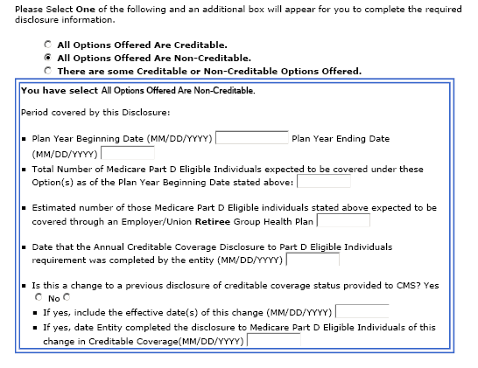
8.
9.
10.
11.
12.

Box E-There are some Creditable or Non-Creditable Options Offered
SAMPLE DISCLOSURE FORM – NOT FOR SUBMISSION TO CMS

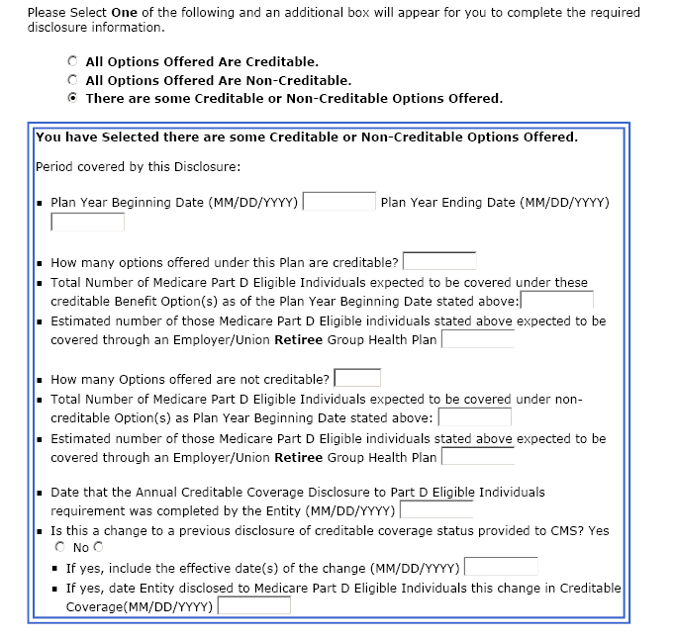
8.
A.
9.
9.
10.
10.
B.

11.
12.

BOX E
SAMPLE DISCLOSURE FORM – NOT FOR SUBMISSION TO CMS

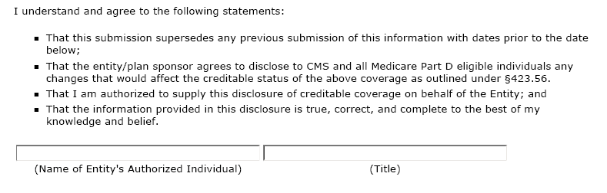
13.


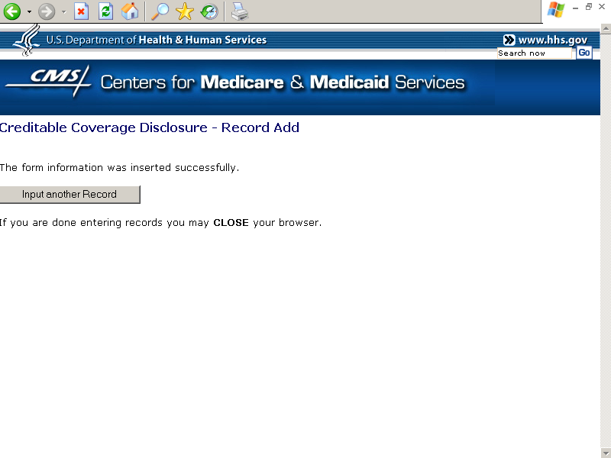
BOX F

SAMPLE DISCLOSURE FORM – NOT FOR SUBMISSION TO CMS

