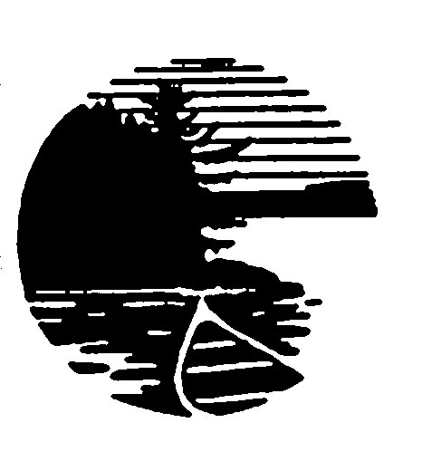

Dear Boundary Waters Visitor:

On your recent visit to the Boundary Waters, you or another member of your group was asked to participate in a current visitor study. Never before has there been so much interest in appropriate management of natural areas. This has made the protection of these unique natural areas and the provision of enjoyable wilderness visits increasingly important. To better accomplish these tasks, the public land management agency needs to hear from you, the visitor.

We would greatly appreciate your help if you would take about 20 minutes to carefully complete the enclosed questionnaire. The questions deal partially with your thoughts about Wilderness and on wilderness management and use in the Boundary Waters.

Please send the questionnaire back to us in the self-addressed, stamped enveloped as soon as possible. We want the opinions of a truly representative group of people, and so we have chosen a diverse sample of visitors to the Boundary Waters Canoe Area Wilderness. But, the sample will be good only if we hear back from the small group we have contacted.

The questionnaire has an identification number for mailing purposes only. We assure you that your name will not be associated with any of your answers. All results will be analyzed in such a way that answers on any single question cannot be identified with individual respondents.

This is a great opportunity for you to express your thoughts on increasingly important regional and national issues as they relate to the Boundary Waters Canoe Area Wilderness. If you would like a summary of the results of this study, please write your name and address on the back of the return envelope. If you have any questions or concerns, please feel free to contact me at awatson@fs.fed.us or (406) 542-4197.

Again, your help in this study is greatly appreciated.

Sincerely,

ALAN E. WATSON
Project Manager

Enclosure

