OMB No. 0581-0093

PRODUCER INFORMATION REQUEST

The National Honey Board will be happy to respond to your request to review the assessment payment history we have on file for you.

In order to protect the confidentiality of your assessment history, we must confirm that this request comes from you. To begin this process, please complete each question below.

Return your request to the National Honey Board by mail or fax. If we have not spoken with you previously regarding this request, we will call you to confirm your request. Upon confirmation, your request will be processed as quickly as possible, with the report being mailed to the address or faxed to the number provided below.

Please print clearly.

Name _____________________________________________________

Company Name _____________________________________________________

Address _____________________________________________________

City, State, Zip _____________________________________________________

Telephone (include area code) _______________________________________

Tax ID# or Employer ID# _______________________________________

- Please mail my report to me. (If you need this information quickly, please use fax option.)

OR

- Please fax my report to me at __________________________ (fax number)

Signature _______________________________ Date _____________________

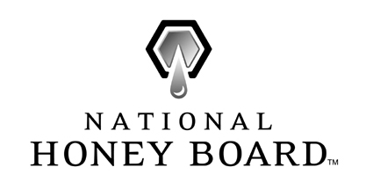
Attention: Xxxxxx
National Honey Board
Street
City, State Zip
xxx-xxx-xxxx
Fax xxx-xxx-xxxx
E-mail xxxxxxxxxxxxxxxxx

HON-PIR (09/07)

The following statements are made in accordance with the Privacy Act of 1974 (U.S.C. 522a) and the Paperwork Reduction Act of 1995, as amended. The authority for requesting this information to be supplied on the form is the Honey Research, Promotion, and Consumer Information Act (7 U.S.C. 4601-4613). Furnishing the requested information is necessary for the administration of this program. Submission of the Tax Identification Number (TIN) or Employer Identification Number (EIN) is mandatory, and will be used to determine affiliation or entity identity.

According to the Paperwork Reduction Act of 1995, an agency may not conduct or sponsor, and a person is not required to respond to a collection of information, unless it displays a valid OMB control number. The valid OMB control number for this information collection is 0581-0093. The time required to complete this information collection is estimated to average 3 minutes per response, including the time for reviewing instructions, searching existing data sources, gathering and maintaining the data needed, and completing and reviewing the collection of information.

The U.S. Department of Agriculture (USDA) prohibits discrimination in all its programs and activities on the basis of race, color, national origin, age, disability, and where applicable, sex, marital status, familial status, parental status, religion, sexual orientation, genetic information, political beliefs, reprisal, or because all or part of an individual’s income is derived from any public assistance program (Not all prohibited bases apply to all programs.) Persons with disabilities who require alternative means for communication of program information (Braille, large print, audiotape, etc.) should contact USDA’s TARGET Center at (202) 720-2600 (voice and TDD).

To file a complaint of discrimination, write USDA, Director, Office of Civil Rights, 1400 Independence Avenue, SW, Washington, DC 20250-9410 or call (800) 795-3272 (voice) or (202) 720-6382 (TDD). USDA is an equal opportunity provider and employer.

HON-PIR (09/07)

