Associations Version

Soliciting Email

Last fall, we asked for your help in promoting the 2007 Economic Census to your members, and sent additional communications through February of this year, when forms were due back from more than 4 million businesses. Now that data collection is complete, we can proudly say that, with your help, business response was the best in years, and, in some categories, the best ever.

Please help us evaluate the promotional activities we undertook with you, and tell us how we can best assist you in the future, by completing a short survey at http://questionweb.com/XXXXX. Your response is voluntary, and is anonymous unless you choose to identify yourself to us.

Page 1

Survey of Associations on the 2007 Economic Census Promotion
December 2008

The U.S. Census Bureau is conducting a study to evaluate its efforts in promoting the 2007 Economic Census. Your input will help us assess last year's outreach campaign and make improvements for the future.

Please take about 5 minutes to complete this survey. Your responses are voluntary and we will ensure your confidentiality under the provisions of Title 13 USC Section 9. We will report findings in summary form only.

This survey is being conducted under OMB Clearance Number 0607-0760, which expires on November 30, 2010. For further information on this clearance, please contact the Customer Liaison and Marketing Services Office at 301-763-4094. For further information about this survey, please contact the Economic Census Staff at 301-763-2547.
Page 2
Q1 – Do you recall receiving materials about the Economic Census (illustrated below) or being contacted by a Census Bureau representative during the past year (primarily October 2007 to February 2008)?
Please check all that apply:
- Yes – Received letter with brochure
- Yes – Received email
- Yes – Received phone call or personal visit from Census staff
- No – Do not recall
Here are some reminders of promotional materials for the 2007 Economic Census.
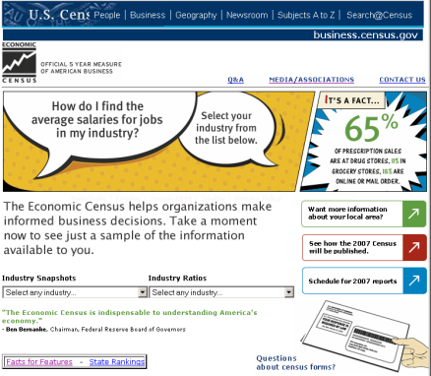  To review more, see:  http://business.census.gov/[resources for businesses]  http://business.census.gov/media[resources for associations including story ideas, web ads] | 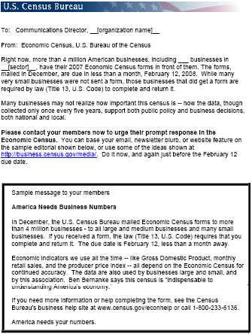  To review more of the communications we sent you, see:  http://business.census.gov/media/email/  assnpromo.htm [copies of emails and other materials sent your organization]

Page 3
Q2 – Did you include anything about the 2007 Economic Census in your communications with your members? Mark all that apply.
- Emails to your members
- Your newsletters, press releases, or other publications
- On your web site
- Presentations or other member contacts
- No, we used the material only for staff information
- Don’t remember

Q3– Did you use any of the background material from the emails and web site we provided? Mark all that apply.
- Statistics for your industry (such from http://business.census.gov/snapshots)
- Story ideas (such from http://www.census.gov/econ/census/media/storyideas.htm)
- Promotional graphics (such from http://www.census.gov/econ/census/media/printpsas.htm)
- None
- Don’t remember
Q4 – Did you link from your web site to http://business.census.gov?
- Yes
- No
- Don’t know

Q5 – Please rate your overall reaction to the communications you received from the Census Bureau:
- Very favorable
- Somewhat favorable
- Negative

Q6 – What could we have done to better help you to provide your members with information about the 2007 Economic Census? Please be specific. (Write in response)
Page 4

Q7 – Did any of your members ask you any questions or give you any feedback about the 2007 Economic Census?
- Yes
- No

Q8 – Please share any specific feedback or questions from your members about the 2007 Economic Census.

Page 5
Q9 – Prior to last year, were you familiar with the Economic Census?
- Very familiar
- Somewhat familiar
- Did not know about it

Q10 – Please rate your impression of the Economic Census prior to receiving publicity last year.
- Very favorable
- Somewhat favorable
- Unfavorable
- No opinion

Q11 – After seeing the campaign and/or being contacted by the Economic Census last year, how have your impressions of the Economic Census changed?
- More favorable
- Less favorable
- No change
- Do not recall publicity

Page 6
2007 Economic Census data for the industries or areas you are interested in will be
published starting in a few months:
March 2009: Advance report (national data for 2- and 3- digit NAICS industries)
April-December 2009: Industry Series (national data for 6-digit NAICS industries)
Sep 2009-Aug 2010: Geographic Area Series (industry data for states, metropolitan areas, counties, cities)
Q12-What is the best way to inform you when data relevant to your interests become available?
- Special Web site you can check any time
- Press releases when each new series begins
- Emails announcing the availability of data for specific industries or areas you check on a list
- Other, please specify:_____________________________________________
Page 7
Q13 – Which of the following best describes your role within your organization?
- Executive Leadership
- Marketing and communications
- Membership relations
- Publication editor
- Web site manager
- Researcher
- Other (please specify)_________________________

If you would be willing to discuss your reaction to the Economic Census or this promotional effort with Census Bureau staff, please tell us how to reach you.
Name_____
Organization___
Phone___
Email____

Page 8
Thank you for helping us help you with the Economic Census.
2007 Economic Census data for the industries or areas you are interested in will be published starting in a few months:
March 2009: Advance report (national data for 2- and 3- digit NAICS industries)
April-December 2009: Industry series (national data for 6-digit NAICS industries)
Sep 2009-August 2010: Geographic Area Series (industry data for states, metropolitan areas, counties, cities)
For other series, see http://www.census.gov/econ/census/guide/g07sched.htm.
We will email you as these dates get closer.
If you have questions, contact us at 301-763-2547 or econ@census.gov.

