Representative Guide for
Communication Utility

Sending Communication
by Secure Website



Office of Disability Adjudication and Review

June 2007

ODAR COMMUNICATION UTILITY
INSTRUCTIONS

New User Instructions for the Communication Utility

Logging In

- Open an Internet browser (such as Internet Explorer or Netscape).

- In the address window type in: http://eme.ssa.gov (do not type “www.”).

- Once you have this page up, click on “Favorites”
- Click “Add to Favorites”
- Where it says name, type in “ERE Website” and click the OK button.

- Enter your case-sensitive Username and Password
NOTE: The Office of Disability Adjudication and Review (ODAR) will assist you in obtaining a Username and Password.

- Click the LOGIN button.
NOTE: Users should be aware that, after three failed attempts to sign in, their account will be locked. If this occurs, additional assistance may be obtained online by sending an email to EEAccountInfo@ssa.gov or calling 1-866-691-3061. You may also report problems to odar.hq.rep.mail@ssa.gov.
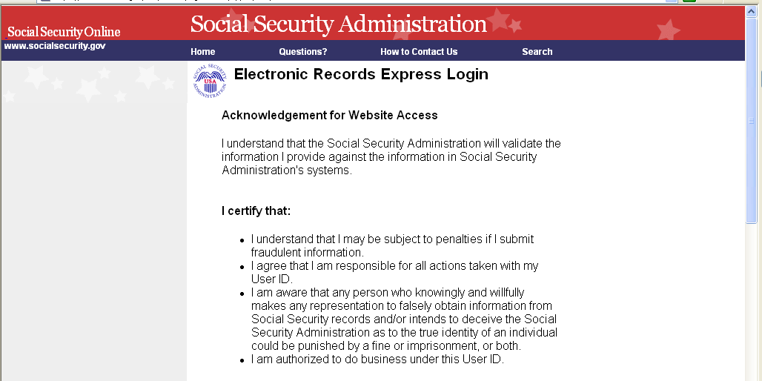
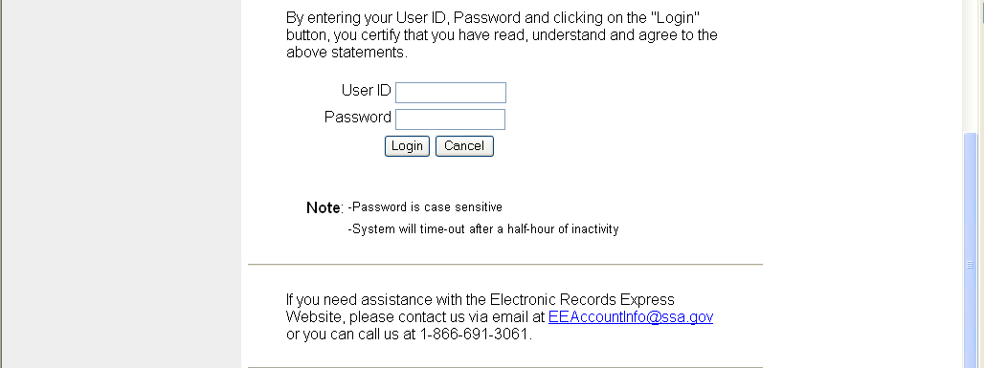
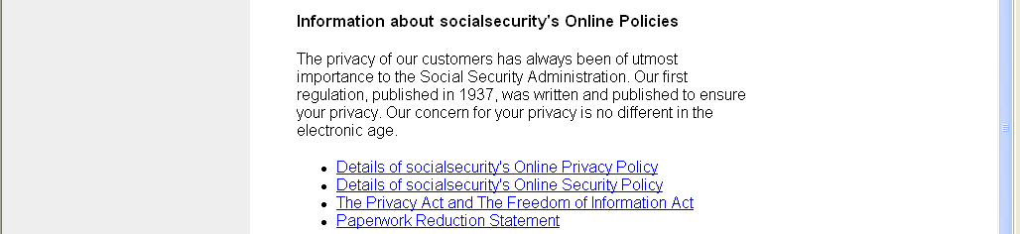

- If this is the first time you are logging into the ERE website, you will be required to change your password; this is a security feature.
  - The Change Password page should automatically appear. You can also access the “Change Password” option from the ERE Home Page (scroll down and the “Change Password” option is on the left side of your screen).

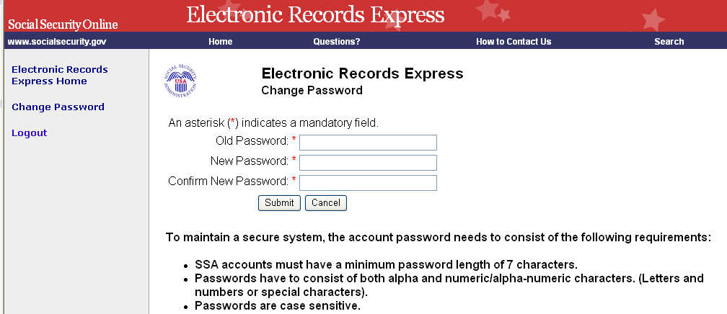

  - Enter the password you were given by ODAR in the old password window.
  - Enter a new password that is at least 7 characters long and includes both letters and numbers. Confirm your new password by entering it again in the last box. Remember that your Username and Password are case sensitive.
  - Your password will expire every 90 days and you will be prompted to change your password; the screen below will appear after you login.

NOTE: You are given three attempts to enter your password. After the third attempt you will be locked out. If you are locked out of the website, you will need to send an email to EE Account Info.

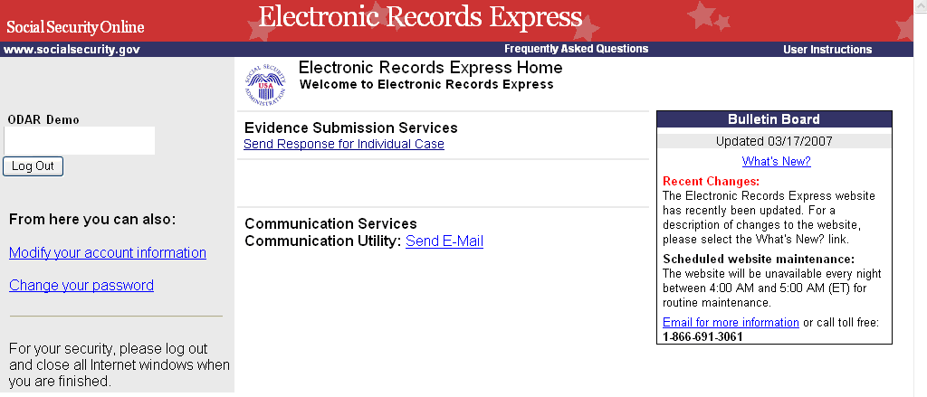

When you have changed your password after your first login, you may proceed with sending a secure one-way communication to ODAR.

Note: The ERE Home Page lists a number of electronic transmission features. Only the “Communication Utility” under “Communication Services” and “Send Response for Individual Case” under “Evidence Submission Services” are available for ODAR users at this time.

- Entering a correct Username and Password will bring you to the ERE Home Page.

Getting Started

At the Home Page click on the Communication Utility link under in the Communications Services section.

This will bring you to the Communication Utility page.
- Click on the drop-down menu to select the HO where you wish to send the communication. Enter the subject of the communication in the SUBJECT box.

- If you are attaching a document, select the “Browse” button to select the file you want to send. To send additional files, select the “Add Another File”. The file(s) you are sending cannot exceed 5 megabytes in size.

NOTE: DO NOT SEND DOCUMENTS THAT ARE CASE RELATED. The communication utility is for general information purposes only.

- If you are including a narrative, enter your text message here.
- Click the Submit button to send your message. You will get a confirmation indicating your message has been sent.

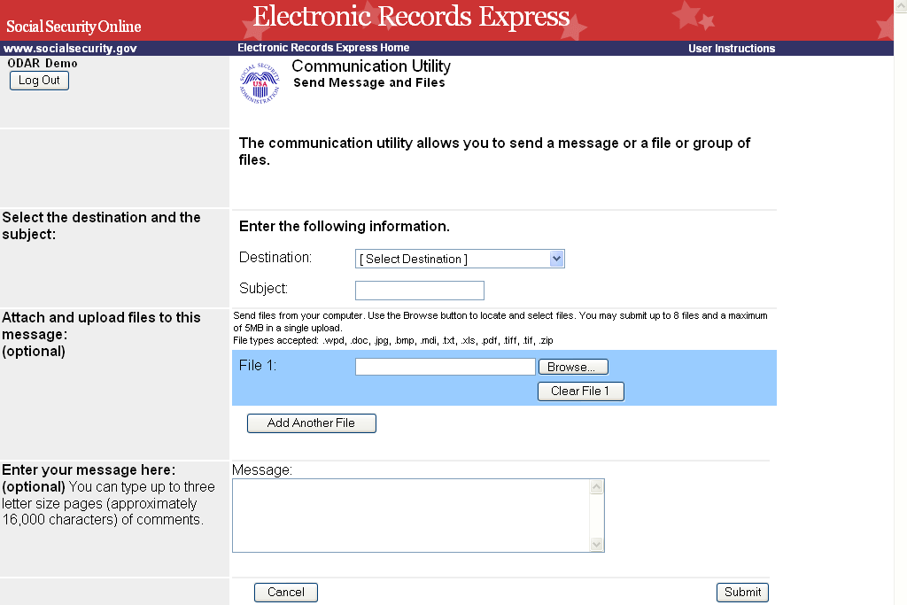

CONFIRMATION PAGE
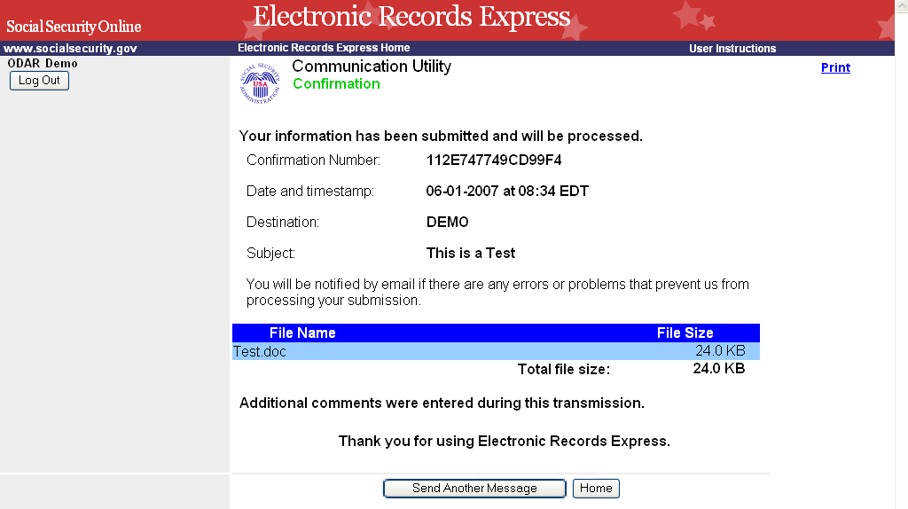

Change Your Email Address:
If your email address shown on the ERE website Home page (in the User Information box) is incorrect, take the following steps to correct:

- Select the ‘Change’ link within the User Information box.
- Enter your new email address within the ‘Email’ field.
- Select the ‘Submit’ button to forward the change.
- A Confirmation Email will be sent to your new email address once the change is processed.

