Appendix A

Notification Letters

[informational letter to be sent to survey districts]

Date

[name and address]

Dear Superintendent:

We are writing to inform you about an upcoming evaluation sponsored by the U.S. Department of Education. The Study of Education Data Systems and Decision Making is part of the National Technology Activities Task Order (NTA) which is an effort by the Department to provide analytic and policy support for educational technology leadership activities focused on the implementation of Title II Part D of NCLB. A copy of the study brochure is enclosed for your information. The study will document the availability of systems and supports for using data to improve instruction, and the prevalence and nature of data-informed decision making in districts and schools. It will examine the challenges that educators face in trying to use data systems in their efforts to improve instruction and the practices employed by districts and schools that have used data to inform their decisions and have obtained successful outcomes for their students. Data for the study will include case studies of 30 schools conducted during the 2006-07 school year and a nationally representative survey of 500 districts conducted in fall 2007. Your district has been selected to be part of the national survey sample.

Given the topics covered in the survey, the most appropriate respondent will be your district staff member who has primary responsibility for leading data-driven instructional improvement activities. We would appreciate it if you can provide this information through an e-mail message to SRI International who is conducting the study under contract to the U.S. Department of Education (bladimir.lopez-prado@sri.com) or in the envelope provided.

The information collected for this study can be used by (1) states and districts to identify and develop policies to support promising practices in data-driving decision making and to develop and implement performance measurement systems that utilize high quality data, and by (2) U.S. Department of Education staff to design outreach efforts to stimulate and enhance the use of data systems to improve instruction. Please note that we will provide participants with an executive summary of our findings that will include information on promising practices in data-driven decision making drawn from the study.

The information that is collected for this study will be used only for statistical purposes and no information that identifies individual districts will be provided to anyone outside the study team, except as required by law. Reports prepared for the Department of Education will summarize findings across the sample of schools and districts, and will not associate responses with a specific district, school or individual. The final report for the study will be available in fall 2008.

If you have any comments or questions regarding the study, please contact the Deputy Project Director, Christine Padilla, at 650-859-3908 or via e-mail at christine.padilla@sri.com. Thank you very much for your time and cooperation.

Sincerely,

Timothy J. Magner Alan Ginsburg
Director, Office of Educational Technology Director, Policy and Program Studies Service

Enclosures (2)

[cover letter for district survey]

Date

Dear Colleague:

Enclosed you will find a copy of the district survey for the Study of Education Data Systems and Decision Making sponsored by the U.S. Department of Education under Title II, Part D, of the Elementary and Secondary Education Act. While data has been collected on the range of database systems that manage, collect and analyze data, much less is known about actual system usage in ways that support better teaching and learning. The purpose of the study is to document the availability of education data systems, their characteristics, the prevalence and nature of their use in districts and schools, and the conditions and practices associated with effective data usage. A copy of the study brochure is enclosed for your information.

We are sending you this survey because you were identified by your district as the staff member who has primary responsibility for leading data-driven activities related to instructional improvement. In some instances, you may need to consult with colleagues in responding to items. Collectively, it will take approximately 60 minutes to complete.

We recognize that participation in this study will require time and energy from you, however, we are requesting your support of this important study so that we can develop a body of knowledge in this emerging field that can inform both educational policy and school district practice. The information collected for this study can be used by (1) states and districts to identify and develop policies to support promising practices in data-driving decision making and to develop and implement performance measurement systems that utilize high quality data, and by (2) U.S. Department of Education staff to design outreach efforts to stimulate and enhance the use of data systems to improve instruction. Please note that we will provide participants with an executive summary of our findings that will include information on promising practices in data-driven decision making drawn from the study.

Under the U.S. Department of Education General Administrative Regulations (EDGAR Section 76.591) grantees are required to cooperate with Department evaluations of programs for which they receive funds. Your prompt response to this survey is crucial to the study, as your district has been selected to represent many others nationwide.

The information that is collected for this study will be used only for statistical purposes and no information that identifies you or your district will be provided to anyone outside the study team, except as required by law. Reports prepared for the Department of Education will summarize findings across the sample of schools and districts, and will not associate responses with a specific district, school or individual. The final report for the study will be available in fall 2008.

The study is being carried out by SRI International, a not-for-profit research organization under contract to the U.S. Department of Education. If you have any questions or concerns about this survey, please call Bladimir Lopez-Prado at 650-859-4898, or e-mail him at bladimir.lopez-prado@sri.com.

Sincerely,
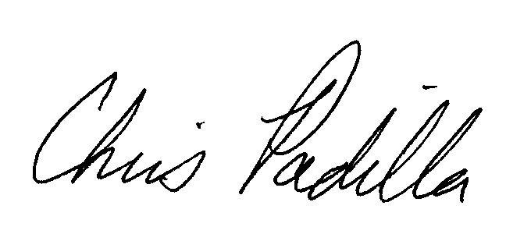
Christine Padilla
Deputy Project Director

Enclosure (2)

SRI International is a not-for-profit research organization located in Menlo Park, California.

