The following screens represent the minimum required actions for PHAs to report mitigation of exigent health and safety deficiencies identified during the property’s inspection. The term “user” throughout this document refers to a PHA.

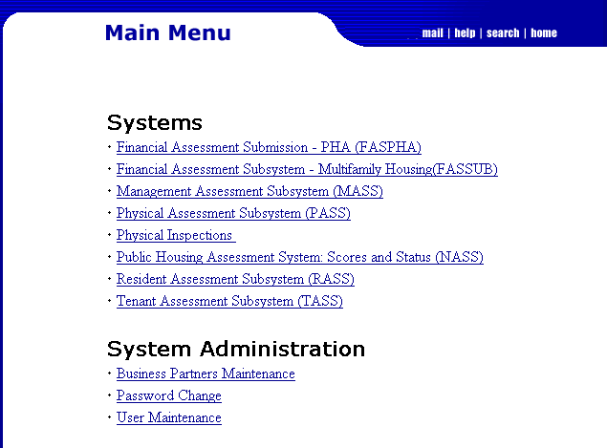
1

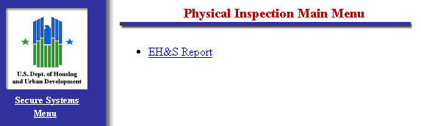
2

Note: The hyperlinks available on the above menus may vary according to the user’s login credentials; therefore the screens may differ from what is shown.

The user will enter any search criteria (e.g. Inspection ID or Property ID), then click the Search button in order to retrieve the desired properties and their inspections.
3
4
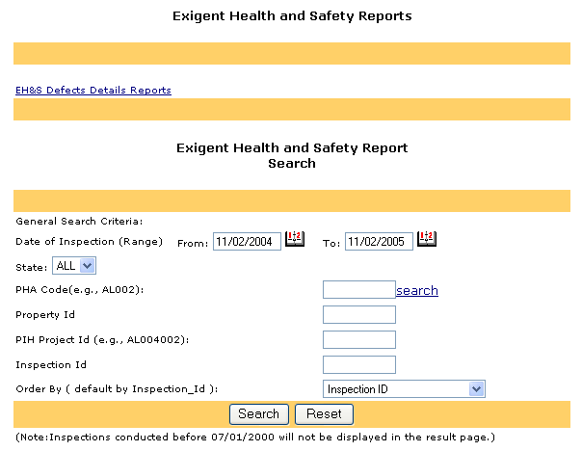

Note: Inspections only appear in the application after they have been finalized and released to the PHA.

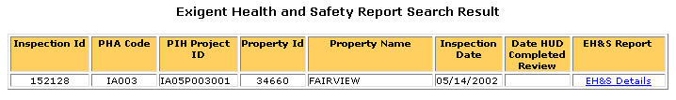
5

For each inspection, the user will select the “EH&S Details” hyperlink in order to see all EHS deficiencies originally recorded during the inspection.

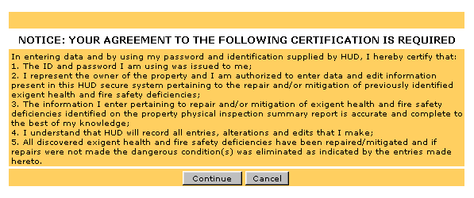
6

The user must select the “Continue” button from the certification screen. By agreeing to these terms, the user understands that entries of repair or mitigation of deficiencies are certifications for those activities.

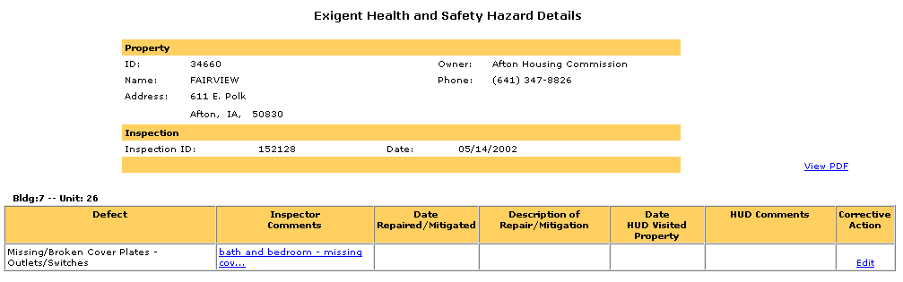
7

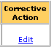
The user will select the “Edit” link in the “Corrective Action” section of the EHS details page. This will bring the user to the following page.

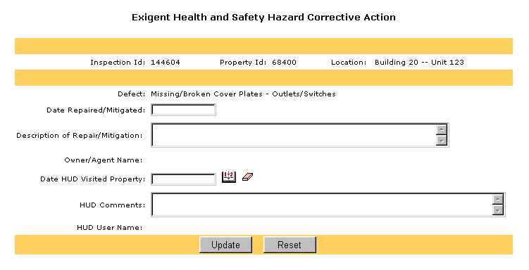
8

The user will complete the “Date Repaired/Mitigated,” and the “Description of Repair/Mitigation” fields, according to the mitigation or abatement activity conducted. (Note: The “Description of Repair/Mitigation” will be the same information the PHA would have entered into the paper-based certification form.).
9

Once the information has been entered, the user will select the “Update” button to save their changes.

