NCMHD Research Endowment Program

Annual Progress Report Supplemental Instructions to
PHS 2590

Nathan Stinson, Jr., PhD, MD, MPH
Acting Program Director
NCMHD Research Endowment Program
stinsonn@mail.nih.gov
301-402-1366

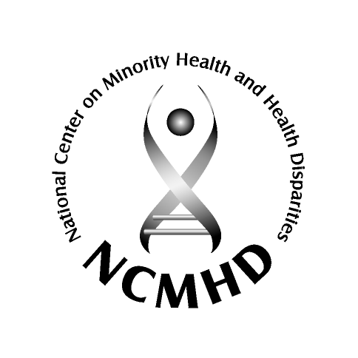



Annual Progress Report Supplemental Instructions to PHS 2590
Research Endowment Program
National Center on Minority Health and Health Disparities (NCMHD)
National Institutes of Health (NIH)
Department of Health and Humans Services (DHHS)

These supplemental instructions specify certain information
to be included as part of the PHS 2590.

SUPPLEMENTAL INSTRUCTIONS TO THE GRANT PROGRESS REPORT
This report should provide information about changes in your program, and a summary report of the evaluation of your program. These annual progress reports will be closely monitored by NCMHD staff to ensure that the grant is achieving the goals of the Research Endowment Program and the NCMHD.

In addition, the overall progress report should include the following information: (This expanded progress report is in addition to, and does not replace, other management reports required by PHS policy):

A summary (equivalent to no more than 2-4 single-space typewritten pages) of the goals and significant activities of your institution’s Research Endowment. This summary should be prepared for a general audience. Honors and/or promotions of professional personnel should be mentioned.

A discussion of the effectiveness of your institution’s Research Endowment in furthering the goals of the NCMHD Endowment Program. This should include a summary of the specific accomplishments that can be attributed to the award.

We are interested in learning about both successes and unintended outcomes of your program. Include your efforts to measure your program’s progress. Changes that you will make in your project as a result of this evaluation. You may append your assessment tools (i.e., questionnaires) to this Progress Report. Please include answers to the following questions in your update (3-5 page limit).

- What were the significant unexpected outcomes (positive or negative) of your NCMHD Research Endowment Program activities?
- What were the challenges or obstacles your Program encountered in reaching its goals and what are your plans to overcome these challenges? Give a brief discussion of problems that impede accomplishment of the stated goals in the administration of the Program.
- What has been the impact of the Program on your institution?
- What are the best products of your Program (new courses and techniques, scientific findings, other…)?
- Did you credit NIH-NCMHD funding in your publications?*

Links to on-line journal or the NIH PubMed Central submission identification number for publications resulting from Endowment support (for papers and abstracts published or accepted for publication). Copies of submitted manuscripts and abstracts should not be sent.

………………………………………………………………………………………………

* All publications from NCMHD Research Endowment Program activities supported entirely or in substantial part by the NIH should include the following or comparable acknowledgement of support: “The project/study described was supported by Grant Number S21/S22 MD XXXXX, from the National Center on Minority Health and Health Disparities, National Institutes of Health. Its contents are solely the responsibility of the authors and do not necessarily represent the official views of National Institutes of Health or the National Center on Minority Health and Health Disparities.”

