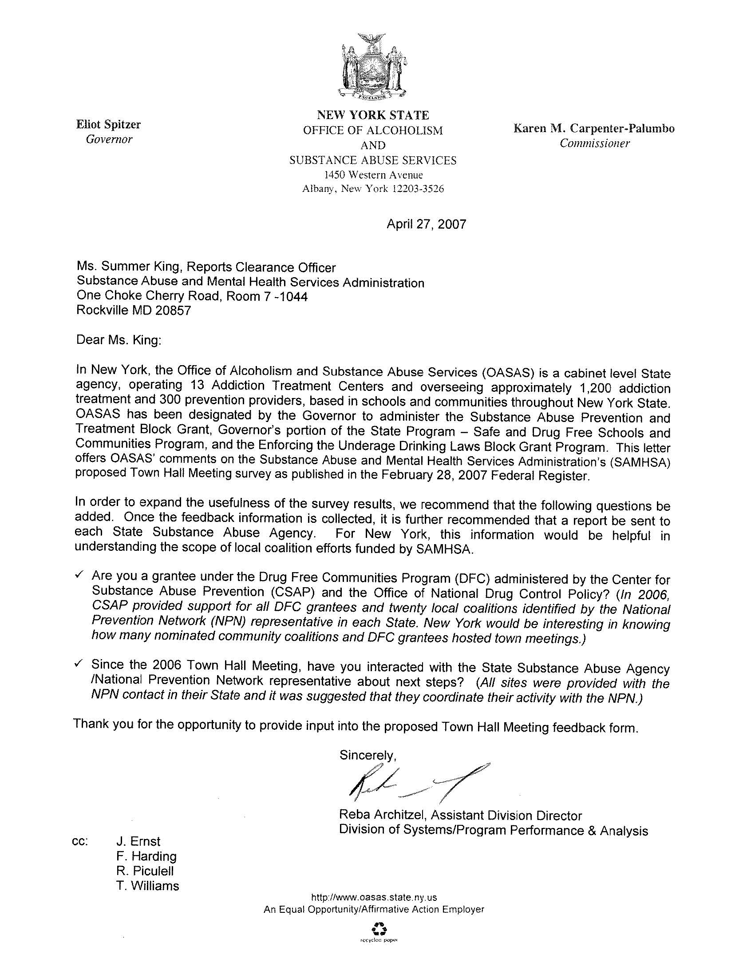

Attachment 2

Comment Received to FRN and Response

