|  |  |
| --- | --- |
|  | |
|  | Social Science ProgramNational Park Service **U.S. Department of the Interior**  **Visitor Services Project** |

# Klondike Gold Rush

# National Historical Park

# Seattle Unit

### Visitor Study

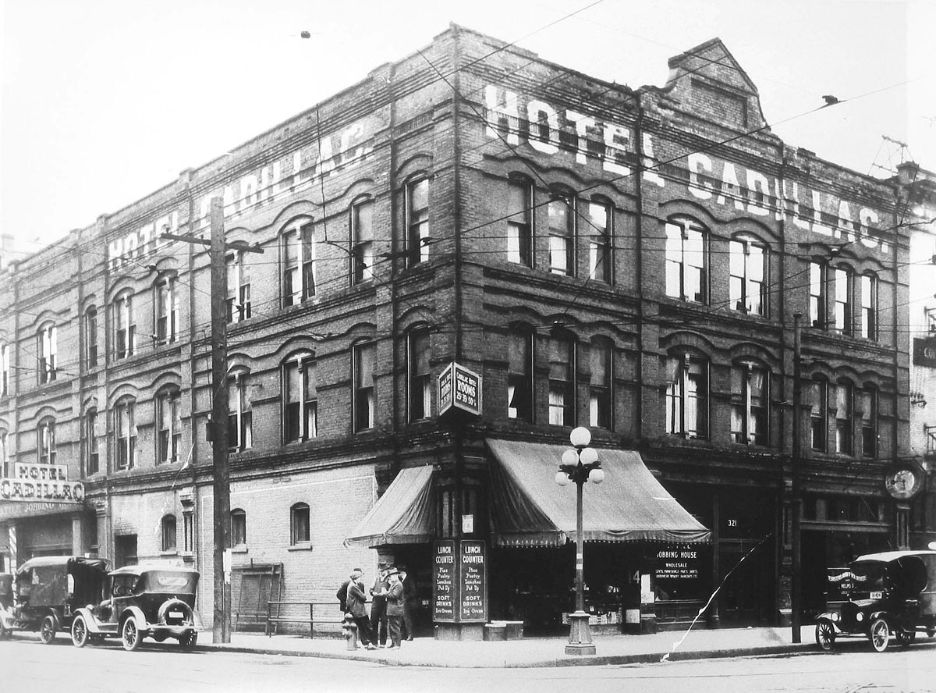

ca 1920’s

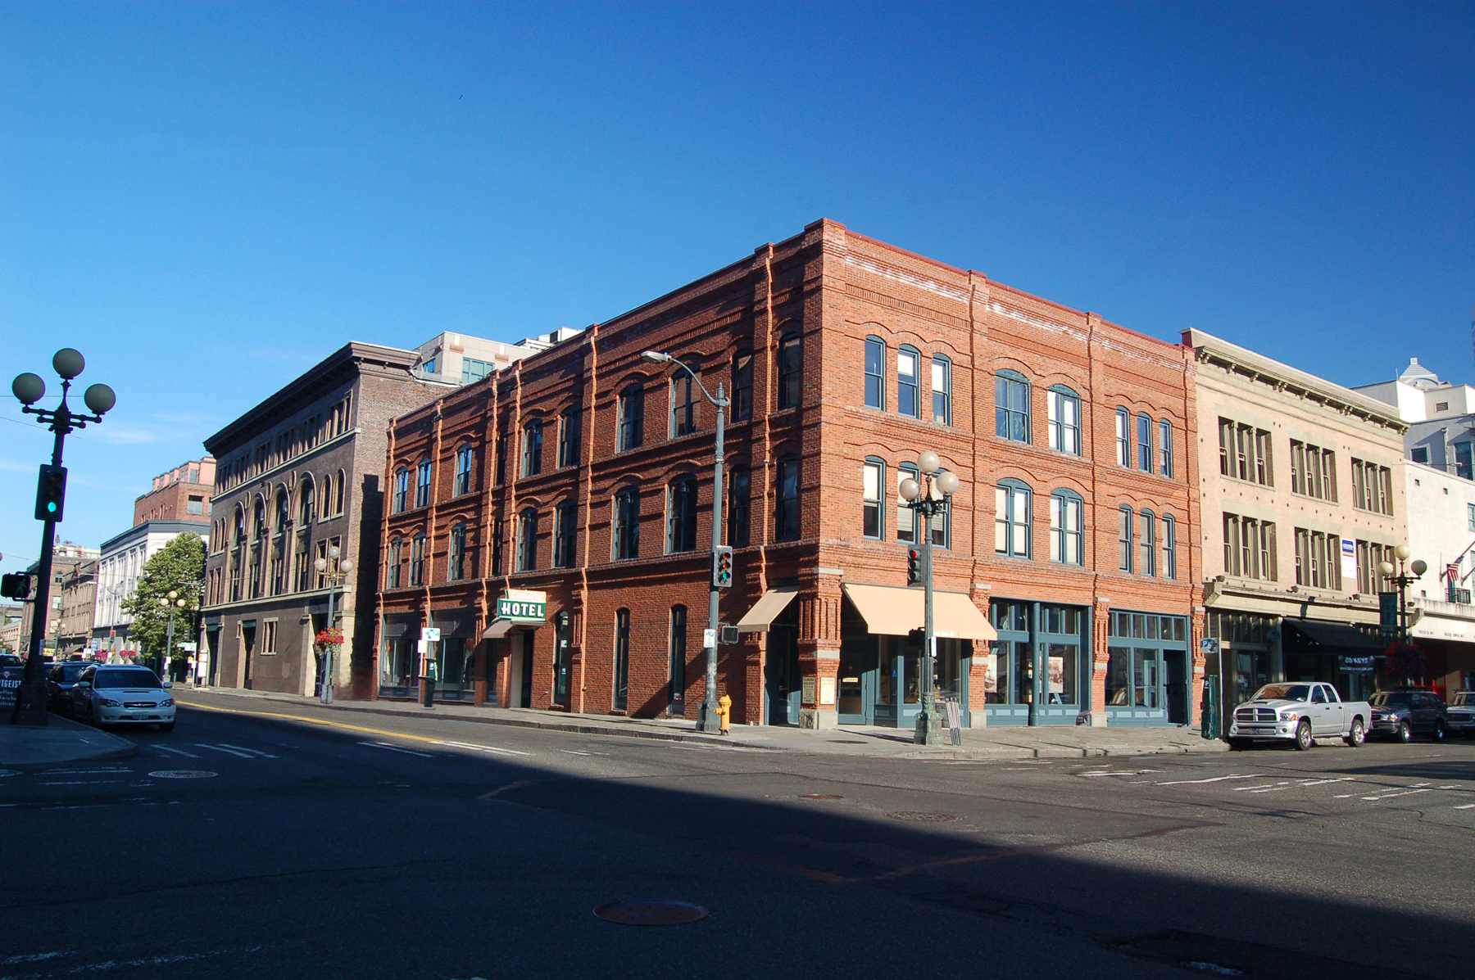

OMB Approval 1024-XXX (NPS# 09-XXX)

Expiration date: XXX-2010

|  |  |  |
| --- | --- | --- |
| IN REPLY REFER TO: | **United States Department of the Interior**  NATIONAL PARK SERVICE  Klondike Gold Rush National Historical Park  Seattle Unit  319 Second Avenue South  Seattle, WA 98104 |  |
| July/August 2009  Dear Visitor:  Thank you for participating in this important study. Our goal is to learn about the expectations, opinions, and interests of visitors to Klondike Gold Rush National Historical Park Seattle Unit. This information will assist us in our efforts to better manage this park and to serve you, our visitor.  This questionnaire is only being given to a select number of visitors, so your participation is very important! It should only take about 20 minutes after your visit to complete.  When your visit is over, please complete this questionnaire. Seal it with the stickers provided on the last page and drop it in any U.S. mailbox.  If you have any questions, please contact Margaret Littlejohn, NPS VSP Coordinator, Park Studies Unit, College of Natural Resources, P.O. Box 441139, University of Idaho, Moscow, Idaho 83844-1139, phone: 208-885-7863, email: littlej@uidaho.edu.  We appreciate your help.  Sincerely,  Karen Beppler-Dorn  Superintendent | | |

**DIRECTIONS**

At the end of your visit:

1) Please have the selected individual complete this questionnaire.

2) Answer the questions carefully since each question is different.

3) For questions that use circles (O), please mark your answer by

filling in the circle with black or blue ink, or a pencil with dark

(e.g. #2) lead.



4) Seal it with the stickers provided.

5) Drop it in a U.S. mailbox.

Thank you!

**PRIVACY ACT and PAPERWORK REDUCTION ACT statement**:

16 U.S.C. 1a-7 authorizes collection of this information. This information will be used by park managers to better serve the public. Response to this request is voluntary. No action may be taken against you for refusing to supply the information requested. Your name is requested for follow-up mailing purposes only. When analysis of the questionnaire is completed, all name and address files will be destroyed. Thus the permanent data will be anonymous. Please do not put your name or that of any member of your personal group on the questionnaire. An agency may not conduct or sponsor, and a person is not required to respond to, a collection of information unless it displays a currently valid OMB control number.   
 **Burden estimate statement**: Public reporting burden for this form is estimated to average 20 minutes per response. Direct comments regarding the burden estimate or any other aspect of this form to Margaret Littlejohn, NPS Visitor Services Project, College of Natural Resources, University of Idaho, P.O. Box 441139, Moscow, ID, 83844-1139; email: littlej@uidaho.edu.

**Your Visit To Klondike Gold Rush National Historical Park Seattle Unit**

NOTE: In this questionnaire, your **personal group** is defined as anyone that you are visiting the park with, such as spouse, family, friends, etc. This does not include the larger group that you might be traveling with, such as school, church, scouts, or tour group.

1. a) Prior to your visit, how did you and your personal group obtain information about Klondike Gold Rush National Historical Park (NHP)? Please mark (•) **all** that apply in column (a).

b) If you were to visit Klondike Gold Rush NHP in the future, how would you and your personal group prefer to obtain information about the park? Please mark (•) **all** that apply in column (b).

a) **Prior to this visit** b) **Prior to future visits**

O Did not obtain information prior to visit 🡺**Go to part b of this question**

O Previous visits O

O Friends/relatives/word of mouth O

O Travel guides/tour books (such as AAA, etc.) O

O Maps/brochures O

O Newspaper/magazine articles O

O E-mail/telephone/written inquiry to park O

O Television/radio programs/videos O

O Klondike Gold Rush NHP website: [www.nps.gov/klse](http://www.nps.gov/klse) O

O Other websites O

O School class/program O

O Local businesses O

O Tour businesses (hotels concierge, Amtrak, cruise lines, etc.) O

O Chamber of Commerce/visitors bureau/state welcome center O

O Referral from other tourist attraction--Which one? (Specify below) O

This visit Future visit

O Other (Please specify below) O

This visit Future visit

c) From the sources you used prior to this visit, did you and your personal group receive the type of information about the park that you needed?

O No O Yes 🡺 **Go to Question 2**

d) If NO, what type of park information did you and your personal group need that was not available? Please be specific.

2. a) **Prior to this visit**, were you and your personal group aware that Klondike Gold Rush NHP is a unit of the National Park System?

O Yes O No

b) **Prior to this visit**, were you and your personal group aware that Klondike Gold Rush NHP is a part of the Klondike Gold Rush International Historical Park?

O Yes O No

c) **Prior to this visit**, were you and your personal group aware of the related site, Klondike Gold Rush NHP in Skagway, Alaska?

O Yes O No

d) Have you and your personal group visited Klondike Gold Rush NHP in Skagway, Alaska?

O Yes O No

e) Would you and your personal group be likely to visit Klondike Gold Rush NHP in Skagway, Alaska in the future?

O Yes, likely O No, unlikely O Not sure

3. a) On the day that you received this questionnaire, what was your last mode of transportation to arrive at Klondike Gold Rush NHP? Please mark (**•**) **one**.

O Taxi/limousine

O Van/bus provided by tour company/hotel/school/church, etc.

O Walk from public transportation station (bus, train, trolley, etc.)

O Walk from home or hotel or from other attractions in the area

O Bicycling from home/hotel/other attractions/bus stop

O Rental or private vehicle (car, RV, motorcycle, etc.)

O Other (Please specify)

b) If you arrived at Klondike Gold Rush NHP by rental or private vehicles, how many vehicles did you and your personal group use to arrive at the park?

Number of vehicles

4. a) Were the signs directing you to sites of Klondike Gold Rush NHP adequate? Please mark (**•**) **one** response for each.

**Pedestrian signs** in Seattle directing you to Klondike Gold Rush NHP adequate?

O Yes O No O Did not use

**Driving signs** in Seattle directing you to Klondike Gold Rush NHP adequate?

O Yes O No O Did not use

b) If your answer is NO to either of the above, please explain the problem.

Pedestrian signs

Driving signs

5. a) On this visit to Klondike Gold Rush NHP, did you and your personal group experience any parking problems?

O Yes O No

b) If YES, what parking problems did you experience?

6. How did your visit to Klondike Gold Rush NHP fit into you and your personal group’s travel plans? Please mark (•) **one.**

O Klondike Gold Rush NHP was primary destination

O Klondike Gold Rush NHP was one of several destinations

O Klondike Gold Rush NHP was not a planned destination

7. On this visit, which of the following sites in the city of Seattle did you visit? Please mark (•) **all** that apply.

O Art galleries O Seattle Aquarium

O Glass blowing shop O Smith Tower

O National Park Conservation Association O Theatre/plays

O Sculpture Garden/other gardens O Underground Tour

O Sports arenas/stadiums O Woodland Park Zoo

O Pike Place Market/Space Needle/Seattle Center

O Museums (Museum of History & Industry, Museum of Flight, Seattle Art Museum)

O Other (Please specify)

8. a) On this visit, how long **in total** did you and your personal group spend visiting Klondike Gold Rush NHP?

Total number of hours (Please list partial hours as ½, ¼, etc.)

b) On this visit, did you and your personal group visit the park on more than one day?

O No O Yes 🡺 c) If YES, on how many days did you visit?

Number of days

9. a) On this visit, how safe did you and your personal group feel while walking around/visiting the following locations? Please mark (•) **one** for each location.

|  |  |  |  |  |  |  |
| --- | --- | --- | --- | --- | --- | --- |
|  | Did not visit/ take walk | Very unsafe | Unsafe | Neither safe nor unsafe | Safe | Very safe |
| Self-guided walking tour of Pioneer Square--Seattle’s first neighborhood (20 blocks) | O | O | O | O | O | O |
| Ranger-led walking tour of Pioneer Square | O | O | O | O | O | O |
| Visiting Seattle locations other than Pioneer Square | O | O | O | O | O | O |

b) If you and your personal group were to visit Klondike Gold Rush NHS in the future, would you interested in attending an outdoor ranger-led program at a location near the park?

O Yes, likely O No, unlikely O Not sure

c) How safe would you and your personal group feel attending an outdoor ranger-led program at a location near the park?

|  |  |  |  |  |
| --- | --- | --- | --- | --- |
| Very unsafe | Unsafe | Neither safe nor unsafe | Safe | Very safe |
| O | O | O | O | O |

10. a) During your visit to Klondike Gold Rush NHP, did you and your personal group learn about the following topics? Please mark (**•**) all that apply.

b) If you were to visit the park in the future, would you and your personal group be interested in learning or learning more about the following topics? Please mark (**•**) all that apply.

a) **Learned on this visit** b) **Learn on future visits**

O The Klondike Gold Rush attracted a large number of diverse people for O

different reasons from all over the world

O Seattle’s location, promotion of the Klondike Gold Rush and ability to O

provide supplies/services improved Seattle’s financial prosperity/status

O Klondike Gold Rush affected diverse individuals, cultures and O

environments differently, both good and bad

O Klondike Gold Rush links the past to the present within the Pioneer O

Square National Historic District

O Klondike Gold Rush established Seattle as a leading seaport city O

O Through worldwide advertising, Seattle became the primary O

transportation gateway and supplier for the gold rush

O Other (Please specify below) O

This visit Future visit

c) In your opinion, which stories, if any, presented at Klondike Gold Rush NHP need to be emphasized or strengthened?

11. a) On this visit, which activities did you and your personal group participate in while visiting Klondike Gold Rush NHP? Please mark (•) **all** that apply.

O Participated in Junior Ranger program

O Attended ranger-led gold panning demonstration

O Attended ranger-led walking tour

O Attended ranger talks

O Attended special events/programs

O Enjoyed Seattle and Puget Sound

O Explorer Passport booklet

O Obtained information about Seattle

O Obtained information to plan a trip to Alaska

O Obtained National Park Passport stamp

O Took part of Seattle tour

O Purchased National Park annual pass

O Shopped in park bookstore

O Viewed museum exhibits

O Watched films--Which ones? Please mark (•) below.

O *Days of Adventure, Dreams of Gold* (27 minutes)

O *Hiking the Chilkoot Trail* (15 minutes)

O *Seattle: Gateway to the Goldfields* (15 minutes)

O Other (Please specify)

b) Which **one** of the above activities was the primary reason you and your personal group visited Klondike Gold Rush NHP on this visit? Please list **only one.**

12. a) Please mark (•) **all** of the information services and facilities that you and your personal group **used** at Klondike Gold Rush NHP during this visit.

b) Next, for only those services and facilities that you and your personal group **used**, please rate their importance to your visit from 1-5.

c) Finally, for only those services and facilities that you and your personal group **used**, please rate their quality from 1-5.

|  |  |  |
| --- | --- | --- |
| **a) Information services/facilities used?**  Mark (•) | **b) If used,**  **how important?**  1=Not important  2=Somewhat important  3=Moderately important  4=Very important  5=Extremely important | **c) If used,**  **what quality?**  1=Very poor  2=Poor  3=Average  4=Good  5=Very good |

O Access for people with disabilities

O Assistance from park staff

O Bookstore sales items

(selection, price, etc.)

O Comment sheet

O Exhibits

O Foreign language translation

O Interactive exhibits

O Films

O Junior Ranger program

O Park brochure/map

O Park website: www.nps.gov/klse

used before or during visit

O Ranger-led gold panning demonstration

O Restrooms

O Visitor Registration Log

O Ranger-led walking tour

13. a) Did you and your personal group visit the park bookstore in the visitor center?

O Yes O No 🡺 **Go on to Question 14**

🡻

b) If YES, did you find the types of sales items that you and your personal group wanted?

O Not interested in sales items 🡺 **Go on to Question 14**

O No O Yes

🡻

c) If NO, what types of sales items would you and your personal group like to have available?

14. If you were to visit Klondike Gold Rush NHP in the future, which park programs would you like to have available? Please mark (•) **all** that apply.

O Not interested in park programs 🡺 **Go to Question 15**

O Outdoor setting program

O Art exhibitions

O Family-oriented activity

O Genealogical research programs to find gold rush relatives

O Hands-on gold panning

O Living history/costumed interpretive programs

O Programs about nearby National Park sites

O Programs in community at libraries, schools, etc.

O Junior Ranger program and Citizen Ranger programs for adults

O A day long children’s program

O Expert/historical talks/lectures (Please specify)

O Other (Please specify)

15. Would you and your personal group visit Klondike Gold Rush NHP again?

O Yes, likely O No, unlikely O Not sure

16. a) If you were to visit Klondike Gold Rush NHP in the future, would you and your personal group be interested in attending lectures/demonstrations on topics such as Seattle, Northwest history, local writers and artists, cultural and natural history of the Pacific Northwest, and historic and antique preservation?

O Yes, likely O No, unlikely O Not sure

🡻 🡻 🡻

🡻  **Go to Question 17**

b) If YES, please specify program:

c) For the program that you are interested in, how long a program would you and your personal group most likely attend? Please mark (•) **one.**

O 2 hours O 4 hours O 1 day O Multiple days

d) Would you and your personal group be willing to pay $15 per adult to attend a program of up to 4 hours in length?

O Yes, likely O No, unlikely O Not sure

17. a) If you were to visit Klondike Gold Rush NHP in the future, would you and your personal group be interested in taking a self-guided tour of Pioneer Square?

O Yes, likely O No, unlikely O Not sure

🡻 🡻 🡻

🡻 **Go to Question 18**

b) If YES, which methods of learning about Pioneer Square would you and your personal group prefer to use? Please mark (•) **all** that apply.

O Brochure

O Cell phone

O Electronic media/devices available to visitors (downloadable podcasts, MP3/MP4 players, Windows Media™, etc.)

O Interactive exhibit

O Sidewalk exhibit

18. If you were to visit Klondike Gold Rush NHP in the future, how would you and your personal group prefer to learn about cultural and historic features of Klondike Gold Rush NHP? Please mark (•) **all** that apply.

O Not interested in learning about the park 🡺**Go to Question 19**

O Indoor exhibits

O Outdoor exhibits

O Park website: [www.nps.gov/klse](http://www.nps.gov/klse)

O Special events

O Volunteer opportunities

O Self-guided tours

O Interactive computer program tours

O Electronic media/devices available to visitors (downloadable podcasts, MP3/MP4, Windows Media™, etc.)

O Audiovisual programs (DVD, video, or movie)

O Printed materials (brochures, books, maps, etc.)

O Ranger-led activities

O Other (Please specify)

19. a) Would you recommend visiting Klondike Gold Rush NHP to others?

O Yes O No

🡻 🡻

b) If YES, please explain why. c) If NO, please explain why not.

20. On this visit, were you and your personal group part of the following types of organized groups?

a) Commercial guided tour group O Yes O No

b) Cruise tour group O Yes O No

c) School/educational group O Yes O No

d) Other (scouts, work, church) O Yes O No

e) If you were with one of these organized groups, how many people, including yourself, were in this group?

Number of people in organized group

21. a) On this visit, with what kind of personal group (not guided tour/school/other organized group) were you? Please mark (**•**) **one**.

O Alone O Friends

O Family O Family and friends

O Other (Please specify)

b) On this visit, how many people were in your personal group, including yourself?

Number of people in your personal group

22. For you and your personal group on this visit, please provide the following. (If you do not know the answer, leave blank).

|  |  |  |  |
| --- | --- | --- | --- |
|  | **a) Current age** | **b) U.S. ZIP code or name of country other than U.S.** | **c) Number of visits to Klondike Gold Rush NHP**  **Since June 2006**  (including this visit) |
| Yourself |  |  |  |
| Member #2 |  |  |  |
| Member #3 |  |  |  |
| Member #4 |  |  |  |
| Member #5 |  |  |  |
| Member #6 |  |  |  |
| Member #7 |  |  |  |

23. How important is it to you and your personal group that the park is preserved for future generations? Please mark (•) **one**.

Not Somewhat Moderately Very Extremely

Important Important Important Important Important

O O O O O

24. If you were a manager planning for the future of Klondike Gold Rush NHP what would you and your personal group propose?

25. Is there anything else you and your personal group would like to tell us about your visit to Klondike Gold Rush NHP?

26. Overall, how would you rate the quality of the facilities, services, and recreational opportunities provided to you and your personal group at Klondike Gold Rush NHP during this visit? Please mark (•) **one**.

Very poor Poor Average Good Very good

O O O O O

Thank you for your help! Please seal the questionnaire with the stickers provided and drop it in any U.S. mailbox.

Printed on recycled paper



**OFFICIAL BUSINESS**

**Visitor Services Project**

**Park Studies Unit**

**College of Natural Resources**

**University of Idaho**

**P.O. Box 441139**

**Moscow, Idaho 83844-1139**