|  |  |
| --- | --- |
|  | |
|  | Social Science ProgramNational Park Service **U.S. Department of the Interior**    **Visitor Services Project** |

**Laurance S. Rockefeller Preserve**

**Grand Teton National Park**

### Visitor Study

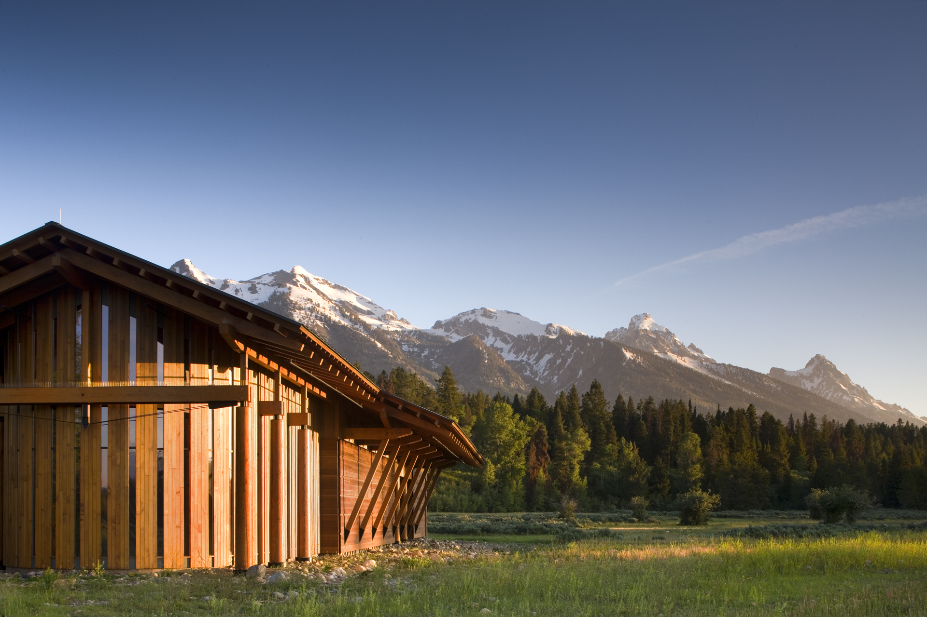

Photograph by Nic Lehoux

*The trees, the animals, the streams, the flowers, preserved as much as possible in their natural state of beauty, will in turn help preserve our most precious resource—the human spirit.*

--Laurance S. Rockefeller

OMB Approval 1024- (NPS# )

Expiration date:

|  |  |  |
| --- | --- | --- |
| IN REPLY REFER TO: | **United States Department of the Interior**  **NATIONAL PARK SERVICE**  Grand Teton National Park  Laurance S. Rockefeller Preserve  P.O. Drawer 170  Moose, WY 83012-0170 |  |
| August, 2009  Dear Visitor:  Thank you for participating in this important study. We want to learn about the expectations, opinions, and interests of visitors to the Laurance S. Rockefeller Preserve. This information will help us improve our management of Grand Teton National Park and better serve you, our visitor.  This questionnaire will be given to only a select number of visitors, so your participation is very important! It should only take about 20 minutes after your visit to complete.  When your visit is over, please complete the questionnaire. Seal it with the stickers provided on the last page and drop it in any U.S. mailbox.  If you have any questions, please contact Margaret Littlejohn, NPS VSP Director, Park Studies Unit, College of Natural Resources, P.O. Box 441139, University of Idaho, Moscow, Idaho 83844-1139, phone:  208-885-7863, email: [littlej@uidaho.edu](mailto:littlej@uidaho.edu).  We appreciate your help.  Sincerely,  Mary Gibson Scott  Superintendent | | |

**DIRECTIONS**

At the end of your visit:

1) Please have the selected individual complete this questionnaire.

2) Answer the questions carefully since each question is different.

3) For questions that use circles (O), please mark your answer by

filling in the circle with black or blue ink, or a pencil with dark

(e.g. #2) lead.



4) Seal it with the stickers provided.

5) Drop it in a U.S. mailbox.

Thank you!

**PRIVACY ACT and PAPERWORK REDUCTION ACT statement:**

16 U.S.C. 1a-7 authorizes collection of this information. This information will be used by park managers to better serve the public. Response to this request is voluntary. No action may be taken against you for refusing to supply the information requested. Your name is requested for follow-up mailing purposes only. When analysis of the questionnaire is completed, all name and address files will be destroyed. Thus the permanent data will be anonymous. Please do not put your name or that of any member of your group on the questionnaire. An agency may not conduct or sponsor, and a person is not required to respond to, a collection of information unless it displays a currently valid OMB control number.

**Burden estimate statement**: Public reporting burden for this form is estimated to average 20 minutes per response. Direct comments regarding the burden estimate or any other aspect of this form to Margaret Littlejohn, NPS Visitor Services Project, College of Natural Resources, University of Idaho, P.O. Box 441139, Moscow, ID, 83844-1139; email: littlej@uidaho.edu.

**Please go to the next page 🡺**

**Your Visit to the Laurance S. Rockefeller Preserve**

**part of Grand Teton National Park**

**NOTE**: In this questionnaire, **personal group** is defined as anyone that you are visiting the park with, such as spouse, family, friends, etc. This does not include the larger group that you might be traveling with, such as school, church, scouts, or tour group.

1. a) Prior to your visit, how did you and your personal group obtain information to plan your visit to the Laurance S. Rockefeller Preserve? Please mark (•) **all** that apply in column (a).

b) For the sources of information that you and your group used to plan your visit to the Preserve, please rate their importance in column (b).

**b) If used, how important?**

1=Not important

2=Somewhat important

3=Moderately important

4=Very important

**a) Prior to this visit** (•) 5=Extremely important

O Obtained no information prior to visit 🡺**Go to Question 2**

O Previous visits to the Laurance S. Rockefeller Preserve

O Friends/relatives/word of mouth

O Travel guides/tour books (such as AAA, etc.)

O Park visitor centers

O Maps/brochures

O *Teewinot* (Grand Teton National Park newspaper)

O Newspaper/magazine articles

O Inquiry to park via phone, mail, or email

O Grand Teton National Park website: [www.nps.gov/](http://www.nps.gov/blri/)grte

O Information from local motel or other business

O Other (Please specify below)

c) From the sources marked above, did you and your personal group receive the type of information about the Preserve that you were seeking?

O No O Yes 🡺**Go to Question 2**

d) If NO, what information did you need that was not available? Please be specific.

2. a) On this trip, what was the **primary** reason that you and your personal group came to the Grand Teton National Park **area**--Teton County, which includes Jackson and Grand Teton NP? Please mark (•) **one**.

O Resident of Teton County (you or any member of your personal group)

O Visit Laurance S. Rockefeller Preserve

O Visit Grand Teton National Park

O Visit other attraction (Please specify)

O Visit friends/relatives

O Business

O Other (Please specify)

b) On this visit were you and your personal group **planning** to visit Grand Teton National Park (NP) and/or Laurance S. Rockefeller Preserve?

O No, neither O Yes, LSR Preserve only

O Yes, Grand Teton NP only O Yes, both

3. a) On this visit, what were the reasons that you and your personal group visited the Laurance S. Rockefeller Preserve? Please mark (•) **all** that apply**.**

O Walk/hike trails

O Scenic views

O Experience solitude and contemplation

O View native plants and animals

O Experience natural quiet/sounds of nature

O Experience the Preserve visitor center

O Attend ranger-led programs

O Inspiration

O Learn to be a better steward of the environment

O Other recreational opportunities (fishing, swimming, etc.)

(Please specify)

O Other (Please specify)

b) Which of the above reasons was your **primary** reason for visiting? List **one**.

4. a) The Laurance S. Rockefeller Preserve lies along the Moose-Wilson Road. On this visit, how did you arrive at the Preserve? Please mark (•) **one**.

O From the south (Teton Village)

O From the north (Moose area)

O By park trail

b) In which direction did you go when you departed the Preserve? Please mark (•)**one.**

O Toward the south (Teton Village)

O Toward the north (Moose area)

O Any direction on park trail

5. On the day that you received this questionnaire, what was the last mode transportation that you used to arrive at the Laurance S. Rockefeller Preserve? Please mark (•) **one.**

O Personal vehicle (car, SUV, pickup, RV, etc.) O Rental vehicle

O Motorcycle O Bicycle

O On foot O Horse

O Other (Please specify)

6. a) The main visitor season at the Laurance S. Rockefeller Preserve is from May 1 through October 31 each year. How many times have you visited between May 1, 2009 and the date that you received this questionnaire?

Number of times visited

b) How many times do you plan to visit the Preserve between the date you received this questionnaire and October 31, 2009?

Number of visits planned

c) How often do you visit the Preserve? Please mark (•) **one.**

O If this is your first visit 🡺 **Go to Question 7**

O Daily O Weekly O Monthly O Other

(Please specify)

7. a) During this visit, in which activities did you and your personal group participate? Please mark (•) **one**.

O Walked/Hiked trails O Visited Preserve visitor center O Both

b) If both, which activity did you and your personal group do first? Please mark (•) **one.**

O Walked/Hiked trails O Visited Preserve visitor center

8. a) On this visit to the Laurance S. Rockefeller Preserve, did you and your personal group visit or use any of the following facilities? Please mark (•) **one** for each facility.

b) For the facilities that you visited, did you and your personal group encounter other visitors at any time during your activities? Please mark (•) **one** for each.

c) How did the encounter with other visitors affect your experience? Please mark (•) **one** answer for each.

|  |  |  |  |  |  |  |  |
| --- | --- | --- | --- | --- | --- | --- | --- |
| Facility | a) Visited facility? | | b) Encountered  other visitors? | | c) Effect on your experience? | | |
| Yes | No | Yes | No | Positive | No effect | Negative |
| Preserve visitor center | O | O | O | O | O | O | O |
| Restrooms | O | O | O | O | O | O | O |
| Trails | O | O | O | O | O | O | O |
| Parking lot | O | O | O | O | O | O | O |
| Other (Specify) | O | O | O | O | O | O | O |
|  |  |  |  |  |  |  |  |

d) If you used any the above facilities, please rate how crowded you and your group felt at that facility. Please mark (•) **one** answer for each.

|  |  |  |  |  |  |
| --- | --- | --- | --- | --- | --- |
| Facility | d) How crowded? | | | | |
| Not at all crowded | A little crowded | Moderately crowded | Very crowded | Extremely crowded |
| Preserve visitor center | O | O | O | O | O |
| Restrooms | O | O | O | O | O |
| Trails | O | O | O | O | O |
| Parking lot | O | O | O | O | O |
| Other (Specify) | O | O | O | O | O |

9. a) On this visit to Laurance S. Rockefeller Preserve, how long **in** **total** did you and your personal group spend in the Preserve?

Number of hours (e.g. ¼ hr, 1 ½ hrs, 5 ¾ hrs)

b) How long did you and your personal group spend in the Preserve visitor center? Please mark (•) **one**.

O Did not go to the Preserve visitor center

Number of hours (e.g. ¼ hr, 1 ½ hrs, 5 ¾ hrs)

10. a) On this visit, did you and your personal group see wildlife, including birds?

O No O Yes 🡺 What kind?

b) Did you and your personal group hear wildlife?

O No O Yes 🡺 What kind?

c) Did you and your personal group see signs of wildlife, such as tracks or scat?

O No O Yes 🡺 Please specify

d) How did these experiences affect your visit? Please mark (•) **one**.

O Added to O No effect O Detracted from

11. a) Which trails did you and your personal group hike during this visit to the Laurance S. Rockefeller Preserve? Use the map on the next page to locate the trails. Please mark (•) **all** that apply in column (a).

O Did not hike on this visit 🡺 **Go to part b**

b) Which trails have you hiked during past visits to the Preserve? Please mark (•) **all** that apply in column (b).

O First visit OR did not hike on past visits 🡺 **Go to Question 12**

**a) This visit: b) Past visits:**

O Lake Creek Trail O

O Woodland Trail O

O Aspen Ridge Trail O

O Boulder Ridge Trail O

O Phelps Lake Loop O

O Death Canyon Trail O

O Open Canyon Trail O

O Valley Trail O

O Granite Canyon Trail O

c) If you hiked during this visit to the Preserve, what was your destination?

LSR Preserve Trails

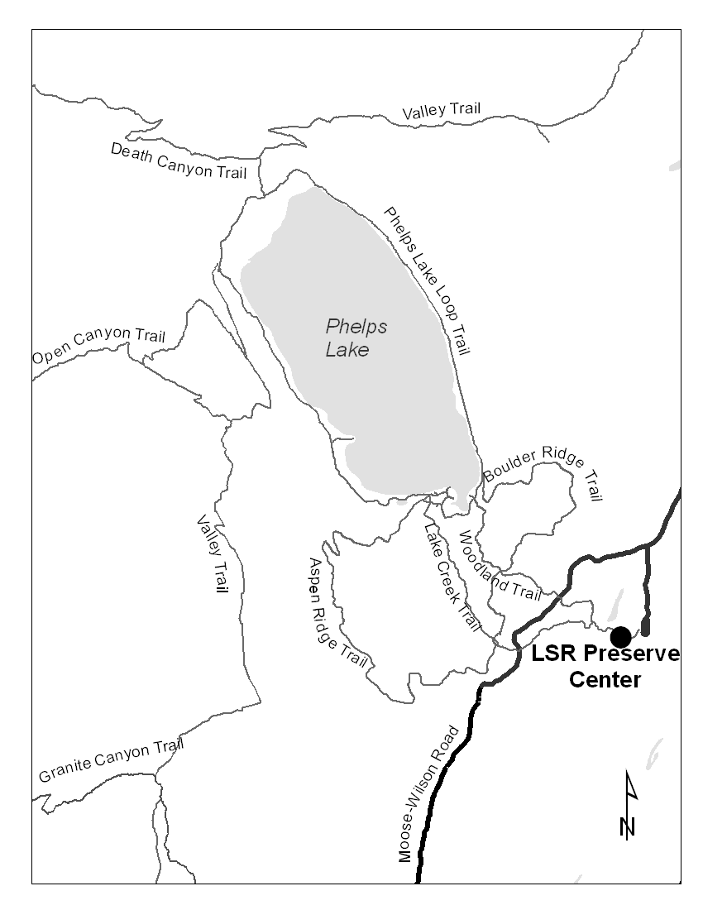

12. a) Please mark (•) **all** visitor services and facilities that you or your group **used** during your visit to the Laurance S. Rockefeller Preserve.

b) Next, for only those services and facilities that you or your group **used**, please rate their importance to your visit from 1-5.

c) Finally, for only those services and facilities that you or your group **used**, please rate their quality from 1-5.

|  |  |  |
| --- | --- | --- |
| 1. **Visitor services and**   **facilities used**  Mark (•) | **b) If used,**  **how important?**  1=Not important  2=Somewhat important  3=Moderately important  4=Very important  5=Extremely important | **c) If used,**  **what quality?**  1=Very poor  2=Poor  3=Average  4=Good  5=Very good |

O Preserve visitor center

O Preserve visitor center exhibits

O Preserve visitor center library/resource room

O *Building Green* brochure for the Preserve

O Restrooms

O Trails

O *Trail Guide* for the Preserve

O Parking Lot

O Seating in Preserve visitor center

O Seating along trails

O Signs

O Ranger-led programs

O Assistance from park staff at information desk

O Access for disabled persons

O Laurance S. Rockefeller Preserve website

(part of Grand Teton National Park website):

[www.nps.gov/](http://www.nps.gov/)grte (used before or during visit)

d) If you and your personal group have comments on any of the above services and facilities, please use the lines below.

**Service/facility** (List) **Comment** (Please be specific)

13. a) Please list the sounds, natural or human-caused, that you heard on this visit.

Laurance S. Rockefeller Preserve Visitor Study 11

b) Please list any feelings or emotions that you associate with the sound.

c) How did you interpret the sound? Please mark (•) **one** for each sound listed.

d) How acceptable was hearing this sound in the Preserve? Please mark (•) **one** for each sound listed.

|  |  |  |  |  |  |  |  |  |  |  |  |
| --- | --- | --- | --- | --- | --- | --- | --- | --- | --- | --- | --- |
| a) Sounds heard on this visit | b) Feelings or emotions associated with the sound (write-in) | c) How did you interpret this sound? | | | | | d) How acceptable was this sound in the Preserve? | | | | |
| Very annoying | Slightly annoying | Neutral | Slightly pleasing | Very pleasing | Very unacceptable | Slightly unacceptable | Neutral | Slightly acceptable | Very acceptable |
| Animal sounds |  | O | O | O | O | O | O | O | O | O | O |
| Bird singing |  | O | O | O | O | O | O | O | O | O | O |
| Flowing water |  | O | O | O | O | O | O | O | O | O | O |
| Motor vehicles |  | O | O | O | O | O | O | O | O | O | O |
| People talking/yelling |  | O | O | O | O | O | O | O | O | O | O |
| Personal audio devices (iPod, cell phones, etc.) |  | O | O | O | O | O | O | O | O | O | O |
| Wind |  | O | O | O | O | O | O | O | O | O | O |
| Other (Please specify) |  | O | O | O | O | O | O | O | O | O | O |

14. a) On this visit, were you and your personal group with an organized group?

O With organized group

O Not with organized group 🡺 **Go to Question 15**

b) Please specify the exact name of the organized group.

c) How many people were in your organized group?

Number of people

15. a) On this visit, with what kind of personal group (not guided tour/school/other organized group) were you? Please mark (•) **one.**

O Alone O Family

O Friends O Family and friends

O Other (Please specify)

b) On this visit, how many people were in your personal group, including yourself?

Number of people

16. a) On this visit, how many vehicles did you and your personal group use to arrive at the Laurance S. Rockefeller Preserve?

Number of vehicles

b) On this visit, did you and your personal group choose to carpool?

O Yes O No

c) Whether or not you carpooled on this visit, would you and your personal group be willing to carpool on a future visit to the Preserve?

O Yes, likely O No, unlikely O Not sure

17. a) & b) When visiting an area such as the Preserve, what **one** language do you and most members of your personal group prefer to use for the following?

a) Speaking: O English O Other (Specify)

b) Reading: O English O Other (Specify)

18. For you and your personal group on this visit, please provide the following. If you do not know the answer, please leave it blank.

**Current U.S. Zip Code**

**age or name of**

**country other**

**than U.S.**

Yourself

Member 2

Member 3

Member 4

Member 5

Member 6

Member 7

19. For you and each group member (age 16 or over) on this visit, please indicate the highest level of education completed. Please mark (•) **one** for each person. If you do not have the information for any group member, please leave that line blank.

**Highest level of education**

|  |  |  |  |  |  |  |
| --- | --- | --- | --- | --- | --- | --- |
|  | Some high school | High school diploma/ GED | Some college | Bachelors degree | Master’s degree | Doctoral degree |
| Yourself | O | O | O | O | O | O |
| Member 2 | O | O | O | O | O | O |
| Member 3 | O | O | O | O | O | O |
| Member 4 | O | O | O | O | O | O |
| Member 5 | O | O | O | O | O | O |
| Member 6 | O | O | O | O | O | O |
| Member 7 | O | O | O | O | O | O |

20. a) Does anyone in your personal group have a physical condition that made it difficult to access or participate in Preserve activities or services?

O Yes O No 🡺 **Go to Question 21**

b) If YES, on this visit, what activities or services did the person(s) have difficulty accessing or participating in? Please mark (•) **all** that apply.

O Visitor center O Restrooms

O Trails O Ranger-led programs

O Publications

O Other (Please specify)

c) Because of the physical condition, what specific problems did the person(s) have? Please mark (•) **all** that apply.

O Hearing (difficulty hearing preserve visitor center exhibits, ranger-led programs, or park staff, even with hearing aid)

O Visual (difficulty seeing exhibits, signs, visual aids that are part of ranger-led programs, publications, even with prescribed glasses or due to blindness)

O Mobility (difficulty accessing facilities, services, or programs, even with walking aid and/or wheelchair)

O Other (Please specify)

21. What do you feel that you gained from the time you spent at the Laurance S. Rockefeller Preserve?

22. During this visit to the Laurance S. Rockefeller Preserve, what was the most memorable sight, sound, and feeling that you experienced?

23. How could your experience at the Laurance S. Rockefeller Preserve be improved?

24. Is there anything else you and your personal group would like to tell us about your visit to Laurance S. Rockefeller Preserve?

25. a) Overall, how would you rate the quality of the visitor facilities, services and recreational opportunities at the Laurance S. Rockefeller Preserve during this visit? Please mark (•) **one**.

Very poor Poor Average Good Very good

O O O O O

b) Did you travel to other destinations within Grand Teton National Park during this visit?

O Yes O No 🡺 **You are finished with this survey**

c) If YES, how would you rate your overall experience in the rest of Grand Teton National Park on this visit, **not including** your experience at the Laurance S. Rockefeller Preserve? Please mark (•) **one**.

Very poor Poor Average Good Very good

O O O O O

|  |  |
| --- | --- |
|  | Printed on recycled paper |

Thank you for your help! Please seal the questionnaire with the stickers provided and drop it in any U.S. mailbox.

**OFFICIAL BUSINESS**

**Visitor Services Project**

**Park Studies Unit**

**College of Natural Resources**

**University of Idaho**

**P.O. Box 441139**

**Moscow, Idaho 83844-1139**